The 4 C’s
Terms to know before the 4 C’s
These terms and diamond anatomy are important to know before learning about the 4C’s

BRIGHTNESS
Internal and external white light reflected from a diamond.

FIRE
The scattering of white light into all the colors of the rainbow.

SCINTILLATION
The sparkle a diamond produces, and the pattern of light and dark areas caused by reflections within the diamond.
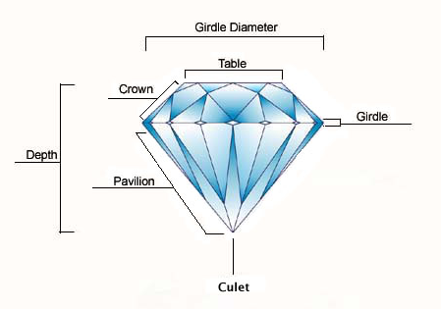

Cut
Cut is the most important of the 4 C's because it has the greatest impact on a diamond's brilliance, fire and scintillation. It is the only factor that is controlled by man/woman. Cut is also known as the shape of the diamond. Some cuts are going to reflect light better than others, for example a round is more brilliant than a princess cut.
Cut determines how a diamond reflects light. Whether the cut is deep, shallow or ideal is important to understand how that cut is going to affect the brilliance of your diamond. Brilliance is the total effect of light reflected and refracted from the interior and exterior surfaces of the diamond. Reflection refers to returning light like a mirror; refraction refers to the bending of light. Brilliance depends on the extent to which light entering from above is reflected back from the facets. The more light reflected, and the less that is leaked or refracted out through the pavilion, the more brilliant the diamond.
Fire also known as dispersion. Fire is the breaking up of white light into the colors of the rainbow. This is what gives a diamond it’s sparkle.
Sparkle is also called scintillation. It is the flashing effect seen when a diamond moves in the light.
Three factors determine cut quality: proportions, symmetry and polish. Proportion refers to the relationship between the size, shape and angle of each facet. Symmetry refers to the exactness of the diamond's shape as well as the even placement and symmetrical arrangement of the facets. Polish is the diamond's smoothness and shine. Cut grade is determined by a diamond's face-up appearance (brightness, fire, and scintillation), design (ratio and durability), and craftsmanship (polish and symmetry). The Gemological Institute of America (GIA) cut grades are Excellent, Very Good, Good, Fair and Poor.
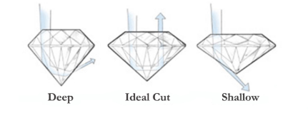
Cut Grade | Action | Result
Excellent Cut | Essentially all light that enters the diamond is reflected | Maximum brilliance and fire
Very Good Cut | Nearly all of the light that enters the diamond is reflected | High brilliance and fire
Good Cut | Most of the light that enters the diamond is reflected | Brilliance and sparkle
Fair Cut | Much of the light that enters the diamond escapes through the pavilion | Very little brilliance and fire
Poor Cut | Most of the light that enters the diamond escapes through the pavilion | Little to no brilliance or fire

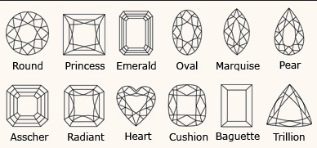

Color
The color of a diamond is actually referring to the lack of color. The closer a diamond is to being totally colorless or clear, the rarer and more valuable it is.
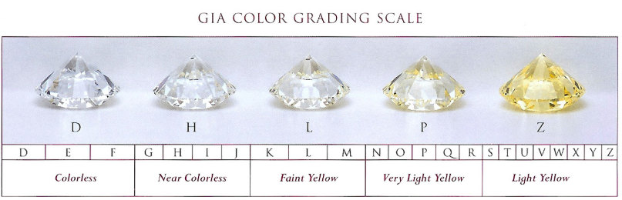
Carat
A diamond's weight is measured in units called carats. A metric “carat” is defined as 200 milligrams. As carat weight increases, so does rarity and value. Each carat can be subdivided into 100 ‘points.’ This allows very precise measurements to the hundredth decimal place. A jeweler may describe the weight of a diamond below one carat by its ‘points’ alone. For instance, the jeweler may refer to a diamond that weighs 0.25 carats as a ‘twenty-five pointer.’ Diamond weights greater than one carat are expressed in carats and decimals. A 1.08 carat stone would be described as ‘one point oh eight carats.’

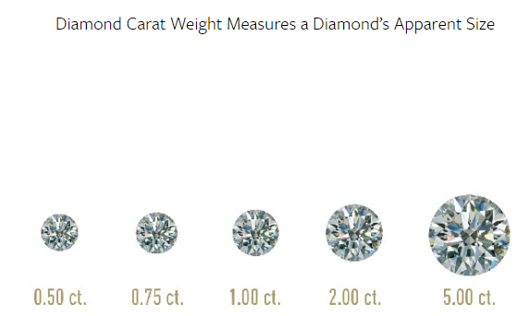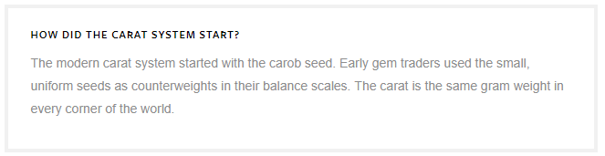

Clarity

Diamond clarity refers to the absence of inclusions and blemishes, clarity is the least important of the 4 C's because it has little effect on a diamond's beauty. Natural diamonds are the result of carbon exposed to extreme heat and pressure deep within the earth. This process can result in a variety of internal characteristics called ‘inclusions’ and external characteristics called ‘blemishes.’
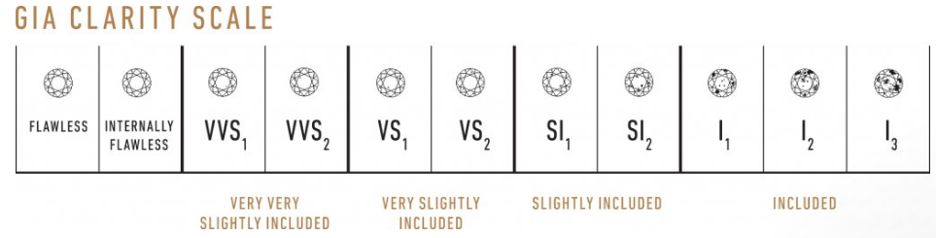
- Flawless (FL) No inclusions and no blemishes visible under 10x magnification
- Internally Flawless (IF) No inclusions visible under 10x magnification
- Very, Very Slightly Included (VVS1 and VVS2) Inclusions so slight they are difficult for a skilled grader to see under 10x magnification
- Very Slightly Included (VS1 and VS2) Inclusions are observed with effort under 10x magnification, but can be characterized as minor
- Slightly Included (SI1 and SI2) Inclusions are noticeable under 10x magnification
- Included (I1, I2, and I3) Inclusions are obvious under 10x magnification which may affect transparency and brilliance

