Style
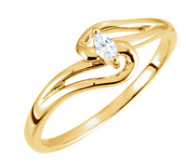 | Promise Ring | An outward symbol who have no immediate plans for marriage but are clearly in a committed relationship. If an engagement ring comes along in the future, the promise ring often moves over to the opposite hand.
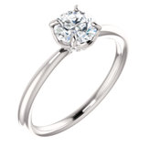 | Solitaire | A single stone ring. Solitaire is the most popular engagement ring style as it can be dressed up with a wrap or guard after the big question has been proposed.
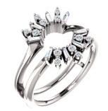 | Wrap | A wrap is an enhancer is to complement a solitaire ring with additional diamonds or gemstones, to enhance the size and appearance of a solitaire engagement ring. When worn together, the two rings appear to be a single, multi-stone ring.
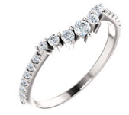 | Guard | A guard is a lovely choice to complement many different engagement ring designs. A wedding ring guard is a specialized type of wedding band designed to protect both sides of the engagement ring while also enhancing its style.
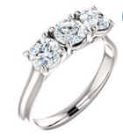 | 3-Stone Ring | A three stone is often referred to representing the past, present, and future. It is also known as a trinity ring or trilogy ring.
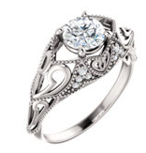 | Vintage | Vintage-inspired styles are often found with milgrain or filigree designs that represent pay homage to the past.
See Vintage | Milgrain | Derived from the French 'mille-grain', which translates to “a thousand grains”, milgrain detailing is a close-set row of metal beads that are typically used as a border
See Vintage | Filigree | A delicate embellishment in which fine, pliable threads of precious metal
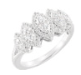 | Multi Stone | Also known as a diamond cluster ring, a multi-stone ring features multiple diamonds grouped together to form a center stone.
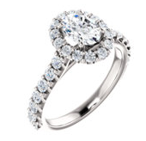 | Halo | A halo style setting features a center stone surrounded by a halo of round pavé or micro-pavé diamonds that enhance the appearance of the center stone.
See Halo | Pavé | Pronounced “pa-vey” is a setting that consists of a lot of small stones attached to the jewelry by droplets of metal. As a result, the ring looks like it has been paved with stones.
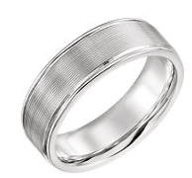 | Band | Finger ring that indicates that its wearer is married. It is usually forged from metal
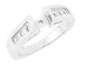 | Mounting | Is essentially the metal structure of the ring which allows you to choose and have your own stones set.
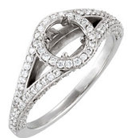 | Semi-mount | Along the same premise of a mounting, but some accents stones are already set into the ring.

