## **Conflict Free Sourcing**

We at Legacy Jewelry are very conscious about how we buy our diamonds. Conflict diamonds came to the attention of the world media during the extremely brutal conflict in Sierra Leone in the 1990s. The UN, governments, and the diamond industry recognized the need for a global system to prevent conflict diamonds from entering the legitimate diamond supply chain and aiding to fund conflict. We are committed to selling diamonds that are ethically sourced and will not tolerate conflict diamonds or human suffering in any way. We do everything in our power to buy conflict free diamonds from reputable vendors who support the Kimberly process. Most of our vendors obtain the diamonds from Canada, South Africa, Russia, Botswana and Namibia avoiding supply chains who directly or indirectly finance armed conflict or serious human rights violations around the Democratic Republic of Congo or it’s adjoining countries.

Diamonds are a vital source of revenue for people in Africa and there are many who follow the appropriate laws, we will only support those who are ethical and follow the Kimberly Process. The Kimberley Process ensures that rough diamonds are:

* + Exported and imported with a government validated Kimberly Process certificate stating the diamonds are conflict-free.
  + Transported between signatory countries in a sealed and tamper-proof container.
  + Sold with a statement from the seller (known as a warranty) on all invoices guaranteeing that the diamonds being sold are conflict-free.
  + Each certificate must be resistant to forgery, uniquely numbered and describe the shipment's contents
  + It is illegal for uncertified shipments of rough diamonds to either be imported or exported by a Kimberley Process participant country
  + Failure to comply with these procedures can lead to confiscation or rejection of parcels and/or criminal sanctions
  + If any concerns arise regarding a country's adherence to the Kimberley Process, they are investigated and dealt with at an intergovernmental level.

We believe that a responsible, conflict-free supply chain is fundamental to the reputation of the jewelry industry and are committed to advance responsible sourcing throughout the supply chain for all jewelry including metals and colored gemstones. In May 2017, the EU passed “conflict minerals legislation” to ensure that minerals and metals exported to the EU do not contribute to conflict, that smelters and refiners in the EU and globally do not use raw materials from sources which may contribute to conflict, and that mine workers are not abused, these are the trends that Legacy is staying on top of to ensure engagement in verification of product supply chains to evaluate and address risks of human trafficking and slavery.

Most of Legacy Jewelry’s largest suppliers are certified members of the Responsible Jewelry Council (RJC), as Legacy Jewelry encourages all its suppliers to be. Suppliers that are certified RJC members receive scheduled audits by independent third-party firms as part of a rigorous Code of Practices certification process. Audits are only announced within enough advanced notice to permit access to the facility. Any country that is found not to be in compliance can be sanctioned by the Kimberley Process.

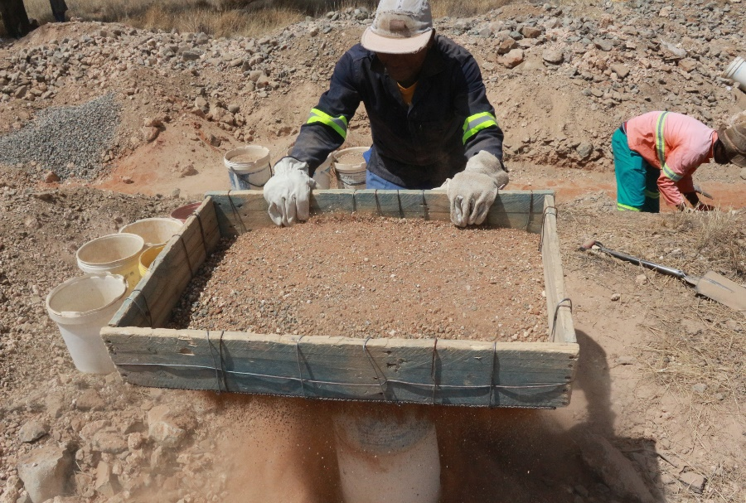

[This Photo](https://www.groundup.org.za/article/ekapa-case-shows-south-africas-stark-inequalities/) by Unknown Author is licensed under [CC BY-ND](https://creativecommons.org/licenses/by-nd/3.0/)

## **SYSTEM OF WARRANTIES**

Under this system, which has been endorsed by all Kimberley Process participants, all buyers and sellers of both rough and polished diamonds must make the following affirmative statement on all invoices:

"The diamonds herein invoiced have been purchased from legitimate sources not involved in funding conflict and in compliance with United Nations Resolutions. The undersigned hereby guarantees that these diamonds are conflict free, based on personal knowledge and/or written guarantees provided by the supplier of these diamonds."