Watches
The movement, or inner workings, of a watch are what make up the main timekeeping mechanism. These movements can be entirely mechanical, entirely electronic or a combination of the two.

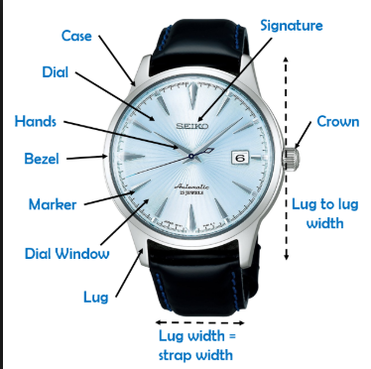

- Mechanical movements-such as hand wound, or automatic watches require winding in order to run.

- An automatic- watch uses the force of gravity to constantly wind itself. Automatic watches have a greater consistency of power and therefore can be more accurate.
- An electronic watch- also known as a quartz watch, employs the use of a tiny quartz crystal that vibrates in the presence of electricity. This type of watch is powered by a battery.
- Solar powered- watches convert energy from light into electricity which is then stored in a rechargeable battery. These watches need regular exposure to light.
- Kinetic powered- watches use a combination of mechanical and electronic elements. Usually a weight rotates with the motion of the wearer’s arm which turns a generator to supply power. It is similar to an automatic watch except that electrical power is generated by the mechanical motion.

Crystal
The crystal is the protective cover on the face of the watch. The most common crystals are made of glass, acrylic or synthetic sapphire.
- Acrylic crystals- are made from a plastic composite and are generally less expensive
- Glass crystals- are hard and difficult to scratch but can shatter
- Synthetic sapphire crystal- can be shatter-resistant and nearly scratch-resistant.
Watch types
- Casual Watches: Casual watches are usually made from stainless steel and have a relatively plain face. They are watches that can be worn every day and have a durable strap.
- Dress Watches: Dress watches are characterized by a case made from gold or other precious metal. They usually have an elegant design and leather strap.
- Sport Watches: Sport watches are heavier and more durable than dress or casual. These watches have a casual type strap that can be a rubber-based band, padded leather band, or bracelet. Most of these watches are digital and have more advanced functions than those of a dress or casual watch.

Water Resistance
The amount of water that watches can withstand is rated in depths, ranging from 30 meters (100 feet) to 200 meters (660 feet). On average most watches can withstand depths of 200 meters making them acceptable to use for recreational swimming or diving, but you should always consult your owner’s manual before use.

Watch cleaning
There are two parts of a watch you need to keep clean: the face, and the band.
- Screw down the crown (If necessary)
- Set up one bowl of clean warm water, and one bowl of warm soapy water using mild detergent, like Dial dish soap. A dime-sized amount will suffice.
- Dip a chamois cloth or soft-bristled toothbrush into the soapy water, and gently brush over the top of the watch face and band.
  - Leather bands cannot be exposed to moisture
- Carefully dip only the bracelet or strap of your watch into the soapy water for 15-20 seconds. It is important to not expose the movement to moisture especially if your watch is not water resistant.
- Take it out, and gently scrub with a clean, damp toothbrush.
- Rinse the watch under warm water.
- Dry the watch using a microfiber cloth.

