**Diamonds**

Diamonds repel water and attract oils like those found in makeup, so it’s best to put on your jewels after you have used cosmetics or perfumes/colognes. Avoid wearing your diamond jewelry during arduous activities, because although diamonds are the strongest substances they can be damaged, or the jewelry holding the diamonds can be damaged. Also, diamonds can be scratched by other diamonds, try to avoid having them jumbled up together in a jewelry box

**Professional Cleaning**   
Every six months take your ring to an established jeweler and have your ring cleaned and polished. When you have a professional jeweler do this they will inspect your stones and the mounting to ensure that it has not been chipped or that any stones are loose.

*Reminder:* Legacy Jewelers will clean and inspect your jewelry for ***FREE***.

**Jewelry Cleaners**   
Consult Legacy Jewelry to purchase jewelry cleaner and polishing cloths for maintaining your jewels between professional cleanings.

**Mild Liquid Detergent Soak**   
Get a small container and fill it with warm water and a few drops of mild liquid detergent. Soak your jewelry for about hour, this will break up any dirt and grime on your jewelry. When it is done soaking, take a soft toothbrush and gently scrub your jewelry. After, rinse your jewelry under warm water. Dry with a soft cloth, free of lint. Remember; plug the drain before you begin to ensure your jewelry does not fall down the drain.

*Tip:* Use an old tea strainer that closes, to use when rinsing, this allows for a better grip on the piece.

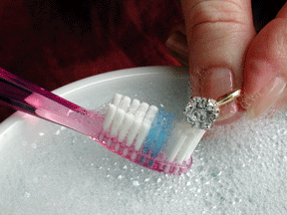

[This Photo](http://www.centromujer.es/belleza/trucos-caseros-para-limpiar-las-joyas/) by Unknown Author is licensed under [CC BY-SA-NC](https://creativecommons.org/licenses/by-nc-sa/3.0/)