Pearls
A simple rule of thumb will keep your pearls like new: Put them on last and take them off first. Pearls are porous and will absorb beauty products. Never bathe or swim in your pearls, water can weaken the silk or nylon cord. After each wear, gently wipe your pearls with a soft cloth, like a microfiber cleaning cloth. For a more through cleaning follow the steps below:
- Use a gentle, natural soap.
- Use distilled water. The chlorine and other chemicals present in tap water can damage your pearls.
- Apply soapy water using a soft cloth. Do not submerse or soak your pearls in the soap-water solution; instead, use the cloth to transfer the soapy water to the pearls. Do not use a toothbrush as this may scratch your pearls
- Lay flat to dry, make sure they air dry completely before wearing or storing. By laying them flat it prevents tension on the cordage allowing your pearls to last longer.
  - Store separately and away from other jewelry as pearls can be scratched easily. The container should be soft such as a silk pouch or pearl folder. Do not store in a plastic bag as some of them release chemicals that can deteriorate your pearls. Do not store your pearls in a safe. Safes are humidity-controlled to protect paper. Pearls need to draw moisture from the air to maintain their beauty. When pearls are deprived of moisture, tiny fractures form and they can become discolored. Also keep them away from direct sources of heat.
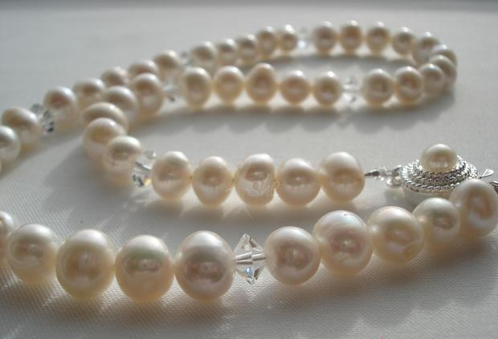
This Photo by Unknown Author is licensed under CC BY-SA-NC

