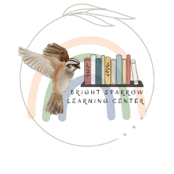
Application Form
Parents Full Name
Address
Email(s)
Cell & Phone number(s)
Children’s Full Name(s)
Birthdate & Current Age(s)
Grade(s)
Any allergies, please describe
Any special needs, please describe
Start Date
(i.e. immediately, next semester)
Length of Term
(i.e. entire school year, few months)
Reason for your interest with Bright Sparrow Learning Center
Academic History (has the student(s) ever been suspended, expelled, or received any disciplinary actions? If so, please share in detail)
How did you hear about us?
Who can we thank for the referral (if any)?

