* SHOWER IMMEDIATELY
* **SCRUB HAIR WITH HEAVY DANDRUFF SHAMPOO DAILY**
* CHECK YOUR BODY DAILY
* CUT YOUR NAILS
* **TAKE WORK OUT CLOTHS HOME EVERY DAY TO WASH IN HOT WATER**
* WEAR CLEAN GEAR EVERY DAY
* NEVER SHARE GEAR
* COVER ALL WOUNDS
* KEEP SHOES CLEAN – ONLY WEAR ON THE MATS
* TELL YOUR COACH IF YOU HAVE:
  + AN OPEN WOUND
  + A WOUND IS FILLED WITH PUS
  + A WOUND THAT HAS A GOLDEN CRUST
  + A WOUND OR AREA THAT ITCHES
  + AN ILLNESS

**NO PRACTICE GO TO YOUR DOCTOR IMMEDIATELY IF YOU SEE ANY OF THE FOLLOWING:**

**Ring Worm:** red ring, itchy, scaly **Impetigo:** blisters, golden crust sores

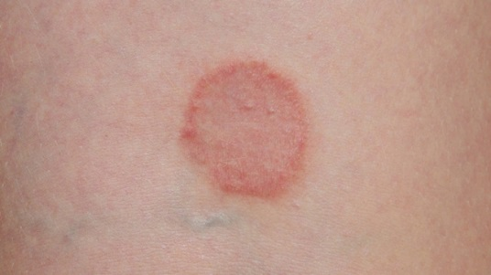 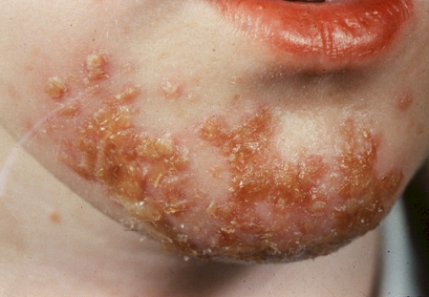

**Staph:** red, swollen, pus filled **Herpes Gladitorium:** clusters of blisters

[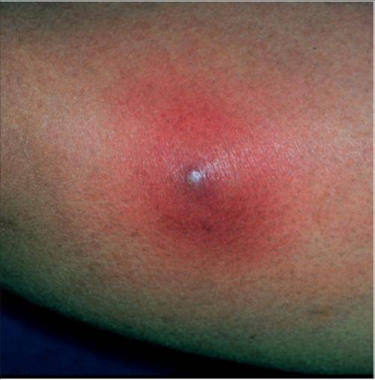](http://www.google.com/url?sa=i&rct=j&q=&esrc=s&source=images&cd=&cad=rja&uact=8&ved=0ahUKEwiYoJDtnsTXAhWo54MKHUVbAiEQjRwIBw&url=http%3A%2F%2Ferinatc.blogspot.com%2F2013%2F05%2Fstaph-infections.html&psig=AOvVaw0qL-wWVTmmXVYcmC3bFv1F&ust=1510961007661026) 