Comfort Theory: Offering Palliative Care and MAiD Providers Opportunities to Coordinate Comfort

Rebecca J. MacLure
University of Calgary
NURS 724: Philosophy, Knowledge, and Research in Nursing
Dr. Graham McCaffrey
April 7, 2024

Offering Palliative Care and MAiD Providers Opportunities to Coordinate Comfort
Over a dozen countries around the world have implemented a form of Medical Assistance in Dying (MAiD), and more are working to develop a system for assisted death (Ho et al., 2021). The legalization of assisted dying has impacted palliative care services and providers, and determining how MAiD intersects with palliative creates challenges in the working relationships between palliative and MAiD providers. These relationships are necessary to develop end-of-life care plans for patients and families (Antonacci et al., 2021). Registered nurses (RNs) have the practice knowledge to improve the care of patients receiving MAiD and can work to increase care coordination between these two services. This paper will outline the development and use of Katharine Kolcaba's Comfort Theory and how it may be incorporated into research exploring opportunities for palliative care and MAiD to coordinate end-of-life care. How the theory moved through concept analysis, the creation of its framework, and how this theory enhances comfort care in nursing practice will be detailed. The empirical, theoretical, and practical knowledge represented in comfort theory will be shared.
The literature on end-of-life care planning conveys a need for increased communication between MAiD and palliative care. This research study aims to explore the experiences of palliative care providers (PCPs) when their patients consider MAiD as an end-of-life option and seeks to enhance nursing knowledge that may inform end-of-life care planning. Interpretive Description (ID) will be the methodological approach for researching this topic. The research questions and the logic of using ID will be shared. The following paragraphs introduce palliative care, MAiD, and Comfort Theory.

Palliative Care
The Government of Canada's (2018) Framework on Palliative Care outlines a plan for a natural, pain-free death that includes support for patients and caregivers in their final days and bereavement support for the family after the patient's death. Palliative care is a family-centered plan that gives the patient and family a voice. The comprehensive material provided by the World Health Organization can be summarized to describe palliative care as a program that aims to provide the best, holistic quality of life and a natural death for individuals when a cure is no longer possible (Vanderveken et al., 2019).
Palliative care providers aim to achieve a holistic approach to end-of-life decisions while offering timely care, education, and support for patients and families (Ho et al., 2021). Palliative nurses acknowledge MAiD may become part of a patient's end-of-life plan, and they aim to provide holistic care until the day the client dies, regardless of how they choose to die (Pesut et al., 2021)
An extensive systems perspective may be required to develop the relationships between MAiD and palliative care providers (Pesut et al., 2021). Research suggests that lessons may be learned from other countries that have developed more advanced programs coordinating MAiD and palliative care (Ho et al., 2021). PCPs share several areas of concern when communicating with patients about MAiD, including confusion about the differences between MAiD and palliative care, diminished trust in the palliative care approach, gaps in education for end-of-life professionals, diversion from palliative care programs to MAiD, lesser care options for MAiD patients, less attention for the suffering of patients and families, and more focus on the quick solution of assisted death (Ho et al., 2021). Currently, there is no unification between palliative care and MAiD programs in some locations across the country (Pesut et al., 2021). Other areas, such as Ontario and British Columbia, have MAiD nursing coordinators who are not PCPs, working in advanced practice roles, providing the public with education, and connecting patients with the PCPs involved in the MAiD plan (Pesut et al., 2021). Creating these coordinated systems is a goal cited in the National Framework for Palliative Care (Government of Canada, 2018).

Medical Assistance in Dying
The law supporting MAiD Bill C-14 was first passed on June 17, 2016 (Government of Canada, 2021). This law allows individuals to request either lethal injection or medication from a nurse practitioner (NP) or physician when diagnosed with a life-ending illness (Antonacci et al., 2021). Although MAiD and palliative care are two distinct options for end-of-life and two separate programs provide them, palliative care nurses are increasingly being asked to educate and support patients about the MAiD process (Pesut et al., 2021). Comfort Theory may offer these independent healthcare services new opportunities to communicate with each other and coordinate comfort needs for their end-of-life patients.

Comfort Theory
Comfort may be described in various ways. It may be a person or an object providing comfort, something or someone that can relieve stress, a state of quiet contentment, or something that offers calmness or motivation (Kolcaba & DiMarco, 2005). These authors consider comfort a holistic, diverse, and complex term that may be a process or a product offering relief from discomfort. The theory of comfort may present MAiD and palliative care providers (PCPs) an opportunity to provide a holistic plan to reduce physical pain and other feelings of discomfort in their patient population by coordinating to meet these comfort needs. Kolcaba (1994) discussed how the concepts of comfort theory when offered together, could support the goal of holistic client comfort. Kolcaba's theory suggested that comforting measures be provided simultaneously to produce a more significant overall desired comfort level. This theory may expand PCPs' practice knowledge of how to meet their clients' end-of-life comfort needs, whether they choose a palliative natural death or MAiD. Kolcaba (1994) addressed three types of comfort by measuring relief, ease, and transcendence. These areas recognized the client's physical, psychospiritual, environmental, and sociocultural contexts of comfort. The following sections will discuss the evolution of Kolcaba's theory and framework and provide examples of how this theory provides comfort.

The inception of Comfort Theory
Kolcaba's mid-range comfort theory was initially developed in the 1990s and used as a patient and family-centered approach. Kolcaba (2003) describes her early phases of work as exploring and analyzing the definitions of comfort and her devotion to understanding comfort from being used as a common term for care to how it may describe patients' outcomes. Kolcaba's early nursing career included medical-surgical, long-term care, and home care practice settings. When she first began theorizing about comfort, she was the head nurse in a dementia unit. While working in this area, she looked at patient comfort outcomes. While pursuing her Master of Nursing (MN) degree, a professor asked the class to consider the concepts used in their practice setting. Kolcaba's work with dementia patients led her to consider how small environmental changes could affect their stability and cause emotional disruptions. Patients who could not verbalize their feelings were especially vulnerable, and staff became familiar with their sensitivities. Kolcaba observed that when her residents were in a state of comfort, they were more cooperative with staff and were visibly more content with their behavior and environment. The development of the first framework of comfort care came from Kolcaba's MN assignment and was the first step in developing the theory (Kolcaba, 2003).
Kolcaba (2003) then spent two years working with her husband, Ray Kolcaba, who specialized in epistemology, on a concept analysis for comfort. The study considered using comfort in several disciplines, including nursing, medicine, psychology, theology, psychiatry, and ergonomics. When this work was questioned about being too complicated, Ray Kolcaba, as a philosopher and educator, explained that when using Comfort Theory, nursing must clearly define the terms used for the concepts of comfort. If these terms are to be used within the discipline, there must also be consistency in how these terms are used to address the comfort needs of patients. As a result of the concept analysis, the Kolcaba and Kolcaba article was completed in 1991, the first and only journal article Katharine published with her husband. Despite her feelings that the content was too complicated and hard to understand because of the philosophical terms, this article was published in the Journal of Advanced Nursing and continues to be consulted today for its work on the concepts of comfort (Kolcaba, 2003). The following section describes Kolcaba's development of the types and concepts of comfort.

Types and Concepts of Comfort
Kolcaba (1994, 2003) used the findings from the 1991 concept analysis to construct more simplified and defined types and concepts of comfort. She identified three types: relief, ease, and transcendence. Relief was attained when the individual comfort needs of the patient were met. A state of ease was described as an overall feeling of calmness. Transcendence represents the ability of the patient to rise above their health challenges. Following her development of the three types of comfort, Kolcaba examined the literature on holism in nursing. Four contexts of patient comfort were formed from the literature: physical, psychospiritual, environmental, and sociocultural comfort (Kolcaba, 1994, 2003). Kolcaba (2003) developed a taxonomic structure (TS) to illustrate how the types and contexts of comfort from a practice area could be mapped, and this structure became the foundation of all her future work (Appendix A).
The altruistic goal of health care is to help patients increase their comfort level from baseline by implementing comforting interventions. Examples may provide insight into the types of nursing knowledge used to address comfort needs (Kolcaba, 2003).
- Empirical nursing knowledge is used to check vitals and provide pain medication, and this would be an example of providing the physical context of comfort and comfort in the form of relief.
- Ethical nursing knowledge is used to discuss advanced planning at end-of-life for patients' finances and health care. This comfort measure may offer an example of the context of psychospiritual comfort and relief or transcendence.
- Cultural nursing knowledge aids in offering and supporting patients' personal cultural needs and may increase comfort in the patient's sociocultural context and transcendence as the type of comfort.
- Nursing knowledge gained from practice and experience is key to the environmental comfort needs that offer relief and ease. Nursing education and training make nurses experts in setting temperature, light, sound, medical devices, and furniture that best suit the patient's needs.
Kolcaba (2003) states that it is not as important to distinguish which comfort types the intervention falls under as they may fit into more than one box on the TS. It is, however, more important to be confident in addressing all comfort needs.
Kolcaba (2003) found that the nursing theorists Joan Hamilton, Patricia Benner, and Marilyn Donahue discussed a broad range of topics on patient comfort, the most prevalent being the concept of pain reduction. Kolcaba explains how a study by Hamilton influenced the development of the physical context of comfort theory. Hamilton contributed to the context of physical comfort when she suggested that physical comfort includes pain reduction, maintaining homeostasis, and the freedom of independent movements within the patient's environment (Kolcaba, 2003). Hamilton also provided context to psychospiritual comfort by combining the psychological and spiritual themes of increased patient relaxation, knowledge, and confidence. The definition of psychospiritual comfort context continues to evolve as patients seek personal connections to their mental, emotional, and spiritual health. Kolcaba states that her perception of the environmental context started with the work of Florence Nightingale and has been modified by the influence of many nursing scholars since its inception. Environmental factors remain a focus of patient care settings and are often altered by nurses to enhance patient comfort. In addition to physical objects, Kolcaba's environmental comfort context includes all patient surroundings. It considers the influence of natural sources such as light, air, noise, and overall feelings or perceptions about their living space. Hamilton's work was essential to developing the sociocultural context with her findings of the patient's desire to have increased social support from nurses and family members involved and informed about their care (Kolcaba, 2003). The sociocultural context has evolved to include increased patient knowledge in health and finance and the development of interpersonal and family relationships. The significance of including culture is also essential to this concept as nurses expand their cultural knowledge and learn to advocate for their client's customs to be included in the care plan (Kolcaba, 2003).

The Philosophical Perspective of Comfort Theory
As a response to repeated questions from graduate students about the philosophy of Comfort Theory, Kolcaba organized a reply and put together an organized version of the philosophical perspectives taken from her many prior publications. Kolcaba (2003) states that her husband, Ray Kolcaba, produced additional work on the concepts of holism in 1997, which contributed to the philosophy of Comfort Theory by bringing the concepts together in an organized and understandable form. The philosophical levels of comfort will be discussed. Starting with the highest, most abstract level, holism, next to the level of human needs and human press, and finally, the mid-level nursing theory, including the contributions of Orlando, Henderson, and Paterson to this category of Comfort Theory.

Holism
Kolcaba (2003) explains that the first level of the theory is based on the concept of holism, which is when interactions between organisms and their environments develop complex relationships and responses simultaneously. People's bodies respond to their surroundings with physical, mental, and behavioral responses. Each person has developed knowledge of the surrounding world and how they react to it, allowing individuals to make a holistic life plan (Kolcaba, 2003). Assumptions of holism taken from Kolcaba's previous work include how human beings respond to stimuli, and the response is more significant when the stimuli are used together to effect response (Kolcaba, 2003).
When the goal is a whole-person response, the nurse will explore that interventions would be applied to address comfort needs using a holistic approach (Kolcaba, 2003). An example may be using massage, therapeutic music, and pleasing artistic visuals simultaneously. The comprehensive and concurrent treatments offer the patient a holistic, comforting response. Kolcaba (2003) shares how these interventions are often used with medical treatments such as chemotherapy and may aid in decreasing side effects such as nausea. Holistic interventions are added to the patients' medical treatments and address the patient's therapeutic needs, remembering that missing just one critical comfort need can lower the overall comfort effect (Kolcaba, 2003). To prove these interventions and succeed with patients' nurses must document them in their medical records. Comfort is an immediate outcome and can be altered when the patient's state of health changes. Kolcaba developed general comfort questions using the TS. An example of measuring and documenting comfort can be presented using a questionnaire with the patient to allow nurses to address the concerns and fears of patients using comfort measures. An example of the general comfort questionnaire (GCQ) may be seen in (Appendix B). Within each practice setting, using appropriate questions, comfort measures can be discovered, implemented, and reassessed quickly to alleviate patient discomfort. Taking time to measure the outcome of holistic interventions may provide clinical significance to care. The patient outcomes may allow the patient to reduce pain, heal wounds, adhere to the maintenance plan, or offer important administration information about patient satisfaction (Kolcaba, 2003). The next level of the philosophy of Comfort Theory we will outline covers human needs and Henry Murray's human press to describe ways of meeting the basic comfort needs of the patient.

Human needs
The next level in the Comfort Theory hierarchy is a category of human needs, adaptation, and the health/illness continuum (Kolcaba, 2003). This level in the philosophy of Comfort Theory is based on the current state of a patient's needs and what they need to maintain or improve their well-being. Because this theory is based on the physical, psychospiritual, sociocultural, and environmental needs of the patients, it aims to help them meet their health goals within the health system (Kolcaba, 2003). When comfort needs are met, patients experience feelings of motivation to be involved in health-seeking behaviors that maintain their enhanced comfort. Kolcaba (2003) states that these needs are motivated by culture and the expectation that health care will provide a competent care plan that is thorough and holistic. Two attributes of human needs are identified. The first is personally motivated behavior that provides the patient an internal strength to heal and participate in health-seeking behaviors. The other is driven by social expectations and societal norms where patients expect to receive competent care from their health system (Kolcaba, 2003).

Human Press
Kolcaba (2003) informs how Henry Murray's system of needs, developed in 1938, is used here as a model that offers the same element for a holistic view of how all parts of a person act together and should be assessed simultaneously. Murray's perception was that a person consists of many interconnecting physical and psychological issues from their past, and because they act together, these issues may affect the desired outcomes (Kolcaba, 2003). Murray's theory of Human Press, the third philosophical level of Comfort Theory, proposes that the total obstructing forces on a patient may threaten their health and treatment efforts. Kolcaba explains that the Alpha press is the result of all acting forces, both positive and negative, on the patient, and the Beta press is the patient's perception of all acting forces on their health. The beta press may also allow patients to appraise their outcomes. This process of self-evaluation motivates patients when they have positive outcomes, increasing their confidence to achieve future positive outcomes. Nursing interventions are designed to address each client's issues and overcome each person's obstructing forces, aiming to reach the desired outcome of overall patient comfort (Kolcaba, 2003).

Nursing Theory
The fourth philosophical level of Comfort Theory is nursing. Kolcaba (2003) shares how the nursing theorists Orlando, Henderson, and Paterson directly contributed to developing the three types of comfort, relief, ease, and transcendence. Based on the importance of relationships between nurses and patients, Orlando's interaction theory completed physical and mental comfort assessments before and after nurses completed comforting interventions. Kolcaba used Orlando's research in achieving comfort to influence her development of an overall state of relief and comfort. The work by Henderson balanced the patients' health using basic physical and psychological interventions that addressed environmental control and many human functions, including respiration, nutrition, elimination, sleep, and skin integrity. Kolcaba cultivated the state of ease from Henderson's work, as it describes the homeostatic state when the patient attains the above processes. Paterson, a former psychiatric nurse, characterized comfort from a mental health view. She describes comfort as a free, open, mindful state in which patients feel in control of their circumstances. This interpretation of comfort is called transcendence in Kolcaba's Comfort Theory (Kolcaba, 2003).
This section summarized the philosophical levels of Comfort Theory. The next area to be considered will describe the details of metaparadigm concepts and include empirical data that supports Comfort Theory.

Metaparadigm Concepts for Nursing and Comfort Theory
Kolcaba (2003) uses Fawcett's 1984 definition of a paradigm as a detailed group of phenomena that are pertinent to the discipline of nursing. Although some have argued that her concepts may not accurately represent the nursing discipline, they have endured. The concepts include person, environment, health, and nursing. Kolcaba clarifies that Fawcett did not define these concepts. Instead, she recognized that each theorist would propose a definition that would harmonize with their theory. For her theory, Kolcaba defined the metaparadigm concepts as:
- Nursing: the intentional assessment of comfort needs of patients, families, or communities; design of comfort measures to address comfort needs, including re-assessment of comfort level after implementation of comfort measures, compared to previous baseline
- Patient: an individual, family, or community in need of health care, including primary, tertiary, or preventative care
- Environment: aspects of patient/family/community surroundings that affect comfort and can be manipulated to enhance comfort
- Health: optimum function of a patient/family/community facilitated by enhanced comfort (Kolcaba, 2003, p. 68)

Comfort Theory Research and Development

Empirical Research
Her PhD supervisor approached Kolcaba (2003) to do an experimental study using Comfort Theory. She developed a guided imagery (GI) audiotape that women would listen to at least once per day when going through the treatment process of having a lumpectomy and radiation therapy (RT). The research question is "Will women who receive GI going through RT for early-stage breast cancer have greater comfort over time compared to a control group?" (Kolcaba, 2003, p. 49). Kolcaba hoped this work would result in an overall increase in comfort that could be established empirically. The GCQ was altered to include relevant questions for the study population and was called the Radiation Therapy Comfort Questionnaire. These questions were developed with the help of patients and healthcare providers with RT experience. A total of 26 questions were used using positive and negative items to reduce response bias. The questionnaire would be completed three times: before simulation and RT started, three weeks into RT, and three weeks after the RT treatments were completed. A Visual Analog Scale (VAS) was developed, 100mm long, with 100 possible scores labeled to match the areas of relief, ease, and transcendence. The VAS was scored using the means and standard deviations of the three-time points during the study. A pilot test satisfied the Ethics Board, and the research proceeded. An oncology physician represented the outside members of Kolcaba's dissertation committee.
The nurses at the RT department informed women of their first appointment and took the names of those who chose to participate. With students' help, Kolcaba collected all the data sets on 53 women within one year of the Ethics Board approval. The University of Akron statistician agreed to use the Repeated Measures Multivariate Analyses of Covariance (RM MANCOVA) because it looks at group interactions at different times. Kolcaba's result showed an increase in comfort in the treatment group using the strength of an instrument to change the comfort level over the time of the intervention (Kolcaba, 2003, p. 51). This work, which she would continue to build upon, would be for completing Kolcaba's Ph.D. dissertation and the first Comfort Theory results from an experimental study. Kolcaba (2003) provides research suggestions and recommendations and openly offers the use of all her available tools and interventions in her book Comfort Theory and Practice (2003). The following section moves to how Kolcaba developed her Mid-Range Theory of Comfort.

Theory Development
Kolcaba (2003) felt that her research results were positive because she had provided a strong foundation of research on the types and concepts of comfort and used those to develop the TS. A mid-range theory is relatable to practice, easy to understand, and applicable to current healthcare needs. The development of her theory was based on types and concepts, and the process followed the stages of induction, deduction, and retroduction.

Induction
Bloomberg (2023) describes induction as starting with observations and generalizing data collected from what is seen to discover general ideas, concepts, or theories. Kolcaba (2003) used induction to create generalizations about observations she made about comfort in nursing practice. Kolcaba developed her first detailed data on comfort when working with dementia patients and identified which patient activities produced comfort and optimum health.

Deduction
Bloomberg (2003) explains deduction as a theory-driven analysis, progressing from general ideas to more specific ones, used to create a framework. Kolcaba (2003) used the major concepts of Henry Murray's Theory of Human Press in the initial stages of creating Comfort Theory. Because Murray's theory considered the positive and negative stimulus on a person in each situation, Kolcaba used this situation as being in any healthcare setting. When patients perceive enhanced comfort, they are more likely to engage in consistent interventions that achieve these positive outcomes. Kolcaba called these health-seeking behaviors (HSB). For example, HSB could include internal healing behaviors, external self-care, or a peaceful death by resolving family issues. Kolcaba's diagram consists of three levels, including the human press theory and a fourth and fifth level, which work in unison to specifically address comfort needs in the health care setting. This deductive process brings Murray's more abstract concepts to more specific, easy-to-perceive concepts (Appendix C). This framework represented a new theory for nursing. It was presented at the Midwest Nursing Research Conference in 1994 and sent to the Journal of Advanced Nursing, which they promptly accepted and printed as the Theory of Comfort. Kolcaba (2003) felt that Murray provided a framework and that the next stage of theory development would move on from his work using retroduction to create a new, operational level of the comfort theory.

Retroduction
Kolcaba (2003) realized the theoretical framework required adding components to achieve the desired level of holistic comfort at the institutional level. Kolcaba describes retroduction as a form of reasoning that she used to address missing areas of her framework that would be required to reach the goal of overall comfort. Kolcaba added appropriate staff levels, a professional work environment, and the investment of the health care institution to adapt her mid-level theory and increase comfort levels realized by patients and staff. Institutional integrity motivates each institution to address its staffing levels and work environment. Kolcaba proposed that developing and testing the additional concepts would increase patient engagement, improving the professional working environment and institutional commitment, all contributing to enhanced comfort measures for patients and staff (Kolcaba, 2003).

Implementing Institutional Comfort Theory
Kolcaba (2003) maintains that most people experiencing health issues, who may prefer to receive care at home, will require hospitalization. Kolcaba suggests that if hospitals prioritize comfort interventions for staff and patients, it will offer the institution improved productivity and better outcomes and conceivably achieve Magnet Status (Kolcaba, 2003).
The goal of the research by Kolcaba et al. (2006) was to implement a level of study, leadership, and practice that allowed a not-for-profit New England hospital to achieve Magnet Recognition Status. This project exemplifies how a Comfort Theory campaign was brought into the institution and implemented at all levels, including leadership, clinical staff, nursing, patients, and family. Kolcaba et al. state that the advantages of using Comfort Theory include common language, direction for improved comforting interventions, improvement of working environment, evaluation methods for comfort interventions, speaking to all levels in the organization, a plan for valuable holistic patient and family comfort outcomes, and correlation with the online education aimed to improve nursing work environments. In this study, institutional commitment was vital to achieving the desired comfort level for staff, patients, and family members (Kolcaba et al., 2006). The interventions of comfort used at this hospital served as a unifying framework, which was identified as a desirable model during the Magnet site visit, and the medical center achieved Magnet Status in 2006.
The previous sections described the metaparadigm, empirical evidence, and theory development of Comfort Theory. The following section will describe comfort care at end-of-life and how the theory of comfort may be used to guide a research study that explores the experiences of palliative care nurses when their end-of-life patients consider MAiD as an option.

End-of-Life Comfort
Although Kolcaba's mid-range theory of comfort is described as a complicated concept, this theory aims to provide an overall feeling of pleasure and increased satisfaction. These feelings may increase confidence in decision-making and facilitate healing or aid in a peaceful death (Lin et al., 2023). In palliative care, comfort measures aim to reduce anxiety for PCPs, clients, and family members by helping them make difficult decisions about their end-of-life plans. Kolcaba's theory may offer options to inform nurses' practice and meet clients' comprehensive care needs by setting goals to achieve comfort and peaceful death.
The concept map of comfort measures at end-of-life (Appendix D) presents a detailed example of comfort measures that are implemented by palliative care providers for their end-of-life clients to meet their comfort needs by providing relief, ease, and transcendence. These areas are reached by addressing a client's physical, psychospiritual, environmental, and sociocultural comfort needs. The conceptual framework modified for comfort at end-of-life (Appendix E) illustrates how applying comforting interventions can move the client towards health-seeking behaviors and achieving a peaceful death (Kolcaba, 2003). Kolcaba's (2003) position is that all decisions made for a patient at end-of-life should consider the aspect of comfort. The decisions made with and for these patients should only contribute to patient comfort so they can "meet death with peace, dignity, and comfort" (Kolcaba, 2003, p. 143). Kolcaba suggests that institutional support is required to aid nurses in setting and achieving the health-seeking behaviors chosen by the patients and their family members. Open discussions about achieving client comfort measures may offer opportunities to develop relationships between the palliative care and MAiD teams by increasing their opportunities to support client care.

Research Questions
The preceding sections introduced Comfort Theory and how the types and contexts of comfort are used to offer patients relief, ease, and transcendence in physical, psychospiritual, sociocultural, and environmental comfort. Comfort Theory will guide interview questions for palliative care nurses about their experiences when patients consider MAiD as an end-of-life option. The following questions guide this study.
- What stories do registered nurses who work in palliative care share about their experiences with MAiD?
- How do the narratives of registered nurses who work in palliative care illuminate the challenges and opportunities of palliative care and MAiD coexisting as options for end-of-life care?

Methodology
The experiences of palliative nurses when providing care for patients at end-of-life will be led by the questions above. This study aims to listen to and understand the experiences of palliative care nurses and see how this information may reveal ways to improve support for palliative nurses, clients, and families as they face end-of-life decisions. Sally Thornes' (2016) interpretive description (ID) is the form of qualitative research chosen as the methodology for this study. Bloomberg (2023) explains that interpretation considers the findings' similarities and differences while attempting to rationalize the meaning found within the message. The researcher must make their interpretations of the data while considering previous research findings and the effect of their personal practice knowledge, feelings, and reactions (Bloomberg, 2023). The interpretive analysis will decipher detailed stories, creating new awareness and understanding of the chosen phenomena (Bloomberg, 2023). Thorne et al. (2016) maintain that nursing knowledge has established competent and useful frameworks for qualitative studies. These authors express how "applied qualitative methodology" study designs are developed by nurses who can examine current disciplinary knowledge and strive to expand that knowledge (Thorne et al., 2016, p. 452.). Using ID to explore the stories of palliative nurses experiencing MAiD as an option for end-of-life aims to add to the body of current nursing knowledge and inform the practice environment with relevant information for the end-of-life practice area.

Using Interpretive Description
By developing ID, Sally Thorne (2013) provided qualitative researchers with a new design and approach that moves away from traditional methodologies and offers a more adaptable approach for studies within applied disciplines. Thorne explained how, in the 80s, nursing research would borrow from the methods of the social sciences. This practice would result in criticism about the lack of ownership over these methods and questions about their suitability for nursing (Thorne, 2013). Those research methods did not contribute to the unique expertise of the nursing profession and did not specifically use nursing knowledge. Thorne states that nursing knowledge reflects the comprehensive and complex nursing practice application. Nursing researchers must be responsible for their profession by answering to their research methods and measurements (Thorne, 2013). ID aims to offer the nursing researcher a thorough and rigorous approach to qualitative methodology that implements the logic of nursing knowledge and philosophy (Thorne, 2013). The framework of ID, based on constructivist and naturalistic philosophies, suggests that people build and incorporate new knowledge based on prior experience and knowledge. The participant and the researcher coconstruct their understanding of the phenomena: "the knower and the known are inseparable" (Hunt, 2009, p. 1285). The existing knowledge of the phenomena may also be found within the literature and the body of clinical knowledge (Thorne, 2016). Critical analysis of this knowledge aids in determining the qualitative design by considering theoretical assumptions and biases. If the description of the knowledge and design creation is clear, this will provide a solid rationale for data appraisal (Thorne et al., 1997).
Interpretive description has tested many questions within the nursing literature. Areas such as public health, clinical medicine, and gerontology have pursued this method to seek answers in nursing research (Thorne, 2013). ID has been used to explore those experiencing sorrow and uncertainty, as well as cancer treatment, and address the issues of culture and language. ID has consistently offered patterns and themes within selected healthcare settings to address complex issues and further advance how nurses contemplate and manage various healthcare problems (Thorne, 2013). An essential feature of ID is that it is not connected with just one research method. It tailors the chosen method to the practice problem under consideration (Thorne, 2013). ID recognizes other traditional methodological approaches and draws on guidance from what makes sense to the applied research investigation. Interview guides, coding techniques, and steps for data analysis may be inspired by ethnography, grounded theory, or phenomenology if a logical model explains their use and the guiding principles (Thorne, 2013).

Data Collection for Interpretive Description
The data collection method will be interviewing palliative care nurses, starting with an open-ended question, "What are your experiences with MAiD in practice?" followed by probing questions about the comfort needs of end-of-life patients considering MAiD as an option. A purposive sample, those individuals who are knowledgeable about the topic, will be palliative care nurses who choose to share their experiences of MAiD (Polit & Beck, 2021).
Thorne (2016) discusses the strength of interviewing those with first-hand knowledge and experience to answer the research question and how most nurses feel comfortable in the context of interviewing. The in-depth discussions from individual interviews offer an ideal primary data source if conducted effectively (Thorne, 2016).
In analyzing the data, the researcher must use a constant iterative process of going back and forth through the collected data to see what informs us about the subject (Thorne, 2013). Concepts may be revealed that are unique or previously not recognized as significant to the phenomenon. The narratives may be grouped by considering all the common relationships among some and what separates them from the other narrative descriptions (Thorne, 2013). ID intends to capture the essence without declaring definite terms or restrictions for the data. The nursing researcher who has practice knowledge in the study may consider exceptions to what is found in the data from their nursing experience (Thorne, 2013). This expertise may help to reduce over-generalizing in the data analysis. The creation of new nursing knowledge is attainable when the overall process and analysis are guided by the practice problem (Thorne, 2013)
The knowledge found in an ID study does not aim to be conclusive. These findings are part of the growing knowledge in the nursing profession that informs practice. Research contributions continue to expand the evidence-based practice that the nursing profession continues to build upon (Thorne, 2013).

What Influences Interpretive Description
ID does not establish itself with just one philosophy or traditional method (Thorne, 2013). It is influenced by and borrows from several methodological traditions. ID addresses the perspective and knowledge needs of the nursing discipline. Thorne (2013) considers the standpoint of ID in nursing to be somewhere between constructivists and post-positivists; they feel there is some flexibility in their version of reality. Risjord (2010) defines the nursing standpoint as expressing personal nursing perspectives. Nursing knowledge and expertise continue to grow and develop with their training and experience. Nurses must value the research practice problem to gain recognition and value from the nursing standpoint (Risjord, 2010).
Qualitative research has long been challenged to explain its findings as "evidence." ID considers the evidence from the chosen inquiry and uses these findings to fill in the areas of practice that require informed interpretations, inductive reasoning, and increased knowledge (Thorne, 2013). A growing body of nursing knowledge is informed by nursing researchers who have taken a leadership role in expanding and developing qualitative methods. As nurses embrace knowledge in practice, they remain leaders in qualitative research methodologies (Thorne, 2013).

Conclusion
More research is required to find ways that assisted dying and PCPs can work together as their communication and collaboration continue to be complicated (Gerson et al., 2020). There is a need to expand existing resources to provide these two programs the ability to coexist as end-of-life options (Mathews et al., 2021). This paper presents Kolcaba's Comfort Theory, a middle-range nursing theory, to address the comfort needs of patients making end-of-life care plans. Comfort Theory may offer MAiD and PCPs opportunities to enhance their working relationship by collaborating to achieve desired comfort measures for their shared patient population making end-of-life decisions.
Kolcaba's Comfort Theory was outlined from its early stages, the creation of types and concepts created from conceptual analysis, the philosophical perspective from abstract to mid-range theory, the creation, and use of comfort theory research tools, examples of how to use Comfort Theory using nursing practice knowledge, metaparadigm concepts of Comfort Theory, empirical research, theory development, and use of theory for end-of-life comfort needs.
The stated research questions will guide this study by interviewing palliative care nurses about their experiences with MAiD using the ID methodology. ID is the qualitative method used to design this research study because it is firmly grounded in the construction of nursing knowledge and focuses on building on the existing knowledge to provide practical solutions to practice problems (Thorne, 2016).
When I reflect on my practice working with palliative care nurses, I realize they share an intense persistence and dedication to ensuring they meet all final wishes of their clients. Palliative patients who are approved for assisted death often have weeks to months of care time left before they have MAiD. Perhaps considering Comfort Needs could offer MAiD and PCPs a common framework for coordinating care for their shared population in their final days of life.

References
Antonacci, R., Baxter, S., Henderson, J. D., Mirza, R. M., & Klinger, C. A. (2021). Hospice palliative care (HPC) and medical assistance in dying (MAiD): Results from a Canada-wide survey. Journal of Palliative Care, 36(3), 151-156. https://doi.org/10.1177/0825859719865548
Bloomberg, L. D. (2023) Completing your qualitative dissertation: A road map from beginning to end. (5th Ed.). Sage.
Gerson, S. M., Koksvik, G. H., Richards, N., Materstvedt, L. J., & Clark, D. (2020). The relationship of palliative care with assisted dying where assisted dying is lawful: A systematic scoping review of the literature. Journal of Pain and Symptom Management, 59(6), 1287-1303. https://doi.org/10.1016/j.jpainsymman.2019.12.361
Government of Canada. (2018). Framework of palliative care in Canada. https://www.canada.ca/en/health-canada/services/health-care-system/reports-publications/palliative-care/framework-palliative-care-canada.html#p2.3.2
Government of Canada. (2021). Health systems and services. https://www.canada.ca/en/health-canada/services/medical-assistance-dying.html
Ho, A., Norman, J. S., Joolaee, S., Serota, K., Twells, L., & William, L. (2021). How does medical assistance in dying affect end-of-life care planning discussions? Experiences of Canadian multidisciplinary palliative care providers. Palliative Care & Social Practice, 1-14. https://doi.org/10.1177/26323524211045996
Hunt, M. (2009). Strengths and challenges in the use of interpretive description: Reflections arising from a study of the moral experience of health professionals in humanitarian work. Qualitative Health Research, 19, 1284 - 1292. https://www.semanticscholar.org/paper/Strengths-and-Challenges-in-the-Use-of-Interpretive-Hunt/720df2d96c9208be4cc4fc21e31a0568e1632ee3
Kolcaba, K. Y. (1994). A theory of holistic comfort for nursing. Journal of Advanced Nursing, 19(6), 1178-1184. https://doi:10.1111/j.1365-2648.1994.tb01202.x
Kolcaba, K. Y. (2003). Comfort theory and practice: A vision for holistic health care and research. Springer Publishing Company.
Kolcaba, K., & DiMarco, M. A. (2005). Comfort Theory and its application to pediatric nursing. Pediatric Nursing, 31(3), 187–194. https://pubmed.ncbi.nlm.nih.gov/16060582/
Kolcaba, K., Tilton, C. & Drouin, C. (2006). Comfort Theory. JONA: The Journal of Nursing Administration, 36 (11), 538-544. https://oce-ovid com.ezproxy.lib.ucalgary.ca/article/00005110-200611000-00010/HTML
Lin, Y., Zhou, Y. & Chen, C. (2023) Interventions and practices using Comfort Theory of Kolcaba to promote adults' comfort: an evidence and gap map protocol of international effectiveness studies. Syst Rev 12, 33. https://doi.org/10.1186/s13643-023-02202-8
Mathews, J. J., Hausner, D., Avery, J., Hannon, B., Zimmermann, C., & al-Awamer, A. (2021). Impact of medical assistance in dying on palliative care: A qualitative study. Palliative Medicine, 35(2), 447-454. http://doi:10.1177/0269216320968517
Pesut, B., Thorne, S., Wright, D. K., Schiller, C., Huggins, M., Puurveen, G., & Chambaere, K. (2021). Navigating medical assistance in dying from bill C-14 to bill C-7: A qualitative study. BMC Health Services Research, 21(1), 1-16. https://doi.org/10.1186/s12913-021-07222-5
Polit, D. & Beck, C. (2021). Nursing research: Generating and assessing evidence for nursing practice. Wolters Kluwer.
Risjord, M. (2010). Nursing Knowledge: Science, practice, and philosophy. Wiley-Blackwell
Thorne, S., Kirkham, S. R., & MacDonald-Emes, J. (1997). Interpretive description: a noncategorical qualitative alternative for developing nursing knowledge. Research in Nursing & Health, 20(2), 169–177. https://doi.org/10.1002/(sici)1098-240x(199704)20:2<169::aid-nur9>3.0.co;2-i
Thorne, S. (2013). Interpretive description. In C.T. Beck (Ed.) Routledge international handbook of qualitative nursing research (pp. 295-306). http://ebookcentral.proquest.com
Thorne, S., Stephens, J., & Truant, T. (2016). Building qualitative study design using nursing's disciplinary epistemology. Journal of Advanced Nursing (John Wiley & Sons, Inc.), 72(2), 451-460. https://doi:10.1111/jan.12822
Thorne, S. (2016). Interpretive description: Qualitative research for applied practice (2nd ed). Routledge.
Vanderveken, L., Schoenmakers, B., & De Lepeleire, J. (2019). A better understanding of the concept "A good death": How do healthcare providers define a good death? American Journal of Geriatric Psychiatry, 27(5), 463-471. https://doi.org/10.1016/j.jagp.2018.12.017

Appendix A

Taxonomic Structure or Concept Map

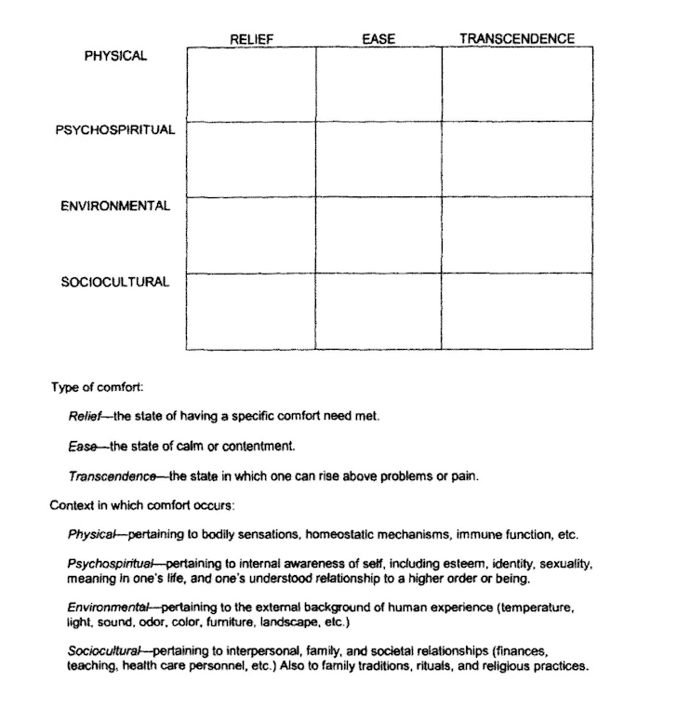

Appendix B
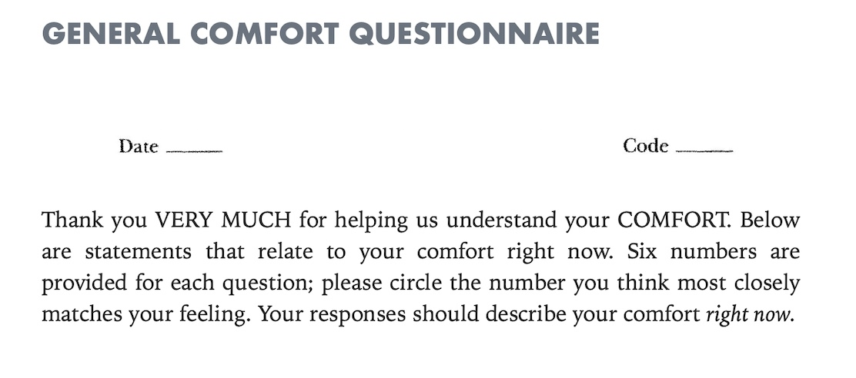
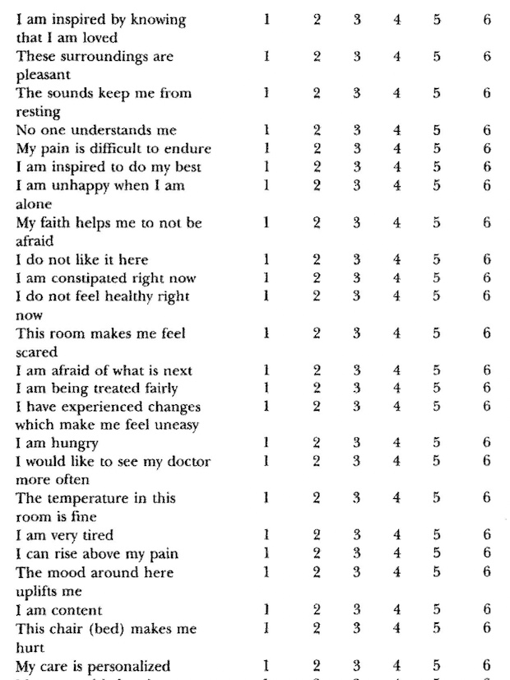

Appendix C

Comfort Theory based on the Theory of Human Press
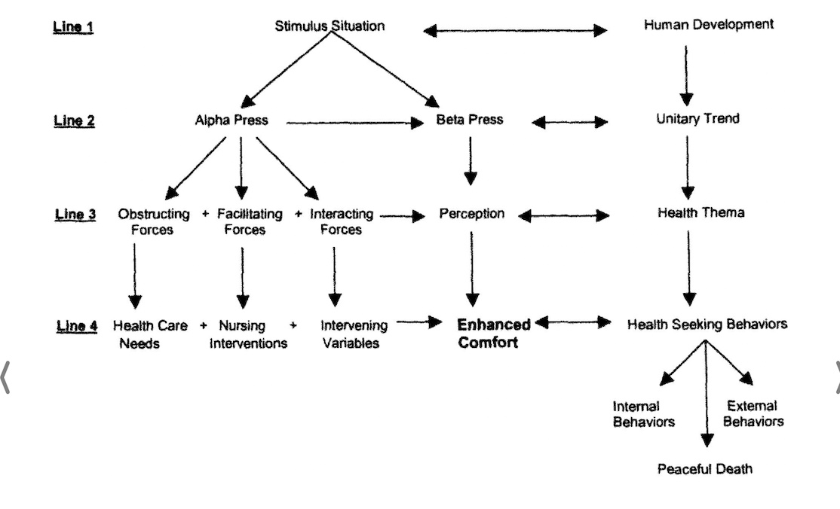

Appendix D

Concept Map of Comforting Measures at End-of-Life
Modified from Kolcaba (2003)
Kolcaba (2003) describes how using a visual guide to view holistic care aids in defining comfort. She shares how comfort is patient-focused, and it is a complex process to attempt to reach comfort in all areas simultaneously. Each cell is interconnected, and by developing a pattern of care, comfort needs may be assessed in all three types and contexts. Although reaching a state of comfort in every cell would be rare in healthcare settings, the goal is to improve the comfort level from the patient's baseline.
This concept map has been modified from Kolcaba (2003) to give examples of comfort measure that are provided by the palliative care experts when creating a care plan for their end-of-life clients.
Table 1

Concept Map | Relief –  specific comfort needs met | Ease –  state of contentment | Transcendence –  rise above the challenge
Physical | PCPs are managing chronic disease issues and symptoms. | Therapies Continue with pharmacological and non-pharmacological strategies.  When clients and family members receive education on MAiD and palliative care options, it aids in overall contentment. | Symptom control using the methods provided may relieve physical challenges.  When clients choose Goals of Care for end-of-life, they rise above this difficult decision-making challenge.
Psychospiritual | Anxiety related to a decline in health is relieved by providing resources and guidance for clients and family members. | Encourage discussion and education for decision-making for difficult end-of-life decisions (funeral home/burial/cremation) | Anxieties decrease when patients and families are supported in ACP with mental health and spiritual support.
Environmental | Being removed from noisy, cold, busy areas of home, LTC, or hospital to a quiet place of home or palliative care center for final moments provides relief. | Support chosen space and reassessed comfort measures to promote a peaceful environment. | The patient was supported in a peaceful environment and had comforting needs.  They are choosing perhaps to die at home with family at their side.
Sociocultural | Addressing cultural or traditionally sensitive care requires surrounding clients and families with their chosen people and customs to provide relief. | Find out how the family is available to support people with cultural, language, or financial barriers.  A natural death may be more accepted in some cultures. | Challenges are reduced when nursing supports are in place and spiritual needs are met for the end-of-life care plan.

The following definitions expand on the concepts used in the table above:

Relief
- specific needs are met, such as pain, and comfort is experienced in the sense of relief.
- provide relief because the client and family come together to make the advanced care plan.

Ease
- comfort for ease of mind, such as addressing anxiety.
- providing the client and their family with education about palliative care and MAiD.

Transcendence
- the state of comfort achieved when patients can rise above health care challenges.
- enhanced with decision-making processes that include loved ones.

Physical
- bodily sensations, homeostatic mechanisms, and immune function.
- providing symptom management for end-of-life.

Psychospiritual
- pertaining to the internal awareness of self, self-esteem, identity, sexuality, meaning of life, and relationship to a higher being.
- comfort with choices and the comfort of family members with those choices.

Sociocultural
- interpersonal, family, societal relationships, finances, teaching, health care providers, etc.
- traditions, rituals, and religious practices may be part of end-of-life practices.

Environmental
- external background of human experience that impacts the patient's quality of life.
- providing a comfortable environment for the time of death.

Appendix E

Conceptual Framework Modified for Comfort at End-of-life
Modified from Kolcaba (2003).
Kolcaba (2003) describes how nurses identify and design comfort interventions for patients and their families when developing a care plan. The PCCs use advanced care planning (ACP) to develop comfort interventions and communicate with patients and family members about achieving the desired comfort and a peaceful death. Kolcaba (2003) suggests that institutional support is required to aid nurses in setting and achieving the health-seeking behaviors chosen by the patients and their family members.
