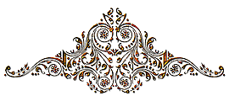

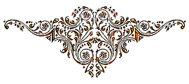
Baby
Dedication

“Let the children come to me; do not hinder them, for to such belongs the kingdom of God.”
Mark 10:14
This is to certify that
Baby Name
was publicly dedicated to the Lord
on the 7th day of December
in the year of our Lord two thousand fourteen
at Southfield Road Baptist Church, Allen Park.

Mothers name
Fathers Name
Parents

Pastor’s Name
Pastor

