Join us
Our A.M. worship is a blended worship style, combining the best of contempor-ary Christian music and the best of traditional hymns. The morning messages are geared to presenting the truths of the Bible in a clear and simple manner.
Our P.M. worship is a simple service of hymns, prayers and a practical message for your life.
Nursery is provided for birth through three years old during our morning worship.
We have a variety of Bible Study classes on Sunday mornings at 9:45 am. We have classes for preschoolers, children, youth and adults.
We provide ministry opportunities for those looking to serve others and share their faith.
We have fellowship opportunities for adults and families.
We have an annual Halloween outreach.
We have an annual Christmas Eve service.
Sunday Services
Bible Study 9:45 am
Worship 11:00 am
Evening Worship 6:00 pm
Wednesday Services
Bible Study 6:30 pm

Our Church Location
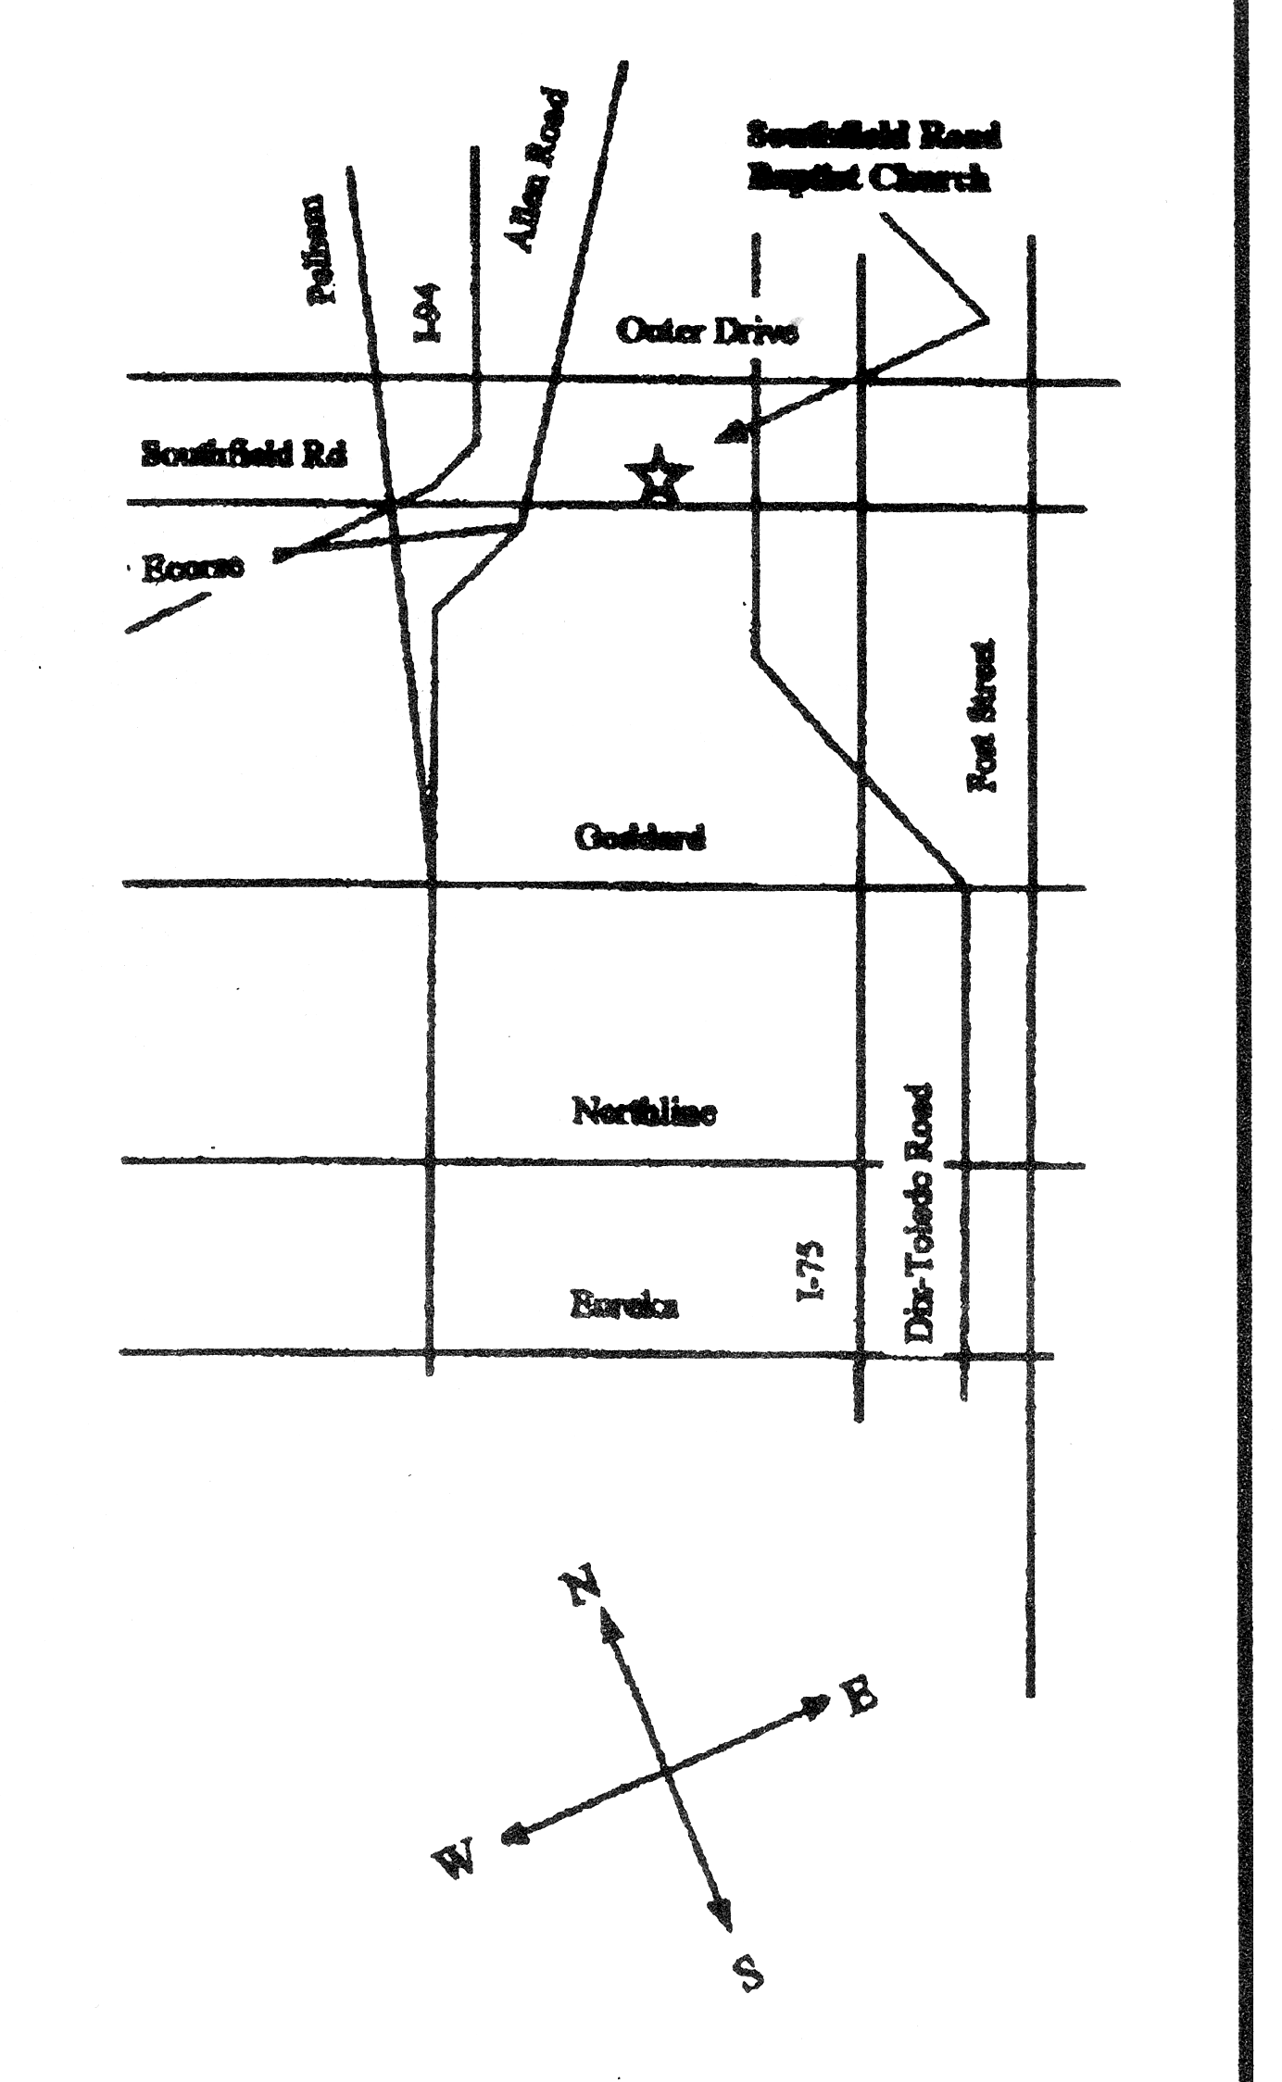
We are located on Southfield Road between Dix Avenue and Allen Road (next door to Arby’s).

Find us on FaceBook
www.theroadbyfaith.org
View additional services on our OnLine service at: http://ustre.am/K2yc

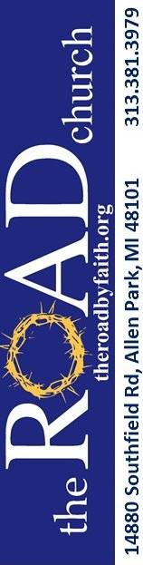

Our Mission

Love God + Love People + Change the World!

The central focus of our fellowship is shared with the common mission to help people become followers of Jesus Christ. Christ-followers are people growing in three vital relationships in their lives.
1. Love for God
2. Love for People
3. Connection with God’s mission in the world.
Jesus made it very clear: when our lives reflect the Great Command-ments (Matthew 22:36-40) and the Great Commission (Matthew 28:18-20), we are fulfilling the heart of what it means to follow Him.
The Road Church does not merely receive people to be members… We are inviting people to be part of “God’s Global Mission”.
God’s Plan for us!
1. God - The Bible tells us that God created everything from the expanse of the universe to you and me and He is in charge of everything (Genesis 1:1, Colossians 1:16-17 and Revelation 4:11).
2. We Sinned- We all choose to disobey God and the Bible calls this disobedience “sin”. It is sin that separates us from a relationship with God. The (wages) or the punishment for sin is death (Romans 3:23 and 6:23).
3. GOD provides a way out- God sent His Son Jesus as the solution to our sin problem. Jesus came to rescue us from the punishment we deserve. We could never achieve this freedom on our own. Jesus alone saves us (John 3:16, Ephesians 2:8-9).
4. Jesus gives us the free gift- Jesus lived the perfect life. He died on the cross for our sins and rose again. Jesus is alive sitting at the right hand of the Father and one day He will return. Because Jesus freely gave up His life for us, we are adopted into God's family for eternity. Eternal life in heaven is the BEST GIFT! (Romans 5:8-12, 2 Corinthians 5:21, 1st Peter 3:18 and Ephesians 2:8-9).
5. We RESPOND- Responding means that we repent turning from our sins and turning to Jesus.
It is as simple as the ABC's:
A= Admit- First we admit to God that we are a sinner. The Bible says "for all have sinned and fallen short of the glory of God" (Romans 3:23).
B= Believe- Believe in Christ Jesus and receive the free gift of forgiveness from sin.
C= Confess- The Bible tells us "If you confess with your mouth that Jesus is Lord and believe in your heart that God raised Him from the dead, you will be saved" (Romans 10:9).

Our Pastor
Pastor Tim cares about making an impact on the Kingdom of today. We are a “come as you are” church. Jesus met the people where they were in life. As a church, we must be prepared to do the same. The goal is simple: We are called as Christians to love God, love others (this is the first and second commandment – Luke 10:27), and we are charged with changing the world. Jesus tells us to “Go, therefore, and make disciples of all nations, baptizing them in the name of the Father and of the Son and of the Holy Spirit.” (Matthew 28:19).

Our Affiliations
Greater Detroit Baptist Association
Baptist State Convention of Michigan
Southern Baptist Convention

Our Statement of Faith is the 2000 Baptist Faith and Message statement adopted by the Southern Baptist Convention.

National Prayer Help Line
1-800-554-PRAY

Our Church Staff
Senior Pastor – Rev. Timothy Jones
Associate Pastor – Gill Regalado Interim Worship Leader - Eliezer Sagansay

