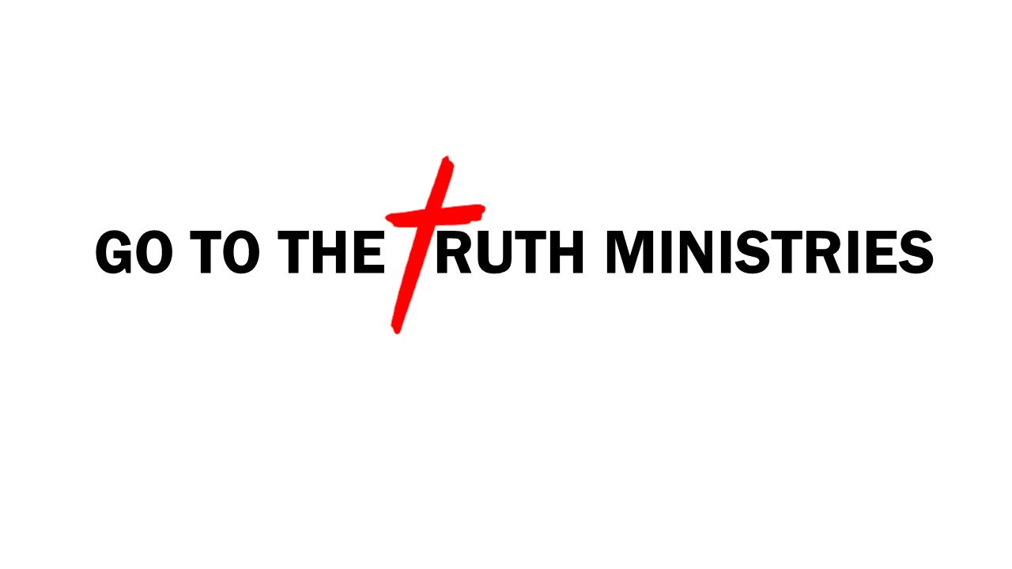

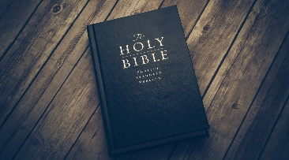
Bible Study Notes
1st Thessalonians

Part 1
Introduction

SUMMARY OF THE LETTER:
- The beginning of the Thessalonica Church is found in the book of Acts 17:1-10.

- Paul and Silas entered the city of Thessalonica and began to preach and teach about Christ’s death and resurrection in the local synagogue. (Acts 17:1-3)
- Paul stayed less than a month (three Sabbaths) in the city when he was forced to leave because of riots. (Acts 17:2, 5-10)
- Jews and Greek had become saved (Acts 17:4)
- It was over a year and Paul had not heard from the believers. He sent Timothy to check on them. (I Thess 3:1-5)
- Timothy’s report was favorable, the church was intact, growing and at the same time there were concerns in the church. (I Thess 3:6)
- This report was the reason Paul writes the first letter to the church.
- Believers were experiencing great persecution, yet their faith and the church grew.
- Paul’s letter encouraged and challenged the new church.

- The letter to the church was the first epistle written by Paul.

- Each chapter of ends with Paul referencing the second coming of Christ.

- The main theme of the letter is “standing firm in the faith”

- Secondary themes are “hope of the resurrection” and “daily living”.

- Key verse 1 Thessalonians 3:8
“For now we live, if you stand firm in the Lord.” (HCSB)

