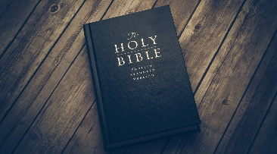
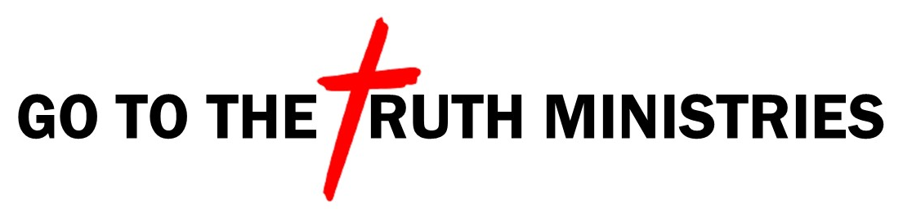 Bible Study Notes
1st Thessalonians
Pastor Timothy Jones

Part Ten
God’s GPS for Living a Holy Life

1st Thessalonians 3:11-13
“Now may our God and Father Himself, and our Lord Jesus Christ, direct our way to you. 12 And may the Lord make you increase and abound in love to one another and to all, just as we do to you, 13 so that He may establish your hearts blameless in holiness before our God and Father at the coming of our Lord Jesus Christ with all His saints.”

GPS- Global Positioning System

Wouldn’t it be great for God to give us something like a GPS?
God’s Positioning System

Everyone wants God’s direction in life.

Through Paul’s prayer for the Thessalonian church we find three ways for us to have God’s GPS for a holy life.

- WE MUST LET GOD DIRECT OUR LIVES: (v3:11)
- The Bible defines people in two ways:
Lost and found
Obedient and Disobedient
Saved and unsaved or Heaven and hell
- Two Roads - Matthew 7:13-14
- The wide road leads to destruction, ruin, pain, gnashing of teeth.
- The narrow road leads to life, love, inheritance, God, heaven.
- The word “DIRECT” in v11 means to move something or someone in a straight line towards a place without changing direction.
- Proverbs 3:6 “Acknowledge Him in all our ways and he will direct your path”

- WE MUST INCREASE AND OVERFLOW IN LOVE: (v3:12)
- “Greater love has no one than this to lay down one’s life for his friends.”( John 15:13)
- The word increase means to add to something that is already there.
- The word abound or overflow means to have so much that it spills over the top.
- Paul’s desire is for believers to have the same love that God has for us overflowing into other people’s lives.

- WE MUST MAKE OUR HEART BALMELESS: (V3:13)
- A daily pursuit of God.
- The word blameless means to be without fault.
- We became blameless through the blood of Christ.
- The robe of righteousness (Job 29:14).

Biblical Application:
As we pursue God daily, He will direct our lives to live in the overflow of love for people. As we seek Him daily to make our hearts blameless before Him, He covers our forgiven and naked heart with the robe of righteousness as we wait for the coming of our Lord Jesus Christ.

