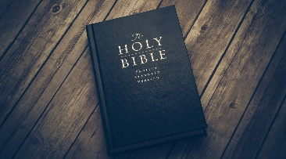
 Bible Study Notes
1st Thessalonians
Pastor Timothy Jones

Part Fifteen
Habits of Spiritual Victory
Part 1
1st Thessalonians 5:16-22

¹⁶“Rejoice always, ¹⁷pray without ceasing, ¹⁸in everything give thanks; for this is the will of God in Christ Jesus for you. ¹⁹Do not quench the Spirit. ²⁰Do not despise prophecies. ²¹ Test all things; hold fast what is good. ²²Abstain from every form of evil.”

Everyone wants victory in their life: Physically AND Spiritually

PAUL GIVES US SEVEN HABITS OF SPIRITUAL VICTORY FOR A BELIEVER.

- REJOICE ALWAYS (V16)
To rejoice is to _______________________________________
  - The Apostle Paul wrote to the Philippian church ,“rejoice in the Lord. I say again rejoice! Let your graciousness be known to everyone.” (Phil 4:4-5)
  - Rejoice not for all things but IN all things.
  - Four reasons why we can rejoice.
    - Christ's forgiveness
    - The love, grace and mercy of God.
    - The promise of eternal life through Jesus Christ.
    - Christ’s return.

- PRAY WITHOUT CEASING (v17)
To pray without ceasing (or “continually”) means having a frequency and regularity of a constant and consistent prayer life.
  - “Is anyone among you suffering let him pray” (James 5:13)
  - Jesus taught His disciples ‘when you pray’ the Lord’s Prayer (Matthew 6:5-13.
  - Bible Prayer Stats:
    - 650 prayers in the Bible.
    - 450 answers to prayer.
    - 25 records of Jesus praying during His earthy ministry.
    - Paul mentions prayer 41 times in his writings.
    - The first prayer recorded is in Genesis 4:26

- GIVE THANKS IN EVERYTHING (v18)
- “IN” everything, not “FOR” Everything (Psalm 107).
- When you pray “IN” everything you are recognizing God’s power over all things.
- Nothing can do more to restore contentment and joy than a heart filled with thankfulness.
- Three reasons to be thankful:
- For the material blessings God gives you.
- For the people in your life.
- Salvation, His presence, and His power in your life.

Biblical Application:
It is God’s will that Born-Again Believers live a life that includes rejoicing in all things, continually praying, and being thankful in all things.

