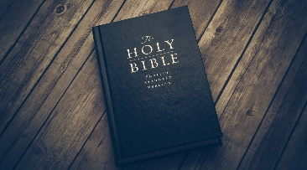
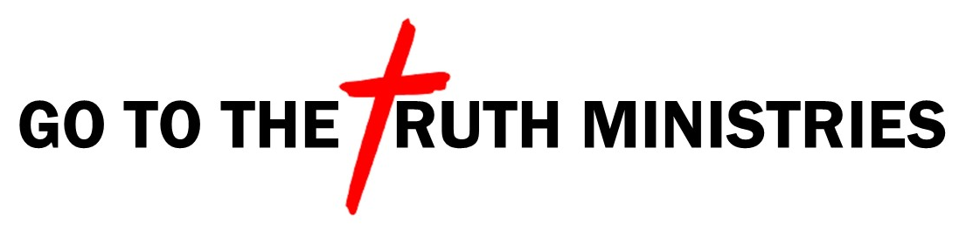 Bible Study Notes
1st Thessalonians
Pastor Timothy Jones

Part Sixteen
Habits of Spiritual Victory
(Part 2)
1st Thessalonians 5:16-22

¹“Rejoice always, ¹⁷pray without ceasing, ¹⁸in everything give thanks; for this is the will of God in Christ Jesus for you. ¹⁹Do not quench the Spirit. ²⁰Do not despise prophecies. ²¹Test all things; hold fast what is good. ²²Abstain from every form of evil.”

IT HAS ALWAYS BEEN GOD’S WILL FOR HIS CHILDREN TO REJOICE, PRAY, AND GIVE THANKS TO HIM.

NOW WE LOOK TO THE LAST FOUR HABITS OF VICTORY FOR A BELIEVER.

- WE ARE NOT TO QUENCH THE SPIRIT (V19)
Quench means to extinguish or suppress.

- The Holy Spirit dwells in us (1st Cor 3:16).
- Two example’s Paul gives.
- “Do not neglect the gift that is within you” (1 Tim 4:14).
- “Stir up the gift of God within you” (2 Tim 1:6-8).
- Quenching the Spirit is:
- Not applying the Spiritual Gifts given to you.
- To despise the supernatural work of the Holy Spirit.
- Resisting the Fruits of the Spirit (Gal 5:22-23)
- Not acting on the prompting of the Spirit in your life.

5. DO NOT DISPISE PROPHECIES (v20)
In biblical days God used prophecies often as warnings, but also to show His power, love, and forgiveness.

- The word “despise” in this context means to make something of no account or to treat something with contempt as it is entirely worthless or despicable.
- Prophecy is God speaking to His people through someone.
- Matt 16:28 Jesus prophesied about His own return.

6. TEST ALL THINGS, HOLD FAST TO WHAT IS GOOD (v21)
This is a two part command.

- First part of the command is to test all things.
- Act on facts not gossip.
- “Do not believe every spirit, but test the spirits to see whether they are from God, for may false prophets have gone out into the world” (1 John 4:1).
- Second part of the command is; hold fast to what is good.
- Keep what is true and get rid of what is not true.

Five Truths You Can Depend on:
- The saving Grace of Jesus.
- God is Love.
- The truth of God’s Word.
- Your relationship with God.
- Your adoption as a child of God.

7. ABSTAIN FROM EVERY FORM OF EVIL (V22)
a. God has called us into holiness.
b. Evilness takes our focus off God.
c. “For where your treasure is your heart will be also” (Matt 6:21).
d. Luke 16:13-15.

Biblical Application:
When you live out your life focused on these seven habits of victory, your life with flourish both physically and spiritually. It is God’s will that you live our life for Him and through Him you will experience an abundant life.

