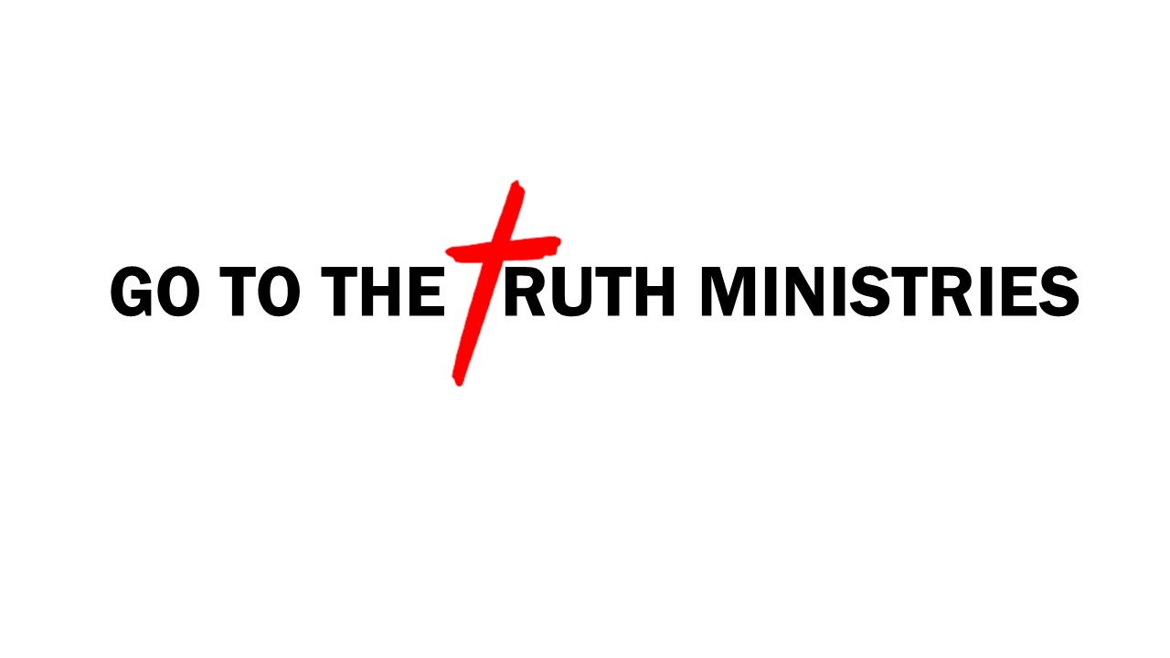

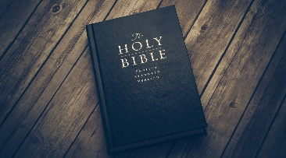
Bible Study Notes
1st Thessalonians
Pastor Timothy Jones

Part 1
Outline

THEME: “standing firm in the faith”

KEY VERSE: 1 Thessalonians 3:8
“For now we live, if you stand firm in the Lord.”

PURPOSE OF AN OUTLINE:
- Provides a skeleton overview of the book.
- Provides you with perspective of the book.
- Provides you with the context of the book.

OUTLINE OF 1ST THESSALONIANS:

Chapter One- Paul’s introduction
Prayer and Thanksgiving for the Thessalonians faith.

Chapter Two- Paul reminds the Thessalonians of his previous visit and of their faith.

Chapter Three- Paul encourages the church of standing firm in their faith.

Chapter Four- Paul challenges the church to walk in love.
To live a life that will gain respect of outsiders.

Chapter Five- Paul gives instruction to be ready for the day of the Lord.

Biblical Truth: We don’t know the day nor the hour of Christs return (Matt 25:13) therefore we should be remined to stay steadfast in our faith, loving others, living a Christian life worthy of respect and for each of us to ready for the Lords return.

