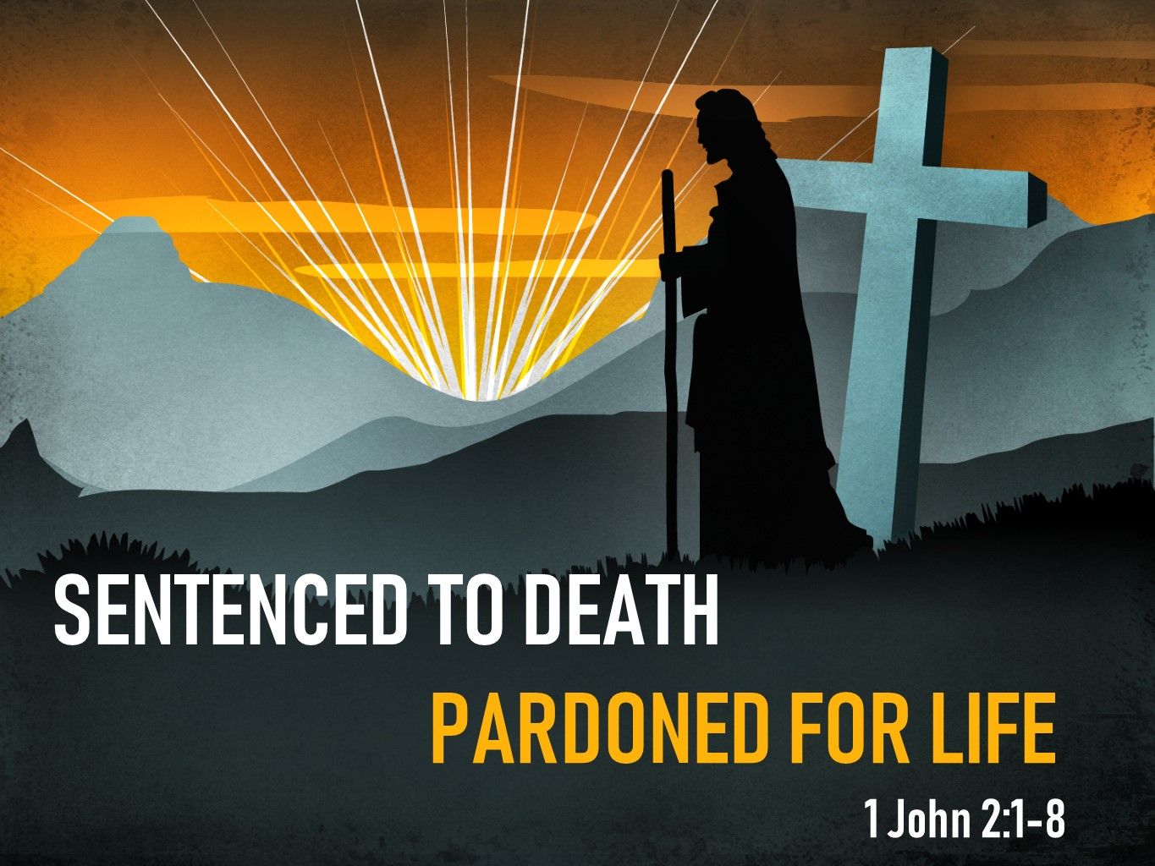
The Road Church
1st John Sermon Series
GETTING BACK TO THE BASICS
Part 3
Sentenced to death, pardoned for LIFE
Scripture: 1 John 2:1-8
Pastor Timothy Jones June 24, 2018
Prayer
Good morning everyone, WOW it is great to be right here today. On the 18th if June it was our 4-year anniversary here at the church and now we are going into our 5th year right here at the Road Church. AMEN? I am excited about what God is going to do with us in this 5th year.
A couple weeks ago we began a sermon series on the book of 1st John, so lets open our Bibles or your Aps with me to 1 John, I hope some of you have that marked 1st John by now, but if not 1 John is the 5th book from the back of the Bible, starting with Revelation, Jude, 3rd John, 2nd John then you will find first John.
In the first week our sermon title was “The Vital Signs of Life” and we said just like having in a pulse or a heartbeat that proves there is life, we also have proofs that we are alive spiritually. That sign of begin alive spiritually is called Spiritual fellowship, Spiritual Fellowship is the vital sign of true life. It is what shows God, you and others that you are alive spiritually.
We talked about three truths of spiritual fellowship:
1st We receive Spiritual fellowship when Christ has been revealed to us.
2nd Spiritual fellowship is experienced through Christ.
3rd Because Christ has been revealed and experienced Him now Spiritual fellowship brings us great joy.
And then last week, who could forget Father’s Day.
Last weeks sermon was My Daddy is the Light of the World, and we discussed what the apostle John said that God is Light.
We talked about how we are to walk in our heavenly Fathers shoes. We discussed two ways of doing so, first we must first abstain from darkness, the world is full of darkness and we need to be able to separate ourselves from the darkness. Then second, we must become the light ourselves.
I love that verse from last week when Jesus said “You are the Light of the World” and later he said “let your light shine before men that they may see your good works and glorify your Father which is in heaven” (Matthew chapter 5).
We must become the light.
Which brings us to today: The title for today’s message is:
SENTENCED TO DEATH - PARDONED FOR LIFE.
If you are there in the Book of 1st John let me know by saying “AMEN” Begin reading with beginning from chapter 2 verse 1 and it begins like this:
2 My little children, I am writing you these things so that you may not sin. But if anyone does sin, we have an advocate with the Father—Jesus Christ the Righteous One. 2 He Himself is the propitiation for our sins, and not only for ours, but also for those of the whole world.
3 This is how we are sure that we have come to know Him: by keeping His commands. 4 The one who says, “I have come to know Him,” yet doesn't keep His commands, is a liar, and the truth is not in him. 5 But whoever keeps His word, truly in him the love of God is perfected. This is how we know we are in Him: 6 The one who says he remains in Him should walk just as He walked.
I like how John begins this section of his letter. It’s probably not appropriate for me to address the church as “my little children” and if I did I am sure a few of you would say- “I’m old enough to be your parent”. But John begins in this fashion to establish his authority to the second and third generation Christians. John was at least an “octogenarian”, we have a few octogenarians in our church today, they are people who are from 80-89 years of age. And John is probably in his late eighties when He wrote this letter.
When I was a kid older folks were respected by the younger people. During biblical times the elderly were very respected within families. So, the apostle John in his elderly years was probably the last surviving member of the original 12 disciples. AS he begins with these words my little children he not only is exercising his authority, Just as Jesus did over His disciples in John 13:33. John is also signifying his affection for the people who he wrote the letter. And lastly, he is establishing a family connection with them, teaching that Christianity is a family. He is a grandfather figure within the church and has a lot of respect and also known for the last eye witness alive to the resurrection of Jesus.
Then John begins to deal with real issues at hand which is sin in Christians lives.
WHICH LEADS US TO OUR BIG IDEA-
The Big Idea is: SIN IS NOT SUPPOSED TO BE A PART OF THE CHRISTIAN LIFESTYLE
One of the dominate themes in the Bible and this letter is dealing with the issue of walking with God or living in sin. The Bible has another theme of a Savior who came to take away the worlds sin so that people all people can have life (essentially walking with God) here John calls it walking in the Light. We see that in the Bible there is a battle for us and the battle is a constant pushing and pulling of the human spirit. Although because of the First Adam’s sin we are born to sin, but because of one man’s death Jesus we can be exonerated from sin.
Let me share with you a story I read last week: Imagine being convicted of a crime you deeply regretted – intentional or unintentional – and being offered a pardon to absolve you of any penalty. Would you accept it? Let me tell you about a man who did not.
In 1829 two men, George Wilson and James Porter, robbed a United States mail carrier. Both were subsequently captured and tried in a court of law. In May 1830 both men were found guilty of six charges, including robbery of the mail “and putting the life of the driver in jeopardy.” Both Wilson and Porter received their sentences: Execution by hanging, to be carried out on July 2.
Porter was executed on schedule, but Wilson was not. Influential friends pleaded for mercy to the President of the United States, Andrew Jackson, on his behalf. President Jackson issued a formal pardon, dropping all charges. Wilson would have to serve only a prison term of 20 years for his other crimes. Incredibly, George Wilson refused the pardon!
An official report stated Wilson chose to “waive and decline any advantage or protection which might be supposed to arise from the pardon….” Wilson also stated he “…had nothing to say and did not wish in any manner to avail himself in order to avoid sentence….” The U.S. Supreme Court determined, “The court cannot give the prisoner the benefit of the pardon, unless he claims the benefit of it…. It is a grant to him: it is his property; and he may accept it or not as he pleases.” Chief Justice John Marshall wrote, “A pardon is an act of grace, proceeding from the power entrusted with the execution of the laws…. (But) delivery is not completed without acceptance. It may then be rejected by the person to whom it is tendered, and…we have no power in a court to force it on him.”
George Wilson committed a crime, was tried and found guilty. He was sentenced for execution, but a presidential decree granted him a full pardon. When he chose to refuse that pardon, he chose to die. Reading this amazing story, we might wonder, “How could anyone refuse a pardon for the death sentence? The man was a fool!” But what if you also are refusing a pardon, one enabling you to spend eternity in the presence of God rather than eternal separation from Him in a place the Bible calls hell?
This is what John is getting at when he wrote this letter.
So, I want to spend some time with you this morning discussing three reasons Sin is not supposed to be part of the Christian Lifestyle.
FIRST, SIN IS A DEATH SENTENCE.
Look at verse 1, John says “I am writing you these things so that you may not sin”
A lot of people may think that sin is just a part of life, but I must tell you that sin is part of death.
Not only does the Bible tell us that the penalty of sin is death, Romans 6:23 “The wages of sin is death”, wages means penalty. And the Old Testament says the same “the soul that sins, it shall die” (Ezekiel 18:4) Just as in our story the two men broke the law, they were tried and sentenced to death. But it also born from darkness and that is really not hard to see Last week showed us that if we are not walking in the Light we are walking in darkness.
This is Johns purpose in writing to not only to those in Biblical times but also to us today. Just as sin was a problem in biblical times it is a problem in todays world.
Think about it, if sin was ok for the Christian, then John would not say these words. The fact is John is writing this letter because of sin and false teachers. Remember the Gnostics who believed they were above sin and that they had no sin and some even thought that Jesus never had a human form of a body which then would have prevented the virgin birth. Which declines Christ deity as God.
And these false teachers were leading people down the wrong path in life, causing them to stumble and causing them to sin against God.
And let me say to you, there are false teachers in our world today doing that same thing, leading others astray in todays world.
Now when it comes to sin, I think that we all have our own definition of sin, and that makes it dangerous for each of us. I don’t know if you ever looked up or thought about the definition of sin, but here it is: It is the evildoing seen in religious perspective, not only against humanity, society, others or oneself, but against God.
Better said; it is an immoral act considered to be a transgression against the divine law. When we go against God’s law the Bible says that are rebelling against Him and that is sin.
Sin is the work of the devil around us. Turn over to chapter 3 look at verse 8 with me, it says this:
“when people keep on sinning, it shows that they belong to the devil, who has been sinning since the beginning. But the Son of God came to destroy the works of the devil.”
Folks the truth here is that sin is very very serious. Because sin suggests that we have a nature of the devil rather than God. And we see that sin is the fruit of Satan’s nature rather than God’s nature. Most of us, Christians do our very best not to sin, it is not supposed to be a part of Christian life. However, the Bible plainly teaches we all are sinners, people who have repeatedly broken God’s laws. Romans 3:23 states, “For all have sinned, and come short of the glory of God.” And the consequence for breaking the law is death.
That Great preacher Charles Spurgeon, said that the longer and the more you are in a love relationship with God, “the more expensive will you find it to sin. The ordinary sinner sins cheaply: the child of God sins very dearly."
So sin remains a problem for the Christian, but a very different problem than for one who is not in Christ.

For the Christ-follower, sin can threaten our sense of closeness and intimacy with God.
Which Brings us to our second reason that sin is not a part of the Christian lifestyle:
2. JESUS PARDONS OUR SINS.
NOW THAT IS GREAT NEWS! AMEN?
Just as our title suggests we are sentenced to death but pardoned for life. God has provided a pardon, one He makes available to us all. Yet just like the story at the beginning you must be willing to accept the pardon.
Look back at verses 1 and 2:
“My little children, I am writing you these things so that you may not sin. But if anyone does sin, we have an advocate with the Father—Jesus Christ the Righteous One. 2 He Himself is the propitiation for our sins, and not only for ours, but also for those of the whole world.”
I know that John uses the word if, but I believe he understood that there can be an occasional sin. John just like myself has to be real at this point and understand that not if but when we do sin, because we have the nature to do so.
Now there is a lot to be said here and I want to keep it as plain and clear as I can. This pardon which is offered to all is described in three words. These three words are often difficult to understand in the Christian culture but they also describe Jesus and they paint a picture of us being redeemed by God.
THE FIRST WORD IS ADVOCATE: Jesus is our advocate. An advocate is one who is called alongside of another to help in a time of need, (In Johns Gospel He uses this word to describe the Holy Spirit) but the advocate is one who also lends his voice in our defense, one who speaks up on our behalf in a courtroom.
Jesus Christ speaks to God the Father pleading for our defense in the heavenly courtroom. As a defense attorney would argue our case before a judge. Jesus our advocate speaks with extraordinary authority before the judge, because His defense for us is that He already paid the any price the judge would impose.
THE SECOND WORD IS RIGHTEOUS. William Barclay a popular Scottish Theologian said “we have one to plead our cause He is Jesus Christ the righteous one.”
Dictionaries define righteousness as “behavior that is morally justifiable or right.” Such behavior is characterized by accepted standards of morality, justice, virtue, or uprightness. The Bible’s standard of human righteousness is God’s own perfection in every attribute, every attitude, every behavior, and every word.
Often people have a righteous attitude, they walk around thinking that they are better then everyone else. You may know someone who thinks there stuff doesn’t stink… Now I have to admit that I had been there. When in the Army I considered myself to the best of the best, in appearance, in work ethic, in leadership, it also didn’t help that I received an award as the Best of the best. Amen, it help my ego soar.. but the bad news is; true and perfect righteousness is not attainable on our own; the standard is simply too high. However; the good news is true righteousness is possible for mankind, but only through the cleansing of sin by Jesus Christ. The Bible tells us in Romans 3:23 that “The righteousness of God is through faith in Jesus Christ to all who believe”
In other words, for us to obtain Godly righteousness is through the only one who is righteous and that is Jesus.
THE THIRD WORD IS PROPITIATION
Look back at verse 2
“He Himself is the propitiation for our sins, and not only for ours, but also for those of the whole world.”
Propitiation is the removal of the wrath of God against the sinner through the sacrificial death of His Son Jesus Christ. Now the word propitiation is an uncommon word in today’s society, You dot here that world outside of the Christian context and its not used very often within the church. It’s also uncommon in the Bible only used four times this context. The best definition is the term atoning sacrifice.
The ultimate problem of course is that no one in the world can be the atoning sacrifice for our sins, but the good news is God made a way for us. It was through Jesus’ death on the cross that that satisfies Gods honor and justice. Jesus not only is the advocate for us, but He also is the atoning sacrifice for all our sin. 1 Timothy 2:5 says that “there is only one mediator between God and man”
Meaning that Jesus is able to be our advocate and to forgive sin because he himself became the sacrifice for sin. Laterally taking on the death sentence for us.
The Bible says that in 2 Corinthians 5:21 that “He (GOD) made Him (JESUS) who knew no sin to be sin on our behalf, so that we might become the righteousness of God in Him.”
The key to understanding to propitiation is this Jesus dies to satisfy the wrath of God so that we can be back in fellowship with God.
Here is what I see, propitiation is a personal word, it is personal for each of us because Christ went to the cross for each of us. But it is also a word that invokes the world, past, present and future.
And although Christ has done this great thing for each of us, it is meant to be spread to throughout the ever-changing, dark and sinful world.
We people often like to be stingy when we find a great thing, but John says don’t hog Jesus for yourself, He is enough for each person to have. Share your good news with the world.
Sin is not supposed to be part of the Christian Lifestyle Because:
1st SIN IS A DEATH SENTENCE.
2nd JESUS PARDONS OUR SINS.
Then third- Sin is not supposed to be a part of the Christian lifestyle because THE PROOF OF NEW LIFE IS IN US.
Here is how we can be sure that we are saved and have fellowship with God.
Look back at verses 3-6 with me:
3 This is how we are sure that we have come to know Him: by keeping His commands. 4 The one who says, “I have come to know Him,” yet doesn't keep His commands, is a liar, and the truth is not in him. 5 But whoever keeps His word, truly in him the love of God is perfected. This is how we know we are in Him: 6 The one who says he remains in Him should walk just as He walked.
People ask me all the time; How can I know? People want assurance and there is nothing wrong with that at all.
It is no doubt that John is saying that we are a work in progress, First, we are to profess Jesus as our Lord and Savior and then through our walk there will be sin that will separate us from God, but John is saying continue to come to Jesus and seek forgiveness and He will stand before God for us and He says this is how you will know that you are in fellowship with God. Now let me say that this doesn’t not give you a license to sin without regard to the consequences.
Because a live that with Christ, is a life that represents Christ to the best of your ability.
When folks ask the question, the answer comes in the form another question; is there is evidence of Change! Are you the same as you were two weeks ago, three months ago. John says that the proof is in the pudding…
Here are the three ways John says that you can be sure that you are saved.
1st. Are you keeping God’s commands?
Look at verse 3 This is how we are sure that we have come to know Him: by keeping His commands. Can I just say here that this is not rocket science. It’s an either you are or you’re not.
Compare todays popular cultural view with the Biblical view. It is defiantly not the same. So when John says “Now by this we know that we know Him”. The word know translates a Greek word which means to know in fact. The word keep means to guard as if guarding a priceless treasure.
“Know Him” is more than knowing we are saved—it is abiding in Christ. And the truth is God places His highest priority on obedience to His Word and commands.
Are you striving to keep God’s Commands?
Are we perfect? no, but are you working at doing what God tells us to do.
Jesus Himself said; “If you love me, you will keep my commandments” (John 14:15).
How in the world can a Christian think that obeying Christ’s Word or reading God’s Word is no longer necessary or valuable? Imagine if a person says; “All I need to do is love God and Jesus. I don’t need to read or understand the Bible when Jesus said;
“if you obey my commands, you will remain in my love, just as I have obeyed my father’s commands, and remain in his love” (John 15:10).
Obedience leads to our assurance of Faith.
2. Do we love others the way God loves us?
Look at verse 5 “But who ever keeps His word, truly in him the love of God is perfected”
John makes the point here that God is the one who took the initiative in loving us despite our sinful nature by sending His Son to die in our place as an atoning sacrifice. This is the demonstration for us to love others who don’t merit to be loved.
I posted on Face book this week: LORD, help me love the people you love, because sometimes for us its hard, but just because its hard it doesn’t mean we don’t have too.
Just as Christ laid His life down for us, He provides the illustration for the true meaning of love. And when believers demonstrate this love toward one another God’s love is perfected.
3. Are you walking in the way?
Look at verse 6 with me “The one who says he remains in Him should walk just as He walked”
The early church was called THE WAY. I love that because Jesus said that He is the way the truth and the life. And if we are going to walk like Jesus than we have walk in the way, the truth and the life.
This goes back to theme from last week are we walking in the shoes of our father?
Walk is a word that describes both action and direction. How did Jesus walk? In complete submission and obedience to the Father.
There’s a story in baseball about Earl Weaver (he was the manager of the Baltimore Orioles). On the team was a born-again believer named Pat Kelly. As the story goes, Kelly is said to have told Weaver that he had learned to walk with God; to which Weaver is reported to have said rather sarcastically, “I’d rather you walk with the bases loaded.” The Christian walk is incomprehensible to those who are not motivated by Christ.
Are you walking as Christ walked?
How can you be assured of your faith?
- Keep His commands
- Love like He loves
- Walk as He walked
Sin is not supposed to be part of the Christian Lifestyle Because:
1st SIN IS A DEATH SENTENCE.
2nd JESUS PARDONS OUR SINS.
3rd THE PROOF OF NEW LIFE IS IN US.

INVITATION

