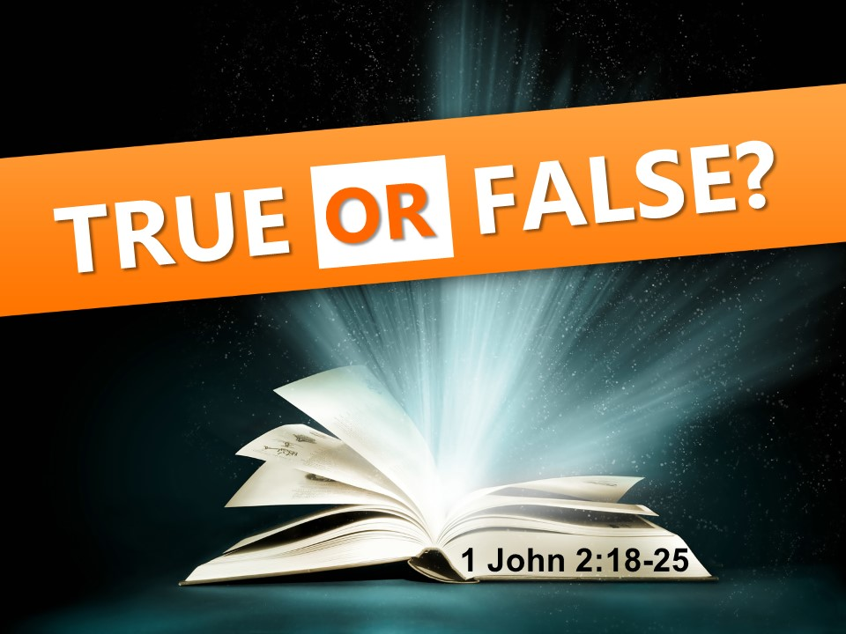
The Road Church

1st John Sermon Series
GETTING BACK TO THE BASICS
Part 7
TRUE OR FALSE
Scripture: 1 John 2:18-23
Pastor Timothy Jones July 22, 2018
Good Morning, Happy Resurrection Day!
Before we dig in the Word that God has for us today, let’s take a moment in prayer.
That YOUR message would be heard around the world.
That this message will cause us to regain our focus on making the right decisions in our lives.
We seek Your encouragement and truth in Your Word this morning. Forgive us of our trespasses against you.
Amen and Amen.
Hey, Welcome back to our sermon series “GETTING BACK TO THE BASICS”, we also want to welcome those of you joining us through the internet today - as we walk the road of faith together through the Book of 1st John.
Let’s begin by opening your Bibles or your Aps with me to the book of 1 John chapter 2. Many of you have it booked marked, but if you don’t have it book marked you can find 1 John by going to the back of the Bible and working forward 5 books, Revelation, Jude, 3rd and 2nd John, then you will find 1st John chapter #2 and when you get there let me know by saying “AMEN”
Let me remind you that John wrote this letter to the 2nd and 3rd Generation Christians in Asia Minor, which is present day Turkey. It is also important to remember that in Apostle Johns days there were some problems that rose within the Christian community which was causing confusion for some of the Christians, some were following a cult called Gnostic’s, others were being led astray by false teachings in the church. So, John writes to the brothers and sisters as a father or grandfather figure, emphasizing that the Christian community needed to get back to the Basics. Meaning they needed to get back to the fundamentals that they were taught in the beginning.
Now, I used to golf a lot, in-fact at point in my life I golfed almost every day. Golf is a game of fundamentals. Fundamentals are the necessary base or core of what you do. A basic fundamental of a golf swing is that you must keep your head down and your eye on the ball. This is at the core of your swing. If your head is not down and you are not looking at the ball, then you will miss it every time. Wouldn’t you agree with me that; all things in life have some sort of basic fundamentals? A home budget for example has some basic fundamentals. Christian Financial advisors say the basic foundation is returning a portion back to God, then pay yourself and certainly don’t spend more than you have. AMEN?
Driving a car has basic fundamentals as well. Gas break, steering wheel, Stop- go- yield, look both ways- don’t take your eye off the road -or you will run into the car in front of you. Right?
But here is the thing the thing, when we mess up what we are doing, whether it be sports, driving, blowing the budget, anything in life 99% of the time it’s because we have abandoned the basics.
When I would have a bad shot on the golf course I would hear my buddies say- “keep the fundamentals”…. but you know sometimes through the busyness of life, the pressures of life, the problems of life even through the busyness of church or an attempt of serving God we can take our eye of the ball, we can lose the fundamentals, Church attendance begins to drop or people forget why we are supposed to give, what our purpose is all about. It is at these moments that we must get back to the basics. And that is what we see in this book. John is calling the Christians who have lost their way, people who might have gotten sidetracked with the false teachers, side tracked because the first-generation Christians are gone and they don’t have others to keep them on track. For some life has gotten in the way of the Church, these are people just like us. So John is teaching the Christian community to get back to the basics of their faith. And if I am honest we all from time to time in life have to get back to the basics of our faith. We all have to sure up the foundation. And that is what I love about this sermon series. If we take the Word of God that John is teaching and apply it to our lives, it will keep us with the basics of our faith. And the basics of our faith will drive what we believe what we say and do for the Kingdom of God.
So far John has really hit the nail on the head; would you say? He began this letter talking about the vital sign of life as a Christian and that is having fellowship with God and other believers. He said that Spiritual Fellowship is the pulse of the Disciple. Then John went straight for the jugular when he said that God is light and as those who have fellowship with God we are to walk in God’s shoes- and we should then illuminate the World by reflecting God’s light. He then reminds us that as children of God we have been pardoned from the death sentence of sin. John continues by taking the old command to love God and others and describes it as a new command as Jesus came to earth to show us what love supposed to look like and how as disciples we are to love others. Then he tells us of the often-forgotten spiritual growth is process. We begin at the infant stage then grow into the youth stage and then we enter the seasoned stage adulthood.
And each stage brings with it revelation of Scripture, revelation of God, Revelation of the Holy Spirit in our lives and last week was something, where we discovered that the decisions in life are based from the priority that we have. John gives a command not to love the World- He said don’t place your priority on the world because it’s the wrong choice. Because when you love the world it is an obstacle to loving God, the world is driven by the lust of the flesh and the world is passing away. But rather we should love God- and by loving God we will doing His will in our lives.
Today is all about knowing the difference between True and False.
So, if you are there in the Book of 1 John chapter 2 begin reading with me from the 18th verse and it begins like this:
“Children, it is the last hour. And as you have heard, “Antichrist is coming,” even now many antichrists have come. We know from this that it is the last hour. 19 They went out from us, but they did not belong to us; for if they had belonged to us, they would have remained with us. However, they went out so that it might be made clear that none of them belongs to us.
20 But you have an anointing from the Holy One, and all of you have knowledge. 21 I have not written to you because you don’t know the truth, but because you do know it, and because no lie comes from the truth. 22 Who is the liar, if not the one who denies that Jesus is the Messiah? This one is the antichrist: the one who denies the Father and the Son. 23 No one who denies the Son can have the Father; he who confesses the Son has the Father as well.
24 What you have heard from the beginning must remain in you. If what you have heard from the beginning remains in you, then you will remain in the Son and in the Father. 25 And this is the promise that He Himself made to us: eternal life. I have written these things to you about those who are trying to deceive you”.
Amen and amen
WOW! John is not holding back. He is telling it like it is. I think we need that more from the church today.
WHICH BRINGS US TO OUR BIG IDEA TODAY:
THE BIG IDEA IS: WE ARE LIVING IN THE AGE OF DECEPTION.
Notice with me the beginning words of verse 18: John again speaks as the authority figure in the lives of the Christians.
I once did a poll and asked people if the pastor has spiritual authority over the congregation. Only 75% of the people participated said yes. Even though scripture gives a clear expectation of it. Here John speaks as the spiritual authority over the Christians lives. Look what he says:
“Children, it is the last hour”- and then look at the last few words of verse 26, He says I am writing you because of people “trying to deceive you”
What is the age that we are living in? John calls it the “the last hour”, The Apostle Paul calls it “the last days” They are defined as the period of time after the first coming of Jesus Christ, some 2000 years ago, and before His second coming in the future to establish a new kingdom. This period of time is marked by two happenings, noted in the books of Acts and 2 Timothy and in what we read this morning. The first happening is the gift of the Holy Spirit to believers. The second happening is the increase of opposition by unbelievers against God and God’s ways.
It is so important for us to recognize that we are living in the last hour. Because If we think we have forever, then we will think we have plenty of time to go back and forth with our beliefs.
This much we know about the “last hour.” God’s measurement of time is not same as ours. (2 Pet 3:8-10). But when the end does come – it will surprise all people – including Christians. The Bible tells us in Matt 24:44 that Jesus said, “This is why you also must be ready, because the Son of Man is coming at an hour you do not expect.”
The last hour or the last days are times of DECPETION, and the deception is a tool which slowly takes people away from our true purpose and worship of God and here’s the thing; deception has become normal to us.
In today’ world people are taken advantage of others through deceiving them. Deception for some has become a way of life. In today’s lifestyle we are deceived with phone scams, internet scams our older generation have lost millions to people deceiving them. Then there are credit card scams. Then of course there is identity theft. People have push the envelop so much that they are now scamming our tax returns. Completing tax returns sending them to the IRS getting the money for it. And now they are even posing as the IRS.
And if that is not bad enough there are people infiltrating the church who are deceiving others into believing NOT WHAT the Word of God says but rather using it to abuse the church and take advantage of people in an attempt to pull people away from God. Deception in these last days are are creating ethical and doctrinal issues within the church.
This is not something that has just come to light. If you study the Bible and the New Testament Church you will find that since the creation of the church there have people against the church.
And this is why John is addressing to the Christian community then and to us today. John isn’t telling us something that we don’t already know, he is speaking about things that we already know are going on in the world and in the Church. It is the age we are living in.
WE ARE LIVING IN THE AGE OF DECEPTION.
John gives us three facts about living in the age of deception or the last days.
The first fact that we are living in the last days is there are two types of people.
The First type of people John addresses are the Antichrists.
Now notice with me that John is describing two things; a future event that has yet to take place and the current situation that is happening as he is writing.
V18: “Children, it is the last hour. And you have heard “Antichrist is coming”, even now many antichrists have come”
V 22 Who is the lair, if not the one who denies that Jesus is the Messiah? This one is the antichrist: the one who denies the Father and the Son.
The title antichrist can have two meanings. It can mean "in opposition to” or “against Christ" or it can mean “instead of.” So an antichrist is either one who stands in opposition to Christ or who stands in the place of Christ.
The antichrist is both in a sense the "opposite" of Jesus Christ, but also, and primarily, is someone who comes "in the place of" Jesus Christ, trying to take His place in our lives.
This term also describes anyone who opposes Jesus Christ and what He stands for. The Bible teaches that at some point in the future a person will arise who embodies this opposition to Christ. Paul calls him the "man of lawlessness" in the book of 2 Thessalonians, and this figure "will oppose and will exalt himself over everything that is called God or is worshiped, so that he sets himself up in God’s temple, proclaiming himself to be God" (2 Thess. 2:4). This person will embody every hostility toward Christ that’s ever been expressed in all of the world’s history, all in one person.
John isn’t saying that the single Antichrist has come, but rather the people who oppose Christ Jesus is the precursor of the coming of the Antichrist.
And as he writes “many antichrists have come” These antichrists are people who do not believe in Christ Jesus- they are in opposition Christ Jesus.
Now notice with me that there have been antichrists within the church- John says in verse 19 They went out from us, but they did not belong to us; for if they had belonged to us, they would have remained with us. However, they went out so that it might be made clear that none of them belongs to us.
These people, were people who were in the church- notice the words “they went out from us” John is describing people who were part of the Church and then left it. Notice what he says “they did not belong to us; for if they belonged to us, they would have remained with us”
DID THAT JUST BLOW YOUR MIND? Now generally when someone stops coming or leaves the church I don’t get up and speak ill of them, but I see what john is saying and I cannot help to think of the recent people who left the church- One person left the church because He believes that the only true Bible is the King James and anything less is heresy. He admitted to me that one He has never even read a whole book of the Bible, needless to say the New Testament- also admitted to me that that He cannot understand it. Yet, he listened to some fool on the internet telling him that the KJV is the only version of the Bible- and he believed him. As I look back, I see that he was never part of the Body of Christ, sure he was here but he never was part of us. He was always against what we were doing. If you are part of the body then you support the body.
Another family who left the church – gave the excuse that we became non-denominational. Let me say they didn’t read the front of the church that says Baptist Church- nor did they come to me and ask me. As I look back on it today, I see that they were never part of the body of Christ, Sure they came to church, sure they were here on Sundays, but they were not the church.
These are just a few examples:
If you look at all the people who leave churches other than moving, missions or God calling them elsewhere we see one common theme, they were not part of the church when they left it. I look back at people who don’t come, people who only show up when they feel like it, it all comes down to it at that time they were not part of the body. John said if they did belong to us- if they were truly part of the body of Christ, look at the end of verse 19 they would have remained.
Listen folks you can be present in the church and not be part of the body.(X2)
John’s idea here is that these people had been believing and even teaching heresies in the church, departing from the truth of God, and it got to the point where they left the church.
The first type of person is the antichrist- those who opposes Christ.
The second type of people are believers- disciples- Christ followers:
Look at back at verse 24: What you have heard from the beginning must remain in you. If what you have heard from the beginning remains in you, then you will remain in the Son and in the Father.
John reminds the Christian community and us today that if we stay focused on what we heard in the beginning of our faith. That Christ died for our sins and that our redemption comes from His blood and resurrection then we will remain in Him.
Becoming or restoring yourself as a Child of God has always been easy, easy as ABC.
Admit - to God that you are a sinner.
Believe - in Christ Jesus – John 3:16 whoever believes in Him will not perish.
Confess - with your mouth that Jesus is Lord and believing in your heart that God raised Him from the dead.
Believers- Disciples- Christ followers are not a perfect breed of people. In-fact, the Church is far from perfect. We have difficult folks, but we are a family. Listen, You were born into it through your New birth in Christ Jesus.
The first fact there are two types of people.
The second fact that we are living in the last days is there are two types of truth.
The first truth is False Truth.
Verse 22- Who is the lair, if not the one who denies that Jesus is the Messiah? This one is the antichrist: the one who denies that Father and the Son.
The antichrists were telling people a false truth. Paul points out that they are liars. The Bible says in John 8:44 that there is no truth in the devil. “When he tells a lie, he speaks from his own nature, because he is a liar and the father of liars.”
Folks, we live in a day and age that so many things are being reported as truth that we often don’t know what is the truth.
False truths in this age can be defined as fake news, rumors, fake beliefs and even gossip.
Its purpose is to deceive you into believing things that what they seemed to be. The end result is disbelief in what is true. It is not okay to have false truth about Jesus!
Mormonism is fake truth- sure they are good people, the have a great emphasis on family but what they believe about Jesus is not true- no lie that misguides anyone of who Jesus is can be of truth. Muslims proclaim that Jesus is not the Son of God, but rather a prophet, listen to me- it is fake news, its fake beliefs, they have it all wrong.
Every modern cult goes astray on the person and work of Jesus Christ. Some deny his death on the cross, some deny his deity. Some talk in mystical fashion of the “Christ within” each of us. But by denying the Son of God they prove they do not have a relation-ship with the Father. And in the words of John they are liars, deceivers and antichrists.
False truth is all over our world today, infecting our young people, infecting our older people, infecting the church.
The Second truth is true truth: or absolute truth
Look back at verse 20 with me:
“But you have the anointing from the Holy one, and all of you have knowledge. I have not written you because you don’t know the truth, because you do know it”
This word knowledge means truth. And this truth that the early Christians had was the truth of the Gospel, Verse 24 John explains it “what you have heard from the beginning” Clearly this is a reference to the gospel that has been given to them from the apostles. Since the days of the early church Satan has actively opposed the truth of God’s Word, especially with regard to the gospel.
Too many times in life people know that true truth is there, but they are guided by false truths of the world.
For example, when we use a compass the compass directs us to Magnetic North, yet magnetic north is not the absolute or truth north. While we have both magnetic North and true north they are not the same thing. Magnetic north is always moving, (the margin of error is called declination) this is the difference between true north and magnetic north. Although with short distances the declination may be only a few feet of difference long distances can take you completely off course.
the same with fake truth, you can never put your finger on the place of truth because it is always moving to keep you guessing. While True North never moves it is according to the earth's axis. Listen to me God set the earth in a rotating way on what we call the axis, so true North was set by God. And although we know that there is a true north we have managed ourselves to be dependent on magnetic north.
When Jesus was standing before Pilate before He was sentenced to die on the cross. Pilate asked Jesus if He was a king, Jesus replied:
“I was born for this, and I have come into the world for this: to testify to the truth. Everyone who is of the truth listens to My voice.”
While the worlds focus is on magnetic north – false truth- Believers, Disciples- true Christ Followers know and understand that The Gospel is for true salvation and that God’s Word according to the Bible is the very inspiration of God and as Paul writes to Timothy, In 2nd Timothy 3, he says that the truth makes the man of God complete for every good work.
Psalm 119 verse 105 says “Thy word is a lamp unto my feet, and a light unto my path”
What is it in this world that we can be assured of absolute truth?
The very truth of God is the Gospel of Jesus Christ.
First there are two types of people.
Second there are two types of truth.
Then the third fact that we are living in the last days is that there is only one promise.
Look back with me to verse 25
“And this is the promise that He Himself made to us: eternal life”
But notice the John had laid the foundation of receiving Christ in verse 23- He who confesses the Son has the Father as well.
The promise of eternal life is found all throughout the Bible. The antichrist knows of this promise. All those who stand against Christ know this promise, the question is do you?
The Rich man and a beggar called Lazarus is a great illustration of eternity is in the book of Luke chapter 16:
We are all destined to God’s promises. God promises eternal life to all, but where you spend it is up to you.
Jesus said: I am the way, the truth and the life, no one comes to the Father except through me.
Jesus is the way to heaven; all His words are absolute truth and all who believe in Him shall receive the reward of life in Heaven with the absolute truth.
I want to close with three questions that each of us need to ask ourselves today:
In today’s age of deception:
- What type of person are you?
- What truth do you believe in?
- What eternal life will you experience if you died today?
Application: Becoming a Christian is not hard it’s all about surrendering it all to God. Most of you have already done that. Once you have become a Christian the next thing is to invest in your new identity by praying, reading your Bible each day, living out the truth that you have and becoming part of the body of Christ. Becoming a member of the Body is more than just showing up, it is also doing and living life with the rest of the body. It is connecting with others in Bible studies, it loving others when they might not deserve it. Its being committed to the rest of the body.

Invitation:

