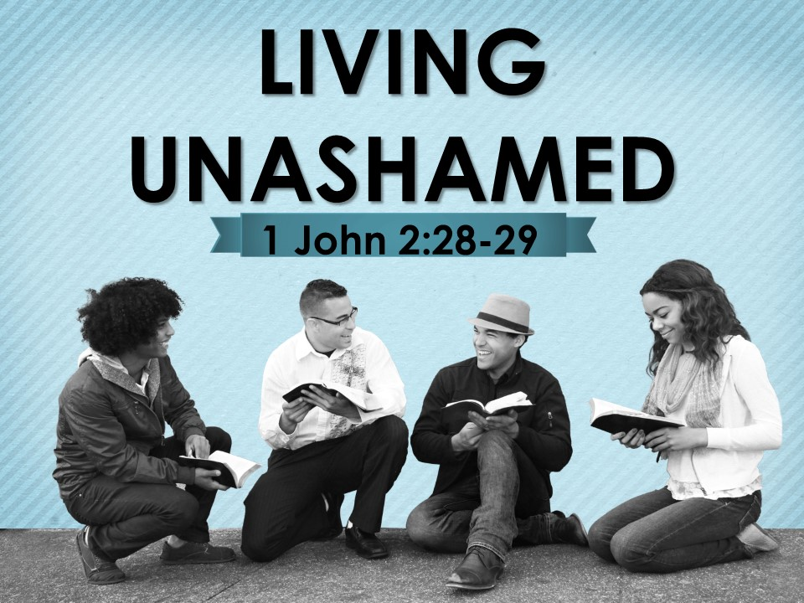
The Road Church
1st John Sermon Series
GETTING BACK TO THE BASICS
Part 8
Living Unashamed
Scripture: 1 John 2:28-29
Pastor Timothy Jones July 29, 2018
WOW, what an exciting VBS we had. I am so proud of everyone who participated in VBS. In fact - if you helped in VBS in anyway please stand up to be recognize: thank you very much. There is a special person who invested all their time and efforts is such a way that was so sacrificial. And that person is Anita Regalado, and we praise God for her and her decorating ideas, putting together the hard stuff of VBS and making it all happen. Give God a clap offering for Anita.
As a result of God’s amazing work through Anita and the others volunteers. I believe that this year was better than all the other years combined, we ran the bus this year and we had close to 70 Kids with well over 20 professions of faith and those kids raised 318.00 for Hope cry village in Uganda, Africa.
And that is a direct result of God working through her and all the other volunteers.
Thank you so much!
Then Friday was the party and it was fun, especially when the winning class silly stringed and whipped creamed me. It was fun for all the kids and as a result we have some of those kids that came back for today. Amen?
We thank God and rejoice for everything that God accomplished during VBS.
As we get ready to dive into God’s Holy Word let’s ask for His blessings.
Hey can you believe that we have been studying the book of 1st John for 8 weeks.? We have learned so much about the who, what, why, where and how of this book already.
Remember that John is a very old man; he must be the last survivor of his generation, maybe the last man alive who had walked and talked with Jesus in the days of HIS ministry on this earth. He writes as a pastor to the Christian community to encourage the Christian community to go back to the basic foundation of faith because of the trouble within the church of false teachers – a group called Gnostics – who were leading people away from what they first learned about Jesus and His resurrection.
Can I ask you this question to think about? If Jesus was not born with a physical body how could a Spirit die on the cross? And if He was a Spirit what the Gnostics believed, then there couldn’t have been a resurrection. And that goes against the very basic foundation of Christianity.
So, can you see the dilemma that John is dealing with?
There are people today who deny the existence of God, there are people who deny that Christ was born of a virgin, that He walked this earth and that He died, was buried then was risen again.
If you remember from last week John called those people antichrists. As he said that were many antichrists during that day.
We learned that antichrist are people who are against God. These are people in todays culture who are spreading false truth in the world today about Jesus. Although false truth is designed to look like truth in the short distance it only takes you of course a little, but in the long distance it takes your completely off course. And we know from last week that this false truth is taking people off course of what their purpose in life is and that is worshipping God. John also said that these antichrists were part of the church at one time but have strayed away. You can look at any cult and find that they were part of the church but then began moving away from the teachings of the truth.
Remember what we said last week- “you can be present in the church and not be part of the body” But we also learned last week that there are people like us who are disciples of Christ Jesus, who are being led by the true truth, the absolute truth which is governed by God and His word- according the Bible makes each person complete for God’s good work.
Well this week will also bless you as we talk about living unashamed.
Open your Bible or your Aps with me to the book of 1 John chapter 2, 1 John chapter 2 if you don’t already have that book marked, you can find 1st John if you go to the back of the Bible and count 5 books from the back, Revelation, Jude, 3rd and 2nd John then you will find 1st John.
When you get to 1st John chapter 2 let me know by saying “UNASHAMED”.
It is important remember as we read from God’s Holy Word that John is speaking to Christians just like us, who are in the church, who are in the last days and are having difficult times in life.
If you are there in 1 John chapter 2 begin reading with me from verse 28:
“So now, little children, remain in Him, so that when He appears we may have boldness and not be ashamed before Him at His coming. 29 If you know that He is righteous, you know this as well: Everyone who does what is right has been born of Him.”
Amen
These two verses are called the hinge verses, because they are a transition point of the letter. John has divided his letter into two sections first is fellowship with God and other believers and the second is our sonship, being Children of God. In the first section of the letter the John points out the contrasts between Light and darkness, love and hate, truth and nontruth. He has explained to us that real Christians live in obedience to God through love and truth and it is impossible to live in fellowship with God if we are living disobedient to Him. One commentator said it this way:
“You will have an artificial life instead of an authentic life.”
AS verses 28-29 act as a bridge from the first section to the second John also uses these verses to encourage us about Christ’s return.
Which brings us to our Big Idea today:
The Big Idea is: We must live with confidence of Christ’s return.
I have been thinking about these verses for the last week and about the lack of confidence that we often have when it comes to showing our faith to the outside world. In today’s world it is all about if you say this or that you will be offending someone. I know that certain words do offend others, but I think that many of us Christians have bought into the program that we don’t want to offend anyone - but the cross should be offensive, the message of Jesus is offensive to those who are without Christ.
I have been thinking about my walk with Christ and realizing that I am just as guilty as everyone else. And I have decided to put things in place in my life to say enough is enough because I don’t know about you but I don’t want to be caught as Christ is coming back not doing His work.
The Bible says in 1 Peter 4:16-17 that “if anyone suffers as a “Christian,” he should not be ashamed but should glorify God in having that name. 17 For the time has come for judgment to begin with God’s household, and if it begins with us, what will the outcome be for those who disobey the gospel of God?
We are Christians, we are Christ Followers and we should be shaking the world by our convictions and beliefs. And we should be shouting from the roof tops of who we are, not hiding in the four walls of the building.
What good is this life that God has given us if we live it out in the shadows?
What good is life if we are shackled to the bondage of this world?
What good is this life that God has given us if we don’t live it out for God?
John’s message is clear, we must live with confidence of Christ’s return.
The Bible tells us that Jesus will return and there is no doubt about that.
In the book of Hebrews chapter 9 verses 24-28 tells us that not only did Jesus appear but He is coming back again.
Hebrews 9:26 tells us of His past appearance:
“He has appeared one time, at the end of the ages, for the removal of sin by the sacrifice of Himself.”
Then in Verse 28 of His return: “will appear a second time, not to bear sin, but to bring salvation to those who are waiting for Him.”
Folks, We need to be ready, with confidence- Can you honestly say today that you are ready for Jesus?
My very first pastor said that if could choose where he could die and what he could be doing, he would die in church preaching the Word of God. And I get that now… Doing the work.
So how can we live with confidence?
The Apostle John gives us two keys on how to live with confidence of Christ’s return.
THE FIRST KEY TO LIVING WITH CONFIDENCE OF CHRIST’S RETURN IS WE MUST REMAIN IN HIM.
Look back at verse 28:
“So now, little children, remain in Him, so that when He appears we may have boldness and not be ashamed before Him at His coming.
Let me just note that again John addresses the Christian Community as “little children” this is the fifth time John has called them Children- He is using the grandpa card. amen- do you know what the grandpa card is- some of you know what I am talking about- I love being the grandpa- the Texas girls call me pop-pop and the Michigan grandkids call me Pappa Tim- but either way I am the grandfather and I get to use the grandpa card. Now the grandpa card is this- I get to be very direct, I can be stern – I don’t have to sugar coat anything to them, and then I get to spoil them and our kids say that’s grandpa..
John says that the number one key to being confident when Jesus comes back is to remain in Him. There is no sugar coating words. If you are going to have confidence in Jesus’ return you must remain in Him. This word remain is translated in other versions as abide, it also is Johns favorite word, he uses the word remain or the remnants of the word over 11 times just in chapter 2 and a total of about 24 times in this letter. Jesus used the word remain 11 times in in the upper room speaking to His disciples in John 15:4-16. The theme was remain in Me and I will remain in you.
Now I prefer the word remain over abide, because to remain means that you already are there, in our case we are already Christians, John is speaking to people who are Christians. The Greek word is used here describes living in a particular location. The word also carries with it the idea of persistence, where one continues to live. Here is what we need to be thinking about when we read that we are to “abide” in something or “remain” in someone is that we are persistently living in that location. We are persistently living in Christ. Our life is all about Him. We are staying with Him. It doesn’t have to do with reaching salvation, but rather walking close to the Lord in daily fellowship.
Last week we talked about how John wrote the Christians “what you have heard from the beginning must remain in you”.
The truth about Christianity is that is not about a feel-good experience, it’s not about the choice of music, it’s not about you being completely satisfied with today’s service, but rather a life commitment. If you have professed Christ through faith then God resides within you and true Christian living is a life lived with Christ- He resides in you.
Look back at verse 28 “So now, little children, remain in Him (Live life for Christ), so that when He appears we may have boldness and not be ashamed before Him at His coming.
Now notice with me that if we are remaining in Christ- that we are in Him and He is in us and that our lives are reflecting that life, and John says that this gives us two benefits:
FIRST BENEFIT IS BOLDNESS- The Greek definition of this word means confidence – out spoken- to be frank, to be blunt- assured. Our boldness is not of ourselves or what we can accomplish, but rather it is boldness that comes from God abiding in us. It is a deep confidence that shows itself in bold, candid speech, by one being "ready and willing" to make their convictions known in public without fear of repercussions.
The Bible illustrates this boldness in the book of Acts chapter 4. The Church began in Acts 2, chapter 3 Peter and John heal a lame man and began teaching when they were held by the priests and the Sadducees confronted them. They were arrested the next day they were questioned and when they began to speak the religious leaders saw their boldness and that they were uneducated men they were amazed and recognized that they had been with Jesus. After threating them they released them- the Bible then says that they went back to the church and reported everything that had happened. The church began to pray and the Bible says in Acts 4:31 the whole place was “shaken and they we all filled with the Holy Spirit and Began to speak God’s message with boldness.”
The truth is when we remain in Jesus not only do we have the boldness to speak the truth, but we have the boldness to be able to go to approach God at any time in our lives. Because Jesus remains in us we have God’s undivided attention.
The Bible says in Hebrews 4:16 “Therefore let us approach the throne of grace with boldness, so that we may receive mercy and find grace to help us at the proper time.”
Turn over to the 5th chapter look at verses 14 with me, John says: “This is the confidence we have in approaching God: that if we ask anything according to his will, he hears us.
Because of Christ living in you, you can approach the God of Creation, the God of the entire universe and you have His undivided attention.
That’s bold!
THE SECOND BENEFIT IS THAT WE CAN LIVE UNASHAMED
Verse 28 again “and not be ashamed before Him at His coming”
The phrase, "not be ashamed before Him" could be translated, "will not shrink in shame from Him."
Here John is talking about two kinds of people:
- Those who are unsaved they will be ashamed of final judgment.
- Christians- those living like there is no God.
When Eisenhower was president, he vacationed in Denver, Colorado. There was a 6 year old Denver boy who had incurable cancer. He expressed his wish to meet President Eisenhower. One day, Eisenhower arrived in his presidential limousine. He came to the front door and knocked. The father opened the door, wearing blue jeans, an old shirt, and a day's growth of beard. When he saw the president, he was speechless! Eisenhower took the boy out to the limousine and talked with him for a while. Then he shook his hand and left. When the father would recount the story, he would say, "And to think, there I stood in my blue jeans, my old shirt, and a days growth of beard. What a way to meet the president!"
Some of those Christians who had been in the church were leading others away from the church into false teachings about Jesus. Others were living lives outside of Christ Jesus. Today there are many who professed Jesus as their savior and leading other lifestyles than remaining in Him.
Jesus gives a warning to all people in Luke 9:26 “For whoever is ashamed of Me and My words, the Son of Man will be ashamed of him when He comes in His glory and that of the Father and the holy angels.”
That father's embarrassment is nothing compared to the embarrassment that will be felt by too many of God's children when Jesus returns.
If you are ashamed to call Jesus your Lord today in front of people in your life, what will it look like when you come face to face with Him?
Here is the thing- if you are abiding in Christ and He in you, you will never have worry about being embarrassed when Jesus returns. Listen to the best advice I can give you right now- are you ready? You might want to write this down…… Don’t get caught with your pants down!.
In other words don’t be doing something you shouldn’t when Jesus comes – because it will be a surprise!
We need to maintain the kind of fellowship with the Lord on a daily basis so we will always be ready to face Him with confidence!
THE FIRST KEY - WE MUST REMAIN IN HIM.
THE SECOND KEY TO LIVING WITH CONFIDENCE OF CHRIST’S RETURN: WE MUST LIVE RIGHTEOUSLY.
Look back with me at verse 29
“If you know that He is righteous, you know this as well: Everyone who does what is right has been born of Him.”
Verse 29 really explains how we won’t get caught with our pants down- or ashamed when Christ Jesus returns.
Let me explain right now that verse 29 is not – I repeat not saying that righteous behavior is a condition on new birth in Jesus.
In-fact, there are a lot of false teachers out there that say if you just live a good life you will get to heaven, there are people who believe that if they are not as bad as an axe murderer they will get to heaven. Others believe that only the really bad people will go to hell. These are all false teachings, false desires to make one feel good about themselves in the state of acting in their sinfulness.
The term “has been born of Him” means just the opposite. It means that a righteous life is the evidence of being born again. This is where we turn water into wine in our lives.
Righteousness is the right actions proceeding from right character. The principle of righteousness is found throughout the Bible.
Just as children are like their parents because they share their nature and character traits. Those who practice righteousness are those who are born of God because they know that God is righteous. Being born of God carries a simple picture. Since God is righteous, then it is not possible for us to be born of God unless we also practice righteousness. It is a matter of character traits. The Bible says that when we are born again that God gives us everything that we need to live this life:
2 Peter 1:3 “His divine power has given us everything required for life and godliness through the knowledge of Him who called us by His own glory and goodness.”
God has given us everything we need to live a life that is pleasing to Him. God has given us His Son so that if we have faith in Him we have eternal life. He has given us victory over sin and death. He has given us access to Himself (when Jesus dies on the Cross the veil that separated man and God was torn given us full access to Him). He has given us The Word in the form of the Holy Bible, some call it the instruction book of life. The Bible is the living Word of God to govern our lives by. God has given us His Church to live with others like us, to be encouraged by others, to serve others and to be loved by others. He has given us Mercy and Grace that what we have done in the past is forgiven if we just ask. He has also given us a future, a future in the presence of Him in the one place the Bible describes as heaven.
He has literally given us everything we need to succeed in righteousness.
SO how can we live a life of Righteousness?
Let me give you three practical ways to live righteously.
First, FOCUS ON GOD -The Bible tells us “set your minds on what is above not on what is on earth” (Colossians 3:2).
To live a righteous life we must always have God on our minds. We all have stuff in our lives that can overtake our thoughts and our actions. The world has a way of dominating us- but if we set our minds on what is Godly- we will always put God first.
When I am living out my discipleship the most is when my thoughts and worship are all about HIM.
Second, read and study the Word of God- notice that I said read and study- Joshua 1:8 “Keep this Book of the Law always on your lips; meditate on it day and night, so that you may be careful to do everything written it.”
This is true to us today- Keep Gods Word on your lips, study it, put it on your heart – live by it daily.
I believe that this is were most people fail. We have so many ways to be encouraged by God’s Word, read the Bible itself, download an ap that sends you verses- receive emails or text messages of daily readings- God’s Word has never been more accessible than in todays world, yet so many people don’t read the Bible daily. If you want to live what you believe – you have to know what you believe- you cannot live a righteous life if you don’t know what it takes to be righteous.
Listen to this conversation between two little boys
One of the boys noticed that the other's grandmother spent a lot of time reading her Bible. "Why does she read the Bible so much?" the boy asked his friend. The other boy replied, "She is cramming for her final exam!"
Then Third is prayer –
Listen, you have to talk to God.
What God’s Son went through so you can have access to Him is beyond amazing. When you go to a concert people who can get back stage have an access pass- Everyone wears it around their neck. So that people know that you are supposed to be there- you have an unlimited access pass to God- You need to take advantage of that. Father God wants to hear from His children. The Bible says in 1st Thess 5:18 to pray continually, now we talk about this all the time, praying at the beginning of the day is great, but you need to speak to God throughout the day- give thanks, give Him honor and praise – seek your desires- listen for Him to answer- watch for Him being at work around you.
Live life unashamed!
THE FIRST KEY IS TO REMAIN IN HIM.
THE SECOND KEY LIVE RIGHTEOUSLY. We can live righteously if we put God first , Read and study His Word and pray,,
Invitation:
If Jesus came back today- would you be ashamed?

