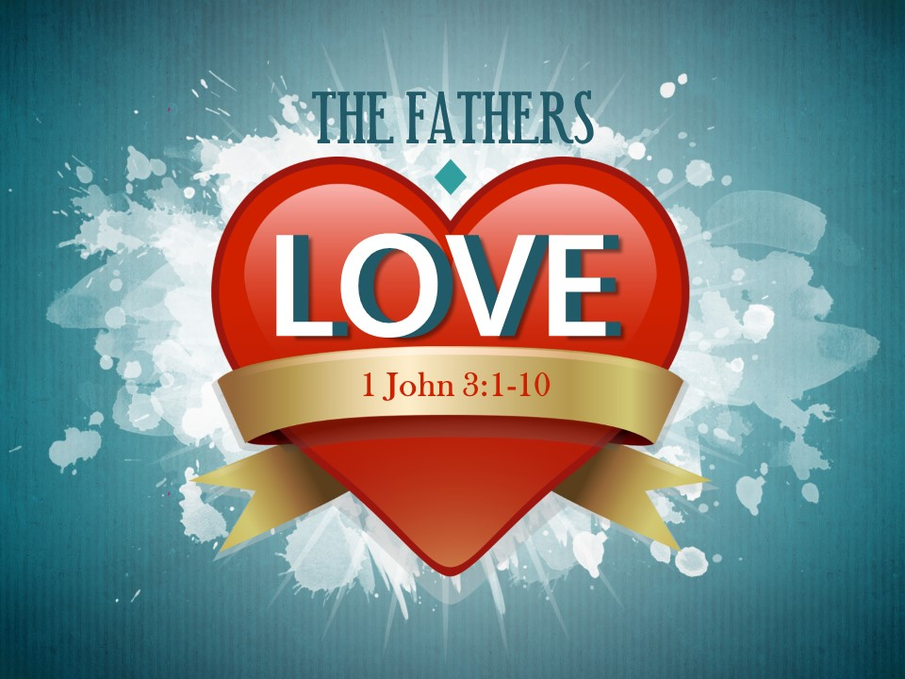
The Road Church
1st John Sermon Series
GETTING BACK TO THE BASICS
Part 9
A FATHERS LOVE
Scripture: 1 John 3:1-10
Pastor Timothy Jones August 5, 2018
Good Morning, it is great to be here with you this morning – We had a great weekend witnessing and encouraging people. I had so much fun at the Allen Park booth, my favorite thing is to handle the game. It is a bean bag game and people try to throw the bean bags into the hole and when kids and even adults miss the hole, it gives me an opportunity to tell them this; I tell them the Bible says “I can do all things through Christ who strengthens me” now focus on that and put it into the hole and 99% of the time they make it. I love that!
Thanks to all the people who served at the booth on Friday and Saturday. Often times your presence is what helps others connect to a church like ours. It is important that our presence is felt in the community. So, I just wanted to personally thank all those who served this weekend who made it possible. Jesus wants us to serve not only one another, but also the world. Amen? Amen!
Would you bow your heads and hearts with me today in prayer?
There is no other God than you-
Thank you for the greatness of life you have given each person who is your child and how we get to enjoy life because of You.
Thank you for the volunteers and I ask that you would bless them today.
May the teaching of your Word be impactful today to all who here your message, may you be glorified this morning. Amen and Amen..
Open your Bible or your AP with me today to the book of 1 John chapter 3, 1st John chapter number 3. Ok this is test time:… Who can tell me how many books it takes to get to 1st John from the back of the Bible? Who can tell me that?
The answer is five- Revelation- Jude- 3rd John- 2nd John and then 1st John.
When you get to 1st John chapter 3 let me know by saying “God is Love” amen - thank you.
GETTING BACK TO THE BASICS has been our theme in this sermon series. The Apostle John urges the Christian Community to get back to the basics of the faith in Jesus Christ in times of adversity.
Last week we learned that there are two themes of this letter and that our verses last week were the hinge verses that connects the first part of the letter to the second part of the letter. The first half of Johns letter was all about Fellowship with God. We discussed how the Apostle John pointed out the contrast between Light and darkness, love and hate, truth and nontruth. He also explained to us that real Christians live in obedience to God and it is through love and truth that we have fellowship with God.
Last week those hinge verses taught us about living unashamed and that we must have confidence in Christ return. He gave us two ways to be confident: first we are to remain in Christ and second, we are to live righteously. If we do both of these we shouldn’t be caught with our pants down when Jesus comes back.
Now let me point out that in verse 29 John uses the words born again- prior to this verse he doesn’t use it in the first 2 chapters. However, he will be using it ten times from this point of the letter forward. The focus of the letter changes here from the fellowship with God to what it means to be in the family of God. And folks let me say that being part of the family of God is walking the road of faith together.
If you are there in 1 John chapter 3 begin reading with me from verse 1, and it begins like this:
“Look at how great a love the Father has given us that we should be called God’s children. And we are! The reason the world does not know us is that it didn’t know Him. 2 Dear friends, we are God’s children now, and what we will be has not yet been revealed. We know that when He appears, we will be like Him because we will see Him as He is. 3 And everyone who has this hope in Him purifies himself just as He is pure.
4 Everyone who commits sin also breaks the law; sin is the breaking of law. 5 You know that He was revealed so that He might take away sins, and there is no sin in Him. 6 Everyone who remains in Him does not sin; everyone who sins has not seen Him or known Him.
7 Little children, let no one deceive you! The one who does what is right is righteous, just as He is righteous. 8 The one who commits sin is of the Devil, for the Devil has sinned from the beginning. The Son of God was revealed for this purpose: to destroy the Devil’s works. 9 Everyone who has been born of God does not sin, because His seed remains in him; he is not able to sin, because he has been born of God. 10 This is how God’s children—and the Devil’s children—are made evident.”
I love how the King James Version begins verse 1 it uses this word “BEHOLD” it is powerful word of choice because its an exclamation and even command. It doesn’t just mean to see what is there but it means to perceive the meaning of what John is going to say next. The Greek definition of Look or behold used here is to look inwardly with spiritual perception. In other words John wants his readers to take the time and think about, to ponder or study these next words that he writing.
Which brings us to our Big Idea today:
Our Big Idea today is: God’s Love is far greater than we could ever imagine.
Love is the one of the strongest words that we have in the world, it defines relationships, it defines what we like the most, it defines feelings. Love is the one thing that all people have in common and it is the one thing that people search for the most. It provides us with empowerment and it is the greatest motivator in the world. Love is the great conqueror of our hearts and yet the greatest threat to ourselves. Love is the one thing that can devastate us, especially when we feel rejected or unloved by another.
I read this story of a man by the name of George Matheson, He was a 19th century Scottish pastor. He was born with an eye defect that left him totally blind by age 18. Shortly after this, his fiancée left him, deciding she would not be content to be married to a blind preacher. Years later, at age 40, Matheson was alone on the night of his sister’s wedding. Something happened, perhaps the memory of being rejected by his own fiancée years before, that caused him severe mental suffering. Suddenly, the words of a hymn came to him as if dictated by some inward voice. The whole thing was done in five minutes and he never had to edit or correct it (from Kenneth Osbeck, Amazing Grace [Kregel], p. 49). The title of that hymn is “O love that will not let me go”
The first verse goes like this:
O love that wilt not let me go,
I rest my weary soul in thee.
I give thee back the life I owe
That in Thine ocean-depths its flow
May richer, fuller be.
Then the third verse reflects Matheson’s experience of God’s love through suffering:
O joy that seekest me through pain,
I cannot close my heart to thee;
I trace the rainbow thro’ the rain,
And feel the promise is not vain
That morn shall tearless be.
You see, in his blindness and loneliness, perhaps feeling forsaken by the love of a woman, Matheson sought and found comfort in the unchanging love of God. Although we experience great joy and happiness though human love, God’s love is far greater than we can Imagine, it reaches not just the depths of our hearts but it is the nourishment of our soul. It was that nourishment of my soul that I sought so many years ago.
This weekend I was passing out the little John booklets at the Fair and I asked people if they wanted a free book Most of those who said “no” I told them “this is a life changing book full of God’s love”.
In the book of Ephesians chapter 3 the Apostle Paul prayed for the Ephesian Church with these words; “I pray that you, being rooted and firmly established in love, 18 may be able to comprehend with all the saints what is the length and width, height and depth of God’s love, 19 and to know the Messiah’s love that surpasses knowledge, so you may be filled with all the fullness of God.”
Obviously, Paul may be picturing trees that are rooted and grounded and I found that some trees roots go as far as 20 feet deep and sometimes as wide. The foundation of the tree is its root system, and Paul speaking about the family tree of God that its foundation is love and that his prayer is that we will be able to comprehend God’s love- the length – width – height and depth of it. But I believe that The Fathers love for us is so great that in this life form we will never be able to comprehend God’s love for us. It is unimaginable, boundless and even measureless. One commentator said it is like setting up a yard stick to see how tall God is. God’s love far exceeds all other loves.
However, if there was one person who could know such love it would have been John. John spent the greater part of 3 ½ years with Jesus. Perhaps Jesus’ closest friend. He is called the disciple whom Jesus loved. He heard Jesus teachings, He saw the most powerful of miracles – the transfiguration- John was the one who Jesus picked to care for his mother at the time of His death and John saw the greatest love of all, at the death and resurrection of the Son of God and now as the last eye witness alive John tries to teach us this great love of God today; and in this scripture we find four realties of the Fathers love for us.
- THE FIRST REALITY IS THE FATHERS LOVE IS SO GREAT THAT HE HAS ADOPTED US INTO HIS FAMILY.
Look back at verse 1 with me “Look at how great a love the Father has given us that we should be called God’s children. And we are! The reason the world does not know us is that it didn’t know Him.”
Notice with me that John is directing his readers attention to the greatness of God’s love and who we are because of it.

Have you ever experienced adoption? Do you know a person who has gone through the adoption process? By definition adoption is to take voluntarily a child of other parents and make them your own child. It means to accept as if one’s own.
My wife and I have gone through or been a part of a several of adoptions. And I can tell you that the love that is there at the time of adoption comes from depths of one’s heart.
The video you are about to watch is of a girl named Nisha, my wife and I cared for her as a foster child. We had her in our home for about 12 months, She had become the world to me and I love her with all my heart, but we knew we were not supposed to adopt her. Watch this video.
The first thing that you probably noticed is that she doesn’t look like her parents, she is black and they are white. But she is just like her parents. When people see her, they see them. When she talks she talks with her father’s wisdom, when she does things she does it with her mother’s creativity. They have become bonded together. What is the common denominator that makes a little girl like her non-birth parents? Love
It was love that forced the agency to find adoptive parents for her, it was hard to let her go especially for me, because she was my little girl. She waited on me patiently to come home and to give her, her bottle at night. She wouldn’t let no other man pick her up except me, my wife and I watched as she took her first steps in our home. But We sacrificed ourselves so that she would have the life that she has. We could not have given her the rich full life that she has today. For Nisha being adopted it meant that once just stranger, she would now have a new identity, a new name, a new opportunity, a new life and a new inheritance.
The Bible says in Romans 5:8 that God’s love for us was so great that while we were still sinners Christ Died for us- being a sinner in defense is one who doesn’t know God. John says in verse 1 that others do not know us because they don’t know God- the word Know means acceptance – that others are still stranger to God and His love.
When you accept Christ by faith, you become adopted into the family of God and I have to tell that common denominator of this adoption is love. But being adopted into the family of God is infinitely more than you can ever imagine. God loves you so much that He brings you into His family spiritually. This world cannot and will not be able to give you the life, the full rich life that God has for each of us. As adopted children, we enter into a new relationship with God. We are adopted through what is called new birth, it literally means that we have been born again, because the Bible says that the world lives as an enemy to God, but at our New Birth in Christ Jesus we have a new identity as Children of God.
In Johns Gospel chapter 1 verse 12-13 John addresses this very thought by saying
But to all who did receive Him (speaking of Christ Jesus by faith), He gave them the right to be children of God, to those who believe in His name, 13 who were born, not of blood, or of the will of the flesh, or of the will of man, but of God.
Just as my little girl, she immediately began to enjoy the privileges of being in that family no longer a stranger- We now enjoy all the privileges, obligations, and inheritance rights as God’s children. That is how great HIS love for us is. We re no longer a stranger but a child of God.
- THE SECOND REALITY IS THE FATHERS LOVE IS SO GREAT THAT HE HAS AN INCREDABLE PLAN FOR HIS CHILDREN.
Check out verse 2 and 3 with me: 2 Dear friends, we are God’s children now, and what we will be has not yet been revealed. We know that when He appears, we will be like Him because we will see Him as He is. 3 And everyone who has this hope in Him purifies himself just as He is pure.
Listen folks God has greater a greater plan for you than you could ever imagine.
God has this incredible plan for you, me and even others who have the title children of God.
John describes here as what we will be- He says that we are children of God today- but today is not the end of who we will become.
Look at the second half of verse 2 We know that when He appears, we will be like Him because we will see Him as He is.
There are three things to know about this section #1 John asserts again that one day you and I will be face to face with Jesus and Secondly when that day comes there will undergo a great transformation then 3rd our transformation will take us from who we are today to fulfill God’s ultimate plan for our lives for eternity into the fullness of Christ Jesus.
You see God is not only interested in making us His children, but He desires for all His children to bear the family likeness. God is in the business of making us more and more like Jesus. Each day as a Christian God is working in our lives to create in us the mind of Christ. He is at work to help us think like Jesus, talk like Jesus and act like Jesus. John says that God is not satisfied with just having some adoptive kids, He wants us to be in the image of our Lord and Savior Jesus Christ. When I think of this transformation, I cannot help but to think of God’s creation and the transformation of the caterpillar into the butterfly. The other day our granddaughter was so excited when she saw a caterpillar.
The caterpillar lives for the day that it will be make its own cocoon to live there for a period of time while the old body undergoes a remarkable transformation called metamorphosis and once achieved it breaks through that cocoon and emerges a beautiful butterfly. Completely totally different than what it started out to be.
Listen to me folks I have great news for you we many have begun as sinners, but God didn’t just save you so that you wouldn’t go to hell. The Bible says that God saved us to transform us into the likeness of His Son in spiritual unity and righteousness.
To be a child of God means that we have been given the very nature of God. Verse 9 tells us that God’s seed is in us. That is to say that His holy DNA is placed in us when we place our faith in Him. This is so important for us to understand. You must understand your identity or you will never live the life you were meant to live.
Just like the butterfly doesn’t know the beauty of its transformation so is true is us.
We know that as John wrote that “we will be like Him” and the Bible says that our bodies will be transformed in Philippians 3:21 and that we will have glorified resurrected bodies. SO, God’s plan is that we will not only become born again and to be adopted, but that we as His children begin to have the characteristics of Him and eventually our bodies will be transformed. Although we will not be little God’s, We will bear the resemblance of Christ and we are destined for His Glory.
Listen folks God has a greater plan for us than we could ever imagine. His love is so Great that:
- He adopted us.
- He has an incredible plan for us for eternity.
- THE FATHERS LOVE IS SO GREAT THAT HE HAS FOUGHT TO WIN US BACK.
7 Little children, let no one deceive you! The one who does what is right is righteous, just as He is righteous. 8 The one who commits sin is of the Devil, for the Devil has sinned from the beginning. The Son of God was revealed for this purpose: to destroy the Devil’s works. 9 Everyone who has been born of God does not sin, because His seed remains in him; he is not able to sin, because he has been born of God.
There has been a battle raging since the beginning of time and at the right time God sent His Son, His #2 guy to fight the battle of sin for us- think of that reality for a moment- God has gone into battle for you and for me.
He has done battle with the evil one and not only has He beaten him at his game but HE took the keys from him.
Paul again speaks of the false teachers and the anti Christs in the world deceiving others- “let no one deceive you!”- Listen folk living a righteous life for Christ Jesus is not only difficult, but it can become overwhelming sometimes. AMEN? Some of us are the odd people in our families, we are the Bible thumpers at our place of work, we the church people in the neighborhood. People will try to convince you, Society will try to pressure you, the world will make up things that look better, to go against the God and your beliefs. It has been happening from the very beginning. At the fall of mankind in the book of Genesis chapter 3, the serpent said to Eve “DID GOD REALLY SAY YOU MUST NOT EAT FROM ANY TREE IN THE GARDEN?” He brought doubt to the world. Doubt is the enemies greatest weapon against the Christian. If they can come up with enough stuff to make us doubt the true nature of the scripture it can take us off course. Remember a few weeks ago we talked about true north verses magnetic north. If you follow the fake north long enough you will of course.
But listen to me- When Jesus went to the cross- When Jesus gave up His Spirit, When Jesus took on the penalty of death and died that day on the cross- I bet the devil was rejoicing, ohhhhhhh I bet there was a big party going on, Just like when your parents left home for the weekend and you had that big party--- BUT THEN- Jesus walked into hell – that party was interrupted – the Bible tells us that when Jesus died His body was in the tomb for three days. Do you ever wonder what Jesus did for three days? He did not just sit there twiddling his thumbs. I don’t have time to go into all the facts but The Bible says in Matthew 12:40 For as Jonah was three days and three nights in the belly of a huge fish, so the Son of Man will be three days and three nights in the heart of the earth.
In Hebrews 2:14
“Since the children have flesh and blood, He too shared in their humanity so that by His death He might destroy him who holds the power of death–that is, the devil.”
The Bible says that In 1st Peter 3 that Jesus went to preach to the spirits in prison who died before the flood of Noah.
And in Revelation 1:18 Turn over there with me, keep your place, but turn over to Revelation chapter 1 verse 17- 18 with me Look at the words of Jesus
“I am the First and the Last, 18 and the Living One. I was dead, but look—I am alive forever and ever, and I hold the keys of death and Hades.”
The Battle of Jesus the truth and the life verses the bad guy of sin and who came out victorious? Jesus the Son of God.
That is victory!
I was telling my wife that I loved watching the eyes of the little ones when they played the game at the fair. When they shoot that bean bag in that hole and I would shout whohoooooo! With excitement for them and I would watch as their eyes were filled with excitement.
Jesus is coming back, don’t let know one put any doubt in your faith because
God loves us with such great love that He fought and won the battle for us.
His love is so Great that:
- He adopted us.
- He has an incredible plan for us for eternity.
- HE HAS FOUGHT TO THE BULLY AND WON US BACK.
And finally
- THE FATHER LOVE IS SO GREAT THAT HE DISTINGUSHES US FROM THE WORLD.
Look at verse 10
This is how God’s children—and the Devil’s children—are made evident.”
How are we made evident? God’s Children live a life of Righteousness. We do right living- God loves us so much that He has even put a provision in living a life of Righteousness and that is found in verse 3 That everyone who has this hope (faith in Christ) that we are to purify ourselves just as Christ is pure.
Listen to me that is a day by day purification sometimes its minute by minute. We know that we mess up and we care to make sure that we are getting right with God. Its not a get out of hell free card, because God has already saved us. It is right living before the right God.
Love and righteousness are the two things that we demonstrate that we are children of God.
God loves you so much..
Invitation..

