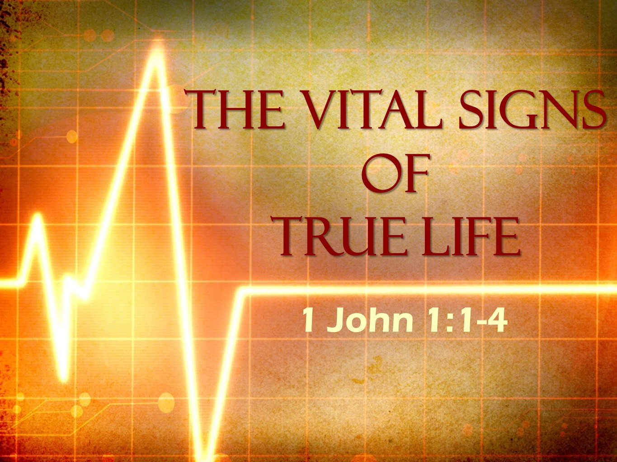
The Road Church
1st John Sermon Series
Part 1
The Vital Signs of LIFE
Scripture: 1 John 1:1-4
Pastor Timothy Jones June 10, 2018
Are you excited about being in the house of God today?
I know I am and I just want to take a moment to praise God for the work and energy God has given Gayle for this week’s praise and worship songs. She put all the slides and songs together. She spent hours working on them. She and Mike practiced. I thank God for giving her the energy. Amen?
THIS WEEK WE BEGIN A JOURNEY TOGETHER.
We are starting a new sermon series on 1st John and during this series we will find that we are walking the road of faith together. The road of faith is not an easy road, in fact the Bible tells that is narrow and difficult, but when we do it together it makes the journey a lot easier, because we are supposed to be encouraging one another, we are loving one another, we are praying for one another and we are living the Christian life with one another. That is the life of the church. Last week we discussed what it takes to love the Church as God loves the Church. We seen three ways to show our love for the church.
- Give sacrificially
- To be loyal
- To be present
Which really is the set up for this sermon series.
So, join with me by opening your Bibles or Aps to the New Testament book of 1st John, 1st John is located towards the back of the Bible working your way backwards you have Revelation, Jude, 3rd John 2nd John then 1st John. When you get there let me know by saying “Fellowship”.
Before we dig into the sermon I want to make sure that we are all on the same page because I don’t take for granted that all of us know certain things about the text. Here are the basic things you need to know about 1 John.
This book was written by no other than the Apostle John, He is one of the original twelve disciples who then become an apostle of Jesus Christ.
John was a normal guy who spent his early years as a fisherman. Until Jesus called him to become a disciple.
By definition he was the one of the closest friends of Jesus. He was one of the inner three disciples Peter, John and His brother James. It can be argued that John was Jesus’ best friend, as you may know, the Bible describes John as “The disciple whom Jesus loved”. Also, we see this incredible friendship in John chapter 19 Jesus was on the cross and Mary, His mother. Mother was there along with John. As Christ is dying on the cross and Jesus said to John Behold your mother and to his mother behold your son. So, Jesus hands of the care of the His mother to John, who then took her and cared for her for the rest of her life.
Here is the thing I get from this, Jesus had levels of friendship. It is also interesting to me that Jesus didn’t love John any more than what He loved the rest of the disciples. God loves all people the same, John 3:16 For God so loved the world- Jesus loved us as He gave Himself up for the church (EPH 5)- so we are all loved by God, but what I see about John and the rest is this – They chose how close they were with Jesus. And isn’t that true in relationships today?
We chose how close we are with other people and listen:
Christians are as close to Jesus as they chose to be.
And we see that John was one of the closest.
At the time of this letter John was probably the only surviving member of the twelve. He wrote this letter in 80-85 AD, therefore we know that he was somewhere in the range 80 to 89 years of age.
He is the co-author along with the Holy Spirit of five books of the New Testament. The Gospel of John, 1,2,3 John and the Revelation.
John had spent his later years around Ephesus and He wrote this letter to the church in Asia Minor where he was a pastor. The first-generation Christians are all gone and now the church in part is compiled of second and third generation Christians. In other words, there were no first-hand witnesses of Christ left in the church.
For some of these Christians it was a time of persecution. For others their devotion to Christ was wavering, some were led astray by false teachers, and then there were the Christians who were becoming relaxed in their Christian standards. Now I know what you are thinking; and it does sound like the church here in the twenty first century. John is addressing the theological issues that existed in the church then and that we still see today in 2018.
He has two central themes: one is about the authentic fellowship with God and His people and the other is about getting back to the basics of Christianity. And we are going to look at both of these throughout our series.
The title of our message today is:
The Vital Signs of Life!
I love what John does here because John writes this letter to the Christian as an older man, the one with experience, maybe even the grandfather figure. In this letter John talks straight about walking the road of faith. He discusses a lot of things that are the vital signs of life with Christ Jesus. He is going to discuss important issues facing our lives as Christians.
And he begins right away dealing with false teachers. People who have infiltrated the church and are leading others astray.
John was confronting the false teaching of those who denied that Jesus had come in “human flesh.” This teaching was known as Gnosticism. Gnostics claimed to have superior knowledge, which ordinary Christians did not possess. They taught “all matter” was evil and the Spirit was good. Therefore, Jesus could not have been in a human body because they believed the body was evil. Some rejected the Incarnation by denying the deity of Christ. Others said the body of Jesus was an illusion that he only seemed to have a human body. John declared anyone who denied that “Jesus Christ has come in the flesh is not of God.”
Gnostics reject the teachings of the early Apostles that Jesus was physically born, lived, did ministry and died in a physical body and that body rose again. This is the foundation of Christianity today, it is the foundation of the Holy Word of God and anyone who does not believe cannot be a Christian. Therefore, cannot be of God.
Today there are Gnostics in our world. There are false teachers in our midst leading people astray.
Well, if you are there in 1st John chapter 1 let’s begin looking and the Vital Signs of True Life with Christ.
Before we begin; can we pray together and ask God to meet us here as we study His Word?
Prayer
1st John chapter 1 Starting with verse 1 it begins like this:
“What was from the beginning, what we have heard, what we have seen with our eyes, what we have observed and have touched with our hands, concerning the Word of life—
2 that life was revealed, and we have seen it and we testify and declare to you the eternal life that was with the Father and was revealed to us—
3 what we have seen and heard we also declare to you, so that you may have fellowship along with us; and indeed our fellowship is with the Father and with His Son Jesus Christ.
4 We are writing these things so that our joy may be complete.”
Now I think it is important to note here that this is a very different tone of letter than what the Apostle Paul would write. John here gets straight to the point about everlasting life and about dealing with the false teachings of Gnosticism.
Which bring us to our Big Idea:
Our Big Idea is: SPIRITUAL FELLOWSHIP IS THE VITAL SIGN OF TRUE LIFE.
Just as there are clear indications that of physical life, there are also indications of Spiritual life.
We have a pulse, we have a heartbeat which indicates that we are alive.
If you suffer from any trauma the first thing the EMS or a Doctor or even a Nurse does, is check your pulse- it’s the first indicator for them that you are alive, if they don’t get a pulse from you the next step is to listen for a heartbeat. It is the indicator that you are alive!
Spiritually we also have indicators. Are you a professing believer? What comes out of your mouth is what you believe in your heart. What does your walk in Christ look like? These are all indicators to others that you are alive spiritually.
According to grandpa John (you don’t mind me calling him grandpa John, do you? He is in his eighties, he is a grandfather figure to the church, He is speaking to the point like grandfathers do.) So, Grandpa John says that the one true indicator of your spiritual life is this word fellowship. Look back at verse 3.
“that you may have fellowship along with us; and indeed our fellowship is with the Father and with His Son Jesus Christ.”
The word fellowship has been hijacked by a lot of people including the church. Some people believe that it is sharing a meal together. Others believe it is being in Bible study together, still others believe that fellowship happens when we are in the presence of one another. If the definitions are stand alone, then by themselves they are not true to the word fellowship, because then fellowship can only happen when you are doing one of these actions with another.
Now the definition of word in the Greek in this context means that people are sharing something in common- it literally means a partnership and community. And this describes the local church. It describes not something that is agonizing to you. But rather things that you cannot wait to get to.
When we have received this spiritual fellowship, we are to in community with other believers and that we are now in partnership with God Father and His Son for the mission to the world.
When you receive this spiritual fellowship, you begin walking the road of faith with those who you are in community with and with God and the Son as your leader.
So, the indicator that you are alive spiritually is to have fellowship with God the Father, God the Son, God the Holy Spirit and brothers and sisters in the faith in community.
Today I want to teach you the three truths which place us in spiritual fellowship with God, the Son and other believers.
The first truth is:
- Spiritual Fellowship is received by Christ being revealed.
Look back at verse 1 and 2 with me:
“What was from the beginning, what we have heard, what we have seen with our eyes, what we have observed and have touched with our hands, concerning the Word of life— that life was revealed, and we have seen it and we testify and declare to you the eternal life that was with the Father and was revealed to us—
From the beginning of history mankind has tried every trick in the book to attempt to bridge the gap between man and God. To reason against the natural need to fill the void of spiritual loneliness. Since sin entered into the world we have failed and that failure has taken our fellowship with God. The Bible tells us that it was Christ has bridged that gap on the cross. So, John begins by grounding his readers in the Historic reality of the Gospel. He also makes a point throughout the book that Fellowship with God is impossible without the fellowship of His Son. Jesus is, has been and always will be the source of our fellowship with God the Father. John reminds us that from the beginning there was a redemptive plan. Verse 1 John says that Jesus is the Word of Life, in verse 2 that it is eternal life and third He brings us back into fellowship with God. It’s been God’s plan all along that we would be in fellowship with Him.
Look at those first five words “What was from the beginning” Now in this Gospel history lesson Paul’s assertion here is that Jesus was the from the very foundation of the universe being formed. Which mirrors what John says in the opening verse of his Gospel:
John 1:1, John plainly declares that “in the beginning was the word and the word was with God and the Word was God.”
Therefore, Jesus existed in the beginning, and there was never been a point of time where Jesus did not exist.
Then John said that in verse 2 Jesus was revealed to Him. His relationship with Christ as Lord was revealed as God opened their eyes to see that the man, Jesus, was not just a godly man or a great teacher. It was revealed to them that He is “the Christ, the Son of the living God”
John experienced the true fellowship of God through His Son Christ Jesus.
We too can experience the same fellowship because Christ is revealed through the Holy Word of God. We come to faith by putting our trust in Him, by believing what the Word tell us about Jesus and the redemptive work completed on the cross.
Jesus said in after His resurrection in John 20:29 “Because you have seen me you believed, blessed are those who have not seen and yet believed”
John said that it was revealed to him that Jesus was God and that he wanted to declare it to his readers so that they would share in the same life the John has.
FIRST, WE RECEIVE SPIRITUAL FELLOWSHIP BY CHRIST BEING REVEALED.
SECOND, SPIRUTUAL FELLOWSHIP IS EXPERIENCED THOUGH CHRIST JESUS.
Now I don’t know about you but I have experienced some things in my life, especially while in the Army. Some of you have experienced a lot as well, I have heard some stories. But the greatest thing in my life was experiencing Christ in my life.
Look at the rest of that 1st verse:
what we have heard, what we have seen with our eyes, what we have observed and have touched with our hands, concerning the Word of life—
John is talking to the readers about what he first hand experienced. Now in a court of law an eye witness will seal the case. Their testimony goes further than any evidence either for or against the accused. In a lot of cases the eye witness testimony single handedly convicted people.
The point that John is making is that Jesus was not only there in the beginning but He was incarnated- He became flesh- and that he himself has experienced the physical presence of Christ?
He uses three words to describe his personal encounter with Jesus-
- He heard HIM-
Jesus called his name and gave John a personal invitation to follow Him. John here can recall the 3 ½ years of Jesus’ teaching from the sermon on the mount to the parables of the ten virgins to the seven I AM statements that John personally wrote about:
I am the bread of life. (John 6:35)
I am the light of the World. (John 8:12)
I am the Gate. (10:9)
I am the Good Shepherd. (10:11)
I am the Resurrection and Life. (11:25-26)
I am the Way the Truth and the Life. (14:6)
I am the Vine. (15:5)
He is giving an eye witness testimony of what he heard.
You know I remember the day Jesus called my name to follow Him, I also remember the day I accepted the call.
We have all heard the Word of God as well, through hymns, preaching – teaching – Bible studies, through prayer -the Church etc...
When we are in spiritual fellowship with Jesus we can hear Him in all things.
2nd John said He has seen Jesus with his own eyes and observed Him.
You know, His memories of the miracles- signs and wonders that Jesus did must have been amazing, and those that John participated in like the feeding if the 5000 or the transfiguration. Think of the amazing things that are written in this Bible that the disciples where personal witnesses too. John says In John 21 “Jesus also did many other things. If they were all written down, I suppose the whole world could not contain the books that would be written.”
Can you just imagine?
But the great thing is, God is at work all around us and we can see the great and wonderful things He does. Just look at this church – God’s house has never been in better shape. We also have seen great growth in the church, we have seen so many come to faith, and in the last four years we have baptized more than the previous 10 years. I just was talking with the deacons about this last week, about how we get to see the spiritual growth of people. In 4 years I have seen people grow spiritually and I can measure it. We have seen prayers answered, amazing works of God done that we have seen with our own eyes.
John says not only has he heard it- he has seen it and third he says He has touched Him.
They lived, worked, ate, walked, ran with Jesus, John also touched the living God. Jesus touched their lives and they physically had touched Jesus. But more than that they got to touch the resurrected Jesus. John touched the holes in His hands. Jesus told Thomas put your fingers in the holes of my hands, reach your hand out and put it into my side… wow!
In the OT God does the same He told Moses – Stretch out you hand- then turned it to leprosy, then God changed it again- feeling the very power of God.
We can feel the power of God, we can feel the touch as well. God allows us to see Him through touching the lives of others. My wife shared with me that it was so exciting this Friday to be the answer to prayer of someone she never had met. We can see God touching the lives of others around us and we can feel the Love of Christ Jesus in our hearts and our lives. John said that the things they he had heard, seen and touched all revealed life, what he means is the death, burial and resurrection of Christ has been declared to you so that we can have the same fellowship that John has.
FIRST, SPIRITUAL FELLOWSHIP IS RECEIVED BY CHRIST BEING REVEALED.
SECOND, SPIRITUAL FELLOWSHIP IS EXPERIENCED THOUGH CHRIST JESUS.
THEN 3RD SPIRITUAL FELLOWSHIP BRINGS JOY.
Look back at verse 4 with me. John says that he writes these things “so that our joy may be made complete.” Some later manuscripts change “our” to “your,” and certainly that is true. But the original reading was probably “our” joy, referring to the joy of the apostles who knew Christ firsthand. Remember that John was by this point the only surviving apostle. He was a grandfather figure to the church and in the since of writing to the church his joy was made complete. In 2nd John 1:4 John says that he was glad they some were walking in the truth. Then 3rd John 1:4, “I have no greater joy than this, to hear of my children walking in the truth” If John’s little children would read these letters and not be carried away by the false teachers, but continue in the truth, he was a happy man.
You may think that joy in the Lord is a nice extra, to the gift of the spirit, but not essential. But as John Piper often points out, we cannot glorify God properly unless we enjoy Him thoroughly. (X2)
Sometimes we get a little lost, we forget about having the joy that can only come from Christ through fellowship with Him, that’s why we have scripture like this to remind us that we are to this joyful attitude about us, that can only be completed through Spiritual Fellowship with God the Father, God the Son, and the community of believers called the local church.
Our joy doesn’t come from the world, in fact if you watch the news it won’t make you a joyous person, but rather a depressed person.
Charles Spurgeon was quoted as saying
“There is a marvelous medicinal power in joy. Most medicines are distasteful; but this, which is the best of all medicines, is sweet to the taste, and comforting to the heart. This blessed joy is very contagious. One dolorous spirit brings a kind of plague into the house; one person who is wretched seems to stop all the birds from singing wherever he goes . . . [But] the grace of joy is contagious. Holy joy will oil the wheels of your life’s machinery. Holy joy will strengthen you for your daily labor. Holy joy will beautify you and give you an influence over the lives of others.”
You see Christian Joy is the presence of Jesus in our lives, by the means if the indwelling of the Holy Spirit.
I Love that Old Testament scripture from Nehemiah 8:10 “The joy of the Lord is my strength.”
The world and all of its glory cannot give us joy. The world cannot lead us to a joyous life on this side of heaven.
Joy doesn’t only come in the morning, but it comes in the afternoon, evening and night time. It is always here waiting for us to take hold of it and spread it out to the rest of the world.
Joy is the pulse and the heart beat that shows the health of your Spiritual life.
John says that this what we have testified to you, what we have declared to you and the truth is people can never experience the true joy without the fellowship with Christ Jesus.
it begins with Christ. It is revealed to us, we can experience it and it brings such JOY.
Invitation….

