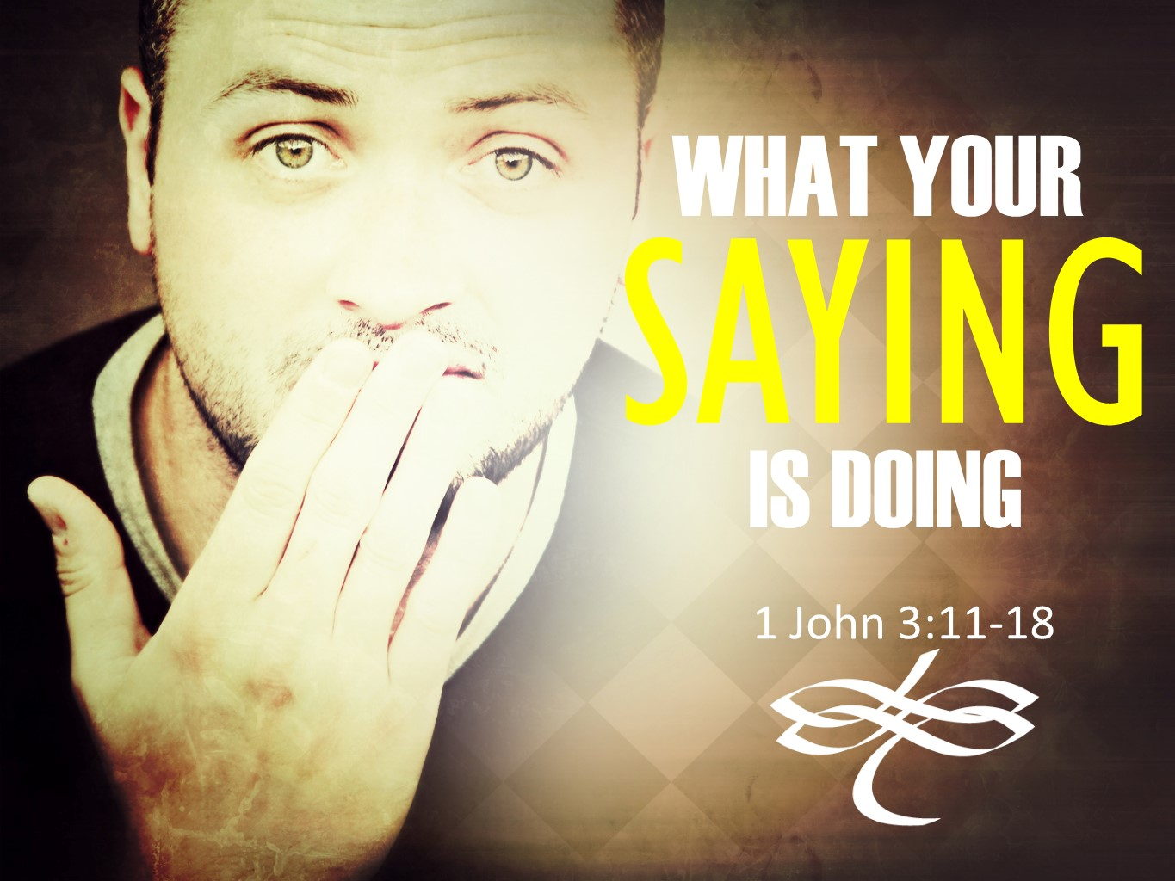
The Road Church
1st John Sermon Series
GETTING BACK TO THE BASICS
Part 10
WHAT YOUR DOING SAYING
Scripture: 1 John 3:10b-18
Pastor Timothy Jones Aug 12, 2018
Welcome back to the Road Church, it has been a great worship service thus far, Amen? Well first, I want to take a moment to welcome those of you who are part of our media church watching from several different states this morning, thanks for tuning in!
Second, we cannot get into the Word of God without asking His blessings. And as we go to the Lord in prayer I ask that you open your heart for God to speak to you.
Father God, speak to us today through your Word. Your scripture says that Your Word is a lamp unto my feet – it lights the way for each Christian to walk with you. I pray that your Word would do that for us this morning. Stretch us, mold us, teach us what it means to be a child of You. Thank you for what you have instore for us for the rest of this service. Teach us how not to hate, but to love. Teach me how to love you more, to love the saints and all others in this world.
Amen and amen!
Welcome back to our sermon series on 1st John. Last week we began the second half of this letter that the Apostle John wrote to the Christian community. As John changed gears from the first half of this letter of being in fellowship with God, He is now taking us on a journey of what it means to be a Child of God. And last week we found we are children of God because God has this immense love for us. His love for us is far greater than we could ever imagine or even understand. But if there was one person who could teach us of that love it would be the Apostle John. He was the best of best friends with Jesus, He saw God’s love and compassion through Christ Jesus as he walked, lived, talked and loved Jesus each day. He watched the Love of God become manifested through the works of Jesus by the healings, miracles, the signs and wonders that He performed, such as the feeding of the 5,000, or when Jesus calmed the storms or when He walked on water. Then he watched as Jesus healed the 10 leapers, the paralyzed man that was lowered from the ceiling to Jesus’ feet by his friends and even the woman, who had a bleeding disease. When she touched the hem of Jesus’s robe and instantly she was healed. He saw God’s love become reality when His eyes saw the resurrected Lord. Now the last living apostle, the last eye witness, He speaks to the Christian community with such grace, knowledge and authority.
So, if there was one person qualified it was John to teach us of the immense love the God has for us.
Last week John gave us four realities of God’s love for us.
- HE ADOPTED US INTO HIS FAMILY. When you accept Christ in your heart by faith. When by faith you make Christ Lord of your life. God’s promise is that you become part of the family of God and part of the body of the church.
- HE HAS AN INCREDIBLE PLAN FOR US FOR ETERNITY. When we are done with this old body, when it returns to the dust that we were made from. God has a great plan to make us like the image of the Son. We won’t have a spot nor a blemish, we will be perfected in Christ.
- HE TOOK THE FIGHT TO THAT BULLY (THE DEVIL) AND WON US BACK. It is remarkable that God loved us so much that even after mankind turned our backs from Him, He still sent His Son to kick some Satan butt. Jesus fought the fight, He went to hell, He took back our lives and the keys to the prison.
- THE FATHER LOVE IS SO GREAT THAT HE DISTINGUSHES US FROM THE WORLD. When you become a child of God, you are forever different than the rest of the world. We have placed the blood of the perfect Lamb of God on the door posts of our hearts and souls. We have been forever marked as Christ followers and spiritual death will pass over us because we have life in Christ.
So, John teaches us of this great love and what it means to be a child of God. But John isn’t done there, today as we discover that the love that God has for us, that it has to be shown to the world. It is not a matter of words, but of action.
Open your Bibles or your electronic devices with me to the New Testament book of 1st John chapter 3. First John 3, you can find 1st John if you go towards the back of the Bible and find the books of Hebrews, James, 1st Peter then 2nd Peter you will find 1st John. Folks on line follow along with us in your Bibles as well. And when you get there let me know by saying “AMEN”
Amen and amen.
Let me remind everyone that John is in His eighties and He is still working to take the Word of God to the people. He is literally speaking to the 2nd and 3rd Generation Christians as a Grand Father Pastor. These folks have had endured some pretty horrific stuff personally, persecution in the church. They have had trouble with false teachers and the teaching of Gnosticism in the church. And John is teaching them to return to the basics of faith, one of his reoccurring sayings is this letter is “this is the message you have heard from the beginning”
In other words, don’t abandon what you have learned from the beginning of your faith. Stay true to it. And He reminds us all of it.
Well, if you are there in the Book of 1 John chapter 3 begin reading with me from the later part of verse 10. It begins like this:
“Whoever does not do what is right is not of God, especially the one who does not love his brother. 11 For this is the message you have heard from the beginning: We should love one another, 12 unlike Cain, who was of the evil one and murdered his brother. And why did he murder him? Because his works were evil, and his brother’s were righteous. 13 Do not be surprised, brothers, if the world hates you. 14 We know that we have passed from death to life because we love our brothers. The one who does not love remains in death. 15 Everyone who hates his brother is a murderer, and you know that no murderer has eternal life residing in him.
16 This is how we have come to know love: He laid down His life for us. We should also lay down our lives for our brothers. 17 If anyone has this world’s goods and sees his brother in need but closes his eyes to his need—how can God’s love reside in him?
18 Little children, we must not love with word or speech, but with truth and action.”
If you haven’t already seen in these three chapters, John is always contrasting things so that we can understand that it is either, or. Folks let me say this; there is never a middle of the road with the Gospel, there is never a no-fly zone for John, there is no safe place, you are either for or against, you are either with the right team or with the wrong team. And here in these verses we see the same technique. John is making a strong correlation between hate and death and love and life. He is making the argument of hate vs love or you could say that His argument is about the world vs the Church.
Which brings us to our BIG IDEA today.
The BIG IDEA is
Loving others is a mark of a child of God. (x2)
The idea that we Christians today should love one another is basic to our Christian life because it is fundamental to Christian teaching, thus John said in verse 11: “This is the message you have heard from the beginning”. The very message is about loving God and Loving others. It is central to our mission statement in this church. Love God – Love People.
This is the second time that John has spoken of Christian love. The first time he spoke of it was in chapter 2 it was in direct relation that if we love our brothers and sisters we walk in fellowship with God, because we are abiding in Christ. And the one who doesn’t love His brother or sister is living in darkness and they have been blinded spiritually. He is saying this because there is a lot of people who were blinded in the church. If tonight at our service we shut off the lights and blindfold you and say walk around the sanctuary what would happen? You would end up not being able to see and there for it would cause you to stumble around everything; Right? And when you cannot see what do you are doing (illustrate putting your hands in front of you). And, that is what John was getting at, those who don’t love the brothers and sisters in Christ, we stumble around because we are blinded by the hate, the discontent, the jealously and every other reason you dislike a person.
Here in our scripture today he magnifies it who we are supposed to love. John is not only speaking of the brothers and sister in the Church, the family of God, but now he is also speaking of the people of the world. That a child of God loves all people regardless of who they are. Listen to me, today we have a lot of people who claim to be Christians but hate other people because of the way they look on the outside. They believe that race is one way. They believe that other races are inferior. They hate people who don’t look like them, talk like them, dress like them, think like them, listen to the same music or watch the same shows or even who don’t vote like them. And listen to me there is no room for that junk in this church; why? Because John is teaching us that a true child of God, loves people regardless of all that stuff. The truth is, Jesus came and died on the cross spilling red blood for all people regardless of Race, Religion, sex, tattoos or even democrat or republican. We are commanded to love others and this is a true mark of a true believer of Christ. And in our scripture today John gives us two instructions about Love and then John calls us to action.
THE FIRST INSTRUCTION OF LOVE IS: HOW NOT TO LOVE.
#1 He describes how not to love people.
Sometimes to define something significant like love it is helpful to contrast the opposite. Here John contrasts the love that we are to have for one another by showing us how not to love by the Biblical illustration of Cain killing his brother Able.
Look back at verses 10-15 with me.
Whoever does not do what is right is not of God, especially the one who does not love his brother.
12 unlike Cain, who was of the evil one and murdered his brother. And why did he murder him? Because his works were evil, and his brother’s were righteous. 13 Do not be surprised, brothers, if the world hates you. 14 We know that we have passed from death to life because we love our brothers. The one who does not love remains in death. 15 Everyone who hates his brother is a murderer, and you know that no murderer has eternal life residing in him.
There are a couple things that we need to know from these verses:
- Cain is a representation of the World that we live in. Cain and Abel were brothers with the same parents, they both brought sacrifices to God, they both sought to worship God. However, the problem became clear that Cain’s sacrifice was against God’s rules for the type of sacrifice they were to bring. When Cain saw the God accepted his brothers sacrifice, but not his, Cain became angry, bitter, he felt rejection, he was jealous, he began to hate his brother and he killed him. And isn’t that what we see today in the world?
Notice his description of Cain is a description of our world today.
He was of the evil one. You have heard it said that the world is the devil’s playground. When God began speaking to the devil about Job, God asked him where he had been and he said in Job 1:7 “going to and fro on the earth, and from walking up and down on it.” It is a place that he can roam- then Peter tells us that the “Devil is prowling around looking for someone to devour”
Notice also that Cane murdered the one closest to him. His brother.
His deeds were evil- if the world is the devil’s playground than that what is within the playground is evil.
John’s reference to Can here reminds me of Jesus’ words in John 8:44, where He states that the devil “was a murderer from the beginning.” So, if we think that either hatred finds its root in the human heart, we have not gone deep enough. Hatred finds its source in the devil, after all it was hatred that killed his brother, because his brother was found to be right before God.
John shows us that Cain and his murderous ways are a representation of the world without Christ Jesus.
He explains it in verses14b and 15 look there with me; “The one who does not love remains in death. 15 Everyone who hates his brother is a murderer, and you know that no murderer has eternal life residing in him.”
Canes actions and deeds were evil because he belonged to the evil one. But here is the caution for the church today; Here is the caution that John tell us today; that we don’t become like Cane. The church can easily slip down the slippery slope, when it measures people sins against its own. John explains that we will follow in Cain’s footsteps every time we hate someone.
- That we are not to be surprised that that world will hate us.
By the world, John means the unbelieving world, which is under Satan’s oppression who is in opposition to God. He is also speaking of the false teachers and the anti-Christs that left the church and who were promoting false teachings about Christ Jesus.
Here is what you need to know- Listen - righteous living will bring unrighteous people hating you.
Jesus said it best in Mark Chapter 13:13 Jesus said to His disciples “you will be hated by everyone because of My name”.
Jesus also said in John 15 If the world hates you, keep in mind that it hated me first. 19 If you belonged to the world, it would love you as its own. As it is, you do not belong to the world, but I have chosen you out of the world. That is why the world hates you.
And Jesus goes on to say “If they persecuted Me, they will also persecute you.”
(Pick up the sign Jesus loves you)
Are you offended by this sign? For the past five days I have been standing in front of the church for almost 2 ½ hours a day holding this sign. Here is what I seen. People who are against Christ began using sign language to show me their disapproval of this message. People began yelling at me because of this message. Some rolled down their windows, while others yelled with the windows up. I saw one guy who violently shook his head No, I thought he was going to give himself Shaken No Syndrome…
People each day who are against Jesus and the Love of God made sure that I knew what they thought of Jesus and me.
The world hates Christians for the same reason Cain hated Abel. Abel’s righteousness was the fruit of his obedience to the Lord, and this revealed Cain’s disobedience and unrighteousness.
Folks, when you begin to live your life under the Biblical standards for righteousness don’t be surprised that the devil will come out of people you know and love the most and some of them will hate you for following Christ.
FIRST DON’T LOVE LIKE THE WORLD LOVES.
But on the other hand, in contrast to the hate of the world is the love of God. And brings us to:
THE SECOND INSTUCTION GIVEN TO US BY JOHN AND THAT IS: HOW TO LOVE
Look back at verses 14, 16-17
14 We know that we have passed from death to life because we love our brothers.
This is how we have come to know love: He laid down His life for us. We should also lay down our lives for our brothers. 17 If anyone has this world’s goods and sees his brother in need but closes his eyes to his need—how can God’s love reside in him?
I want to share with you two things that Lord has put on my heart about these verses.
- Love is about the message we have been taught from the beginning.

14 We know that we have passed from death to life because we love our brothers.
Notice with me that verse 14 is the complete oppose of our physical life. When we are born into this world and from the moment of conception we are moving from life to death.
But spiritually we are born of sin and therefore we are born spiritually dead, This only changes when we Put our faith in Christ Jesus, Jesus said then we are born again or born of God, it’s at that moment we then move from spiritual death to spiritual life. The complete opposite of this life.
And from the very beginning of our new life as John points out in verse 11 love is the at the heart of the message. So, John describes that one of the marks to show that we are Spiritualty alive is to love others. If you want to know how you can find a true believer in Christ Jesus – look for the love of other people in their life.
Second, Christ is our example of love.
If you want to know the cure to hatred in the world it is Jesus. Hate is on the fore front of every newspaper, it is the headliner for all news stations, if there is a story of hope, if there is a story of promise of there is a story of love it is pushed to the back and given minimal time. The world and all its propaganda encourages us to hate, but God and all His power teaches us to love.
John 3:16 to me is the most amazing scripture in the Bible – because it tells us of the love that God has for us, what God was willing to do for that love and that all we have to do is choose Him- John 3:16 is the summary of the Bible: “God so loved the world in this way that He gave His one and only Son that everyone who believes in Him will not perish but have eternal life”.
And here in 1st John, he tells us that this is the example to follow to loving others in the world. In verse 3:16
“This is how we have come to know love; He laid down His life for us”
Our knowledge is based on the historical event of the crucifixion of Christ. And John tell us in four words the importance of it;
1st Jesus “laid down”- this means that is was an act of submission, it was an act of sacrifice and it was a substitutionary death.
The Bible tells that cost of sin is death and that Christ became the sin of the world so that the sacrifice of Himself would save anyone who calls on His name.
He laid down and said to Satan give me your best shot and He voluntarily was placed on the cross.
2nd look at the words “for us” tells us that He died for all people, each person who reads God Word can rely that Christ Gave Himself up for them. God has made a personal plea of love through the cross. This is the greatness of the love that God has for each person of the world. It only can become clear in the cross.
Here is the other point that John is making throughout this letter that Love is originates from God. Notice the words THIS IS HOW WE KNOW LOVE, In chapter 4 verse 16 John says that GOD IS LOVE – And if we Christians are called to Follow Christ both literally and figuratively, we must understand that Hate in the world originates from Satan but Love is of God, it originates from God.
Jesus is God the originator of Love and the example of love teaching the church how to love.
And John tells us that we must do love others as Jesus loved us.
This sign I held, I can’t tell you how many cars have come by probably 3-4 thousand, but I know this they cannot help but to read this sign. I see them looking, they cannot help themselves. But here is what I noticed for every sign language of disapproval there were others with approval, For every person who screamed at me, others we are celebrating by honking their horns and shaking their heads in agreement. I can tell you that when Tuesday came and I was standing out there and one person drove by me and smiled I knew in that instant that their day just went bad to great. I watched it over and over again as people drove by and smiled, It made their day.
Notice in verse 17 what John says: “If anyone has this world’s goods and sees his brother in need but closes his eyes to his need—how can God’s love reside in him?”
That message, so easy, so simple was exactly what people needed. Why did God put me out there, probably because of the one person that needed a sign form God. Often, we assume that we have to spend money to help people and sometimes that is true. John speaks of “the world’s goods.” John does not describe someone here who is rich in this worlds goods, but the average, ordinary person who has the basics of livelihood at his disposal and could help someone in need.
John speaks of “seeing” a brother in need, using a word here meaning much more than a casual glance but rather a careful awareness of the situation where you understand the need.
That’s what I love about our Church – We have the mana ministry helping others with emergency food, we also have others reaching out and volunteering to feed homeless folks, and reaching out to feed others, then we have people volunteering at shelters- we are meeting the needs of people each day. That’s what I love about our church. In a couple weeks we are hosting a car wash to help children with cancer and the list goes on and on.
FIRST DON’T LOVE LIKE THE WORLD LOVES
SECOND LOVE LIKE JESUS
Then John calls us to action: look at verse 18 with me “Little children, we must not love with word or speech, but with truth and action.”
What do they say about talk? Its cheap.
Talk is often empty when there is no practical actions behind it. If I tell my granddaughter that I love her but never embrace her will she know love from me?
John calls us to action to love in a tangible way that produces love in others and that others see the love of God in us. Affirming words are great but they are more powerful with actions.
Imagine for a moment if you will that in the Bible were told by a prophet that the invisible God loved us and that was it. How would that impact your life?
But what happened instead was that the invisible God’s love was manifested through the physical being of the Son of God and then we were showed that God loves us through the work of redemption on the cross. Now how does that impact your life? Do you see the difference?
What is your doing saying?
Our action speaks louder then words
FIRST DON’T LOVE LIKE THE WORLD LOVES
SECOND LOVE LIKE JESUS
THIRD TAKE ACTION
Today our invitation is going to be a little different. I know the importance of the Gospel and I believe that God has spoken to the hearts of each person here today.
So I am going to ask if everyone ehre will bow their heads and hearts right now. And I am going to ask a couple of questions. The first is; If by chance there is some one who needs be freed from the bondage of Satan today, one who need to place their faith in Christ’s love today would you just raise your hand?
Second if the Holy Spirit has moved you today to either join this body of believers, just simply raise your hand.
Last if the Holy Spirit has moved is moving you to a call to action-would you just lift up your hand?
Prayer-
If you raised your hand today, I am now going to ask you to move on that commitment to Christ and come forward right now. For those for salvation, those to join the body and for those called to action, would.
you be bold enough to come forward?
For those of you who feel a call to action would you pray with me, that God would show us how to be extended beyond the 4 wall of the church? Pastor Led

