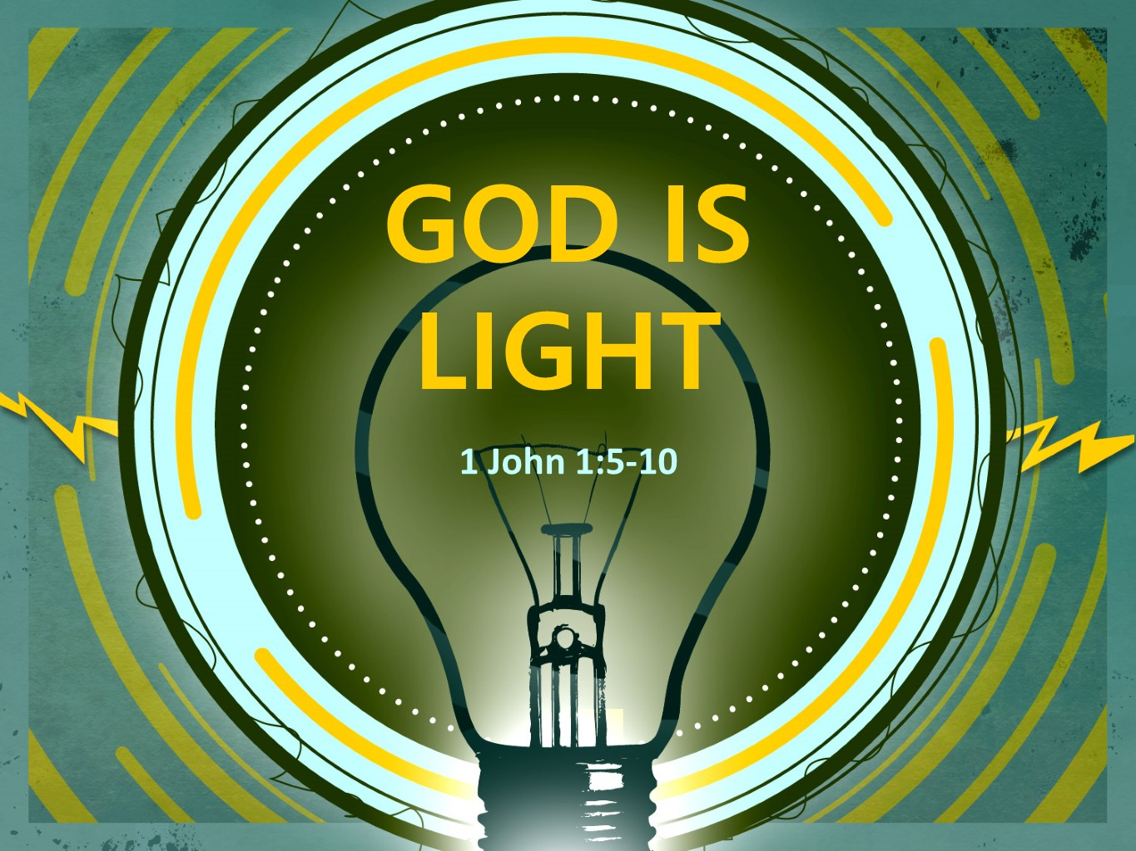
The RoaThe Road Church
1st John Sermon Series
GETTING BACK TO THE BASICS
Part 2
GOD IS LIGHT
Scripture: 1 John 1:5-10
Pastor Timothy Jones June 17, 2018
Hey, listen to all you dad’s and granddads who are here and who are listening over the internet happy Father’s Day!
Father’s Day is a special day that we get to honor our Father for doing the amazing things that often mold us into the people who we are and teach us the great things of life, like…….. how to make that farting noise with your armpit…. Or how to say your ABC’s or your name while burping. And of course how to be funny, by telling Dad jokes
Like: "I'm reading a book about anti-gravity. It's impossible to put down."
Or
"Why did the coffee go to the police? It got mugged."
Thanks Dad’s for everything!
Let’s bow our hearts together as we go to our heavenly Father in prayer.
Well last week we began a journey together through our new sermon series on the book of 1st John. I have titled this series as GETTING BACK TO THE BASICS, because that’s one of the overall themes in the book. Remember that John was one of Jesus’ best friends and was probably at this time the last living apostle. He was writing this letter as the father or grandfather figure to the second and third generation Christians.
Here is the thing that we need to remember as we go through this sermon series- we are walking the road of faith together. It so important to remember that we are not alone in our walk and that is one of the things we will see today.
Last week, the title our first sermon in this series was the Vital Signs of Life and we said that Spiritual fellowship is the vital sign of true life. It is what shows God, you and others that you are alive spiritually.
We talked about three truths of spiritual fellowship:
1st Spiritual fellowship is received by Christ being revealed to us.
2nd Spiritual fellowship is experienced through Christ.
3rd Spiritual fellowship brings joy.
Well today as we celebrate all fathers, we are also going to celebrate our heavenly Father as we discuss how our heavenly Father is the Light.
Open your Bibles or Aps with me to the New Testament book of 1st John, 1st John is located towards the back of the Bible working your way backwards you have Revelation, Jude, 3rd John 2nd John then 1st John. When you get there let me know by saying “GOD IS LIGHT”.
If you are there in 1st John chapter 1 begin reading with me from the 5th verse: It begins like this:
“Now this is the message we have heard from Him and declare to you: God is light, and there is absolutely no darkness in Him. 6 If we say, “We have fellowship with Him,” yet we walk in darkness, we are lying and are not practicing the truth. 7 But if we walk in the light as He Himself is in the light, we have fellowship with one another, and the blood of Jesus His Son cleanses us from all sin. 8 If we say, “We have no sin,” we are deceiving ourselves, and the truth is not in us. 9 If we confess our sins, He is faithful and righteous to forgive us our sins and to cleanse us from all unrighteousness. 10 If we say, “We don’t have any sin,” we make Him a liar, and His word is not in us.”
Now first of all let’s address this message that John had received. If you recall last week we discussed who John was and that John served with Jesus for 3 ½ years. He did the ministry with Jesus, He was His apprentice, Jesus was training Him. So Jesus spoke many things to John, but some of the most profound things that Jesus said to John was about who He was, that God the Father had sent Him and He told and showed John and the rest of the disciples about the nature and character of God. Look at the beginning of verse 5 with me:
“Now this is the message we have heard from Him and declare to you:
First John is telling the 2nd and 3rd Generation Christians and even us today, people who have not physically seen the resurrected Christ Jesus that Jesus had given John a message so that he would go and tell it to others.
This is an important part here because John is fulfilling what Jesus told Him before he ascended into heaven. The Bible teaches us that Jesus said to the disciples. “Go therefore and make disciples of all nations, baptizing them in the name of the Father and of the Son and of the Holy Spirit and teaching them to obey everything I have commanded you” (Matthew 28:19-20)
So, John even in His age of 80-90 years old continues to teach people the Gospel of Christ, especially now that he is probably the only disciple/ apostle alive. John begins with the authenticity of the message and he says that the message came from Christ Jesus.
Authenticity is important; have you ever watched the antique road show for example? Authenticity of an item could take it from being worth 50 dollars to 5,000 dollars to 5 million dollars. Authenticity is the state of something being authentic – authentic means it is indisputably original.
John is telling us that this is the original message given to him by Christ Jesus Himself. He is saying it came straight from Jesus.
And that message from God the Son, is that God Father is light. Our Heavenly Father is light and we are to walk in the light.
WHICH BRINGS US TO OUR BIG IDEA TODAY:
THE BIG IDEA IS: WE ARE TO WALK IN OUR HEAVENLY FATHERS SHOES.
I love watching little kids, they love to imitate Dad’s and mom’s, they want to do the things that dad’s do. They get out their little mower and mow the yard like their dad. Maybe they have a little work bench with tools so they can fix stuff like their dad. At some point all kids try to walk in their dad’s shoes. Have you ever done that before? I was just talking to our youngest daughter and shared with her when she first walked in my shoes. The truth is, children look up to their fathers and aspire to be like them weather they are good or bad, because at that point of life they don’t know the reality of sin.
But, just as kids look up to and aspire to become like their dads, we as Christians, Children of God have a responsibility to become like our heavenly Father. Essentially to walk in our Fathers shoes.
As we aspire to become more like our heavenly Father, the less we become like the sinful world we live in.
Now the Apostle John knows something about walking. As an intern in the Ministry of Jesus, they walked everywhere, from town to town. John also knows about walking in the light. Because he literally walked with the light of God each every day. The Bible tells us in John 8:12 that Jesus said “I am the light of the world whoever follows me will not walk in darkness, but will have the light of life”
Jesus also said in John 10:30 that He and the Father are one. The characteristics, the moral purity, the nature of God is the same as Christ the Son. In fact, I say if you want to know what God is like all you have to do is look at the Son.
Look back with me at second part of verse 5 “God is light, and there is absolutely no darkness in Him.”
If we are God’s Children and we are to walk in the heavenly Fathers shoes then we need to understand what the light is.
The term “God is light” has been interpreted in different ways. First, has been described as the visible manifestation of God’s glory. Second, it has been a reference to God’s self-revelation to man. Such as, Light enables us to see. Both of these are true, but through careful examination this doesn’t seem to be what John is speaking about.
What we see here are two concepts that John is trying to emphasize to his readers by declaring that God is light: to God’s Holiness and His nature or character.
Wouldn’t you agree with me based on your knowledge of God that there is not any blemish, stain, mark, or sin of the character of God? God is absolute perfect. Amen?. Think about this, even the sun with all of its brightness not only does it have spots of darkness, but also the light from the sun cast a shadow. but not God. He is absolute holiness and purity. This is supported by three things, first is the way “God is Light” is written in the Greek text, “light” in this context of the Greek text stresses character and nature. God is, by His character and nature, morally pure and holy. Second, John uses the negative statement, “in him there is no darkness at all,” this statement speaks of who God is in contrast to darkness, evil and imperfection. and then third the Bible tells us that the light of God doesn’t cast a shadow, again this speaks of God’s Character and nature of being pure and also his righteousness.
So, we know that the term “God is light” speaks about God’s Character and nature being pure, holy and righteous.
Now that we have an understanding of the statement that God is Light, let me share with you two points that John makes about walking in the shoes of our heavenly Father.
FIRST, TO WALK IN OUR HEAVENLY FATHERS SHOES WE MUST ABSTAIN FROM DARKNESS.
Look at back at verse 6 with me:
“If we say that we have fellowship with Him, yet we walk in darkness, we are lying and are not practicing the truth”
I say this all time that it doesn’t matter what or who you say you are, what matters is what you do.
You can claim to be a Christian, but we know from last week that a Christian is one who is in fellowship with God, but if your life does not reflect it, then you are lying and not practicing the truth. Literally, you are not doing the truth.
This makes me think of two illustrations. First is when James says in James 1:22 “But be doers of the word and not hearers only, deceiving yourselves.”
James point here is don't just hear God's word and go on with your life. You must do what it says. Otherwise, you are only fooling yourselves. You are thinking that you are in walking the shoes of God but you’re not.
And the second thought is this:
You can go to any Army Surplus store and get all the stuff to dress up like a soldier, but just because your dressed up like one it doesn’t make you one. It reminds me of a story on the local news a few months back about a guy who made his car look like a police car, he had lights on it ect.. and the story was he was pulling over people, he would approach them wearing clothing typical of a police officer, but he wasn’t a police officer.
The point here is you can dress the part, but if there is not a change in your life you are just pretending.
You may think you have the truth, but if you are not doing it, then John says you don’t have it. There is no such thing as a Christian who lives in habitual sin. The evidence of knowing God is a change in your life. If there is not a life change, then there is not a Christian.
Many claim the name of Christ, but do not seem to claim the life of Christ. Too often people call themselves disciples, believers, and followers of Jesus, but if you are, then your life must reflect Jesus, the truth, the light.
Now notice with me that John is questioning the conduct of our lives. He puts to question; What is the general rule of your life? Since God is light we must put aside our sinful way of living. To say that we belong to Christ, but then go out and live how we want is hypocrisy. So we must examine what the general rule of our lives looks like. Now John calls this our walk. Our walk is described in the Bible is how we physically live out what we believe spiritually. It is the idea of our behavior, conduct and lifestyle.
To walk in the darkness means ignoring or denying our sins. It is to block out the light of God’s holiness, as revealed in His Word, and to live as the world lives, making up your own ideas about right and wrong apart from God.
What John is saying to us is that we cannot walk in darkness and practice the truth at the same time.
Now we must remember that part of this letter is addressing the false teachings in the Christian communities.
Now let me say that there is a false teaching in our society today and it says that you can be a Christian and live how you want to live. You don’t have to live by the completeness of God’s Word. You can pick and choose what parts of God’s Word applies to you.
Now let me define that walking in darkness means that we are not seeking God’s will and striving to obey God’s law. It means that the decisions we make and the actions we take are intended for self-care and self-righteousness and not for God.
Remember that Gnosticism was the problem of that day and they believed their higher knowledge lifted them above sin, essentially claiming to be sinless.
And John is calling these false teachings as walking in darkness essentially living outside of the will of God and in verses 6,8 and 10 John gives a of the consequences of people walking in darkness.
- They are not in fellowship with God.
- They are not practicing the truth.
- They are deceiving themselves.
- They make out God to be a liar.
- The Word is not in them.
Folks, we must strive to abstain from walking in the darkness of the world to walk in our heavenly Fathers shoes.
You may be asking; how can I abstain from walking in darkness? And the answer is right here in verse 10, it gives us the answer: If darkness means ignoring or denying our sins then the way from abstaining from darkness is this: If we confess our sins, He is faithful and righteous to forgive us our sins and to cleanse us from all unrighteousness.
Our heavenly Father wants the best for us, that is why there is a provision for us. When we come to God and confess the unrighteousness in our lives, that sin can no longer hold is in bondage to the lifestyle of darkness. If you truly want to change the way you believe, they way that you conduct yourself in public or in private, the confessing your sins to God brings that change.
I remember that when we started going to church, my wife will testify to this. I had my problems with living two lifestyles, I lived as there was a God on Sunday morning and the rest of the 6.75 days I lived as an unbeliever. Until I couldn’t take any longer and God was moving for me to change. I had to understand that my selfishness was preventing me from being everything that God wanted me to become. Maybe you can identify with that today.
So first I had to be real with myself. I wasn’t going to change until the pain to change outweighed the pain of my sin. Then I needed to seek forgiveness for the sin. And you know what I have come to understand is this Christians are people who confess their sins to God each and every day, for me sometimes many times a day.
First, we must abstain from walking in the darkness.
SECOND, TO WALK IN OUR HEAVENLY FATHERS SHOES WE MUST BECOME THE LIGHT.
Look at verse 7 with me: But if we walk in the light as He Himself is in the light, we have fellowship with one another, and the blood of Jesus His Son cleanses us from all sin.
I love this verse because what John is telling me is that I can walk in the shoes of my heavenly Father. If I live by the attributes of God, I CANNOT become God, but I can be like Him in His character and nature. Christians are God’s children, and therefore we are partakers of His nature.
Look down at chapter 2 verse 6 with me:
“the one who says he remains in Him should walk just as He walked”
And listen to what 1st Peter 1:15-16 tells us:
“But as the One who called you is holy, you also are to be holy in all your conduct; 16 for it is written, Be holy, because I am holy”
Walk as God the Father walks, be holy in your conduct as God is holy-
These verses don’t imply that the person walking in the light will never sin, instead John teaches us that when we walk in the light, the blood of Jesus cleanses us from all sin. Saying that the blood of Jesus cleanses us from all sin proves that those who walk in the light are not living perfect lives. Or else there would be no sins for the blood of Christ to cleanse. God has made the provision to cleanse those who walk in the light through the once and for all sacrifice of Jesus Christ.
And here is the tough thing to understand; becoming the light of the world is a transformation from the darkness of the world.
Think about is: The disciples of Jesus were common men, men who needed a savior, they came from different backgrounds, different beliefs, different cultures and different circumstances in life. Yet Jesus took them and changed the world with them. They were all sinners saved by the very grace of God and if you read about their interaction with Jesus, often Jesus rebuked them for things that they either said or done.
They were rebuked in the storm when they had little faith.
How often in circumstances in life have acted in little faith?
Jesus rebuked Peter several times, At one point Jesus told Him get behind me Satan… OUCH… that had to hurt….
How many times in your life have you said or did something at the church level to stop the advancement of the Kingdom of God?
He rebuked the disciples when they got into an argument over which one was greater. How often have you had an argument of something did not bring God the honor and glory?
But that did not deter Jesus from making them the Apostles and staying true to the promises of God.
Turn your Bibles with me over to Matthew chapter 5. In the this 5th chapter is the beginning of the incredible Sermon on the Mount taught by Jesus to His disciples. Of course many people know the be-attitudes which begins the Sermon on the Mount. But in the 14th verse Jesus said something that was striking to even us today.
Verse 14 He said: “You are the light of the world. A city situated on a hill cannot be hidden. 15 No one lights a lamp and puts it under a basket, but rather on a lampstand, and it gives light for all who are in the house. 16 In the same way, let your light shine before men, so that they may see your good works and give glory to your Father in heaven.”
Remember that Jesus told the disciples in John 8:12 that He was the Light of the World and that Anyone who follows Him would not walk in darkness but will have the light of the world. And here Jesus is telling them they are the light of the World-
I read once that; We are the means to displaying God’s light in this world- if we don’t display Him, He won’t be seen. How true is that? Maybe you have heard before that you might be the only Bible a person ever sees.
Jesus tells the disciples of a day to come when they would be the very light that He is. Then what they say and what they do matters for the Kingdom of God’s growth. The truth here is that what you believe in your life is often displayed in the way you walk, in the conduct of your life.
This is God’s plan that we become the light of the World. But not our own lights but we are the reflection of the Light of God.
Here are the benefits of walking in the Light of God.
- We are in fellowship with God.
- We have fellowship with other brothers and sisters. And here is what you need to know about our fellowship with one another- we are walking the road of faith together. We are a family Just like the disciples from different walks of life, cultures, backgrounds and circumstances of life called to turn this world upside down.
- The Blood of Jesus cleanses us from all sin
In the midst of being human we will end up sinning, sometimes against one another, but through the blood of Jesus we will find forgiveness.
TO WALK IN OUR HEAVENLY FATHERS SHOES WE MUST ABSTAIN FROM DARKNESS AND WE MUST BECOME THE LIGHT.
Johns point here is that people are one of the two either one walks in the light with God and loves fellow believers or one walks with darkness and stumbles around blind.
Let me pose this question to your heart today:
What has your walk been like recently, in the last week, month or even year? Have you been walking in the darkness of this world? Have you been tearing people down rather than building them up? Are you living a Christ like life?
Is your light shining for the world to see?
This Invitation for each of you this morning: its time to get back to the basics of shinning the light of GOD in this world.
Invitation:

