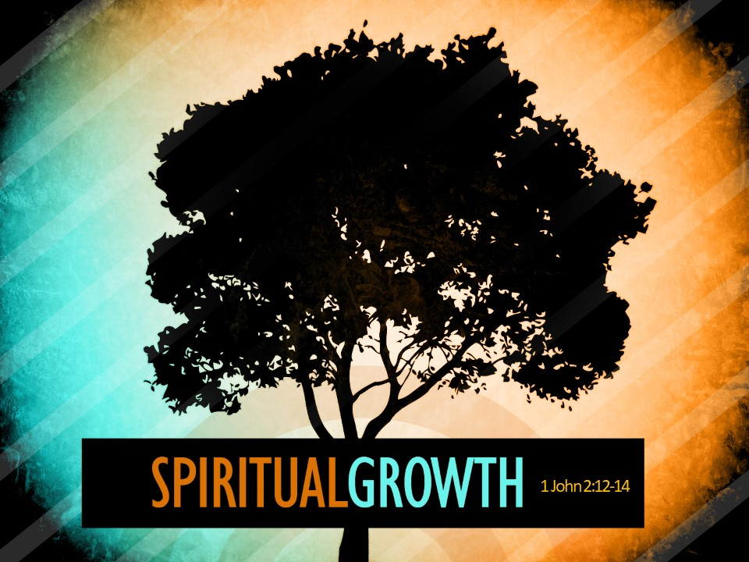
The Road Church
1st John Sermon Series
GETTING BACK TO THE BASICS
Part 5
SPIRTUAL GROWTH
Scripture: 1 John 2:12-17
Pastor Timothy Jones July 9, 2018
Good Morning and praise the Lord!
Well we are back in the teaching series from the book of 1st John called “Back to the Basics”. You know there are times in our lives that we simply need be reminded of not only who we are in Christ but also what our mission as disciples is all about.
Sometimes my phone gives me a message that it time to shut it down and restart it so that it can get back to the settings that its supposed to have. In this letter that the Apostle John is calling the Christian community to reboot. To get back to the basics of being disciples of Jesus. Wouldn’t you agree with me that Life sometimes is unpredictable and because of that we can lose our focus on what is important?
It kind of like going to the grocery store, you are only there to pick up one item, but many times we loose focus because of all the things that are around us and we end up getting home with two bags of groceries and we didn’t get what we went there to begin with. Amen?
Do you know what I mean? There is a lot of things in life that are designed to catch our attention and causes us to lose focus on what is important. There are a lot of things that are in the world that prevent us from being or doing what we are called to. This is what John is addressing- there are things that are not of God that are causing the Christian community to lose focus of not only who they are as Disciples of Christ, but also the mission that they are on. So, John writes this letter combating the heresy which is happening in the Biblical times. Heresy by the by definition is an act or opinion that is contrary to the teachings/ belief of God.
Here is what we know – There was a group called Gnostics- and they were against many of the teachings of the Disciples. Gnostics claim to possess a higher knowledge, not from the Bible, but acquired on some higher plane of existence. Gnostics also believed that physical matter was evil and that the spirit was good. Therefore, asserting that Jesus’ physical body was not real and it was a spirit. They were false teachers, who were swaying the people away from the true belief that Jesus came for all people-
A couple weeks ago John reminded us that the consequence of sin for the unbeliever is death – as Disciples we have been pardoned of that death sentence and the proof of that is our new life.
Then last week we discovered that love is at the core of our faith. Although love is an Old Command it was made new as Jesus showed us by example how great God’s Love is for us because HE is Love and that love is at the heart of true Christians. Jesus said that Love would be the one thing that would separate His disciples from the world.
Well that brings us to this week and the title for this week’s teaching is Spriritual Growth
Say that with me: “Victory in Jesus”
Let’s pray-
Bow your head and hearts with me:
Pray for the one person who needs the specific message of Salvation.
Pray that God will lay upon each person His divine message.
Pray that He will use you to bring Him Honor and Glory. Amen.
Let’s open our Bibles or your Aps to the New Testament book of 1st John, 1 John chapter 2.
Remember that 1st John is the 5th book from the back of the Bible. Revelation, Jude, 3rd John, 2nd John then you will find 1st John.
When you get 1st John 2 let me know by saying Amen.
Now I want you to know before we get into the scripture that John doesn’t pause on teaching what the basics Discipleship looks like. So we are diving right in:
Right, lets begin reading from verse 12
I am writing to you, little children,
because your sins have been forgiven
because of Jesus’ name.
13 I am writing to you, fathers,
because you have come to know
the One who is from the beginning.
I am writing to you, young men,
because you have had victory over the evil one.
14 I have written to you, children,
because you have come to know the Father.
I have written to you, fathers,
because you have come to know
the One who is from the beginning.
I have written to you, young men,
because you are strong,
God’s word remains in you,
and you have had victory over the evil one.
This is a very interesting part of the letter that John writes as he is encouraging all the believers who read this letter to grow. On the surface we see that John is dividing up the people into categories. His use of the terms, little children, young men, and fathers, he is not talking about chronological stages of life, but rather the spiritual stages of life. In other words, he is talking about three very specific stages of our spiritual growth and maturity.
WHICH brings us to our Big Idea today:
Our Big Idea is:
Spiritual Maturity is a process of growth.
Now, as believers in Christ when you think about your spiritual life, you need to think about growth. And really that shouldn’t surprise us because when you think about life itself its all about growth. If you plant a seed in the ground it grows to the full-size plant. That the nature of life. If you get a puppy it grows to be a bigger dog. If you have a baby it grows to be an adult and that is the way life works. It’s all about growth.
Where there is life there is growth and vice-a-versa where there is growth – there is life.
So, it makes since that if we are alive spiritually we should not be stagnated in our faith but we are to be growing or maturing.
Now I know that you may not think about Spiritual Growth in your life on day to day level. However, throughout the Bible it speaks about our Spiritual Maturity and Growth.
1 Peter says: As New born Babies, “desire the sincere milk of the word, that we may grow”
Ephesians 4:13 This will continue until we all come to such unity in our faith and knowledge of God's Son that we will be mature in the Lord, measuring up to the full and complete standard of Christ.
When I look back at my life and I think about my growth and what it took for God to grow me to get right here today. It was a process. I gave my life to Christ one day and I became a Christian. At some point I heard my pastor preaching a sermon and he was a fantastic preacher. A little voice in my head said “I CAN DO THAT”
When I began at our first church, I began working the sound booth, then a trustee, then I became a third grade Sunday School Teacher, We became foster parents along the way, I then moved up to becoming an Adult Sunday School Teacher, a Deacon, then I led Wednesday night services, then I began preaching at a Biker Bar to many of the homeless, my wife and I were involved in a lot of ministries. I finally became the Head Trustee our church. I was an evangelist preaching in other churches then eventually God called me to become a pastor.
But here is the thing, we are not supposed to stop growing spiritually. I know that most people who go to church today are not growing spiritually. I know that because although spiritual growth is spiritual, it is evident in a person’s life. You can see it take place. Even in my life today, I feel God has called me to help other pastors, to be a coach to some and to continue to reach out and teach and preach the Gospel to the world. God wants you to continue to grow and learn so that you can do what He is calling you to do.
Spiritual Growth is not dependent to anything else except your obedience to God. Then just like your growth as a human being, your spiritual growth is a process. It is a process of taking in the truth of God and growing on the basis of believing and responding to that truth in your life. To put it simply, you cannot grow spiritually unless you grow in your understanding of God's truth. As Christians, as Disciples of Christ it is part of our DNA to grow and to mature.
Let me first say that Spiritual Maturity does not have anything to do with age nor with how many years you have been coming to church.
Spiritual Maturity is about becoming more like Christ Jesus, not just in the church, but how we live, speak, act, how we conduct our lives.
4 years ago as I was brought onto be the pastor here, I wondered what I would teach, because most of the folks here were older adults. I asked what could I teach that they had not already heard? Then one day a lady came to me and said that she was mad at herself because she realized through me preaching that she did not know anything. Amazing a woman who had brought her children here and had been a long-time member was still a baby in faith. Here is the truth about this- we are all at different stages of maturity and growth. John realized the same thing therefore he teaches about three stages of spiritual growth-
So I want to talk to you today about the Stages of Spiritual Growth. Listen we have victory in Jesus but we need to be growing in Christ.
The first stage of Spiritual Growth is the Child Stage- some call this the infant stage.
Take a Look at verses 12 and 14 with me- Notice that John says about this stage “I am writing to you, little children, because your sins have been forgiven on account of His name…
V14- I have written to you, children, because you have come to know the Father.” 1 John 2:12, 14a (HCSB)
The first thing we must take note of is that John uses two different words translated from the original GREEK TEXT for children in both these verses. The words little children translated in verse 12 is the word that is commonly used in the New Testament to describe Christians in general as the children of God. He uses this same term at the beginning of Chapter 2 and through this book.
John is saying at the root of anyone who is a child of God is that our sins have been forgiven. That is exactly what happens when a person comes to faith in Jesus Christ. Their sins are forgiven. And John adds an important phrase: “because of Jesus name” making it very clear that the only way to become a child of God is to receive the pardon for sin that only Christ can give. Now listen this is the victory for all Christians.
First he is speaking to all the believers.
But then in verse fourteen John uses a word which translates simply to children. While the word in verse 12 refers to all the children of God, this word is specifically directed to young children who are still under the instruction, care, and guidance of their parents. And John says of them “that they have come to know the Father.”
There are many verses that speak of the New Christians as a New born infants. Like 2 Peter 2:2 where Peter says: “Like newborn babies, you must crave pure spiritual milk so that you will grow into a full experience of salvation.” (NLT).
One pastor said: “when a newborn baby comes into the world and joins the family, it doesn’t know much and can’t do much. But as the baby learns to recognize the faces of this new family it begins to call out to them. And although I know it must frustrate a mother it seems for most babies the first words out of his mouth are DaDa.
In fact, this is exactly what the apostle Paul was talking about in the eighth chapter of Romans. He said that we “you received the Spirit of adoption, by whom we cry out, "Abba, Father!" (Romans 8:15) The word, Abba, is the Hebrew word for DaDa.”
So as a result of our forgiveness of sin through faith in Jesus Christ, we become a child of God.
Now just like a Child or a newborn infant, when a person is born into the family of God they don’t understand all there is to know about their new life. Most new Christians can’t give a theological explanation for what has happened to them, much less know the difference between Jesus being their Savior and Him being their Lord. They know that their sins is forgiven and they have a new life.
There are certain milestones for children’s growth for example when they learn to feed themselves, or drink out of a cup, or going potty on the pot, even tying their own shoes, riding a bike, going to school. Just like children, Spiritual children have milestones – learning to feed themselves through the reading of the Word and prayer. Learning how to dress themselves in the Armor of God.
The First stage is when a person comes to know Christ and they are learning what it means to be a Disciple.
You see infants or young children are not intended to stay like that forever. So John speaks of the second stage of Spiritual growth:
The second stage of the spiritual growth is youth stage.
Again, let me say that spiritual growth is not measured by your age in life.
Therefore, you can have one person who is 60 that just comes to know the Lord and is a new born in the faith, just as you can have some one who is 35 be a youth in the faith.
John describes this stage of spiritual growth in the latter parts of verses thirteen and fourteen: look there with me “I am writing to you, young men, because you have had victory over the evil one…I have written to you, young men, because you are strong, God’s word remains in you, and you have had victory over the evil one.”
Notice with how John identifies the growth that occurs, he sees young people as Christians who are no longer babes in the Lord but are strong and have overcome the evil one because the Word of God remains in them. These are disciples who are no longer ignorant of the Word of God and have grown in their knowledge and practice of the Word.
They have outgrown much of their spiritual childishness and immaturity. They have moved beyond the elementary struggles of a new life in Christ and have adopted a biblical worldview. They have developed a mature love for the truth and sharing that truth with others. This is a stage of intense spiritual growth and maturing. And because of their growth, they have won significant spiritual victories in their lives. It is a place where they can look back and see where they were and the significant change to where they are.
It is important to note that God’s Word is perfectly designed for spiritual growth. In fact, it is impossible to grow up and mature as a Christian unless the Word of God remains in you.
Ephesians 4:14-15 is a great illustration of this maturity that takes place:
14 Then we will no longer be little children, tossed by the waves and blown around by every wind of teaching, by human cunning with cleverness in the techniques of deceit. 15 But speaking the truth in love, let us grow in every way into Him who is the head—Christ.
This is why the devil fights us so hard in the matter of change from the child to the strong young adult. The child can be swayed easily by false teaching, cunningness and deceit if they are not grounded with someone who can teach them. But a youth in the faith is strong. Twice in these verses John speaks of young men who are grounded and rooted in the Word of God having victory over the evil one. There is a certain stage of spiritual growth and maturity that can only be achieved when we become people that are grounded and rooted in the Word of God. That’s why John said in verse fourteen: “I have written to you, young men, because you are strong, God’s Word remains in you, and you have had victory over the evil one.” (v14)
Listen folks, The Christian life will always be a bloody spiritual battle ground. We must remember that there will always be an enemy who is trying to defeat you. The Devil will do everything he can to prevent you from becoming everything that God has planned for you. As we grow spiritually from being a child to a youth we begin to see the plan God has for us. But remember that in the battle the blood of Christ has already claimed victory.
The first stage of SPritual growth is the Child stage
2nd Stage Youth
The thrid stage of the spiritual growth is The Adult Stage.
John uses the term fathers to refer to this stage of maturity. This stage represents a lifetime commitment of a persons relationship with Christ Jesus.
Our oldest son, Jake tells me all the time that he doesn’t like being an adult, because adults have to make decisions that affect a lot of people around them. Those are called adult decisions. When our daughter calls me and she makes a decision she sends me a text that says #adultlife.
When you are in this stage of maturity, you are following God at all cost and the decisions that you make in life are not yours but rather God’s. There is something about a mature Christians walk with the Lord that comes by many years of trusting Him.
Look back with me to verses 13-14 he says the same thing twice in verses thirteen and fourteen: “I am writing to you, fathers, because you have come to know the One who is from the beginning…I have written to you, fathers, because you have come to know the One who is from the beginning.”
Notice with me that phrase he uses twice “you have come to know the One who is from the beginning.”
You have come to know- is a phrase that immediately recognizes the obvious relational value.
This refers to a deeper understand of not just the saved relationship that we have with Christ, Not just the intellectual knowledge of scripture and how to fight evil, but this stage is truly characterized by the intimate experience and the one on one relationship with Christ. This is a stage of spiritual maturity where a person moves beyond simply defending their knowledge of truth to pursuing that intimate and deep relationship with the God from whom all truth comes.
I think simply stated the Adult Stage is a more mature disciple of Christ, still in the family, still a child of God, a person who have fought and won battles through Christ, and who lives the lifestyle of Christ first and foremost.
Folks those are three stages of growth that bring spiritual maturity.
Where do you see yourself in these stages?
I don’t believe that there is no time frame for any of the stages to move from one to another- As I stated earlier of the lady who was mad because she said she didn’t know anything – she was a baby in Christ and had been coming for to church for 30 years. I also believe that you can go back and forth between them. You might be asking the question; How can I grow as a Disciple Of Christ? -or - How do I get from one stage to the next?
So here are three ways to foster Spiritual growth in your life.
- Have a desire to grow. Everything begins with you.
I am convinced that your relationship with God is exactly where it is because it is where you are comfortable. Most of us don’t want to come out of our comfort zone with God. We are afraid it. We are afraid of what people will think of us.
I know this for a fact- When God called me to walk around with a sign that said no more bars in STL at the cardinal’s stadium. I was afraid of what people would say- but God was moving me out of my comfort zone. 7 months later there was an incredible victory. I was riding my motorcycle the other day just praising God, and I remembered Psalm 37 verse 4 “Delight yourself in the Lord and He will give you the desires of your heart”
You must have a deep desire to grow. After you have a desire to grow-
- Give yourself nourishment daily;
We have a garden at the house, and my wife is out there tending to it, she has been concerned because of the heat. But each day she is out there taking care of it. She waters the plants, she is putting mulch around the plants so they retain moisture and the garden is doing very well. In-fact it is beginning to yield fruit. But it would all be dead if she wasn’t out there every day giving it nourishment.
Our Spiritual life is the same way. It needs to be tended to each and every day, coming to church Just on Sunday won’t get you there.
In Matthew chapter 6 Jesus was teaching the disciples to pray and we get to verse 11 “GIVE US THIS DAY OUR DAILY BREAD”
Feed us each day so that we can learn and become more like you.
Here are some ways to feed yourself each day-
Come to church when its open.. Sunday Nights and Wednesday nights.
Read your Bible each day
Pray throughout the day
Read devotionals- my website gotothetruth.org has great devotionals.
Join a Sunday School class or Bible study. Be part of the ministry.
- Have a desire to grow
- Nourish yourself daily
- Spend time with other believers who are growing or have a desire to grow.
Nothing will stunt your growth more than other people who don’t want you to grow. Our defense Menckenism is we don’t want people to grow beyond where are personally. It is not that they want to keep you down, it is just our natural tendencies. God wants you to grow past those who are holding you back.
Proverbs 27:17 Iron Sharpens Iron-
Spend time with others who are growing or have a desire to grow, helps you grow.
I am going to offer a class on _____ beginning there is cost involved of the book and registration.
The THREE STAGE OF SPIRITUAL GROWTH – Child, youth and adult.
Invitation…

