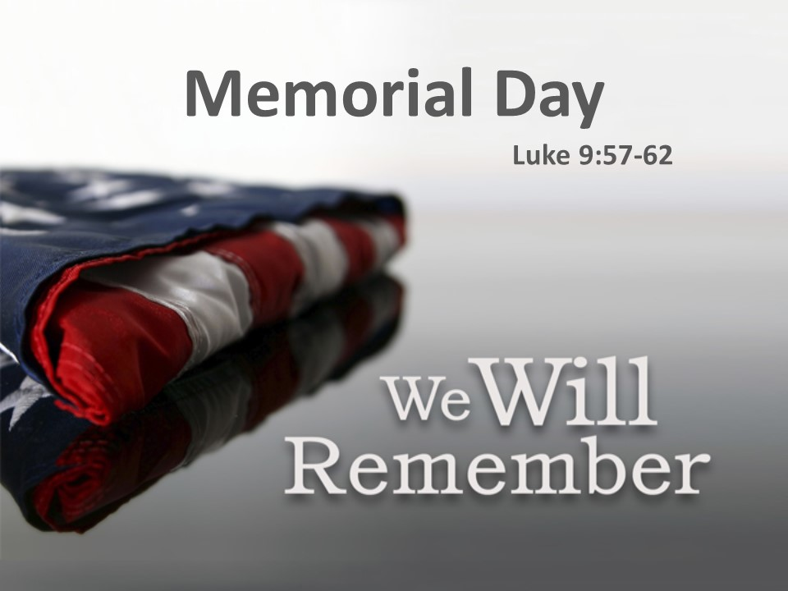

The Cost of Freedom
Luke 9:51-62
Amen, Amen and Amen
Let us pray:
This weekend our nation pauses to celebrate Memorial Day. We will remember the brave men and women who paid the ultimate cost to protect the freedoms that comes with being the United States of America. The freedom to express our ideas, our hopes, our dreams- the freedom to worship as we choose, the freedom to assemble together to pray.
It is a time to remember the greatness of God and the men and women who died for our freedom. Our freedom would be impossible without the sacrifices of those men and women throughout our history.
Memorial Day- dates back to after the civil war when Gen John A. Logan head of the Grand Army of the Republic, an organization of Union Veterans, established a day to decorate the graves of the war dead. As a weary nation began to heal itself after the Civil War, Major General Logan’s call to remember the fallen rang in the hearts of many; He said:
“We should guard their graves with sacred vigilance. Let no neglect, no ravages of time, testify to the present or to the coming generations that we have forgotten as a people the cost of a free and undivided republic”
As many of you know the Church has been the backbone of our Nation from the very beginning of its formation. Our forefathers drafted the Declaration of Independence; they used the very WORD of God to set us free from the rule of England. Throughout the years many great things have happened in this country- we have won wars- we have sent people into space- if you look back through history, we have really done the impossible. America has been a country of freedom and the place where others can seek the impossible. Memorial Day is the picture of freedom in America.
The fact is we live in a nation by which we are free to meet here today, because of the sacrifice of first Jesus Christ and then those men and women who came after Jesus who selflessly gave of themselves for Christ- Christianity- freedom- freedom of this country and freedom of religion.
Today we must pause to consider what Memorial Day represents; its very name calls us to remember. To be red, white and blue is to remember our fallen heroes, to remember the lives that have been lost to not only set us into religious freedom, but to keep us in religious freedom. For those who fought for God and country. We are to honor those who have been lost- To honor those who have died in battle and out of battle.
Memorial Day calls us to remember that freedom is not free- especially our religious freedom!
Which brings us to our Big Idea today:
Our Big Idea is: Freedom comes at a cost: X2
The Cost of Freedom is death-
Death of Savior to free us from sin.
Death of a Soldier to keep us free-
And Death to ourselves to be free.
And that is what we see in our scripture today.
As Jesus begins to make His way back to Jerusalem for the last time towards the crucifixion, He and His disciples were hundreds of miles from Jerusalem at this point and in these verses, Jesus makes a point to explain to the disciples and others following that There is a cost to following Jesus.
If you are there in Luke chapter 9 we are going to begin reading at verse 51. And it begins like this:
“When the days were coming to a close for Him to be taken up, He determined to journey to Jerusalem.52 He sent messengers ahead of Him, and on the way they entered a village of the Samaritans to make preparations for Him. 53 But they did not welcome Him, because He determined to journey to Jerusalem.54 When the disciples James and John saw this, they said, “Lord, do You want us to call down fire from heaven to consume them?”55 But He turned and rebuked them 56 and they went to another village.”
Let’s pause here for a moment; I want you to know that there is no stopping the Mission of Jesus. As the Samaritan village refused Jesus, Jesus reminded them of who the Son of Man was and that He came to save, not to reject- not too destroy. And in this country of freedom that should give us so much hope.
Verse 57 “As they were traveling on the road someone said to Him, “I will follow You wherever You go!”
58 Jesus told him, “Foxes have dens, and birds of the sky have nests, but the Son of Man has no place to lay His head.” 59 Then He said to another, “Follow Me.”
“Lord,” he said, “first let me go bury my father.”
60 But He told him, “Let the dead bury their own dead, but you go and spread the news of the kingdom of God.”
61 Another also said, “I will follow You, Lord, but first let me go and say good-bye to those at my house.”
62 But Jesus said to him, “No one who puts his hand to the plow and looks back is fit for the kingdom of God.”
Luke tells us of this story because He wants us to understand that there is a cost for freedom-a cost to following Jesus, a cost to becoming laborer for Christ. Notice First that in this scripture that the key word is “follow” in the Greek text this word is defines follow as: following someone who takes the lead in determining direction. Verse 51 Jesus was determined to go to Jerusalem in the KJV it says that He set His face towards Jerusalem. Three times follow is used, for these three men. The very essence of being a disciple of Jesus is to follow Him- going where He goes, - listening to what He is saying and walking in step with Him. But it also implies doing what He tells you and going where He tells you to go. Here we find are three men who were proclaiming Christ, probably because Jesus was popular at the time, yet they were only willing to follow Christ on their own terms.
We see that too often, don’t we? It’s like this man who told me the reason he doesn’t come to church is because he works a full work week and Sundays are his only days to sleep in, so he can’t possibly come to church because he is resting.
But notice Jesus’ answer to the three men was there was and always will be a cost involved in following Him. Jesus is saying; if you want to follow me then there is a cost.
Do you realize that if you follow Christ there will be a cost for that freedom? You can’t do the things you did before in the sin- your friends become different – your priorities become different. Its called repentance which means to turn around, to do an about-face setting you on a new direction. Following the One who sets our direction.
In fact, Jesus tells us in Verse 23 that “if anyone wants to come with Me, he must deny himself, take up his cross daily and follow me” (9:23) that is the cost of being a disciple.
If you look back in history from the very beginning of sin- the beginning of America and to where we are today there has always been a cost involved in becoming free. That is the history of Freedom.
When Moses was led by God to free Israel from the bondage of Egypt. Moses left without his family- a cost- the people had to endure suffering before Pharaoh would let the people go- there was a cost. God had to send plagues on the people and animals it affected everyone-a cost- then they were set free from Egypt. Because of their disobedience they spent years after years wondering in the desert-- there was a cost to become free.
In our scripture we find that Jesus outlines for us, He teaches us three truths about the cost of freedom.
The first truth of the cost of freedom is that Freedom requires a sacrifice.
Look back in verse 57 - “I will follow you wherever you go.” 58 Jesus told him, “Foxes have dens, and birds of the sky have nests, but the Son of Man has no place to lay His head.
In the book of Matthew this man is called a scribe, a scribe is an expert in the Law of Moses, the first five books of the Old Testament. This man knew all too well what it took to follow God, he was an expert and well-versed with Moses leading Israel out of the bondage of Egypt towards the Promised Land. So He tells Jesus “I will follow you wherever you go.”
It is in Jesus’ response that we find He wanted this man, this scribe, this expert in the law of Moses to know that following God today would be just as hard as following Him in the Old Testament. During His ministry he would be traveling great distances and often relying on others for food and shelter- and sometimes people will reject Him just like the Sarmatians did in verse 53. You see the ministry would not be easy- Jesus’ ministry would take him to the lowest of places, to the lowest of people- to the sickest of people -Following Christ would not be that easy. It would require sacrifices.
You know the Men and women in the Armed Forces know what sacrifice means. They prepare for one thing and the one thing is for battle, not just fight, but to win- they train, they work, they get tested, they are away from their families, in harsh conditions at times. What for? It is for sacrifice, they are prepared to give their lives for the cost of Freedom.
What does sacrifice mean to you today?
Does it mean your time, money, giving yourself? Does it mean your life?
The ultimate sacrifice-Jesus said that the ultimate sacrifice is this in John chapter 15 verse 13- “No one has greater love than this, that someone would lay down his life for his friends”. Then Jesus turns right around and calls us His friends.
God showed us the ultimate sacrifice As God sent His Son, Christ Jesus to be incarnated. Meaning that He became a breathing, growing, bleeding human being just like you and me. He did that so we could relate to Him. You see, sin blocks the relationship between us and God so he sent a redeemer, (A kinsmen redeemer) on our behalf. The only one who could accept the sin of the world, The Bible tells us in 2nd Corinthians Chapter 5 that “For our sake He made Him to be sin who knew no sin so that in Him we might become the righteousness of God”. Christ Jesus came to accept the sin so we can have the relationship with God that we were created for.
In-turn The Bible tells us as we accept Christ as Lord of our life, our old life is sacrificed. We are told when we accept Jesus Christ, 2 Corinthians 5:17 “if anyone is in Christ, he is a new creation; old things have passed away; and look, new things have come.”
But most of our Christian life we battle against the old life. What God is tells us is that we have to separate ourselves from that old life, so that we can receive the new life that God has for us. That is called sacrifice.
When you truly accept Jesus as Lord to reign in your heart and life- you have sacrificed your old way of life.
The simple truth is If we still have some friends that are keeping us in sin, if we continue to do the same old things that keep us in sin, keeping us in the bondage of sin, then the cost of freedom is to get rid of them, get rid of the chains and get rid of friends who help us sin. Hebrews 12:1 tells us “let us lay aside every weight and the sin that so easily ensnares us”
If our old lifestyle- or old habits are holding us back if they are keeping us in sin- from being what God wants us to be, then we must cast it aside- get rid of it and begin anew.
You have heard me say this- “your friends cannot get you to heaven, but they surely can take you to hell with them.”
Listen to Jesus the cost of freedom requires sacrifice.
Second, we find that the cost of freedom requires the right priorities.
In this second example we find that Jesus is the one who offers the invitation to follow Him and in verses 59-60 Jesus says to another “FOLLOW ME” This second man replies to Jesus and said “Lord” he said, “first let me go bury my father,” 60 But He told him, “Let the dead bury their own dead, but you go and spread the news of the kingdom of God.”
The second man asked Jesus; let me bury my father First? At first glance you would think that this man’s father has died- but the truth of the scripture is revealed that the man’s father wasn’t dead, if he was dead, he would have already been pre-occupied with the burial. I read recently that during Jesus’ days the burial ritual of a loved one took at least a year. But this man wanted to wait to follow Jesus until after his father was dead, which could have been years.
His priorities were set on the earthy priorities- he would have rather sit around and wait for his father’s death than to go out into the world proclaiming kingdom of God- How many times have we sat and waited for the perfect time to do something? And we find that we never do it, why? Because it is never the perfect time to do anything.
Jesus’ point was that we can have many excuses that hold us back- but Jesus wants us all to know that to be followers of Christ we must put Him first.
Matthew 6:33 says “But seek first the kingdom of God and his righteousness, and all these things will be provided for you”.
Putting Christ first, is making choices of the right Priorities in life.
For the Military; training is the priority, training is geared to train and prepare soldiers, leaders and units to fight and win in combat. They are continually trained and tested on these tasks. So when called upon they can use them without thinking.
And What Jesus is telling us: to follow him our priorities must be in the right order.
These priorities keep us in a close relationship with Christ, God the Father and God the Holy Spirit and fellow believers. they also keep us focused on the mission of the church, honoring God and proclaiming the Kingdom of God!
What are our priorities?
Here are three biblical priorities for Every Christian.
Prayer- we must be honestly seeking God through our prayer life- personally and corporately- as a group of believers.
Jesus set the example for prayer.
We need to be reminded that in The New Testament records at least fifteen times when Jesus prayed. The book of Luke records eleven of them. Jesus had an open line of communication with the Father. Jesus prayed to glorify God and that is our example to follow.
God’s word makes it clear. In addition to the words of Jesus, the unmistakable expectation of God in the Scripture is that we pray “Devote yourselves to prayer” (Colossians 4:2) and “pray continually” (1 Thessalonians 5:17) are commands to pray. We are devoted to many things in our lives, making them a priority, but God commands us to be devoted to, and to make prayer a priority.
The 2nd priority is Reading and studying the WORD OF GOD
1st Timothy 3:14 says “give your attention to public reading, exhortation, and teaching”.
Psalm 119:11 says “I have treasured your word in my heart, that I might not sin against you.”
Then the third priority is Submission
Of all the Spiritual disciplines or priorities that should be in our lives I believe that submission is the one that is most abused. Christians have a difficult time giving God their whole lives. The purpose of this discipline is freedom, not slavery. When you think of submission you think of chains, being locked up, giving away your rights, you think about slavery, but when it comes to Jesus it is just the opposite. When we are of Christ, we are free, but when it comes to sin, we are slaves to it.
You see that is the enemy’s deception in the world, people believe they are free to do all the stuff they do- but the reality is that they are in the bondage of sin and the only way to freedom is through the Cross and Jesus crucified and risen. I find that most of all Christians do not give themselves as a whole to God. Because we can’t shake the optimism that submission brings- we cannot comprehend how our submission brings freedom.
American Freedom is the terrible burden of always needing to get our own way. Everyone has the obsession of wanting to get our way with things. And yet in reality we normally don’t. People spend years at trying to get all the things that they want and in one storm, fire, earthquake, it is all gone, and what are we left with? All of our material possessions are gone in an instant. Have seen videos surfaced of the aftermath of tornadoes, hurricanes - everything people have worked for gone in a matter of minutes.
Devastation has no economic impact; it wipes out everyone and everything.
The one thing that matters the most is life: who are we submitting to?
We always have a choice of who we follow. Just after Peter’s confession of Christ, Jesus begins to teach the crowd about His upcoming death. Jesus gives the statement “If anyone wants to be MY follower, he must deny himself take up the cross and follow me” (Mark 8:34). Jesus used the image of carrying a cross- the very thing that HE would die on- to illustrate the ultimate submission required of His followers. He was talking about the heroic effort needed to follow Him moment by moment, in every part of our lives, to do His will even when the work is the most difficult and the future looks undetermined.
In today’s world, Christian church membership declining and churches closing their doors, same-sex marriages and other societal issues we must be clear just who we are following and submitting to.
When it comes to submission if we don’t submit our whole lives to God and follow Him we will never have the freedom of what becoming a Christian is all about.
When these three priorities, Prayer, Study and Submission to the Lord are in place- you will find that you cannot help but to proclaim the Kingdom of God through the life you live.
Following Jesus comes at a cost.
First it requires sacrifice
Second it requires the right priorities
And Third, The Cost of freedom requires the right focus.
This third man, jumped at the chance to be next to follow Jesus and said in verse 61 “I will follow You, Lord, but first let me go and say good-bye to those at my house.”
62 But Jesus said to him, “No one who puts his hand to the plow and looks back is fit for the kingdom of God.”
You know many people today are willing to jump into commitments without thinking about or caring about the cost that comes later. Have you ever jumped into a situation and only to think later, that is was a dumb move? I bet this third guy thought his excuse was better than the others- so he quickly jumps in. After all he just wants to party one more time, to have a barbeque before he leaves, to have a family reunion before he goes.
However, Jesus, lets this third would be follower know that if you’re going to commit to God, that is what your focus needs to be.
A lot of people fit in right here, because this man wanted to go back to his family and to tell them farewell- Jesus’ point: if you are hooked up to a horse pulled plow, and you are plowing your field- you must keep your eyes forward, because if you looked back, you would cause that plow to veer of course.
The lesson if we want to be follower of Him- we should never look back. We should never veer of course.
If we are focused on what we are leaving behind we can never look forward to be a disciple of Jesus. Everyone will have a certain lifestyle, certain friends- stuff- junk- that they we all need to leave behind.
When a soldier is preparing to leave for war- they don’t get to take all their belongings with. When I would get deployed in places all we had is what we could carry. Some of the most cherished things will be left behind. There are men and women who have died not in the comforts of their home nor a hospital, but they have paid the ultimate sacrifice on the BATTLE FIELD. They did not have the most cherished people or things with them. You see at that moment they have given themselves unconditionally to what they believed in, Hopefully Christ Jesus and then to the defense of the constitution of the United States of America.
Jesus’ point to this third Man is that truly following Him means giving oneself unconditionally to Christ.
The apostle Paul writes to the Philippians in 3:13-14
“Brothers, I do not consider myself to have taken hold of it. But one thing I do: Forgetting what is behind and reaching forward to what is ahead, 14 I pursue as my goal the prize promised by God’s heavenly call in Christ Jesus.”.
You know, the interesting fact is when it comes to following Jesus it seems most everyone, well they think that they can follow Jesus on their own terms.
The challenge for us today is to stay focused and to be committed and to follow Jesus on His terms, because this Freedom comes to us at a cost.
Jesus says if you follow me I will take you to places you have never been- I you will take into the wilderness and you will go into the nest of sin and destruction. At times you have leave behind the spiritually dead- and you will have let the dead bury the dead, and if you look back and want it more than me, then you will not be fit for the kingdom of God. Jesus is saying you must seek first the kingdom of God- Jesus died on the Cross to set us free, so that we would have freedom to become His disciples.
Men and women in our Armed forces and civilian counterparts have died to keep our freedom alive today. For us as followers of Jesus Freedom does come at a cost.
Freedom requires sacrifice.
Freedom requires the right priorities.
And freedom requires the right focus.
No matter what: freedom can never be free. When It comes to freedom there will always be a cost involved.
As we close today my question to you is simply what are you willing to sacrifice in your life to follow Jesus?

