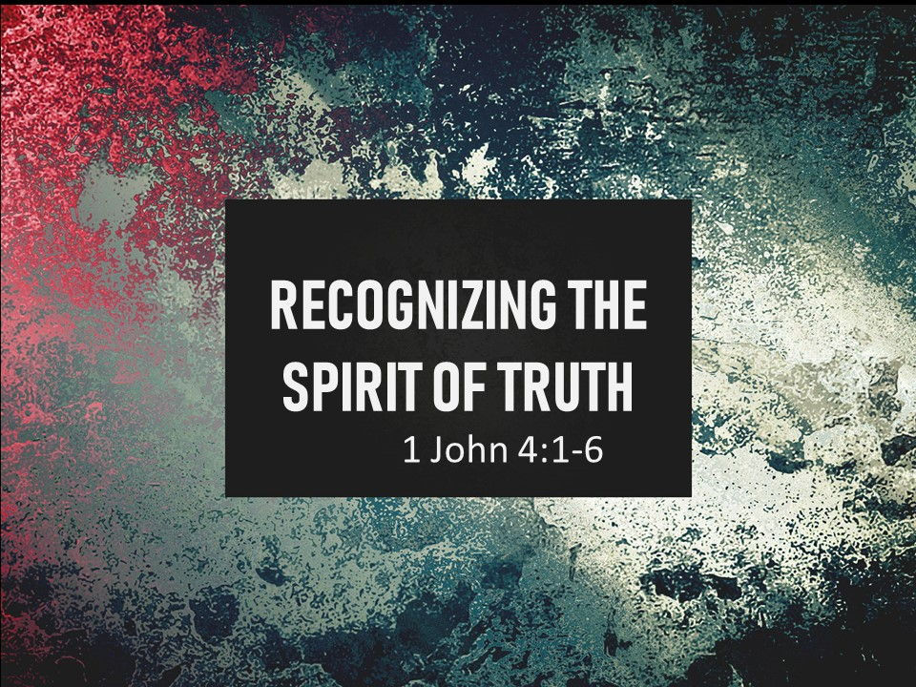
The Road Church
1st John Sermon Series
GETTING BACK TO THE BASICS
Part 12
RECOGNIZING THE SPIRIT OF TRUTH
Scripture: 1 John 4:1-6
Pastor Timothy Jones Aug 26, 2018
Prayer:
Heavenly Father you are the God of all creation, we ask you in the Name of your Son Jesus Christ that you will bless us as we study your incredible word today. Would you open our hearts to your Word? If there is veil covering our eyes so that we cannot see, may you remove it, remove any and all distractions from the world so that our hearts and minds can be open to you. Open our eyes to see your truth and love that you have for your Children, In your Son’s name Jesus Christ we ask of you Amen and amen.
It is so Good to be with you in the house of the Lord this morning, Well, good morning everyone it is so good to be back in Michigan, we got back yesterday from San Antonio, TX and we are glad to see all of yall. And that means all you folks on line with us this morning as well. We are so glad that you are with us watching and connecting with us at the Road. Remember this; we are all walking the Road of faith together. In just a moment we are going to post my email address on the feed so that all of you joining us can connect with me whenever you need to. You can let me know your praises and/or your prayer request or even questions. SO that you have a way to be connected to us right here at the Road.
Well alright! We are forging ahead in the letter of 1st John and wouldn’t you agree with me that this has been an exciting teaching series so far?
We have learned so much from John already.
We learned that John is one of if not the best friend of Jesus. We know that He is on octogenarian, which means that John in his 80’s. We also know because of this letter that John was a pastor and his age has nothing to do with evangelizing and encouraging the Christian community. We also know by the date of this letter that perhaps he is the last surviving person who witnessed the resurrected Jesus and also that he is writing to the second and third generation Christians. This is important to us because there are no Christians left alive that have seen the resurrected Jesus in person. We all are post Resurrection Christians. He writes to them because of the reports that He has heard of the issues dividing the church, and some of those issues are the same that we have today. So, John’s theme is to get back to the basics of faith to combat the false teachers and the problems the church was having. John does this by laying out the foundational nature of truth and love in the context of the local church.
Through our study of 1st John we know that John divided the letter into two halves.
The first half of the letter goes from chapter 1 to the end of chapter 2 and it is all about having fellowship with God. And John says some pretty startling things. Like fellowship with God and other believers is at the heart of a disciple of Christ, that if we are walking in the fellowship with God than we are walking in light of God and that if we are walking in the light then we are keeping God’s Greatest commands of loving Him and loving others, and by doing so we can change the world.
The second half of this letter is about what it means to be a child of God. And again, love is at the heart of the letter.
But John gives a twist in the second part of the letter by telling us these words “THIS IS HOW YOU KNOW” He is saying to the Christian communities and us today that there is an actual way to know that you are a child of God that you are doing the right things.
We found so far in this second half that God loves you and me so much that He did something that people wouldn’t do; He sacrificed His own Son so that we would have the opportunity to be adopted into the Family of God. Jesus brought to life the very love that God has for each person in the world. And John’s mission in his life was not only to share that message but to share that love as well.
And you might be thinking well that was easy enough for John because he was Jesus’ disciple. But I think the opposite, because after a few months of being on the road with Jesus I think that the honeymoon period worn off. Amen--- You know what the honeymoon period is right? It is where everything is going great, everyone is on their best behavior. But then life hits and you get to see the real person. I think that John and the others really began to show their hearts, the sinful people that they were. For example, when one city denied Jesus, John was one of the disciples who asked Jesus if they wanted them to pray that heaven would rain down fire on the people and destroy the city, or even on the way to the last supper after 3 plus years Jesus’ teachings the disciples began to argue about who the greatest, John was in the middle of it.
But everything for them changed when the resurrected Jesus stood before them and talked with them, walked with them and ate with them. It all came to a head all the teachings and love.
Johns mission is for us to experience that love to know that we are who we are because of Christ and that even through there are false teachers in life, that there will be persecution in life, that there will be trails and troubles that can knock us off our game - we can know that for sure that not only are we are loved by God by we have the assurance of being part of the family of God. When I think of that word assurance I think of that old hymn named “Blessed Assurance” That hymn was written in 1873 by Fanny Crosby who was blind. Listen to the first verse:
“Blessed Assurance, Jesus is mine, Oh what a foretaste of glorify define, Heir of salvation, purchased of God, born of His Spirit, washed in His blood.”
She describes us and all the others who have been saved through faith in Jesus Christ.
As we discovered last week John said this is how we know that we have assurance because God is greater than our doubt, that our prayers are heard and answered and we can know because of the Holy Spirit is in us.
And that brings us to today, open your Bibles or your Aps with me to the New Testament book of 1st John chapter #4.
1st John chapter # 4, The book of first John is five books from the back of the Bible. When you get to 1st John chapter 4 let me know by saying “amen”.
Amen thank you.
In our scripture today, John has moved on to speak about a specific problem in the church somewhere in the year AD95. And as we dig into the scripture we will find that it is still a problem in the church in the 2018. And that is the false spirits teaching the wrong things about Christ.
If you are there in 1st John chapter 4 let’s begin reading from verse 1. Folks on line can also follow along with us as well.
And it begins like this:
Dear friends, do not believe every spirit, but test the spirits to determine if they are from God, because many false prophets have gone out into the world.
2 This is how you know the Spirit of God: Every spirit who confesses that Jesus Christ has come in the flesh is from God. 3 But every spirit who does not confess Jesus is not from God. This is the spirit of the antichrist; you have heard that he is coming, and he is already in the world now.
4 You are from God, little children, and you have conquered them, because the One who is in you is greater than the one who is in the world. 5 They are from the world. Therefore what they say is from the world, and the world listens to them. 6 We are from God. Anyone who knows God listens to us; anyone who is not from God does not listen to us. From this we know the Spirit of truth and the spirit of deception.
First. let me say that the word Spirit that John uses means prophets in his day, in today’s world John is meaning teachers, speakers, pastors, writers and those who have followers supposedly because faith.
Second, every time I read this scripture I think of the multitude of people who are following false teachers in our world today, who are naive about false doctrine. You can go on the internet today and find many people preaching their own gospel or the falsehood of the true Gospel in a way that glorifies themselves.
And let me go ahead and get this out of the way-Just because a person has a title of Pastor, Apostle, Evangelist, teacher or educational title of professor or even Dr, it doesn’t mean that they are teaching and preaching the truth of the Gospel.
WHICH BRINGS US TO OUR BIG IDEA TODAY:
THE BIG IDEA IS:
DON’T BE FOOLED BY FALSE TEACHINGS.
IN OTHER WORDS – JOHN IS SAYING YOU CANNOT BELIEVE EVERYTHING YOU HEAR FROM ALL PEOPLE.
Look at verse 1 with me,
Dear friends, do not believe every spirit, but test the spirits to determine if they are from God, because many false prophets have gone out into the world.
Again, John is speaking to the Christian Community saying don’t believe every spirit, prophet or teacher.
The reality is this all throughout the Bible we see that there was been a problem with false teachers and even today we find that Spiritual truth in today’s Christian world is lacking, we have people who teach falsehood in the church or in the churches name. We have what I call easy believer-ism, words that sound like the truth but only lead others astray. And folks we shouldn’t believe every spirit- teacher, preacher, ect…. Every person who comes knocking at your door.
In Matthew 7:15 Jesus said beware of the false prophets who come to you in sheep’s clothing and then Jesus said in verses 17-18
That if anyone wants to do God’s will that he will understand that the teaching is from God or if I am speaking on My own. The one who speaks for himself seeks His own glory.
Listen to me folks, not all people who you hear, not all who preach, teach, write or evangelize are from God. They may look the part, but they are far from the truth.
Anytime that we hear a sermon, read a book, hear a speaker or even go to seminars we must not believe everything that person tell us. John is telling us that it is our responsibility as Children of God to know that who we are listening to and weather they are from God and who is not from God.
Now I don’t have time to stand before you and go down the list of everyone who I believe is from God and is not. But I will tell you that there are prominent people on Television, Radio, who write books, people who some of you are watching that are not from God. Some of you tell me who you are watching and I’m telling you right now some of them are not from God. Many today use the scripture to twist the words to meet their own needs. Just as John tells us that in his day there are many false teachers that have gone out in the world and listen to me if there were many in John’s day think about how many are in our days.
So, the question is how do we discern the Spirit of Truth verses the spirit of deception?
John tells us how we can be sure of such things. And He does so by giving us three tests: He begins by saying “This is how you know” and gives us a three-question true or false test.
You know when I was a kid up growing in school, even when I went to college, I liked the true or false test’s, because it meant that I had a 50% chance of getting them right when I did not know the answer. But in this test, John is giving us not only the questions but the answers as well. These are answers that we can always get right because we have the answer key right before in God’s Holy Word. As Children of God, God is so concerned with our spiritual wellbeing that He used a man like John to help us make the right choices of who we are listening to.
SO, what are these test questions?
THE FIRST TEST QUESTION IS THIS:
DO THEY CONFESS THE TRUTH OF CHRIST?
Look at verses 2-3 with me:
This is how you know the Spirit of God: Every spirit who confesses that Jesus Christ has come in the flesh is from God. 3 But every spirit who does not confess Jesus is not from God. This is the spirit of the antichrist; you have heard that he is coming, and he is already in the world now.
Here is the difference:
Those of God confess that Jesus Christ has come in the flesh.
Those not of God, don’t.
We have been talking about a sect called Gnostics throughout this series, they have gotten into the church during biblical times and really are one of the reasons that John writes this letter.
At the heart of Gnosticism is the belief is that Salvation comes from a superior knowledge and that not all people have this superior knowledge. Therefore, not all can receive salvation.
They also believed that physical matter is was evil and the spirit was good. Therefore, they did not believe the Jesus had a physical body because they believed that would be evil. Instead they though Jesus was a spirit.
Now let me stop here because this goes against everything that we believe, what the Holy Word of God speaks of. If Jesus was a spirit, common sense would say that He could not have been born of a woman, or had childhood, or could die on the cross. But, here is John the man who had been with the very physical presence of Jesus, who watched the physical body of Jesus die on the cross, and that His body was placed in a tomb. He was there when Jesus appeared to them and said I am alive put your fingers in these holes.
They don’t believe that Jesus Christ came in the flesh. Now I know that you know that the Bible says in Colossians 1:15 that “He (Jesus) is the image of the invisible God, the first born over all creation”
The Bible goes on to tell us that salvation is received by grace through Jesus Christ (EPHESIANS 2:8-9) and that Salvation is available to all who call upon the name of the Lord (Romans 10:3).
We have a type of Gnostics in today’s world with Jehovah witnesses who believe the Jesus was God’s first creation, that Jesus is God like but He is not the Son of God. We also Mormons and Christian Scientology all three of these are cults who don’t believe confess Christ as the Son of God.
We also learned in Chapter 2 that anyone who denies That Jesus came in the flesh (INCARNATION) are Antichrists. And John says there are many who are here in the world today, that they bring with them darkness and have fallen away from God. And here John tells us that the one sure way to know false spirits and their teachings is because they fail to confess Jesus. It is not they don’t know Jesus, I mean The Bible says that “even the demons know Jesus” It is not that the world doesn’t know Jesus, because in our culture today most people know of Jesus. It is that they deny that Jesus has come in the flesh. And you a Christian are suppose to test this and not follow these false teachers.
Which then leads us to:
THE SECOND TEST QUESTION:
DO THEIR LIVES REFLECT A LIFE OF CHRIST?
Look back to verse 4 with me
4 You are from God, little children, and you have conquered them, because the One who is in you is greater than the one who is in the world.
I love that song that we did today Our God is Greater. If our God is for us who can stand against us? Our God is greater than the Antichrists in the world, greater than any trouble, doubt, even Satan.
And John says that the Christian life is not just believing the incarnation of Jesus, having faith in Christ, but it also is shown by the way a person lives their life.
As Christians our lives come from God. Notice how John uses the word YOU in the beginning of Verse 4, he makes this personal for all of us. He uses it in contrast to the many false teachers in the world. The Bible continually talks about how our lives are supposed to change in the wake of our faith in Jesus Christ. John has discussed that we are to grow spiritually in Christ. Why? Because if we truly have changed from the Old to the New then Christ is in us. John says that it is because of the One living in you.
Any person standing before you preaching, teaching, writing, or even evangelizing, must have a life that pursues the approval of God. That is why I lead from the front, I believe that I cannot preach to you and ask you to do something that #1 hasn’t already preached to me, #2 that if I haven’t already done or that I am currently doing or that I will do with you. Then there is no reason you should do it. I lead you from the front. Examine our marriage, examine my life, examine my tithes and offerings, examine my social media, examine the sermons, website, my personal website and you will find that although I am not perfect I do my best living for God.
Illustration of the discussion with the stewardess.
I live by what I preach, because what I preach is the from the HOLY WORD OF GOD and that tells me how to live.
That’s the standard! And guess what? That should be the standard for everyone who stands before you, weather in person right here in our Church, in some other church, on the internet or on television. Weather you are reading a book, listening to a podcast or looking at a Christian website. It comes down to is the One who is in you is greater than the one who is in the world.
And folks we have the victory through Christ Jesus and you deserve the best each time someone preaches to you, why because you are a child of God.
John tells us to test them by asking:
Do they confess Christ?
Second, do they live Christ? And
THE THIRD TEST IS: DO THEY SPEAK THE WORD OF GOD?
Look at verses 5-6
5 They are from the world. Therefore what they say is from the world, and the world listens to them. 6 We are from God. Anyone who knows God listens to us; anyone who is not from God does not listen to us.
John quickly explains to us that the spirit of deception speaks from the viewpoint of the world and the world listens to them. The world understands their language. They speak of things and teach things that are contrary to the very Word of God, yet people perceive it to be true.
For example Ophra winfree was just in the news about abortion telling women to celebrate theor abortions. The apostle Paul refers to this as he speaks to the young pastor Timothy in 2nd Timothy 4:3-5 as he says:
“3 For the time will come when they will not tolerate sound doctrine, but according to their own desires, will multiply teachers for themselves because they have an itch to hear something new. 4 They will turn away from hearing the truth and will turn aside to myths.
People want to hear what makes them feel good. People want to hear that they are in destiny of themselves, people do not what God has instore for their lives. You know someone are not of God when they don’t want to hear or be reminded of what God’s Word says.
So the teachers, preachers, writers will change the way they teach to get the crowds, to get the fame, to get the money to please the itching ears of the world. Their source of motivation comes from godless humanity and they will speak the worlds language.
Why is it important? Because the false teachings that were swirling about in the first century and the false teachings that are around us today as well detract from Christ.
In the wake of what the Christian community today has called seeker friendly churches, they have called for the language of the church to be changed because the world doesn’t understand the words. Words such as faith, propitiation, sanctification, redemption and other words of the Bible cannot be understood by the world. In essence a seeker friendly church takes the language of church out of the Church so that the church can look and sound more like the world so other people can be reached.
But in contrast to the false teachers, true teachers and believers John says “We are from God. Anyone who knows God listens to us”
Once you become a believer in Christ you begin to know the scripture and knowing the scripture helps you in discerning the world.
When I look at the early church I feel like the apostles were just tearing up the lost world with all kinds of people coming to know Christ by faith because of the apostle’s teachings. The apostles were men from God, they just didn’t spiritually walk with God but they physically walked with God – In the Book of Acts it tell us that the early Church was devoted to the teachings of the apostles. It was powerful, it was amazing, it was the eye witness accounts of many things that Jesus taught and did. And much of it is right here in our Bibles.
We come to faith by grace of God through Christ Jesus and the Word of God is the anchor to our faith, and if we want to properly discern the teaching of others in our lives then we must have a knowledge of what the Word of God says.
It is clear that New Testament emphasizes the sufficiency of Christ and the Bible as the very Word of God. And as believers we are given this Word for the governing of our lives. The Word of God is our language to the truth and those who are brothers and sisters in the truth know this language.
And here is the fact: Here is what I did not get as an early believer, I did not get that following God was more than a profession of faith, it is a life. The profession of faith in Jesus is where it all begins but then…. the Bible says that once we have professed Jesus as Lord that the Old life is gone and BEHOLD the new life begins.. WOW. I thought that if I just had Jesus I did not need anything else in life and while that is partly true, the other part of that is if we never grow spiritually through the Word of God we can easily be swayed by many false teachings. And here was the lesson, I heard my pastor preach that we needed to be involved more in church and more in the lives of believers and I said I don’t need that, and that week God quickly showed me that I did need it.
I heard a story of a pastor who had a faithful sister in the church for years and she died and went home to be with the Lord, but as the days followed and family began to look at her finances she had given thousands and thousands of dollars to a man on television who was a false teacher with false promises.
Folks it is easy to follow the wrong people, but listen it is our duty as Christ Followers to test the spirit by which people preach, teach and write.
How do we know?
Question 1 Do they confess the truth of Christ?
Question 2 Do their lives reflect a life of Christ?
Question 3 Do they speak the Word of God?
And then lastly look at what John says in the later part of verse 6 “From this we know the Spirit of truth and the spirit of deception.”
We know that there are false teachers in our world today- test them see them for who they are.
This is a way that God has provided to protect His children of God. Folks the focal point of todays message is false teachers/spirits preaching false truth about Christ, these people are trying to get you away from Christ and His Word, but let me just say this- death is coming to us all and each of us should have our eyes, mind and hearts fixed on the truth of our Savior.
Amen?

