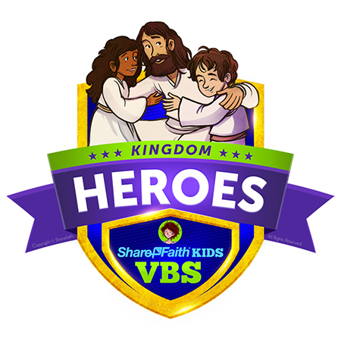
VACATION BIBLE SCHOOL 2018

HAS EARNED THE PARTICIPATION AWARD
for attendance at Kingdom Heroes VBS from July 22-27,2018
The Road Church
Awarded: July 27, 2018
By Pastor Timothy Jones

