FOR IMMEDIATE RELEASE

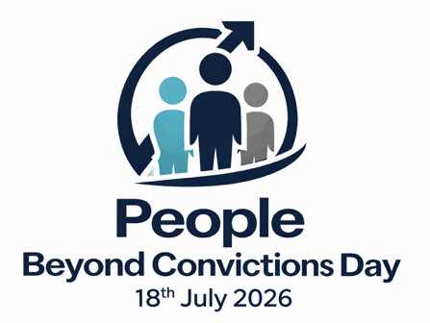

A National Day of Awareness, Recognition, and Opportunity

People Beyond Convictions Day will be observed on 18 July, aligning with Nelson Mandela International Day, a date chosen to reflect the enduring global symbolism of redemption, dignity, and the capacity for human change embodied by Nelson Mandela.
The initiative, founded by David Rowlands of www.BeyondConvictions.com, calls for a fundamental shift in how society views people with past convictions. Moving away from permanent labels and toward recognition of growth, rehabilitation, and contribution.

About People Beyond Convictions Day
People Beyond Convictions Day is a national awareness initiative dedicated to reshaping public understanding of individuals with past convictions. It promotes dignity, inclusion, and opportunity as essential foundations for stronger and more equitable communities.

2026 Theme “From Conviction to Contribution”

Purpose
People Beyond Convictions Day celebrates and uplifts people beyond past convictions by challenging stigma, breaking systemic barriers, and recognising the full humanity and potential of those rebuilding their lives. It calls on communities, employers, and institutions to move beyond labels and ensure fair access to opportunity in work, housing, education, health, and social participation.
By fostering understanding and inclusion, it highlights rehabilitation, second chances, and dignity, and encourages practical steps that support reintegration and long-term personal growth for people rebuilding their futures.

Why It Matters
- Millions of people continue to be defined by past convictions, even long after rehabilitation and reintegration into society.
- Stigma and structural barriers restrict access to employment, education, healthcare, housing, and full civic participation.
- Moving beyond labels creates opportunities for dignity, growth, and inclusion that benefit individuals, families, and communities.
- When people are supported to rebuild their lives, communities become safer, healthier, and more resilient.

Goals of People Beyond Convictions Day
- Raise awareness of the lives, achievements, and contributions of people beyond convictions
- Shift public perception from fixed labels to human potential
- Promote fair access to opportunities and inclusive practices across sectors
- Celebrate employers, organisations, and communities creating pathways forward
- Encourage society to recognise the whole person, not their past

A Word from the Founder
“People Beyond Convictions Day is more than a moment of reflection, it is a call to rethink how we see one another. Too often, individuals are defined by a single chapter of their lives, one that no longer reflects who they are today.
This day challenges us to look beyond labels and recognise growth, resilience, and the human capacity for change.
When we open doors to opportunity, whether in employment, education, health, housing, or community, we do more than transform individual lives, we strengthen society as a whole. Safer, healthier, and more inclusive communities are built when people are given the dignity of a chance to move forward.
I encourage everyone to take part by raising awareness, offering opportunities, or simply shifting perspective. When we see the person beyond the conviction, we unlock potential not only in them, but in all of us.”
David Rowlands, Founder, www.BeyondConvictions.com
Share on Social Meida
#PeopleBeyondConvictionsDay #FromConvictiontoContribution
Media Enquires:
David Rowlands
David@BeyondConvictions.com
www.BeyondConvictions.com

