Flexibility Program

This stretching should be done any time. Keep in mind that warm tissue is always more efficient than cold tissue (so an ideal time would be at the end of a workout). It also works well at the end of the day. Hold each stretch for 15 – 20s. Pay attention to the muscle groups you are stretching – making sure that’s where the stretch is felt.

## Start on your back with both knees bent, feet are flat on the ground.

# HAMSTRINGS / GLUTES

Extend the right leg straight up in the air, wrapping your hands around the back of your knee, interlocking your fingers (1). Keep the leg as extended and as straight as possible. Hold this stretch. Release your fingers; bend your right knee allowing your right ankle to rest on your left knee (2). Lift your left foot off of the ground, extending your left leg straight up into the air. (Your right ankle remains on your left knee) (3). Interlock your fingers around your left hamstring (right hand is in between your legs). Hold this stretch. Relax your left leg, allowing your left knee to bend dropping your left lower leg over your hands (4). Hold this stretch. Repeat (3) & (4). Release your grip allowing your left foot back on the floor. Extend the right leg back up in the air, grabbing behind the right knee back into the hamstring stretch (1). This time try to get deeper into the stretch.

*Repeat this same sequence for the opposite side.*

# 100_3434_small 100_3436_small 100_3437_small 100_3439_small

# (2) (3) (4)

# LOWER BACK

Start with your legs completely extended and flat on the ground. Pull your right knee towards your chest (5); place your left hand on the outside of the right knee. Apply a little force to move your right leg across your body to the left side. Extend your right arm out to the side. Rotate your head to the right, looking down your right arm (6). Hold this stretch. Release your leg.

*Repeat this same sequence for the opposite side. Do each side twice.*

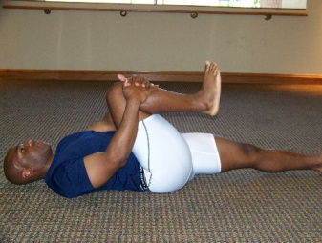 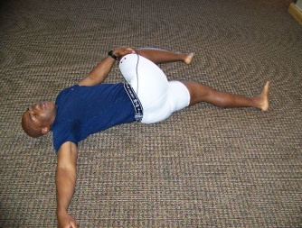

# (5) (6)GROIN / HIP ABDUCTOR STRETCH/SPINAL TWIST

Come up to a seated position – back is upright. Bring the bottom of the feet together pulling them in towards your body, allowing your knees to fall to the outside. Grab your ankles, applying pressure to the inside of your knees with your elbows. Keep your chest up looking straight forward – press down on your knees with moderate pressure (7). (BUTTERFLY STRETCH). Hold this stretch.

Release your ankles, extend your legs back to the starting position. Remain seated in an upright position. Bend your right knee, placing the bottom of your right foot on the outside of your left knee. Rotate your upper body to the right, placing your right hand on the ground behind you. Place your left elbow on the outside of the right knee, driving your right knee towards the left side of your body (8). You may feel this stretch in your lower back as well. Hold this stretch.

Release the stretch and do the same sequence for the left side. After completing each side once, go back to the butterfly stretch and go through the entire sequence one more time.

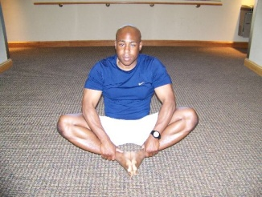 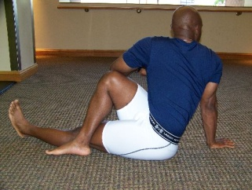

(7) (8)

## Turn over to your stomach

### QUADIRCEPS

With your body completely extended, grab your right ankle with your right hand. Hold that position for about 8s. Continue holding that position – drive your hips down into the ground, pulling a little bit harder on your ankle. Hold this stretch.

*Repeat with the opposite leg. Complete each stretch twice.*

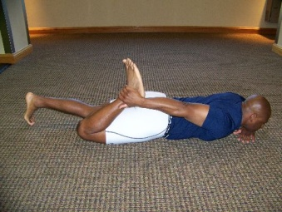

### 

### CALVES

Come up to your hands and knees (all fours). Your hands should be directly under your shoulders (9). Extend your right leg back, placing your toes on the ground. Attempt to move your right heel down the ground behind you (10). Your heel should never touch the ground – attempting to make this happen should put you into the stretch. Hold this stretch.

*Repeat on the opposite side, completing each stretch twice.*

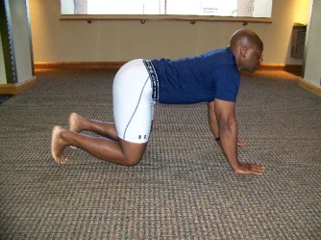 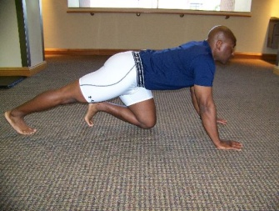

### (9) (10)

### HIP FLEXORS

From all fours (9), step your left foot up and in between your hands. Raise your right knee off the ground, extending your right leg to a straight position. Your left knee should be over your left heel (11). Keeping your right leg straight, open your hips and let them sink. Hold this stretch. Drop your right knee down to the ground, come out of that stretch and switch sides.

*Complete the stretch on each side twice.*

 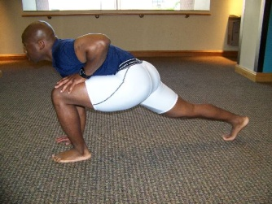 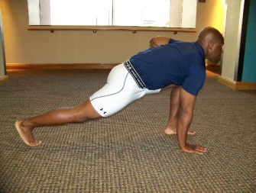

(9) (11) (11)

After the last stretch, instead of dropping your knee down to the ground, step your right foot up to square your body. Extend the legs allowing your upper body to hang down towards the ground. Hold this stretch. Raise your chest and upper body – you should be standing on your feet…this is the end of your stretching session.