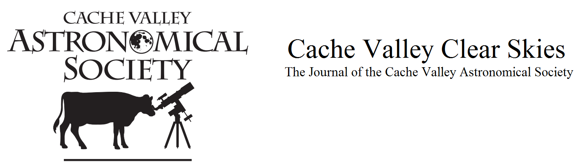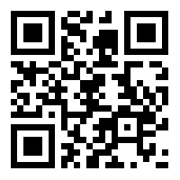
CVAS Executive
Committee

Pres – Dell Vance - (435) 938-8328
avteam.dell@gmail.com

Vice Pres- Bruce Horrocks
bruceh@gembuildings.com

Treasurer- Brad Kropp - (435) 755-0877
brad.kropp@usu.edu

Secretary – Wendell Waters (435) 213-9230
wendellw57@comcast.net
Loaner Scope Coordinator/NSN Coordinator –
Garrett Smith – GarrettGillSmith@gmail.com

Past President, Webmaster, Librarian –
Tom Westre – (435) 787-6380 twestre45@aol.com

Public Relations – Lyle Johnson -
lyledj@aol.com

Vol. 6 Number 10 June 2019 www.cvas-utahskies.org

Meeting Announcement

There is no general meeting this month.

Upcoming Star Parties

June 6 – USU Brigham City Extension
June 7 – Von Baer Park Providence
June 14 – Lee’s Grocery in Logan
June 18 – Green Canyon Parking Lot
June 26 – Bruce Horrocks’ in Wellsville

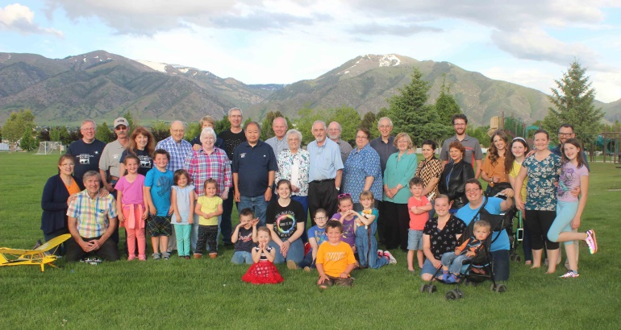
Annual CVAS Dinner May 31

The President’s Corner
By Dell Vance, CVAS President

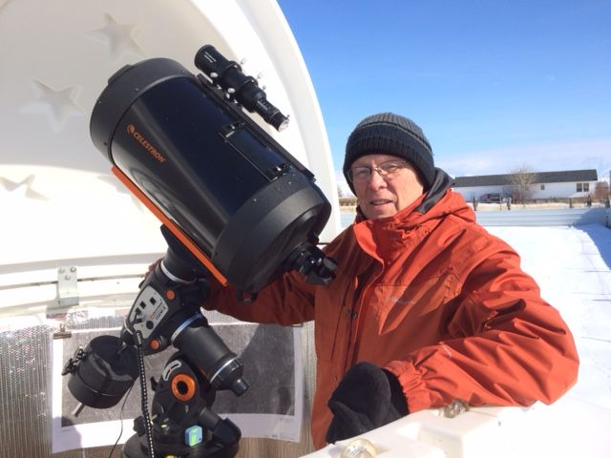

May has been a disappointing month for using my observatory. As of the writing of this article, I have not had a single night of observing from the LP Observatory (my name for my observatory). The last pictures that I took were on April 26th, which is after I wrote my article for the newsletter. I was able to take pictures of M13, the Hercules Cluster and M104, the Sombrero Galaxy.
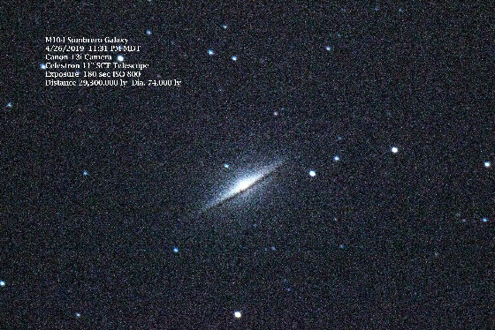
It was another opportunity to practice using the autoguider. This is the first time that I have imaged M104 and I am very pleased with the results I am getting with the 11 inch telescope. I am working on the process to operate the system remotely. I have installed the Cat 6 cable to the observatory and tested the components. I am just waiting for some clear skies to put it all together. You are never completely done when it comes to Astronomy. There are so many things you can work on.
In May we also had some great events. May 11th was International Astronomy Day and we held a Solar Party during the day at the Logan Library. We even had some sun spots to see. It was fun to show the public the sun. We had 5 telescopes including Dale’s Hydrogen Alpha scope. That night we held a Star Party at the Macey’s Parking Lot in Providence. The clouds were not very helpful, but we did get some great views of the moon. There were several people that stopped by and took a look through the telescopes. Overall both parties were successful.
At our monthly meeting on May 22nd, our speaker was ill, so at the last minute, Tom Westre and Bruce Horrocks stepped in to tell us about Galaxies. They did a great job. This was our last CVAS Meeting until next September. We will be hosting several Star Parties through the summer. The information for these can be found on the CVAS website at www.cvas-utahskies.org.
We will hold our Annual CVAS Potluck Dinner on May 31, 2019. We will have Pizza supplied by the club and the usual potluck items brought by those coming to attend. I am sure it will be a good opportunity to get together and socialize. We will have a Star Party afterwards, weather permitting.
We have several events coming up in June for the club.
- June 6th – Star Party at USU Brigham City Extension at 9:00 PM
- June 7th – Star Party at Von Baer Park in Providence at about 9:00 PM
- June 14th – Public Star Party (Lee’s in Logan) at 9:00 PM
Hopefully, you will join us in all these great activities. We are looking forward to working with the public to help them get excited about astronomy. We also have at least two more telescopes in the works for donation to the libraries. Club members have been very helpful in this endeavor.
Thanks again for your great support.
Clear Skies!

CVAS on Utah Public Radio

Listen to CVAS on Utah Public Radio each Tuesday at 4:48 pm. Blaine Dickey and Tom Westre are writing weekly astronomy related scripts and recording the program at their station. We are pleased that the folks at UPR have invited us to present a weekly topic on astronomy. You can listen in Logan on 91.5 KUSU-FM, or 89.5 KUSR Logan, with translators 92.1 Brigham City, 89.3 Bear Lake. There are other translators from Soda Springs to St George. You can also listen anywhere on their live stream or download UPR’s free app on your smartphone. Check this out at www.upr.org.

Omega Centauri, Centaurus A and Messier 3 by Blaine Dickey
With encouragement from Tom Westre, I decided to take my Celestron 6 inch evolution telescope with me to Safford Arizona. The nights in Safford are unusually dark for a city its size because of lighting regulations. Mount Graham looms large to the west of Safford. On top of Mount Graham sits the Large Binocular Telescope, the 5th largest telescope in the world. Because of the dark skies and southern latitude I had high hopes of seeing some of the deep sky objects that can’t be seen from Cache Valley. The latitude of Safford Arizona is 32.8° latitude north which means one can see about 7.5 degrees more of the southern sky than you can in Cache Valley. At a star party the year before near Animas New Mexico I could see the globular cluster Omega Centauri which is considered the best globular in the sky. Near Animas I viewed it through a 1 inch night vision scope and could see perhaps a hundred stars in the cluster.
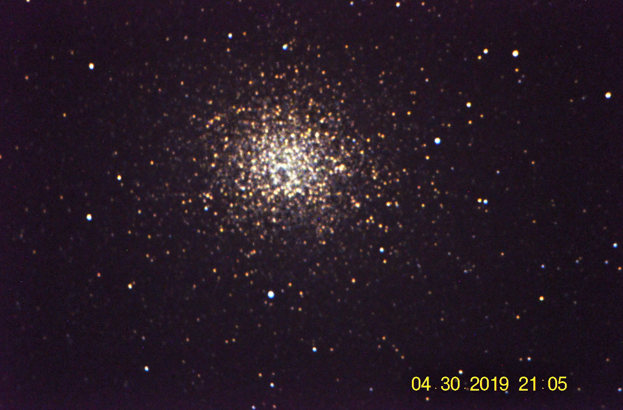
After setting up my telescope the first night, I searched in vain for the cluster even with the aid of my computer controlled scope. Clouds along the southern horizon blocked my view of that part of the sky. The next evening I thought I would give it another try. After syncing my scope I took out my binoculars and searched where I thought it should be and found it quickly as a soft glowing cloud low in the southern sky. Next I located it in the finder scope that was on my Celestron scope and centered it on the crosshairs. With my Nikon D5100 DSLR in the diagonal holder I began taking pictures and adjusted the scope some until Omega Centauri was centered in my camera. The first picture was very red due to thick atmosphere the light was passing through. I continued to image as the cluster rose higher in the sky until I had several acceptable images. With a little processing I was able to get a fairly decent image. (Fig. 1)
Figure 3
Figure 2
Looking at it in my wide angle eyepiece was a thrilling experience. A multitude of stars were just barely visible on the very edge of detection and it appeared quite large in the field of view. Not wanting to let the night be wasted I moved the telescope upward about 4 degrees to NGC5128 also known as Centaurus A (Fig. 2), an unusual elliptical galaxy that collided in the past with a spiral galaxy. The tracking was not too great but it was worth taking an image.
The last picture (Fig. 3) is an image I took of the globular M3 the same night that you can compare with the image of Omega Centauri to get an idea of the size comparison between the two globular clusters.
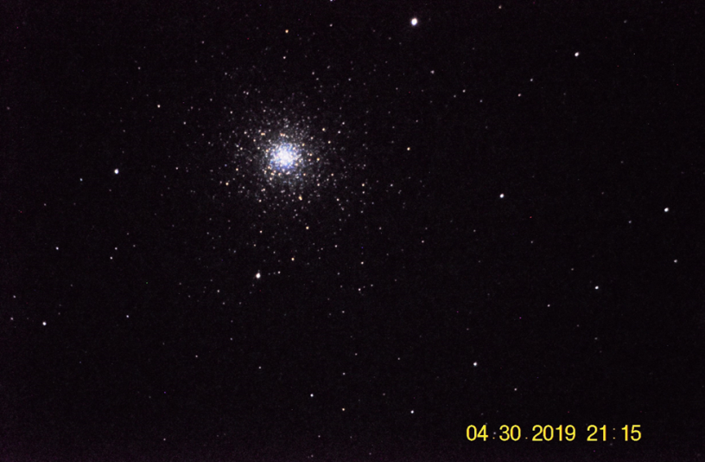
Figure 1
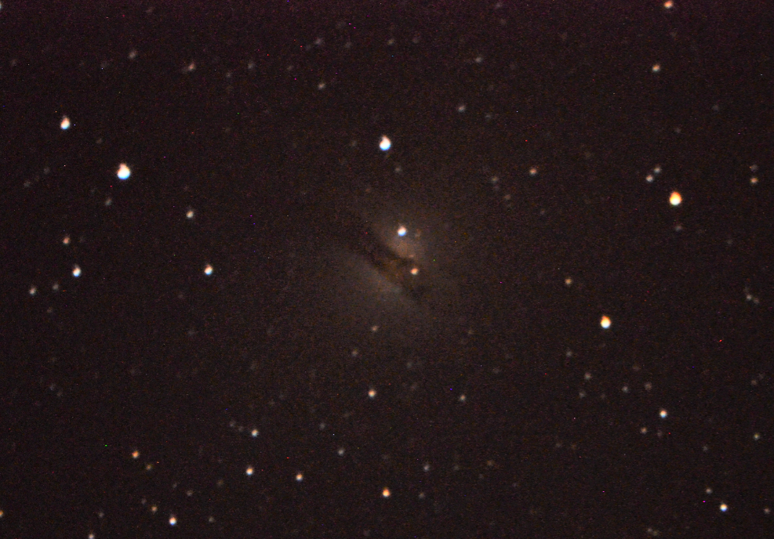

Best CVAS Images and Notes
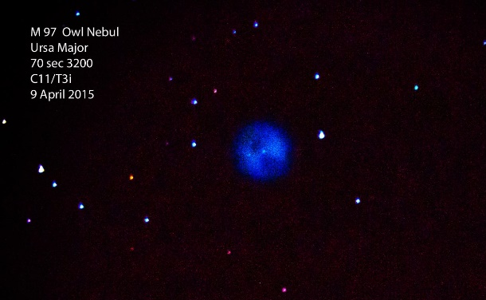
By Tom Westre

Hi CVAS imagers and observers

The constellation Ursa Major is well placed for the month of June. Two favorite deep sky targets are located in Ursa Major, Messier 97 and Messier 108.

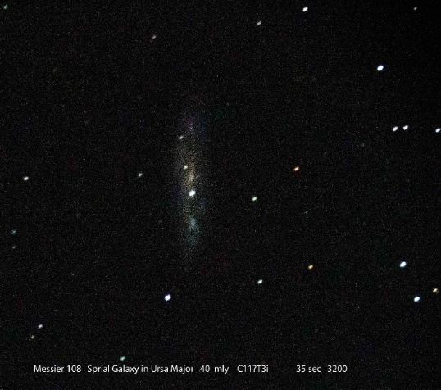
Messier 97(NGC 3587) is a planetary nebula located 2000 light years away and it is about 8,000 years old. It’s not very bright at magnitude 9.9. It is located about 2.5 degrees east of Merek, the southwest corner of the Big Dipper’s bowl. The famous “eyes” are two dark patches the can be seen in dark skies with a ten inch telescope. The magnitude 15 central star is a challenge and needs a telescope of 10 inches or larger.

Messier 108 (NGC 3556) nicknamed the surfboard galaxy is a barred spiral galaxy seen almost edge on, at a distance of 49 million light years with a magnitude of 10.7. It contains about 400 billion stars. Messier 108 has a diameter of 110,000 light years and is inclined 75 degrees to our line of sight. Look carefully and you will see structural details even in an 8 inch telescope. It lies 1.5 degrees east of the star Merek.
Messier 108 by Tom Westre
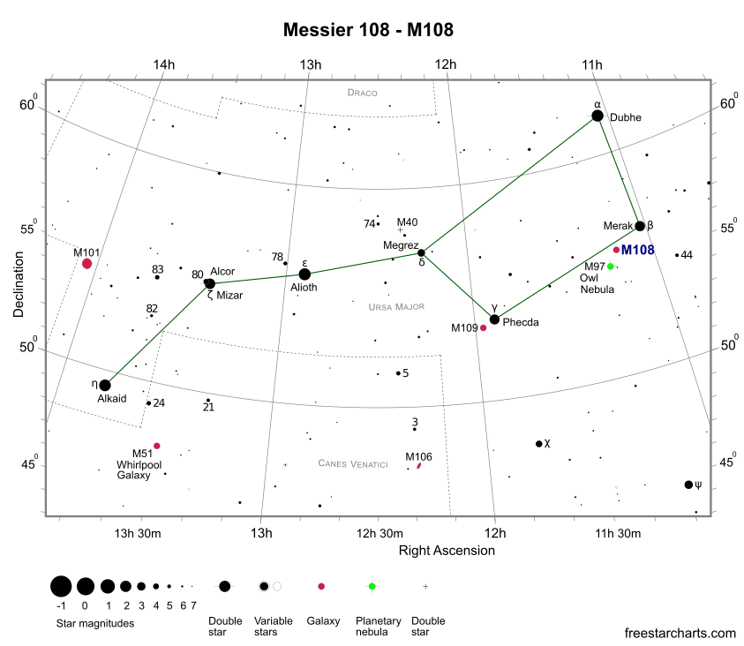
I chose these two objects as they are close enough to be imaged together. They are separated by only 48 arc minutes. With the proper camera both objects could be imaged together.

If you get a chance to observe or image these two together submit your images to
Twestre45@aol.com

Messier 97 Messier 108 finder chart. (Credit freestarcharts)

Messier 97 by Tom Westre
Telescope Pier Stiffness
by Bruce Horrocks

My wife will tell you I spent most of last year in building an observatory for my telescope. At one point this project felt like it had become my own personal Black Hole, sucking in all my time, money, and energy. As my main objective for building this was to get my telescope up in the air and out of the obstruction caused by trees and buildings, this required the floor of my observatory to be roughly 23’ above the ground. My original designed called for (5) columns, one in each corner of a 12’ x 12’ floor, and a center large column to be the pier for the telescope, which I later removed to save some money and a lot of extra work. With only (4) columns I was concerned about movement and deflection in my tall observatory, so being an engineer, I did a little math do determine if I had a problem or not.

When we pull on a spring, the stretch that we can see is a result of how hard we pull, and how stiff the spring is. This stiffness is a key factor in determining how much things will move. There is an “axial” stiffness due to pulling or pushing forces, and a “flexural” stiffness due to the bending forces, much like what we see on a flag pole in the wind. If you are thinking about building a pier for your telescope, keep in mind that this bending or flexural stiffness should be the primary concern of your pier.

I won’t bother you with all the engineering behind this but let me just give you a few numbers to illustrate the point. Also, let me state now that the axial stiffness of any pier you build will be significantly greater than you will ever need, provided you did not build your pier out of used soda pop cans.

Now let’s assume that you were to build a pier to mount your telescope 10’-0” off the ground, and you used a 12” diameter solid concrete shaft. To keep this easy to compare, I am only going to give you a number that will show a relative comparison of these two factors. The axial stiffness of this pier would be 3,200 while the flexural stiffness is only 6. This give us a ratio of 1:530, which means that if you pushed down on your pier with 530 lbs. to move it down, it would only take 1 lbs. of force to move it sideways the same distance.
As the equations that determine the stiffness are directly related to the height let just compare what happens if we shorten our pier to 5’-0”. Now our axial stiffness number would be 6,500 and the bending or flexural stiffness is 50. We now have a ratio of 1:130. Hence, cutting the length in half has made our pier 4 times stronger to resist bending forces. So, this should make it obvious to you that the biggest concern to your pier will be the side-to-side movement. Therefore, when designing a pier for your telescope the base and height conditions should be of the most important factors to consider.

Back to my observatory that is over 23’ feet in the air. The (4) columns that are 12’-0” apart at each corner create a pier that is in effect comparable to a 38” diameter solid shaft. My axial stiffness is 1,870 with the bending stiffness of 370. This gives me a ratio of 1:5, which as I have shown above is a very stiff pier. I have been very pleased with the performance of my observatory and while it is extremely difficult to eliminate all vibrations, I have yet to see where any movements have affected my imaging. For a final quick comparison, I checked the ratio of my Celestron tripod mount, and it has a ratio of somewhere around 1:3. So, if you choose to ditch that tripod and build a pier remember, height and base conditions are the two biggest factors that you should probably address.

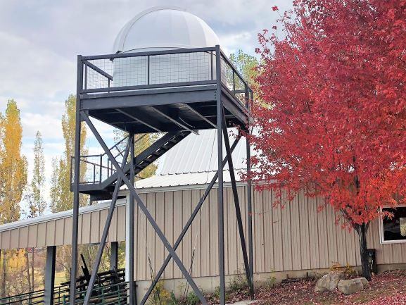

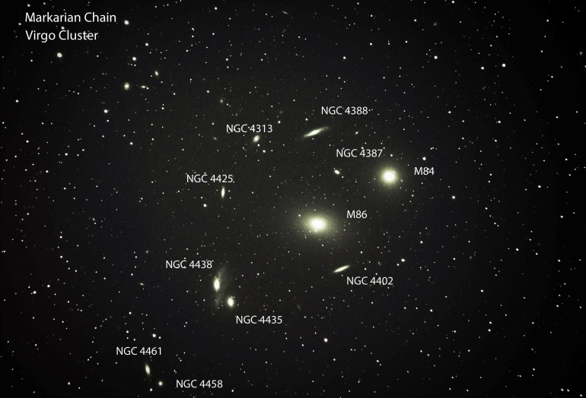
Image by Bruce Horrocks

Newsletter Guidelines
It has been suggested by the CVAS Executive Committee that we come up with some guidelines for article submissions for our newsletter.
- We would like all submissions to be sent to Wendell by the 27th of each month. Just send him an email with the article as an attachment (wendellw57@comcast.net).
- Please submit your articles as a “Word” document.
- If you have pictures or sky maps that go with your article, please place them in the text where you would like them to be, but also send them as separate attachments in the email.
- Please try to keep them at a reasonable length (500 to 800 words or so).
- Preferred font is Times New Roman
- Perfect spelling and grammar are optional.

Your thoughts and suggestions are always appreciated. After all, this newsletter is for you. Thanks for all of your help in making our newsletter GREAT!! (The editor)

Upcoming Events and Anniversaries

- Jun 05 - John Couch Adams' 200th Birthday (1819)
- Jun 08 - World Oceans Day
- Jun 10 - Jupiter At Opposition
- Jun 10 - Jim McDivitt's 90th Birthday (1929)
- Jun 10 - George Dollond's 245th Birthday (1774)
- Jun 11 - William Brook's 175th Birthday (1844)
- Jun 15 - Moon Occults Dwarf Planet Ceres
- Jun 18 - William Lassell's 220th Birthday (1799)
- Jun 19 - Moon Occults Saturn
- Jun 19 - Moon Occults Dwarf Planet Pluto
- Jun 19 - Mercury Passes 0.2 Degrees from Mars
- Jun 20 - Ilan Ramon's 65th Birthday (1954)
- Jun 21 - Summer Solstice, 15:54 UT
- Jun 21 - Oleg Kononenko's 55th Birthday (1964)
- Jun 23 - Mercury At Its Greatest Eastern Elongation (25 Degrees)
- Jun 24 - Carolyn Shoemaker's 90th Birthday (1929)
- Jun 25 - Hermann Oberth's 125th Birthday (1894)
- Jun 26 - Lyman Spitzer's 105th Birthday (1914)
- Jun 26 - William Thomson's 195th Birthday (1824)
- Jun 27 - Asteroid 19695 Billnye Closest Approach To Earth (1.139 AU)
- Jun 30 - Asteroid Day

Library Loaner Telescope Program Status
Library | Telescope Donated By | Telescope Placed | Available for Checkout | Library Status
Logan Library | CVAS | 6/10/2018 | 10/15/2018 | Loaning out with Holds pending
Hyrum Library | CVAS | 12/11/2018 | 2/1/2019 | Loaning out
Smithfield Library | Occipital, Inc | 12/14/2018 | 4/10/2019 | Loaning out
North Logan Library | Utah NASA Space Grant Consortium | 3/4/2019 | 4/5/2019 | Loaning out
Cache County Library (Providence) | INOVAR & CVAS Members | 3/1/2019 | 5/22/2019 | Holds on telescope – waiting for clear skies
Lewiston Library | Schrieber Foods |  |  | Donation check being sent out 6/9
Richmond Library
Preston Library | Idaho NASA Space Grant Consortium |  |  | The Library has submitted the request to the donor
Mendon Library | Campbell Scientific | 4/8/2109 |  | In progress
Newton Library

CACHE VALLEY ASTRONOMICAL SOCIETY
MEMBERSHIP APPLICATION FORM
Member # _______

NAME:______________________ ___________ ________________________________________
First Middle Initial Last

Address:___________________________________________________ ________________ _______ __________
Street City State Zip Code

Home Phone: ___________________________________ Cell Phone:____________________________________

Work Phone : ___________________________________ Occupation :___________________________________

Email Address: _________________________________________________________________

How did you learn about CVAS?
_____Website ____Star Party ____CVAS Member ____Other _______________________________________

Membership: $20 a year

Tell us about yourself: Do you have a special interest in astronomy? Do you have special skills? Are you willing to
volunteer on CVAS projects or attend public outreach star parties? Astro equipment owned.
__________________________________________________________________________________________________

__________________________________________________________________________________________________

By signing this application, I acknowledge I have access to the CVAS website, cvas-utahskies.org , and the CVAS Constitution. I agree to abide by the constitution.

Signature: _________________________________________________________ Date:________________________

Bring this form to the meeting or Mail Application to:
Brad Kropp, CVAS Treasurer
1573 E 1425 N
Logan, UT 84341
For any questions contact our Treasurer at brad.kropp@usu.edu or our Secretary Wendell Waters at wendellw57@comcast.net

