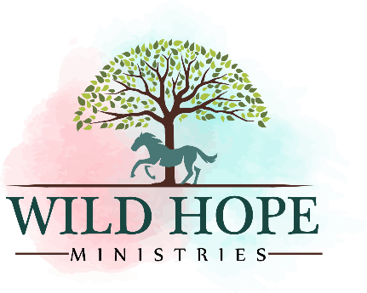

**Code Of Conduct**

**Revised 3/1/2024**

Volunteers are expected to abide by these standards of behavior while representing Wild Hope Ministries. They apply to behavior toward all others they encounter while volunteering including other volunteers, animals, program participants, clients, friends, and family members of volunteers, participants, or clients.

-*I will fulfill assigned tasks to the best of my ability in a safe, efficient, and competent way. Following all Wild Hope policies and procedures as well as any instructions, feedback, and directions reasonably given to me.*

*-I will act and speak honestly, responsibly, respectfully, kindly, compassionately, and with integrity.*

*-I will treat others with fairness, equality, dignity, and respect, including using preferred pronouns when addressing others.*

*-I will not volunteer while under the influence of alcohol or illegal drugs.*

*-I will not cause physical or mental harm or distress to another person or animal (such as physical abuse, assault, bullying, verbal abuse, discrimination, or harassment).*

*-I will do my part to provide a safe and welcoming atmosphere and contribute to bringing wild hope, wild healing, and wild fun to all. I will love and serve others to the best of my ability.*

Type your name here to serve as your signature:Click or tap here to enter text.