**PROPERTY DAMAGE AGREEMENT**

Our House of Hope’s (hereinafter referred to as “OHOH”) policy regarding property damage is subject to reimbursements from the Paying Party. The terms of this OHOH property damage agreement (hereinafter referred to as “Contract”) is as follows:

PROPERTY DAMAGE

1. Intentional damages to OHOH property caused by the Resident with a cost of $50 or more will be the financial responsibility of the Resident or Paying Party.
2. The Resident must promptly notify OHOH management of any damage or situation that may interfere with the normal use of the Property or to any furnishings supplied by OHOH.
3. Should any damage occur, pictures of the damage will be taken.
4. Assessment of damages will be performed to determine the cost of repair(s).
5. The responsible Paying Party will be notified of all damages exceeding $50.
6. Necessary materials will be purchased to make repairs. The paying party will receive copies of all receipts from purchases.
7. Invoice and proof of damage will be forwarded to the Paying Party for immediate and timely payment. Timely payment is defined as:

a. Payment in full must be received no more than 30 days from the date on the invoice. If by the 31st day payment is not received, a daily interest charge of 5% will be added to the total invoice amount until the total payment (plus interest) is received.

1. At the expiration or termination of the residential Contract, the Resident will vacate and surrender the Property in good state and condition, as they were at the commencement of the execution of this Contract. **Note**: Reasonable use and wear and tear excluded.

PROHIBITED ACTIVITIES AND MATERIALS

1. The Resident will comply with standards of health, sanitation, fire, housing, and safety as required by law.
2. The Resident will not engage in any illegal trade or activity on or about the OHOH Property. Should OHOH management become aware of any illegal activities, the appropriate law enforcement agency will be notified of illegal acts.
3. The Resident will not keep or have on the property any article or thing of a dangerous, flammable or explosive character that might unreasonably increase the danger of fire on the Property or that might be considered hazardous by any responsible insurance company.
4. The Resident will not perform any activity on the Property or have on the property any article or thing that OHOH’s insurance company considers increases any insured risk, such that the insurance company denies coverage or increases the insurance premium.
5. The Resident is prohibited from
   1. The storage of expensive articles on the Property if it creates an increased security risk; and
   2. The growing of, or storage of, medical marijuana on the Property.
   3. The Resident will not perform any activity on the Property that the OHOH management feels significantly increases the use of electricity, heat, water, sewer, or other utilities on the Property.

MEDIATION AND ARBITRATION

1. If any dispute relating to this Contract between Parties (i.e. the Paying Party and OHOH) is not resolved through informal discussion within 14 days from the date a dispute arises, the Parties agree to submit the issue first before a non-binding mediator and to an arbitrator if mediation fails. The decision of the arbitrator will be binding on the Parties. Any mediator or arbitrator must be a

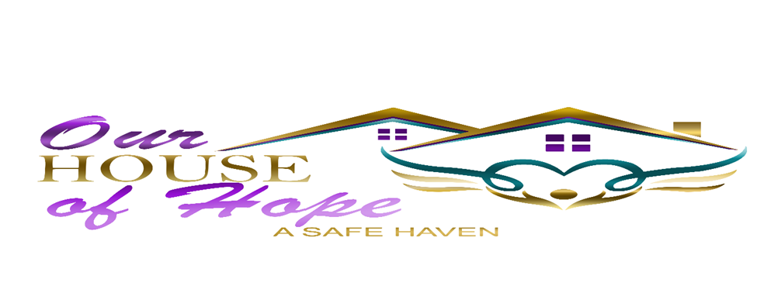

neutral party acceptable to both Parties. The cost of any mediation or arbitration will be paid by the Resident and/or Paying Party.

By signing this Contract, you acknowledge that you understand your financial responsibility as the Paying Party, family member and/or guardian to remit payment for damages because of the above mentioned.

__________________________ _____________

Responsible Paying Party Date

**10592 Fuqua St. A-282 Houston TX 77089***832-387-4135****http://ourhouseofhope.net**