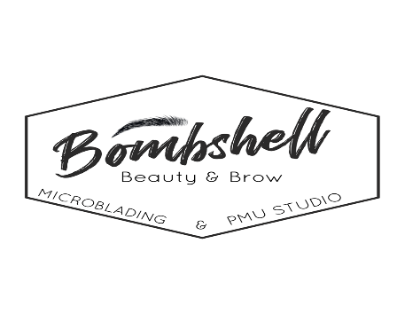

Eyebrow Permanent Makeup Procedure After Care

1. Day1. (day of Procedure)

~oily skin cleans the skin every 30 min for the first 3 hours ( total 6 times) after the procedure using a damp cotton round & sterile water. Washing hands before cleansing each time.

~ Dry skin cleans every hour for the first 3 hours (total of 3 times)

~ Right after the last wipe apply a thin layer of Aquaphor Healing Ointment. The size of a ½ grain of rice for both brows combined!

( not per brow)

~ before bed oily skin may wash using lukewarm water very gently removing lymph, pat dry and apply ointment.

~dry skin may not wash if the skin does not have visible lymph on top of the skin, just make sure skin is moist before bed.

1. Day 2

~Oily or Dry skin may wash one more time if the skin eliminated lymph during the night, pat dry and apply thin layer of ointment as needed, means apply ointment only when you feel the skin is dry.

1. Day3-7-10
2. ~ Everyone’s skin has it’s own healing process and duration. It is recommended to apply ointment as long as the skin is still scabbed, and even after. The ointment will help your skin regenerate faster and better.

**During day 1 to Day 7 or even longer ( until scabs are gone) AVOID water ( for the PMU area),**makeup,excessive sweating,no sauna,no pools,no sunbathing,do not PEEL the scabs at all ( you may cause scarring) Do not apply anything besides Aquaphor ointment such as vaseline, antibiotic creams, neosporin etc. Grapeseed oil may be used to substitute aquaphor.

During 4 weeks after the procedure is best to not use creams that contain acids or ingredients that will lighten or exfoliate the skin.

\*\****The touch up is best to be done 6 weeks later and allow extra tiem for clients that heal longer, also give extra healing time for mature clients as well.***