holy eucharist: rite two
The congregation is asked to remain prayerfully quiet during the prelude.

Prelude
*Processional Hymn Hail Thou Once Despised Jesus Hymn #495
*Opening Acclamation BCP 355

*Kyrie S-#91

*Collect of the Day insert

THE LITURGY OF THE WORD

First Lesson Ezekiel 37:1-14

Psalm (Read as directed) Psalm 130

Second Lesson Romans 8:6-11
*Sequence Hymn Come Gracious Spirit Heavenly Dove Hymn #512

*The Holy Gospel John 11:1-45

Sermon Father Daniel
*The Nicene Creed BCP 358
*The Prayers of the People-Form 1 BCP 383 Please pray for: Peace in the Ukraine, our companion diocese of Botswana and the Anglican Church of South America; for Henry, Debbie M, Jeanne, Max, Edward, Theresa, Donna, Nicole, Charles, Lisa, Ruth, Dylan, Erin and Baby Shimell.
The Confession and Absolution of Sins BCP 360
*The Exchange of Peace
Announcements, Offertory and Doxology

*Signifies times to stand, if able.

THE HOLY EUCHARIST
Celebrant: All things come of Thee, O Lord
People: And of Thine own have we given Thee
*The Great Thanksgiving Rite II: Eucharistic Prayer A BCP 361
*Holy, Holy, Holy S-#130
The Lord’s Prayer BCP 364
Fraction Anthem
Invitation to Communion
Communion Hymn Humbly I Adore Thee Hymn #314

Prayer after Communion BCP 365
*The Blessing
*Recessional Hymn Jesus Shall Reign Hymn #544
*Dismissal

If you seek prayer for someone or something and wish them to be included on our prayer list, please Contact Esther Camm at Sarahnicole151@yahoo.com
Upcoming Events
April 2, Palm Sunday with Palms Processions and Passion Reading, 10:00 AM
April 3, Men’s Night Out, Out West Steak House, 6:00 PM Kernersville
April 6, Maundy Thursday with Foot Washing & Stripping of the Altar 12:00 N The Knitting Group will not meet this week.
April 7, 2023, Good Friday, 12:00 N
April 9, Easter!! 10:00 AM
April 11, Ladies Who Lunch, 11:45 AM, Long Horn, N Main St, HP
April 13, Staying Alive, 1:00 PM, Parish House, Oldies Music with a mystery DJ. Bring a brown bag lunch or snacks and be ready to cut a rug!
***April 30, 2023 Open Door Dinner***
This month only! We will be providing the meal at Open Door on the 5th Sunday of the month instead of the 4th Sunday. See Bonnie Ravazzani for details.

All baptized persons are welcome at the Lord’s Table for communion. You may also come forward to receive a blessing. (Please cross your arms on your chest.) If you cannot come to the altar rail, let us know so we may bring communion to you.
Handicapped accessible restrooms are located in the Parish House. (Use the ramped entrance through the Parish Hall.)

Collection Plate
Please place offerings and pledges in the collection plate located in the center aisle as you enter the church. Many thanks.
Vestry
Fred Watts, Sr. Warden
Ken Keiser, Jr. Warden
Jim Augsburger
Melta Gibbs
Terry Crouse
Bob Bryant, Treasurer Sarah Lawrence, Vestry Clerk

Pastoral Needs The office is open on Tuesday, Wednesday, and Thursday from 9:00-12:00 AM. Father Daniel is usually in the office on Tuesday and Wednesday. It is helpful for our front desk volunteers if you call the office (336-869-5311) ahead of your visit and let them know you are coming. in case of emergencies, Father’s cell phone number is 512-410-9413 and his email is Vicar@st-christopher.org
Those Assisting in Worship Today

Lectors: Ed Catherwood and Ruth Bryant
Verger: Bob Bryant
Acolyte: Ray Norman
Lems: Toni Routt and Jill Keiser
Musicians: Mark Hill (organ), Jim Augsburger (piano)
Altar Guild: Joan Foster, Sharon Ratkus, Kathy Shigo
Coffee Hour Host: Gene and Pam Cribbs

Fifth Sunday in Lent
March 26, 2023

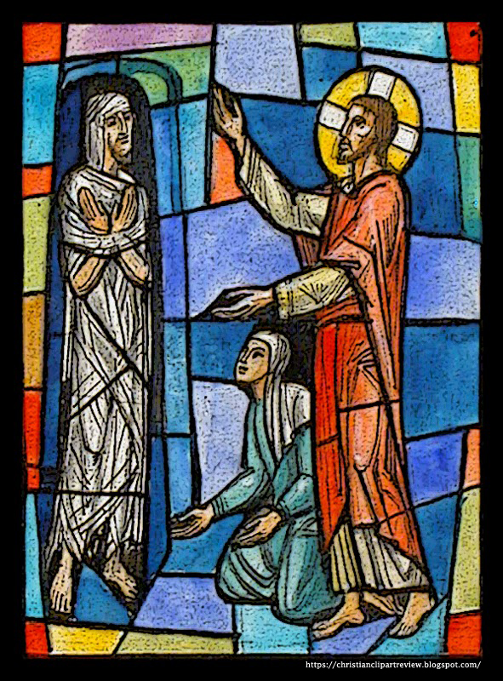

St. Christopher’s
Episcopal Church

The Rev. Daniel P. Strandlund
Vicar
303 Eastchester Drive, High Point, NC 27262
336.869.5311 · st-christopher.org · office@st-christopher.org

