holy eucharist: rite two

Prelude A Mighty Fortress Is Our God
*Processional Hymn I Sing A Song Of The Saints Of God Hymn #293

*Opening Acclamation BCP 355

*The Gloria Hymn #S-280

*The Collect of the Day

THE LITURGY OF THE WORD

First Lesson Isaiah 5:1-7

Psalm Psalm 80:7-14 BCP 703

Second Lesson Philippians 3:4b-14
*Sequence Hymn Lord Of All Hopefulness Hymn #482

*The Holy Gospel Matthew 21:33-46

The Sermon Fr. Daniel
*The Nicene Creed BCP 358
*The Prayers of the People-Form 4 BCP 388
Please pray for the following people this week: Carol and Dennis, Garry, Joan, Don, David B., Jeannette, Anne M., Dennis, Beverly, Deloris, Jenna and Liliana, Taylor, Cecil, Marianne.

The Confession and Absolution of Sins BCP 360
*The Exchange of Peace
Announcements, Birthdays and Anniversaries
OFFERTORY How Great Is Your Love! The loose plate offering today will go the Father Daniel’s Discretionary Fund. *Doxology Hymn #380, vs 3 *Signifies times to stand, if able.
THE HOLY EUCHARIST
Celebrant: All things come of Thee, O Lord
People: And of Thine own have we given Thee
*The Great Thanksgiving Rite II: Eucharistic Prayer A BCP 361
*Holy, Holy, Holy Hymn S#125
The Lord’s Prayer BCP 364
Fraction Anthem Hymn S#152 Invitation to Communion (All baptized persons are welcome at the Lord’s Table for communion.)
Communion Hymn Hear I AM Lord! Insert
Prayer after Communion BCP 365
*The Blessing
*Recessional Hymn Lift High The Cross Hymn #473
*Dismissal
To add someone to our parish prayer list, contact Esther Camm: prayforus26262@gmail.com
The Daughters of the King also pray for more confidential matters. To be added to their prayer list, please drop a prayer request card in the wooden box in the narthex.

Next Sunday: October 11, 2026, Morning Prayer with Jeanne Laute

Fr. Daniel is away for his Oxford residency starting next week. Our friend the Rev. Katy Campbell is on call for pastoral emergencies from October 8-27. Her cell phone # is (337) 852-9880. She’ll also supply for us on Oct 18.

Upcoming Events:
October 6th, Men’s Night Out, 6:00 PM, East of Texas Tex-Mex BBQ, WS
October 8th, Staying Alive, 1:00 PM, Parish Hall, Holiday Wreath making
October 20th, Ladies Lunch, 11:45 AM, Ma’Luz Mexican Grill, Northpoint Ave, HP
October 25th, Open Door Ministry Meal, see Giuseppe Ravazzani
November 8th, Bishop Sam Rodman will be visiting with us
November 15th, Advent Wreath Workshop, after the service
November 20th-21st, 2026, 211th Annual Convention, Benton Convention Center, WS Denise Huffman and Toni Routt are our delegates
Please remember the needs of the Northwood Community Center: toiletries and shelf stable foods
Our annual Angel Tree and Chefherds of Lambs outreach projects are coming up in November!
Handicapped accessible restrooms are located in the Parish House.
(Use the ramped entrance through the Parish Hall.)
Pastoral Needs The office is open on Tuesday, Wednesday, and THURSDAY, from 9:00-12:00 PM. Father Daniel is usually in the office on Tuesday and Wednesday. It is helpful for our front desk volunteers if you call the office (336-869-5311) ahead of your visit and let them know you are coming. in case of emergencies, Father’s cell phone number is 512-410-9413 and his email is Vicar@st-christopher.org
Website: st-christopher.org
Those Assisting in Worship Today
Crucifer: Owen Orefice
Acolyte: Ellie Orefice
Verger: Bob Bryant
Lectors: Tommie Lauer and Randy Foster
LEMS: Bob Bryant and Susan Pabon
Organ: Mark Hill Keyboard: Jim Augsburger Piano: Joan Rauch
Altar Guild: Jenny Niles-Orefice, Jean Lauten, Betsy Austin
Vestry Members of the Week: Toni Routt and Terry Ropic
Coffee Hour: 60th Anniversary Luncheon

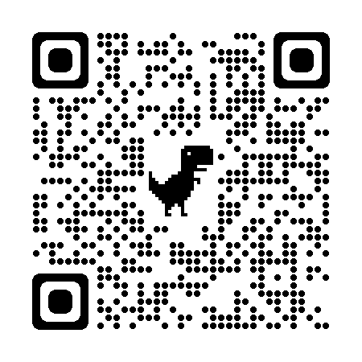
Vestry
Click this QR code to visit Vanco,
our online giving portal.
Toni Routt, Senior Warden
Joan Rauch, Junior Warden
Will Camm
Denise Huffman
Susan Pabon
Terry Ropic
Bob Bryant, Treasurer
Sarah Lawrence, Clerk

Nineteenth Sunday After Pentecost
60th Anniversary Celebration
October 4, 2026
10:00 AM


St. Christopher’s
Episcopal Church
Loving and serving God as we love, welcome, and serve all God’s people

The Rev. Daniel P. Strandlund, Rector
303 Eastchester Drive, High Point, NC 27262

Phone: 336-869-5311
email: office@st-christopher.org

