holy eucharist: rite two

Prelude Lift Every Voice and Sing
*Procession CHRIST WHOSE GLORY FILLS THE SKIES Hymn #7

*Opening Acclamation BCP 355

*Gloria S#280

*The Collect of the Day
THE LITURGY OF THE WORD

First Lesson Isaiah 49:1-7

Psalm Psalm 40:1-12 BCP 640

Second Lesson 1 Corinthians 1:1-9
*Sequence Hymn JESUS CALLS US O’ER THE TUMULT Hymn #550

*The Holy Gospel John 1:29-42

The Sermon Matthew Phillips
*The Nicene Creed BCP 358
*The Prayers Of The People Form 2 BCP 385 Please pray for Mary, Bill, Don, Jacki V, Carol, Dennis, Garry, Joan, Maryanne, Denise, TL, John, Shawn, Fr. Bob, Ruth, Jill, Betty, Don, Becky, Joe and Janet, Bernie, Ricky
The Confession and Absolution of Sins BCP 360
*The Exchange of Peace
Announcements, Birthdays and Anniversaries

Offertory We Shall Overcome
*Doxology Hymn #380 vs 3

*Signifies times to stand, if able.

THE HOLY EUCHARIST
Celebrant: All things come of Thee, O Lord
People: And of Thine own have we given Thee

*The Great Thanksgiving Rite II: Eucharistic Prayer B BCP 367

*Holy, Holy, Holy S#125

The Lord’s Prayer BCP 364
Fraction Anthem BCP 364
Invitation to Communion
(All baptized persons are welcome at the Lord’s Table for communion.)
Communion Hymn WHAT WONDROUS LOVE IS THIS Hymn #439

Prayer after Communion BCP 365
*The Blessing
*Recessional Hymn YE SERVANTS OF GOD Hymn #535

*Dismissal

If you seek prayer for someone or something and wish them to be included in our prayer list, please Contact Esther Camm at Sarahnicole151@yahoo.com

Next Sunday, January 25th, 10:00 AM, Morning Prayer with Bob Bryant

Upcoming events:
January 20th, 2026, Ladies’ Who Lunch, 11:45 AM, Gianno’s, H P
January 27th, 2026, Daughters of the King, 1:00 PM, Parish Hall
February 2nd, 2026, Knitting Group, 4:00-5:00 PM, Parish Hall
April 18th, 2026, Red Cross Blood Drive, 9:30AM-1:30 PM, Parish Hall
https://www.redcrossblood.org/give.html/drive-results?zipSponsor=St%20Christophers
Volunteering to be a part of the Transportation Ministry, Provide Coffee Hour refreshments or donate Altar Flowers is always appreciated. Please choose a Sunday from available opportunities and note it on the appropriate sign-up sheet to the right of the Coffee Hour tables in the Parish Hall. Thank you!
Handicapped accessible restrooms are located in the Parish House.
(Use the ramped entrance through the Parish Hall.)

Pastoral Needs The office is open on Tuesday, Wednesday, and Thursday from 9:00-12:00 PM. Father Daniel is usually in the office on Tuesday and Wednesday. It is helpful for our front desk volunteers if you call the office (336-869-5311) ahead of your visit and let them know you are coming. in case of emergencies, Father’s cell phone number is 512-410-9413 and his email is Vicar@st-christopher.org
Those Assisting in Worship Today
Lectors: Susan Pabon and Toni Routt
Acolyte: Ray Norman
Verger: Bob Bryant
LEMS: Catherine Barnes and Cynthia Watts
Organist: Mark Hill
Altar Guild: Cynthia Watts, Esther Camm, Denise Huffman
Coffee Hour Host: Fred and Cynthia Watts
Vestry Members of the Day: Toni Routt and Susan Pabon


Vestry
Click this QR code to visit Vanco,
our online giving portal.

Toni Routt-Senior Warden
Joan Rauch-Junior Warden
Will Camm
Denise Huffman
Susan Pabon
Terry Ropic
Bob Bryant, Treasurer
Sarah Lawrence, Clerk

Second Sunday after the Epiphany
January 18, 2026
10:00 AM

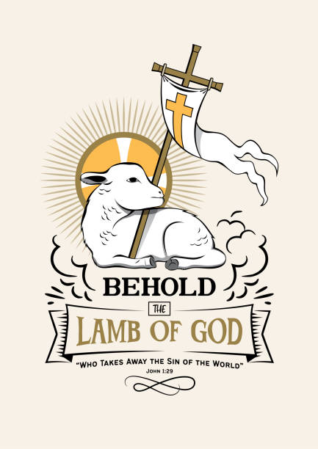

St. Christopher’s
Episcopal Church
Loving and serving God as we love, welcome, and serve all God’s people

The Rev. Daniel P. Strandlund, Rector
303 Eastchester Drive, High Point, NC 26262

Phone: 336-869-5311
email: office@st-christopher.org

