holy eucharist: rite two

Prelude You Are the Salt of the Earth
*Procession Alleluia! Sing To Jesus Hymn #460 vs 1-4

*Opening Acclamation BCP 355

*Gloria S#280

*The Collect of the Day
THE LITURGY OF THE WORD

First Lesson Exodus 24:12-18

Psalm Psalm 2 BCP 586

Second Lesson 2 Peter 1:16-21
*Sequence Hymn O Wondrous Type O Vision Fair Hymn #137

*The Holy Gospel Matthew 17:1-9

The Sermon Father Daniel
*The Nicene Creed BCP 358
*The Prayers Of The People Form 2 BCP 385 Please pray for Mary, Bill, Jacki V, Carol, Dennis, Garry, Joan, Maryanne, Denise, TL, John, Shawn, Fr. Bob, Ruth, Bonnie, Jill, Betty, Don, Becky, Janet, Bernie, Ricky, Edie, Alex, Cheryl, Sally, Jim, Victoria
The Confession and Absolution of Sins BCP 360
*The Exchange of Peace
Announcements, Birthdays and Anniversaries

Offertory Christ Upon The Mountain Peak
*Doxology Hymn #380 vs 3

*Signifies times to stand, if able.

THE HOLY EUCHARIST
Celebrant: All things come of Thee, O Lord
People: And of Thine own have we given Thee

*The Great Thanksgiving Rite II: Eucharistic Prayer B BCP 367

*Holy, Holy, Holy S#125

The Lord’s Prayer BCP 364
Fraction Anthem BCP 364
Invitation to Communion
(All baptized persons are welcome at the Lord’s Table for communion.)
Communion Hymn Draw Nigh And Take Hymn #327

Prayer after Communion BCP 365
*The Blessing
*Recessional Hymn O Zion Haste Hymn #539
*Dismissal
If you seek prayer for someone or something and wish them to be included in our parish prayer list, please Contact Esther Camm at prayforus26262@gmail.com
*** For confidential prayer requests seen only by the Daughters of the King, please complete a prayer request card and place it in the wooden box in the Narthex. ***

Next Sunday, February 22nd, 10:00 AM, Holy Eucharist with Father Daniel
Upcoming events:
February 17th, 2026, Ladies Who Lunch, 11:45 AM, Aqui es Mexico, Westchester Dr
February 18th, 2026, Ash Wednesday Service with Imposition of Ashes, 12:00 noon
February 22nd, Open Door Ministry meal, sign up in the Parish Hall
Paid reservations for the Staying Alive event on March 15th (Joseph and the Amazing Color Dreamcoat) must be made today. Each ticket is $22.00
February 24th, Daughters of the King, 1:00 PM, Parish Hall
February 25th, Bible Study, 6:00 PM, Parish Hall, each week through March 18th.
April 18th, 2026, Red Cross Blood Drive, 9:30AM-1:30 PM, Parish Hall
https://www.redcrossblood.org/give.html/drive-results?zipSponsor=St%20Christophers
Handicapped accessible restrooms are located in the Parish House.
(Use the ramped entrance through the Parish Hall.)

Pastoral Needs The office is open on Tuesday, Wednesday, and Thursday from 9:00-12:00 PM. Father Daniel is usually in the office on Tuesday and Wednesday. It is helpful for our front desk volunteers if you call the office (336-869-5311) ahead of your visit and let them know you are coming. in case of emergencies, Father’s cell phone number is 512-410-9413 and his email is Vicar@st-christopher.org
Those Assisting in Worship Today
Lectors: Toni Holder and Denise Huffman
Acolyte: Ray Norman
Verger: Bob Bryant
LEMS: Susan Pabon and Bob Bryant
Organist: Mark Hill Keyboard: Jim Augsburger Piano: Joan Rauch
Altar Guild: Melta Gibbs, Jenny Niles-Orefice, Jeanne Lauten
Coffee Hour Host: David and Toni Routt
Vestry Members of the Day: Joan Rauch and Terry Ropic


Vestry
Click this QR code to visit Vanco,
our online giving portal.

Toni Routt-Senior Warden
Joan Rauch-Junior Warden
Will Camm
Denise Huffman
Susan Pabon
Terry Ropic
Bob Bryant, Treasurer
Sarah Lawrence, Clerk

Last Sunday after the Epiphany
February 15, 2026
10:00 AM
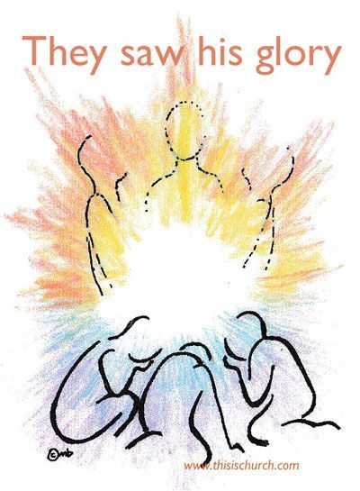

St. Christopher’s
Episcopal Church
Loving and serving God as we love, welcome, and serve all God’s people

The Rev. Daniel P. Strandlund, Rector
303 Eastchester Drive, High Point, NC 26262

Phone: 336-869-5311
email: office@st-christopher.org

