I received some comments or maybe correction on my teaching of the seals so I will let you read it.

The seal judgments are not external wars or food shortages. The second horseman wields the sword of God's word, the Scriptures, which are used according to people's will. The third horseman represents the famine of God's word. The fourth horseman represents false prophets, the savage wolves who destroy Christianity. The fifth seal does not represent physical execution, but the excommunication of faithful Christians from official denominations. The sixth seal does not represent the shaking of the earth's crust, but the shaking of the religious world, of carnal believers. Revelation reveals the judgment of the INNER world within man.

Many teach versions similar to this.

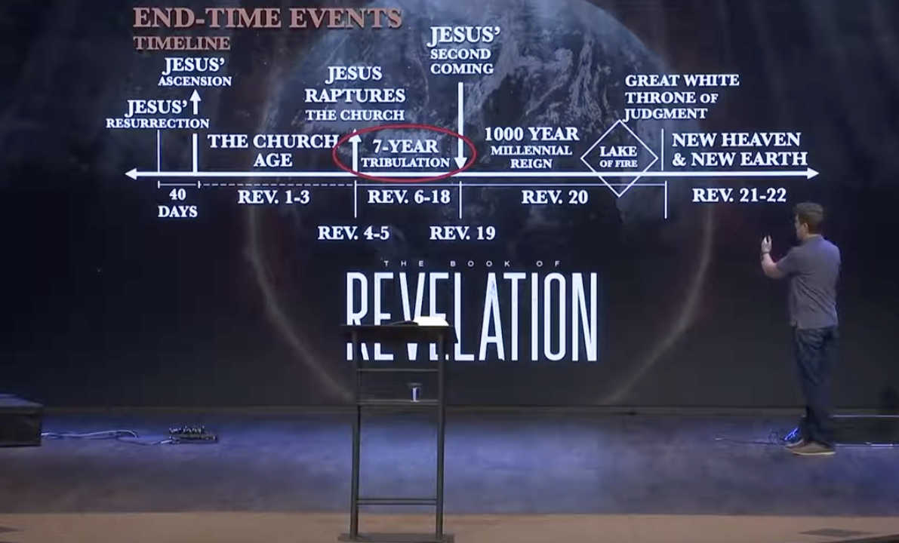

REVELATION 10
1 And I saw another mighty angel come down from heaven, clothed with a cloud: and a rainbow was upon his head, and his face was as it were the sun, and his feet as pillars of fire:

Angel always means messenger and the scripture does not completely identify this angel or messenger other than being mighty. One scripture tells us when Christ transformed His face was at the Sun

Christ is described a little different but who it is not important, or we would have been told. What is important is the message he will give, and all the Word is God speaking through His Son even if it is sent by a different angel. The Word of God does not originate from an angel but from God alone.

REVELATION 2:
18 And unto the angel of the church in Thyatira write; These things saith the Son of God, who hath his eyes like unto a flame of fire, and his feet are like fine brass;
REVELATION 10:
2 And he had in his hand a little book open: and he set his right foot upon the sea, and his left foot on the earth,

I believe the little book to contain the Word of God as the gospel because John was told to eat it and in verse 11, he was given a commission to prophecy before many people, nations and tongues, and kings. Ezekiel was given a similar commission.

EZEKIEL 2:
10 And he spread it before me; and it was written within and without: and there was written therein lamentations, and mourning, and woe.
EZEKIEL 3:
1 Moreover he said unto me, Son of man, eat that thou findest; eat this roll, and go speak unto the house of Israel.
2 So I opened my mouth, and he caused me to eat that roll.
3 And he said unto me, Son of man, cause thy belly to eat, and fill thy bowels with this roll that I give thee. Then did I eat it; and it was in my mouth as honey for sweetness.
4 And he said unto me, Son of man, go, get thee unto the house of Israel, and speak with my words unto them.
REVELATION 10:
3 And cried with a loud voice, as when a lion roareth: and when he had cried, seven thunders uttered their voices.
4 And when the seven thunders had uttered their voices, I was about to write: and I heard a voice from heaven saying unto me, Seal up those things which the seven thunders uttered, and write them not.

To try to say what the thunders uttered is against scripture they are not sealed they were never written. To put an interpretation to them would be to add to the book.

There are three book that we need to understand in the New Testament that are mentioned by name. The seven sealed book isnot given a name as this book in Revelation 10 is also not given a name other than a little book The names given are the book of life, the books of works and the book of the Revelation of Jesus Christ. I believe the book of Revelation ties all the scripture together.

REVELATION 22:
18 For I testify unto every man that heareth the words of the prophecy of this book, If any man shall add unto these things, God shall add unto him the plagues that are written in this book:
19 And if any man shall take away from the words of the book of this prophecy, God shall take away his part out of the book of life, and out of the holy city, and from the things which are written in this book.
REVELATION 10:
5 And the angel which I saw stand upon the sea and upon the earth lifted up his hand to heaven,
6 And sware by him that liveth for ever and ever, who created heaven, and the things that therein are, and the earth, and the things that therein are, and the sea, and the things which are therein, that there should be time no longer:

Most every translation say that there will no longer a delay. It is plain that many events continue to happen as time continues.

Berean Literal Bible
and he swore by the One living to the ages of the ages, who created heaven and the things in it, and the earth and the things in it, and the sea and the things in it, “There will be no longer delay!

When does this angel appear?

The angel came down was over two thousand years ago which is the same as Christ appeared to John by vision over 2000 years ago it is not a future event it came down to deliver a message to John. The time was after the 6th trumpet. If it would be future, then I would thank John would have to once again be there. The fact the angel stood on land and sea was where John was located as he was seeing the vision. It signifies a change is coming something different is about to take place. Let us look at a similar event in the book of Daniel.
DANIEL 12:
4 But thou, O Daniel, shut up the words, and seal the book, even to the time of the end: many shall run to and fro, and knowledge shall be increased
5 Then I Daniel looked, and, behold, there stood other two, the one on this side of the bank of the river, and the other on that side of the bank of the river.
6 And one said to the man clothed in linen, which was upon the waters of the river, How long shall it be to the end of these wonders?
7 And I heard the man clothed in linen, which was upon the waters of the river, when he held up his right hand and his left hand unto heaven, and sware by him that liveth for ever that it shall be for a time, times, and an half; and when he shall have accomplished to scatter the power of the holy people, all these things shall be finished.

This was speaking of future events but there would be a period of time, times, and a half which seems to mean 3 and ½ years you will find that period identified in the New Testament.

In the New Testament it is the time the mystery of God should be finished.

We need to know what is the mystery of God that will be finished by scripture not by our carnal thoughts. First of all, who has the mystery of God to finish it.

ROMANS 16:
25 Now to him that is of power to stablish you according to my gospel, and the preaching of Jesus Christ, according to the revelation of the mystery, which was kept secret since the world began,
I CORINTHIANS 4:
1 Let a man so account of us, as of the ministers of Christ, and stewards of the mysteries of God.
COLOSSIANS 2:
2 That their hearts might be comforted, being knit together in love, and unto all riches of the full assurance of understanding, to the acknowledgement of the mystery of God, and of the Father, and of Christ;

Acknowledgement: 1922 epignosis {ep-ig'-no-sis}precise and correct knowledge; used of the knowledge of things ethical and divine

This verse tells us who has the revelation of the Mystery of God or Christ which is God manifested in the flesh.
EPHESIANS 3:
4 Whereby, when ye read, ye may understand my knowledge in the mystery of Christ )
5 Which in other ages was not made known unto the sons of men, as it is now revealed unto his holy apostles and prophets by the Spirit;

The next verse tells us the mystery.

6 That the Gentiles should be fellowheirs, and of the same body, and partakers of his promise in Christ by the gospel:

If the trumpets were to the Jews or Israel, then that does not conclude until the seventh trumpet. The mystery of the separation of Israel and the gentiles is now over and revealed at the seventh trumpet which would be the seventh judgment in chapter 11.

REVELATION 10:
7 But in the days of the voice of the seventh angel, when he shall begin to sound, the mystery of God should be finished, as he hath declared to his servants the prophets.
8 And the voice which I heard from heaven spake unto me again, and said, Go and take the little book which is open in the hand of the angel which standeth upon the sea and upon the earth.

The mystery had already been revealed to his servants and there will be no further mysteries to be revealed.

Voice: 5456 phone {fo-nay'} a sound, a tone: of inanimate things, as musical instruments; the sound of uttered words.

That word is translated as a voice speaking and also as inanimate sounds as a trumpet.

MATTHEW 24:
31 And he shall send his angels with a great sound of a trumpet, and they shall gather together his elect from the four winds, from one end of heaven to the other.
I CORINTHIANS 14:
8 For if the trumpet give an uncertain who shall prepare himself to the battle?
REVELATION 10
9 And I went unto the angel, and said unto him, Give me the little book. And he said unto me, Take it, and eat it up; and it shall make thy belly bitter, but it shall be in thy mouth sweet as honey.
10 And I took the little book out of the angel's hand, and ate it up; and it was in my mouth sweet as honey: and as soon as I had eaten it, my belly was bitter.
11 And he said unto me, Thou must prophesy again before many peoples, and nations, and tongues, and kings.

John’s commission was to all the world showing that God’s mercy and dealing with Iseral was ending.

I am not going to get very far into the 11th chapter only to show that after the sixth trumpet God is dealing with Iseral.
REVELATION 11:
1 And there was given me a reed like unto a rod: and the angel stood, saying, Rise, and measure the temple of God, and the altar, and them that worship therein.
2 But the court which is without the temple leave out, and measure it not; for it is given unto the Gentiles: and the holy city shall they tread under foot forty and two months.
≠≠≠≠≠≠≠≠≠≠≠≠≠≠≠≠≠≠≠≠≠≠≠≠≠≠≠≠≠≠≠≠≠≠≠≠≠≠≠≠≠≠≠≠≠≠≠≠≠≠≠≠≠≠≠≠≠≠≠≠≠≠≠≠≠
J.C. Ryle
Matthew 11:1, "After Jesus had finished instructing His twelve disciples; He went on from there to teach and preach in the towns of Galilee."
A great change has taken place in the last forty years. A large quantity of church-work is continually being carried on both by clergymen and laymen, which, however well-meant, can hardly be called Christian--and in reality has a painful tendency to throw true Christian work into the background, if not to throw it entirely out!
No one, for instance, can fail to observe that a large number of professors are spending all their time and strength on church music, church decorations, church programs, and an incessant round of church attractions. Others are equally absorbed in social work, feeding the poor, and improved dwellings for everyone. Others are incessantly getting up popular concerts, secular lectures, and evening recreations. These things proclaim everywhere, that the way to do good is to amuse people!
Others are always occupied with secular clubs, and societies, and associations--and think that you are very wrong and heathenish, if you do not join them. Myriads of professors are restlessly busy about such mundane things from one end of the land to the other; and superficial observers are often saying, "What a great deal of church-work there is in these days!"
Now I would not for a moment be supposed to mean that all the things I have just mentioned, are wrong and wicked. Yet I doubt whether the present state of things is spiritually healthy. I doubt whether the work of the Holy Spirit on hearts and consciences, is not insensibly being left out in the cold and neglected. Amidst the incessant hustle and bustle about matters of entirely secondary importance--I doubt whether the sort of direct spiritual work to which Jesus and the Apostles wholly gave themselves, receives as much attention as it ought.
It is quite certain that musical performances, and church decorations, and concerts, and bazaars, and social work, and the like--will not save souls. It is equally certain that, without repentance, and faith, and holy living--that no one will enter Heaven. Do these simple, old-fashioned graces fill the place which they ought to do, in the daily proceedings of many so-called church-workers in this day? I exceedingly doubt it.
I certainly see on every side, a vast increase of what people call "church-work." But there is little or no increase of true religion. There undoubtedly is more show and glitter and display. But I extremely doubt whether there is more spiritual reality, and more practical godliness.
"He said to them: Go into all the world and preach the gospel to every creature!" Mark 16:15

