REVELATION 6:
1 And I saw when the Lamb opened one of the seals, and I heard, as it were the noise of thunder, one of the four beasts saying, Come and see.

The lamb (Christ the Son of God) is the only authority to bring judgment for God gave Him that position.
JOHN 5:
21 For as the Father raiseth up the dead, and quickeneth them; even so the Son quickeneth whom he will.
22 For the Father judgeth no man, but hath committed all judgment unto the Son:
23 That all men should honour the Son, even as they honour the Father. He that honoureth not the Son honoureth not the Father which hath sent him.

These seals have mostly been taught as something to come and private interpretations take over from that point.
My understanding will start with this scripture.

REVELATION 22:
10 And he saith unto me, Seal not the sayings of the prophecy of this book: for the time is at hand.

Is or were the seven seals a prophecy?

Prophecy: profhteiva from 4396 prophecy, i.e. a discourse emanating from divine inspiration and declaring the purposes of God, whether by reproving and admonishing the wicked, or comforting the afflicted, or revealing things hidden; esp. by foretelling future events.
REVELATION 1:
3 Blessed is he that readeth, and they that hear the words of this prophecy, and keep those things which are written therein: for the time is at hand.

Seven times when speaking to the churches we are told that they that have an ear to hear let them hear what the Spirit says. When speaking of prophecy Christ said reading must be linked with understanding.
MATTHEW 24:
15 When ye therefore shall see the abomination of desolation, spoken of by Daniel the prophet, stand in the holy place, (whoso readeth, let him understand:)
JAMES 1:
5 If any of you lack wisdom, let him ask of God, that giveth to all men liberally, and upbraideth not; and it shall be given him.
6 But let him ask in faith, nothing wavering. For he that wavereth is like a wave of the sea driven with the wind and tossed.
Three of the four horses are mentioned in the Old Testament the fourth horse has a different color.
ZECHARIAH 6:
1 And I turned, and lifted up mine eyes, and looked, and, behold, there came four chariots out from between two mountains; and the mountains were mountains of brass.
2 In the first chariot were red horses; and in the second chariot black horses;
3 And in the third chariot white horses; and in the fourth chariot grisled and bay horses.
4 Then I answered and said unto the angel that talked with me, What are these, my lord?
5 And the angel answered and said unto me, These are the four spirits of the heavens, which go forth from standing before the Lord of all the earth.

Grisled: 1261 » barod {baw-rode'} spotted, marked
Bay: 554 » 'amots {aw-mohts'} ) strong; adjective (of a horse) having irregular patches of two colors, typically black and white.

They came from mountains of brass and brass often speaks of judgment.

LEVITICUS 26:
19 And I will break the pride of your power; and I will make your heaven as iron, and your earth as brass:

The feet of Christ in the vision were also like brass.

REVELATION 1:
15 And his feet like unto fine brass, as if they burned in a furnace; and his voice as the sound of many waters.

The book of Revelations opens our understanding of many things more clearly that are spoken about in other scriptures. In Matthew we are told that Herod the king killed children in order to stop the prophecy of Christ the coming king.

MATTHEW 2:
16 Then Herod, when he saw that he was mocked of the wise men, was exceeding wroth, and sent forth, and slew all the children that were in Bethlehem, and in all the coasts thereof, from two years old and under, according to the time which he had diligently enquired of the wise men
REVELATION 12:
3 And there appeared another wonder in heaven; and behold a great red dragon, having seven heads and ten horns, and seven crowns upon his heads.
4 And his tail drew the third part of the stars of heaven, and did cast them to the earth: and the dragon stood before the woman which was ready to be delivered, for to devour her child as soon as it was born.
Herod was the vessel, but the source was Satan motivating him.

Because Christ is represented as being seated, I believe the seals were opened at the beginning after His ascending to heaven. Opened to show events that would happen until the end so the Christian would understand.
AMOS 3:
7 Surely the Lord GOD will do nothing, but he revealeth his secret unto his servants the prophets.

Christ certainly was the fulfillment of being a prophet.

ACTS 3:
22 For Moses truly said unto the fathers, A prophet shall the Lord your God raise up unto you of your brethren, like unto me; him shall ye hear in all things whatsoever he shall say unto you.
23 And it shall come to pass, that every soul, which will not hear that prophet, shall be destroyed from among the people.
24 Yea, and all the prophets from Samuel and those that follow after, as many as have spoken, have likewise foretold of these days.
REVELATION 6:
2 And I saw, and behold a white horse: and he that sat on him had a bow; and a crown was given unto him: and he went forth conquering, and to conquer.

There are many man-made interpretations to these scriptures as some say the white horse s Christ others say it is the antichrist and others in the reformed church teach it is a Muslim as John Macauthor taught.

It is not Christ because He conquered all at Calvary and is always shown with a sword not a bow.
COLOSSIANS 2:
13 And you, being dead in your sins and the uncircumcision of your flesh, hath he quickened together with him, having forgiven you all trespasses;
14 Blotting out the handwriting of ordinances that was against us, which was contrary to us, and took it out of the way, nailing it to his cross;
15 And having spoiled principalities and powers, he made a shew of them openly, triumphing over them in it.

I could go into many explanations of different things taught but by scripture I believe it means what it says. Jesus separated the wars from the false Christ which is openly against Christ but by works is against Christ.

MATTHEW 24:
5 For many shall come in my name, saying, I am Christ; and shall deceive many.

That is the false Christ not a physical force but a spiritual one.

EPHESIANS 6:
12 For we wrestle not against flesh and blood, but against principalities, against powers, against the rulers of the darkness of this world, against spiritual wickedness in high places.

Satan uses the lust of the flesh to cause wars and God allows wars as in the Old Testament for judgment.
JAMES 4
» 1 † ¶ From whence come wars and fightings among you? come they not hence, even of your lusts that war in your members?
MATTHEW 24:
6 And ye shall hear of wars and rumours of wars: see that ye be not troubled: for all these things must come to pass, but the end is not yet.
7 For nation shall rise against nation, and kingdom against kingdom: and there shall be famines, and pestilences, and earthquakes, in divers places.
8 All these are the beginning of sorrows.

Every war is started by someone going forth to conquer and from that we find the next seal opened.
REVELATION 6:
3 And when he had opened the second seal, I heard the second beast say, Come and see.
4 And there went out another horse that was red: and power was given to him that sat thereon to take peace from the earth, and that they should kill one another: and there was given unto him a great sword.

There have been two what is called world wars in my lifetime and many before and wars will continue until the coming of Christ stops them. Can anyone say that people are not killing one another at this day and hour?

In the Old Testament the horses quieted God’s Spirit and wars are also part of God sending judgment on generations that do not love or serve Him.

REVELATION 6:
5 And when he had opened the third seal, I heard the third beast say, Come and see. And I beheld, and lo a black horse; and he that sat on him had a pair of balances in his hand.
6 And I heard a voice in the midst of the four beasts say, A measure of wheat for a penny, and three measures of barley for a penny; and see thou hurt not the oil and the wine.
I do know in all wars generally there is also a rationing of what is available and is happening now in Iran and Ukraine and other places as war happens It also happened in this country doing the world wars. I know oil and wine is used as elements in worship mostly in the old testament. I will not interpret that, but I will say that no war or disaster will every effect true worship. Wine is a symbol of the truth in a prepared vessel.
LUKE 5:
37 And no man putteth new wine into old bottles; else the new wine will burst the bottles, and be spilled, and the bottles shall perish.
38 But new wine must be put into new bottles; and both are preserved.

Oil is used as symbols of spiritual light.

MATTHEW 25:
8 And the foolish said unto the wise, Give us of your oil; for our lamps are gone out.
9 But the wise answered, saying, Not so; lest there be not enough for us and you: but go ye rather to them that sell, and buy for yourselves.
EXODUS 27:
20 And thou shalt command the children of Israel, that they bring thee pure oil olive beaten for the light, to cause the lamp to burn always.
ZECHARIAH 4:
11 Then answered I, and said unto him, What are these two olive trees upon the right side of the candlestick and upon the left side thereof?
12 And I answered again, and said unto him, What be these two olive branches which through the two golden pipes empty the golden oil out of themselves?
13 And he answered me and said, Knowest thou not what these be? And I said, No, my lord.
14 Then said he, These are the two anointed ones, that stand by the Lord of the whole earth
REVELATION 6
7 And when he had opened the fourth seal, I heard the voice of the fourth beast say, Come and see.
8 And I looked, and behold a pale horse: and his name that sat on him was Death, and Hell followed with him. And power was given unto them over the fourth part of the earth, to kill with sword, and with hunger, and with death, and with the beasts of the earth.

We know many religions teach a three and one half or a seven year tribulation and usually teach that the opening of the seals happens at that time but if there would be a “great” tribulation it would include the whole world not just a fourth. Today I believe it would be safe to say that 25% (a fourth part) of the world is in war at this time. Different zones and countries have different definitions of wars but a war is a war.

Major Armed Conflicts by Region (High Severity)

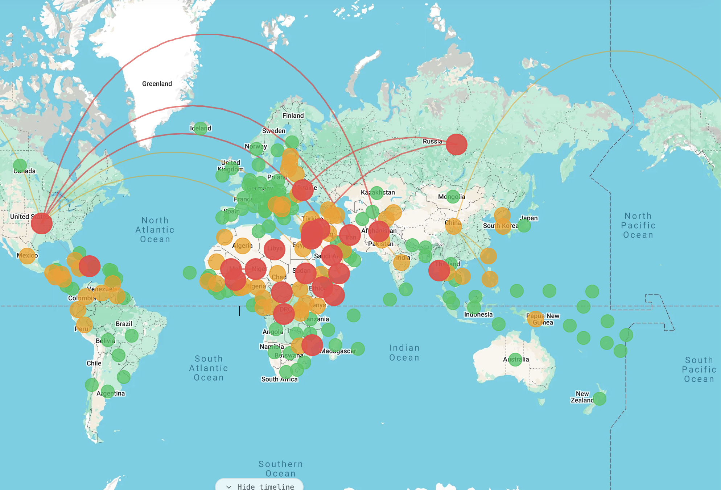

In every war there is death and sometimes Christians are also killed as is most likely today that is why the next seal is important to every Christian.

REVELATION 6:
9 And when he had opened the fifth seal, I saw under the altar the souls of them that were slain for the word of God, and for the testimony which they held:
10 And they cried with a loud voice, saying, How long, O Lord, holy and true, dost thou not judge and avenge our blood on them that dwell on the earth?
11 And white robes were given unto every one of them; and it was said unto them, that they should rest yet for a little season, until their fellowservants also and their brethren, that should be killed as they were, should be fulfilled.

At the time this seal was opened Christ had not yet come and Christians would continue to be killed, and wars would continue until the events of the sixth seal happen.

REVELATION 6:
12 And I beheld when he had opened the sixth seal, and, lo, there was a great earthquake; and the sun became black as sackcloth of hair, and the moon became as blood;
13 And the stars of heaven fell unto the earth, even as a fig tree casteth her untimely figs, when she is shaken of a mighty wind.
14 And the heaven departed as a scroll when it is rolled together; and every mountain and island were moved out of their places.
15 And the kings of the earth, and the great men, and the rich men, and the chief captains, and the mighty men, and every bondman, and every free man, hid themselves in the dens and in the rocks of the mountains;
16 And said to the mountains and rocks, Fall on us, and hide us from the face of him that sitteth on the throne, and from the wrath of the Lamb:
17 For the great day of his wrath is come; and who shall be able to stand?

This is the fulfilling of scripture that Christ spoke about when the first resurrection occurs and the living saints will be caught up.

ISAIAH 13:
9 Behold, the day of the LORD cometh, cruel both with wrath and fierce anger, to lay the land desolate: and he shall destroy the sinners thereof out of it.
10 For the stars of heaven and the constellations thereof shall not give their light: the sun shall be darkened in his going forth, and the moon shall not cause her light to shine.
11 And I will punish the world for their evil, and the wicked for their iniquity; and I will cause the arrogancy of the proud to cease, and will lay low the haughtiness of the terrible.
MATTHEW 24
29 Immediately after the tribulation of those days shall the sun be darkened, and the moon shall not give her light, and the stars shall fall from heaven, and the powers of the heavens shall be shaken:
30 And then shall appear the sign of the Son of man in heaven: and then shall all the tribes of the earth mourn, and they shall see the Son of man coming in the clouds of heaven with power and great glory.
31 And he shall send his angels with a great sound of a trumpet, and they shall gather together his elect from the four winds, from one end of heaven to the other.

The tribulation of those days could be defined by what has happened in the first four opening of the seals.
≠≠≠≠≠≠≠≠≠≠≠≠≠≠≠≠≠≠≠≠≠≠≠≠≠≠≠≠≠≠≠≠≠≠≠≠≠≠≠≠≠≠≠≠≠≠≠≠≠≠≠≠≠≠≠≠≠≠≠≠≠≠≠≠≠
ROMANS SEVEN
“For we know that the law is spiritual: but I am carnal, sold under sin. For that which I do I allow not: for what I would, that do I not; but what I hate, that do I. If then I do that which I would not, I consent unto the law that it is good. Now then it is no more I that do it, but sin that dwelleth in me” (Rom. 7:14-17).
1. The law (that system which makes obedience the condition of life and makes righteousness depend on perfect obedience) can never deliver a person from the curse and dominion of sin. If a man is to be justified,he must be delivered from the law as a covenant or method of obtaining life and be brought into Christ, who is our righteousness.
2. The law can tell a person what is right and what is wrong. It can command a man to avoid wrong and do right. It can threaten, condemn, and curse him if he does not comply; but it cannot eradicate his sinful inclinations (rather, it irritates and stimulates them). So, instead of becoming better and happier under the law, we become more depraved and more wretched as knowledge of the law increases.
3. The law in the hands of the Holy Spirit does not stop sin; it reveals sin. It does not give life;
it kills. It does not make men holy; it exposes their un-holiness.
4. Even now that I am regenerated and in Christ, now that I am brought under influences which make me love and delight in God's law, I still feel my inability and my imperfections. The struggle is like a civil war within me. I did not look to the law for justification, nor can I look to the law for sanctification! I look to Christ for both. Paul proved from his past experience that the law cannot make a saved man holy. Both justification and sanctification are in Christ.
Oh, unhappy, pitiful, and wretched man that I am! Who will release and deliver me from the shackles of this body of death? Oh, thank God, He will, through Jesus Christ the Anointed One!
Henry T. Mahan
Can anyone identify who this woman on the next page represents? I will give the answer next service Lord willing. If anyone has an idea or knows please let me know.

