DEUTERONOMY 29:
29 The secret things belong unto the LORD our God: but those things which are revealed belong unto us and to our children for ever, that we may do all the words of this law.
ISAIAH 41:
21Produce your cause, saith the LORD; bring forth your strong reasons, saith the King of Jacob.
22 Let them bring them forth, and shew us what shall happen: let them shew the former things, what they be, that we may consider them, and know the latter end of them; or declare us things for to come.
23 Shew the things that are to come hereafter, that we may know that ye are gods: yea, do good, or do evil, that we may be dismayed, and behold it together.
24 Behold, ye are of nothing, and your work of nought: an abomination is he that chooseth you.
ISAIAH 45:
6 That they may know from the rising of the sun, and from the west, that there is none beside me. I am the LORD, and there is none else.

https://www.neverthirsty.org/bible-studies/book-of-revelation/timelines-of-revelation/
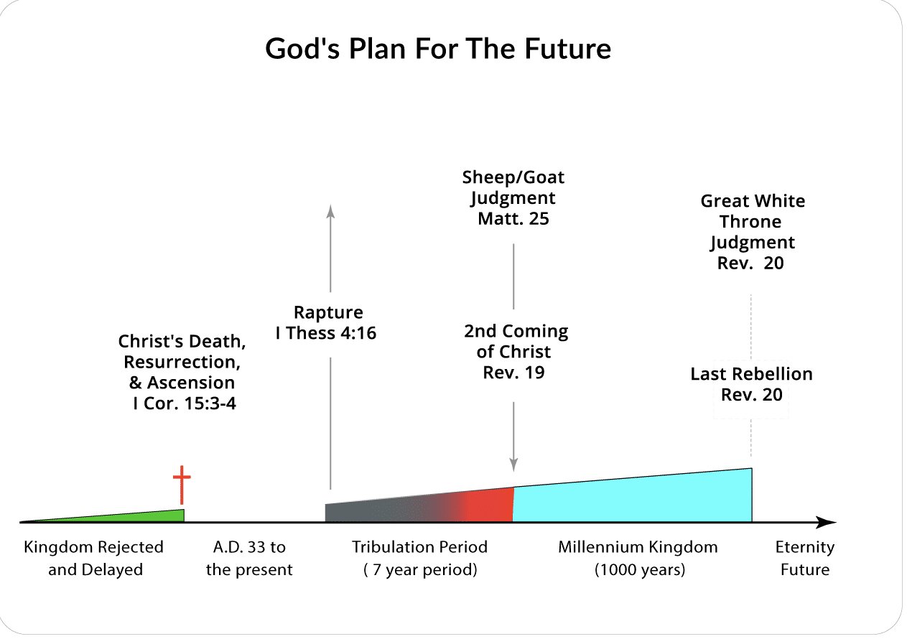

This is not my Chart, and I sincerely doubt it is God’s plan for the future as they are so bodily state. This chart is as 100’s of other with the exception some believe in a 3 ½ year tribulation period.

The purpose of God cannot be understood before the event happens even at that point still God Himself through the Holy Ghost must reveal it to the individual.

No one understood how God would fulfil through John the Baptist the coming of Elijah or even John being the forerunner of Christ how Christ would come and the events surrounding Him and the many scriptures fulfilled could not be known until at or after the event.

My purpose is to show events that could be the fulfilling of scripture and to avoid saying things that have no scripture.

Nearly all teach these two prophets come doing the 7 or 3 ½ year tribulation period. That is taken from these scriptures.

REVELATION 11:
1 And there was given me a reed like unto a rod: and the angel stood, saying, Rise, and measure the temple of God, and the altar, and them that worship therein.
2 But the court which is without the temple leave out, and measure it not; for it is given unto the Gentiles: and the holy city shall they tread under foot forty and two months.
3 And I will give power unto my two witnesses, and they shall prophesy a thousand two hundred and threescore days, clothed in sackcloth.
REVELATION 12:
6 And the woman fled into the wilderness, where she hath a place prepared of God, that they should feed her there a thousand two hundred and threescore days.
REVELATION 12:
14 And to the woman were given two wings of a great eagle, that she might fly into the wilderness, into her place, where she is nourished for a time, and times, and half a time, from the face of the serpent.
REVELATION 13:
5 And there was given unto him a mouth speaking great things and blasphemies; and power was given unto him to continue forty and two months.
DANIEL 12:
7 And I heard the man clothed in linen, which was upon the waters of the river, when he held up his right hand and his left hand unto heaven, and sware by him that liveth for ever that it shall be for a time, times, and an half; and when he shall have accomplished to scatter the power of the holy people, all these things shall be finished.
DANIEL 12:
11 And from the time that the daily sacrifice shall be taken away, and the abomination that maketh desolate set up, there shall be a thousand two hundred and ninety days.

I do not see the word “tribulation” in any of those verses. Yet by combining or splitting them and using a lot of imagination you might come up with that.

God can and has fulfilled his Word by actual events and other time with spiritual fulfilment that has nothing to do with the actual even like John the Baptist was spiritual Elijah.
REVELATION 11:
1 And there was given me a reed like unto a rod: and the angel stood, saying, Rise, and measure the temple of God, and the altar, and them that worship therein.
2 But the court which is without the temple leave out, and measure it not; for it is given unto the Gentiles: and the holy city shall they tread under foot forty and two months.

Let’s try to set a time for what John was seeing. There is no proven date for when John seen the visions and wrote the book of Revelation many dates or disputed among what is called scholars.

If this is a future date then I leave it to be the way God will make it happen, but two things cause me to reconsider.

One in the New Testament there is only one temple of God.

I CORINTHIANS 3:
16 Know ye not that ye are the temple of God, and that the Spirit of God dwelleth in you?
17 If any man defile the temple of God, him shall God destroy; for the temple of God is holy, which temple ye are.
II CORINTHIANS 6:
16 And what agreement hath the temple of God with idols? for ye are the temple of the living God; as God hath said, I will dwell in them, and walk in them; and I will be their God, and they shall be my people.
EPHESIANS 2:
21 In whom all the building fitly framed together groweth unto an holy temple in the Lord:

To measure or number would be impossible for the redeemed.

REVELATION 7:
9 After this I beheld, and, lo, a great multitude, which no man could number, of all nations, and kindreds, and people, and tongues, stood before the throne, and before the Lamb, clothed with white robes, and palms in their hands;

I do not know at what point that the temple in Jerusalem was still considered holy but after it was destroyed, I do not believe it would be holy from that time. Neither is there any scripture except by carnal interpretation for another “holy” temple.

Also consider that Jerusalem was called the Holy City but shortly after this was given a different name in verse 8.

3 And I will give power unto my two witnesses, and they shall prophesy a thousand two hundred and threescore days, clothed in sackcloth.

Note borrowing from the next chapter it is the same amount of time.

REVELATION 12:
6 And the woman fled into the wilderness, where she hath a place prepared of God, that they should feed her there a thousand two hundred and threescore days.

By scripture who are these two witnesses, and we know who they are.

REVELATION 11:
4 These are the two olive trees, and the two candlesticks standing before the God of the earth.
ZECHARIAH 4:
11 Then answered I, and said unto him, What are these two olive trees upon the right side of the candlestick and upon the left side thereof?
12 And I answered again, and said unto him, What be these two olive branches which through the two golden pipes empty the golden oil out of themselves?
13 And he answered me and said, Knowest thou not what these be? And I said, No, my lord.
14 Then said he, These are the two anointed ones, that stand by the Lord of the whole earth.
REVELATION 10:
5 And if any man will hurt them, fire proceedeth out of their mouth, and devoureth their enemies: and if any man will hurt them, he must in this manner be killed.
6 These have power to shut heaven, that it rain not in the days of their prophecy: and have power over waters to turn them to blood, and to smite the earth with all plagues, as often as they will.

Please note these have the power to shut heaven, stop it from raining, turn water to blood and smite with Plagues but it is not written that they did that.

The scriptural identification for the two witnesses is Moses and Elijah at least by their attributes or fruit as Jesus said a tree is known by its fruit.
EXODUS 7:
20 And Moses and Aaron did so, as the LORD commanded; and he lifted up the rod, and smote the waters that were in the river, in the sight of Pharaoh, and in the sight of his servants; and all the waters that were in the river were turned to blood.
I KINGS 17:
1 And Elijah the Tishbite, who was of the inhabitants of Gilead, said unto Ahab, As the LORD God of Israel liveth, before whom I stand, there shall not be dew nor rain these years, but according to my word.

Fire from their mouth would not likely be possible in a fleshly body and I know with God all things are possible.

From this point we are left with three possibilities.

- This is a future event and has not occurred.
- This is an event in the past that has occurred but there is no historical record.
- This is an event that is a spiritual type not a physical.

I am going to go to scripture and leave the finial interpretation to our Lord.

First, they are prophets, and they have always stood before the Lord according to
Zechariah. Certainly, Moses represented the Law.

JOHN 1:
17 For the law was given by Moses, but grace and truth came by Jesus Christ.
Elijah was a prophet but never wrote a book. God considered Elijah important.
MALACHI 4:
5 Behold, I will send you Elijah the prophet before the coming of the great and dreadful day of the LORD:
6 And he shall turn the heart of the fathers to the children, and the heart of the children to their fathers, lest I come and smite the earth with a curse.

Jesus by vision spoke to both Moses and Elijah doing His ministry.

MATTHEW 17:
1 And after six days Jesus taketh Peter, James, and John his brother, and bringeth them up into an high mountain apart,
2 And was transfigured before them: and his face did shine as the sun, and his raiment was white as the light.
3 And, behold, there appeared unto them Moses and Elias talking with him.
4 Then answered Peter, and said unto Jesus, Lord, it is good for us to be here: if thou wilt, let us make here three tabernacles; one for thee, and one for Moses, and one for Elias.
5 While he yet spake, behold, a bright cloud overshadowed them: and behold a voice out of the cloud, which said, This is my beloved Son, in whom I am well pleased; hear ye him.
MATTHEW 17:
9 And as they came down from the mountain, Jesus charged them, saying, Tell the vision to no man, until the Son of man be risen again from the dead.
7 And when they shall have finished their testimony, the beast that ascendeth out of the bottomless pit shall make war against them, and shall overcome them, and kill them.
8 And their dead bodies shall lie in the street of the great city, which spiritually is called Sodom and Egypt, where also our Lord was crucified.

By scripture there came a time that Jerusalem was no longer nor will ever be a Holy City as far as the one on earth is concerned as New Testament scripture point to the heavenly Jerusalem not an earthly one.
GALATIANS 4:
24 Which things are an allegory: for these are the two covenants; the one from the mount Sinai, which gendereth to bondage, which is Agar.
25 For this Agar is mount Sinai in Arabia, and answereth to Jerusalem which now is, and is in bondage with her children.
26 But Jerusalem which is above is free, which is the mother of us all.
REVELATION 11:
9 And they of the people and kindreds and tongues and nations shall see their dead bodies three days and an half, and shall not suffer their dead bodies to be put in graves.
10 And they that dwell upon the earth shall rejoice over them, and make merry, and shall send gifts one to another; because these two prophets tormented them that dwelt on the earth.
11 And after three days and an half the Spirit of life from God entered into them, and they stood upon their feet; and great fear fell upon them which saw them.
12 And they heard a great voice from heaven saying unto them, Come up hither. And they ascended up to heaven in a cloud; and their enemies beheld them.
13 And the same hour was there a great earthquake, and the tenth part of the city fell, and in the earthquake were slain of men seven thousand: and the remnant were affrighted, and gave glory to the God of heaven.
14 The second woe is past; and, behold, the third woe cometh quickly.
15 And the seventh angel sounded; and there were great voices in heaven, saying, The kingdoms of this world are become the kingdoms of our Lord, and of his Christ; and he shall reign for ever and ever.
16 And the four and twenty elders, which sat before God on their seats, fell upon their faces, and worshipped God,
17 Saying, We give thee thanks, O Lord God Almighty, which art, and wast, and art to come; because thou hast taken to thee thy great power, and hast reigned.
18 And the nations were angry, and thy wrath is come, and the time of the dead, that they should be judged, and that thou shouldest give reward unto thy servants the prophets, and to the saints, and them that fear thy name, small and great; and shouldest
19 And the temple of God was opened in heaven, and there was seen in his temple the ark of his testament: and there were lightnings, and voices, and thunderings, and an earthquake, and great hail.
≠≠≠≠≠≠≠≠≠≠≠≠≠≠≠≠≠≠≠≠≠≠≠≠≠≠≠≠≠≠≠≠≠≠≠≠≠≠≠≠≠≠≠≠≠≠≠≠≠≠≠≠≠≠≠≠≠≠≠≠≠≠≠≠≠≠
Archibald Brown
An evil is in the 'professed' camp of the Lord, so gross in its impudence, that the most short-sighted Christian can hardly fail to notice it. During the past few years this evil has developed at an alarming rate. It has worked like leaven, until the whole lump ferments!
The devil has seldom done a more clever thing, than hinting to the Church that part of their mission is to provide entertainment for the people, with a view to winning them. From speaking out the gospel, the Church has gradually toned down her testimony--then winked at and excused the frivolities of the day. Then she tolerated them in her borders. Now she has adopted them under the plea of reaching the masses!
My first contention is that providing amusement for the people is nowhere spoken of in the Scriptures as a function of the Church. If it is a Christian work, then why did not Christ speak of it? "Go into all the world and preach the gospel to every creature--and provide amusement for those who do not relish the gospel."
No such words, however, are to be found. It did not seem to occur to Him. Where do entertainers come in? The Holy Spirit is silent concerning them. Were the prophets persecuted because they amused the people--or because they confronted them? The 'concert' has no martyr roll.
Again, providing amusement is in direct opposition to the teaching and life of Christ and all His apostles. What was the attitude of the apostolic Church to the world? "You are the salt of the world"--not the sugar candy. You are something the world will spit out--not swallow.
Had Jesus introduced more of the bright and pleasant elements into His teaching, He would have been more popular. When "many of His disciples turned back and no longer followed Him," I do not hear Him say: "Run after these people, Peter, and tell them we will have a different style of service tomorrow; something short and attractive, with little preaching. We will have a pleasant evening for the people. Tell them they will be sure to enjoy it! Be quick, Peter, we must get the people somehow!"
No! Jesus pitied sinners, sighed and wept over them--but never sought to amuse them!
In vain will the epistles be searched to find any trace of the 'gospel of amusement.' Their message is, "Therefore, come out from them and separate yourselves from them . . . Don't touch their filthy things..." Anything approaching amusement is conspicuous by its absence. They had boundless confidence in the gospel, and employed no other weapon.
After Peter and John were locked up for preaching, the Church had a prayer meeting, but they did not pray: "Lord, grant unto your servants that by a wise and discriminating use of innocent recreation we may show these people how happy we are!"
No! They did not cease from preaching Christ! They had no time for arranging entertainments. Scattered by persecution, they went everywhere preaching the gospel. They turned the world upside down--that is the only difference from today's church.
Lastly, amusement fails to effect the end desired. Let the heavy-laden who found peace through the concert, not keep silent! Let the drunkard to whom the dramatic entertainment had been God's link in the chain of their conversion, stand up! There are none to answer! The mission of amusement produces no converts!
The need of the hour for today's ministry is earnest spirituality joined with Biblical doctrine, so understood and felt, that it sets men on fire.
Lord, clear the Church of all the rot and rubbish the devil has imposed on her, and bring us back to apostolic methods!

