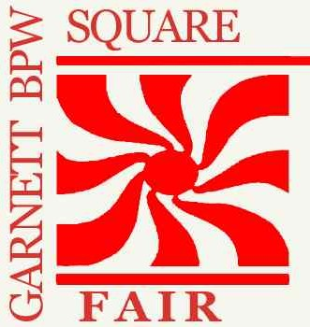
52nd ANNUAL
GARNETT BPW SQUARE FAIR

Saturday, May 10, 2025
9:00 AM to 3:00 PM
Courthouse Square, Garnett, Kansas
EXHIBITOR INFO

Notification of your exhibit will be sent upon receipt of your registration and payment.

It is the responsibility of all exhibitors to collect and remit Kansas sales tax (Garnett/Anderson County: 8.00%). Vendors providing food must adhere to all Kansas Department of Health and Environment regulations.
Overnight Lodging
Chamber Office
(785) 448-6767
Camping Site Info
Garnett City Hall
(785) 448-5496
ALL SPACES 10’ X 10’ If your exhibit doesn’t fit these dimensions, order extra spaces. Payment must accompany registration.

ELECTRICITY WILL BE PROVIDED ON REQUEST ONLY. Limited spaces with electricity are available.

EXHIBITORS MUST PROVIDE OWN TENTS, TABLES, CHAIRS, & DISPLAY SUPPLIES.

SEND PAYMENT AND COMPLETED ENTRY FORM (BELOW) TO:
Garnett BPW, P.O. Box 97, Garnett, Ks, 66032
For more information - email garnettbpw@yahoo.com
NO REFUNDS ON REGISTRATION & PAYMENT. If organizers cancel due to inclement weather, ½ of registration fee will be refunded.

SETUP PERMITTED THE NIGHT BEFORE AT EXHIBITOR’S OWN RISK. NO CAMPING PERMITTED ON THE SQUARE.

It is the responsibility of each exhibitor to execute the individual sales tax requirements. Garnett sales tax rate is 8.00%
- - - - - - - - - - - - - - – - - - - - - - - -- - - - - - – - - - - - - - - - - - (DETACH HERE) - - - - - - - - - - - - - - - - - - - - - - - - - - - - - - - - - - - - – -
GARNETT SQUARE FAIR REGISTRATION FORM
QUANTITY OF 10’ X10’ SECTIONS DESIRED X $50 = $
Registration Deadline is 5/1/25 and includes additional digital marketing.
Registrations received after 5/1/25 will NOT receive additional digital marketing.
MAKE CHECKS PAYABLE TO GARNETT BPW.

NAME: (PLEASE PRINT) PHONE ( )

ADDRESS _________________________________________________________________

CITY _____________________ ST ________ ZIP

TYPE OF MERCHANDISE:

E-MAIL:

YOUR BUSINESS WEBSITE:_______________________________________________________________________ I WILL NEED ELECTRICITY □ 110V □ 220V
I agree that the Anderson County Commissioners, City Of Garnett, Garnett Chamber of Commerce, and Garnett Business and Professional Women are not responsible for any injury to Person or for loss or damage to articles while on exhibit during the Square Fair, May 10, 2025.

SIGN HERE► X

