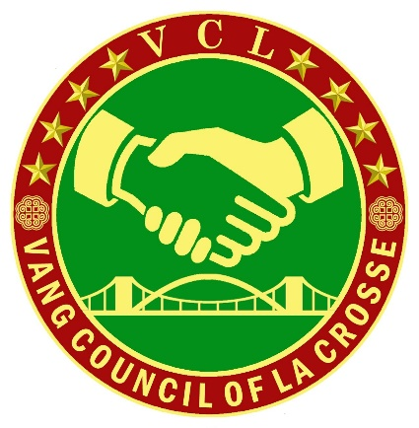

Vang Council of La Crosse Hmong Language & Literacy Class Registration Form

Student’s Name: _______________________________________________________________

Address: ____________________________________________ City: _____________________

State: _________ Phone Number: ____________________________________ Gender:_______

Birthdate: ______________________ Age: ___________

School: _________________________________ Grade: ________

Emergency Contact Name: ___________________________ Phone: ______________________

Emergency Contact Relationship: ______________________ Hospital: ____________________

Known Allergies: __________________________________

Waiver of Liability

This is to certify that I, as a parent/legal guardian with legal responsibility for my child, do consent and agree to his/her participation in the Hmong Language & Literacy Class provided by the Vang Council of La Crosse, Inc. I do hereby waive, release, and hold harmless the organization, its officers, board members, staff, and representatives for any injury that may be suffered by my child in the normal course of participation in the class and the activities thereof, whether the result of negligence of any other cause.

Parents Name: _________________________________________________________________

Parent Signature: _____________________________________ Date: _____________________