TPD 304 Storyboard
Transportation Programs Division
Center of Excellence
Professional Development Academy

Self-Paced Articulate Rise Course

Description
This self-paced module guides learners through the core features and functionality of the TxDOTCONNECT web-based platform. Designed with novel interactive elements that emulate the live TxDOTCONNECT environment, the module allows staff to practice navigating the system in a safe, hands-on setting.

Delivery
This module will be delivered as a self-paced Rise course accessible through TxDOT’s PeopleSoft Professional Development platform. Learners will engage with interactive, simulation-based activities that mirror the TxDOTCONNECT web-based environment, allowing them to practice essential navigation skills directly within the course.

Audience
This course is designed for TxDOT employees and contracted staff who interact with the TxDOTCONNECT platform as part of their daily responsibilities. It is also well-suited for any TxDOT employee seeking to expand their understanding of how TxDOTCONNECT functions.

Included Resources
CROSSROADS LINK/REF MATERIALS
- Security Roles Catalog
- Searching for a Project
- Project Information Reference Guide
TxDOTCONNECT_training@txdot.gov

Course Section 1: Introduction

Lesson 1: Welcome to TxDOTCONNECT!

Rise Block – Paragraph with heading
Welcome to TxDOTCONNECT!
This self-paced module provides the foundational skills needed to navigate and utilize TxDOT CONNECT with confidence. Learners will start with the basics of logging in, then progress through key features that streamline daily workflows. The course covers:

Rise Block – Bulleted List
- Using the Tools Menu to access core functionalities
- Exploring Project Pages to understand structure, data, and workflow relevance
- Applying the Search Feature to quickly locate and open projects
- Navigating with the Left Menu to move seamlessly between sections
- Interpreting and filtering data in the Project Location Map

Rise Block – Paragraph
By the end of this module, you will be able to demonstrate essential navigation skills, apply core functions, and efficiently access the tools they need to perform their job duties within the TxDOTCONNECT environment.

Rise Block – Continue Button
[Continue to Next Lesson]

Lesson 2: The Basics of TxDOTCONNECT

Rise Block – Heading
Getting Started

Rise Block – Image & Text
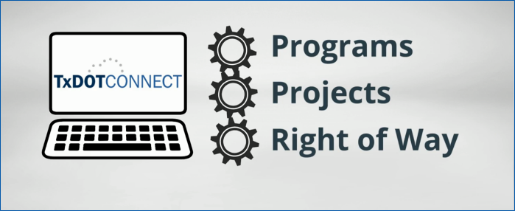
TxDOT CONNECT brings together three key concepts—Programs, Projects, and Right of Way (ROW)—to create a single, streamlined system.

Rise Block – Paragraph with subheading
Integrated Solution:
TxDOTCONNECT automates processes for programs, projects, and ROW activities such as parcel acquisition, utilities, and payments.

Rise Block – Paragraph with subheading
Shared Source of Truth:
All users—district staff, division teams, project managers, funding managers, and leadership—work from the same data, improving collaboration and reducing duplicate entry.

Rise Block – Paragraph with subheading
Continuous Improvements:
The system is updated regularly with enhancements designed to improve the user experience. You’ll receive communications about upcoming updates so you can stay current.

Rise Block – Paragraph with heading
Let’s see TxDOTCONNECT in action!
Now that you’ve reviewed the platform’s purpose and key concepts, it’s time to see how everything comes together. In the next section, you’ll walk through TxDOTCONNECT’s core functionalities and practice navigating its features to build confidence using the system.

Rise Block – Continue Button
[Continue to next lesson]

Course Section 2: Basic Navigation

Lesson 1: Login Page

Rise Block – Paragraph with heading
Logging In to TxDOT CONNECT
To access TxDOT CONNECT, you’ll start at the login page.

Rise Block – Image Centered
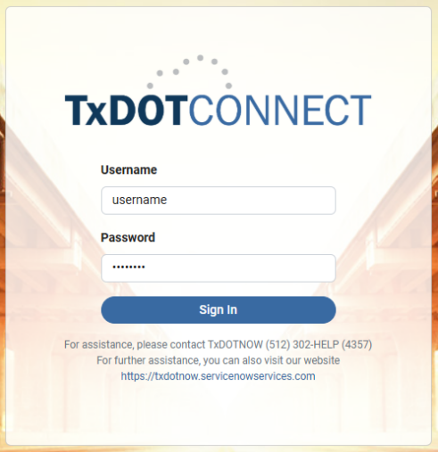

Rise Block – Paragraph
For the best experience, use Google Chrome. Log in with your regular TxDOT username and password and be sure to update your credentials here whenever you change your TxDOT password. Before proceeding, take a moment to review the official Warning Statement located at the bottom of the login page; we’ve also included it for your convenience.

Rise Block – Note
You are accessing a Texas Department of Transportation (TxDOT) Information System (that is provided for TxDOT-authorized use only).By using this Information System (which includes any device attached to this Information System), you consent to the following conditions:
- The TxDOT routinely intercepts and monitors communications on this Information System for purposes including, but not limited to, penetration testing, COMSEC (Communication Security) monitoring, network operations and defense, personnel misconduct, law enforcement, and counterintelligence investigations.
- At any time, the TxDOT may inspect and seize data stored on this Information System.
- Communications using, or data stored on, this Information System are not private, are subject to routine monitoring, interception, and search, and may be disclosed or used for any TxDOT-authorized purpose.
- This Information System includes security measures (e.g., authentication and access controls) to protect TxDOT interests--not for your personal benefit or privacy.
- Notwithstanding the above, using this Information System does not constitute consent to personnel misconduct, law enforcement, and counterintelligence investigative searching or monitoring of the content of privileged communications, or work product, related to personal representation or services by attorneys, psychotherapists, or clergy, and their assistants. Such communications and work product are private and confidential. See User Agreement for details.

Rise Block – Paragraph
Once these steps are complete, you’re ready to log in and begin exploring the system. Watch the video below for a step-by-step example of how to log in to TxDOTCONNECT.

Rise Block – Video
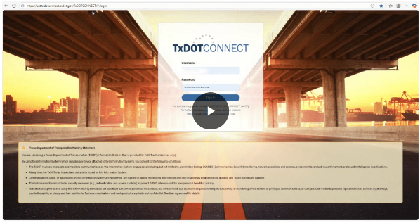
[upload and use the following video file, link below]
Login Video Demonstration Link

Rise Block – Continue Button
[Continue to next lesson]

Lesson 2: TxDOTCONNECT Landing Page

Rise Block – Paragraph with heading
TxDOT CONNECT Dashboard
After logging in, you’ll land on the TxDOT CONNECT Dashboard. While we’ll return to the dashboard later, the first step is to explore the Tools Menu. From here, you can access important features, including your Profile page, where your security roles are listed.

Rise Block – Paragraph with headomg
Tools Menu
The Tools Menu is always available, no matter where you are in TxDOT CONNECT. You’ll find it in the upper right corner, just above the Administrative module, displayed as a set of icons.

Rise Block – Paragraph
Interact with the labeled graphic below to explore the Tools Menu of the TxDOT CONNECT Dashboard.

Rise Block – Labeled Graphic
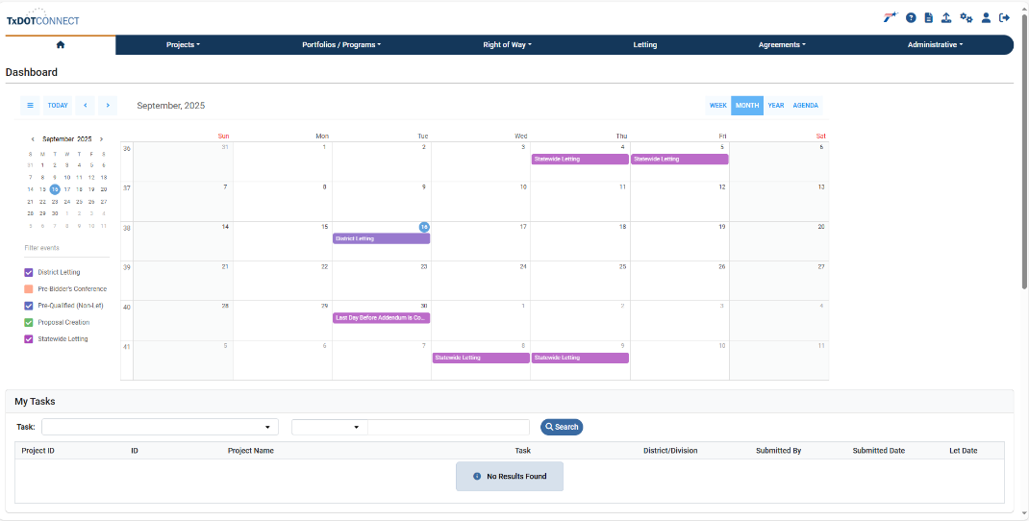

Labeled Graphic Marker
[Place the marker in the top right hand corner identifying the tools menu]
Tools Menu
These are links that will take us to specific pages within TxDOT CONNECT or to links outside of TxDOT CONNECT.
If you don’t remember what the icons were called, you can hover the cursor over each icon and see the label appear telling you what the icon’s name is. This is a "tool tip"

Rise Block - Paragraph with heading
Exploring the Tools Menu
Read the icons in the card grid from top left to right, then continue row by row.

Rise Block – Flash Card Grid
Flash Card | Card Front | Card Back
Card 1-TxDOT |  | TxDOT Icon – A direct link to TxDOT.gov(opens in a new tab).
Card 2-Help |  | Help Icon – Opens the Help page in a new tab. This resource provides definitions and field-by-field explanations specific to the page you are viewing. For example, if you’re on the Home page, the Help icon will display guidance related to that page.  The Help page is organized by modules:  - Projects  - Portfolios/Programs  - Right of Way (ROW)  - Letting  - Administrative  💡 Tip: Use the Help icon anytime you need quick, page-specific guidance without leaving TxDOTCONNECT.
Card 3-Paper Icon |  | The Paper icon links to the Reports feature in TxDOT CONNECT. While this course does not cover reports in detail, a job aid is available to guide you. The feature is regularly updated as new upgrades and enhancements are released.  💡 Tip: Refer to the job aid for the most up-to-date instructions on using Reports.
Card 4-Bulk Upload | 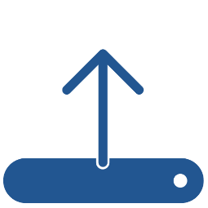 | Bulk Uploads Icon  The arrow pointing up represents the Bulk Uploads feature. Use this option to upload multiple records or files at once, saving time compared to entering data individually.
Card 5-Gears |  | Gear Icon – Administrator Use Only  The Gear icon appears only for system administrators. It is not visible to most users. In the training environment, administrators use this icon to adjust roles and demonstrate different security settings for training purposes.
Card 6-Profile |  | Profile Icon – People Picker  The Profile icon, shown as a person, is also called the People Picker.  When you click this icon, you’ll open your user profile, which includes:  - Contact and administrative information automatically pulled from the TxDOT Active Directory  - Your assigned security roles  - Supporting districts  - A few user preferences  💡 Focus: The most important information is located at the bottom of the profile page, where your assigned security roles are listed.
Card 7-SignOut |  | Sign Out Button  Use this option to securely exit TxDOT CONNECT when you are finished working. Signing out helps protect your account and ensures no one else can access the system from your session.  💡 Tip: Always sign out before leaving your workstation or stepping away from your computer.

Rise Block – Continue Button
[Continue to next lesson]

Lesson 3: Profile Information

Rise Block – Paragraph with heading
Your Profile Information
Your Profile page displays what TxDOT CONNECT knows about you, including:

Rise Block – Bulleted List
- Contact and administrative details pulled from the TxDOT Active Directory
- Assigned security roles
- Supporting districts
- A few user preferences

Rise Block – Subheading
Saving your work and user information

Rise Block – Labeled graphic
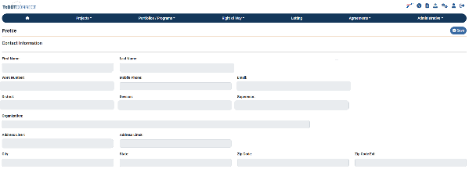

Labeled graphic marker
[Place the marker in the top right hand corner identifying the save button]
Whenever you make updates in TxDOTCONNECT, be sure to click the Save button before leaving the page.
- You cannot change your role or districts directly in the system.
- You can update settings like email notifications, but changes only take effect if you save them.
💡 Note: To request updates to your district or contact information, submit a ServiceNow ticket.

Rise Block – Subheading
Roles, Supporting Districts and Preferences

Rise Block – Labeled graphic
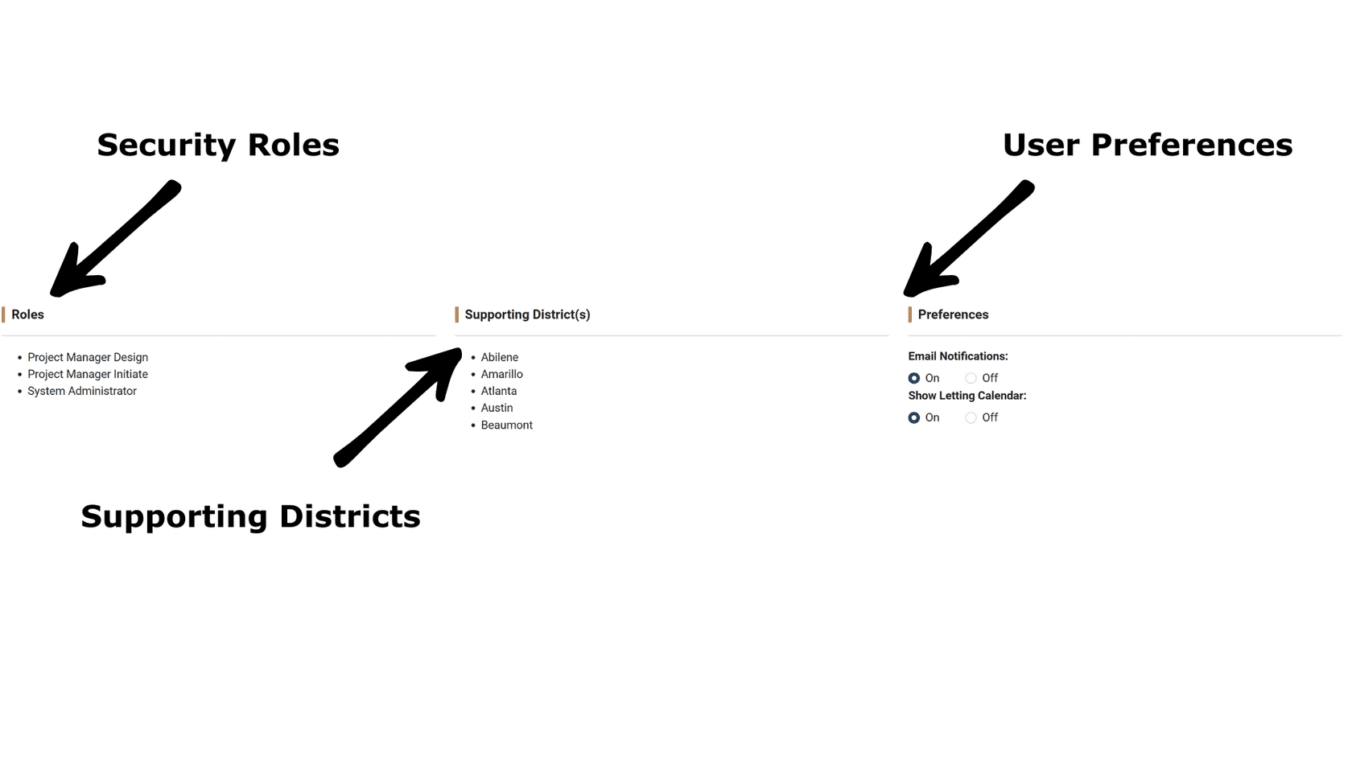

Labeled graphic marker 1
[Place next to Security Roles]
Understanding Security Roles
Your roles determine what you can and cannot do in TxDOTCONNECT.
- Roles are assigned to each user and define system permissions.
- Examples include: Utility Coordinator, ROW Payment Specialist, Utility Manager, Program Manager, or Project Manager.
- Some users may have multiple roles, depending on their responsibilities.
- Only certain security roles have permission to make changes in TxDOTCONNECT, and each role has unique capabilities.
- TxDOT staff can view all projects but can only edit projects for the districts listed under Profile → Supporting Districts.
💡 Tip: The Security Roles Catalog (available on the TxDOTCONNECT Reference Materials page) provides detailed descriptions of each role.

Labeled graphic marker 2
[Place next to supporting districts]
Supporting Districts
The Supporting Districts section shows which districts you can access in TxDOTCONNECT.
- For most users, this will display only their home district(s).
- If you are assigned to work on a project outside your home district, that district will also appear here.
- Division employees may see all districts listed, since their work supports multiple areas.
💡 Tip: Always check your Supporting Districts list to confirm you have access to the projects you’re responsible for.

Labeled graphic marker 3
[Place next to preferences]
Email Preferences
Within your Profile, you can manage your Email Preferences.
- Turn notifications on to receive emails when you are assigned a task.
- You will also receive emails when an action is taken in response to a request you submitted.
- Turn notifications off if you prefer not to receive these updates.
💡 Tip: Keep notifications on to stay informed about important tasks and project updates.

Rise Block – Paragraph with heading
Understanding Security Roles and Permissions
Not every security role in TxDOTCONNECT has permission to make changes. Each role includes a specific set of permissions that define what a user can view, edit, or approve.

Rise Block – Paragraph with subheading
Roles with projection creation permission
To create a new project, you must have one of the following roles:

Rise Block – Bulleted list
- Project Manager Initiate – typically assigned to District Planners; allows users to initiate new projects.
- Project Manager Design – provides broader permissions for managing project design details.

Rise Block – Note
💡 Tip: For a full list of Project Manager security roles and their permissions, review the Job Aid: Security Roles Catalog in the Reference Materials section.

Rise Block – Paragraph with heading
Wrapping Up Your Profile
You’ve now explored your Profile, including roles, supporting districts, and preferences. Next, let’s return to the Homepage Dashboard to see how these settings connect to your day-to-day work in TxDOT CONNECT.

Rise Block – Continue Button
[Continue to next lesson]

Lesson 4: Module Navigation Bar

Rise Block – Paragraph with heading
The Module Navigation Bar
At the top of every TxDOTCONNECT page, you’ll find the Menu Bar—the dark blue oval running across the screen. This is also called the Module Navigation Bar, and it helps you move between key areas of the system.

