Exploring the Parthenon in BSL

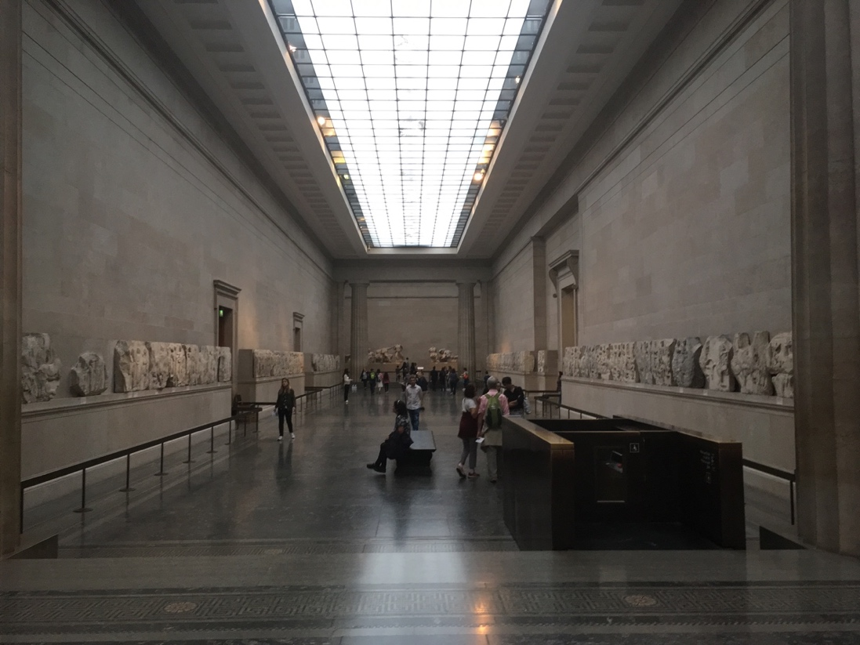

Are you interested in learning about the Parthenon marbles in the British Museum?
Do you have a general interest in art?
Perhaps you have given art tours in BSL, or would like to in the future?
Do you have an interest in BSL linguistics in relation to art?

This short course is designed to explore the Parthenon marbles from ancient Greece. It will also examine how a visual-spatial language (BSL) works in relation to visual art. There will be two sessions at King’s College London, with further possible events in the British Museum itself. Ellen Adams from King’s College London will introduce the Parthenon, and Gabrielle Hodge will introduce the linguistics. Two Deaf art tour guides (Martin Glover and Chisato Minamimura) will provide clips and support. The sessions will include workshop activities for people to explore how they use BSL when discussing art.

Organiser:
Dr Ellen Adams, Senior Lecturer in Classical Art and Archaeology, King’s College London
ellen.adams@kcl.ac.uk

- The course is free.
- The course is in BSL (or with BSL interpretation).
- Priority will be given to people who can attend both sessions.
- To apply, please fill in an application form below, or contact ellen.adams@kcl.ac.uk for a Skype interview in BSL.
- Participants will be expected to fill in an ethics form and a feedback questionnaire.

1) 26 October 2019, 1-5pm, Strand Campus, KCL (WC2R 2LS)
Building within buildings: setting the scene, place and space

2) 23 November 2019, 1-5pm, Strand Campus, KCL (WC2R 2LS)
Art as performance: audience engagement and BSL

Ellen Adams is happy to arrange a meeting in the galleries themselves (probably during a Friday late night opening).

She may also organise a hands-on session of Greek vases and figurines at the British Museum. This will be in small groups, and depend on the Museum’s availability.

This is part of Dr Adams’ research, please see www.mansil.uk for details.

BSL interpreters will be present.

There may be some filming in the sessions (only with consent).

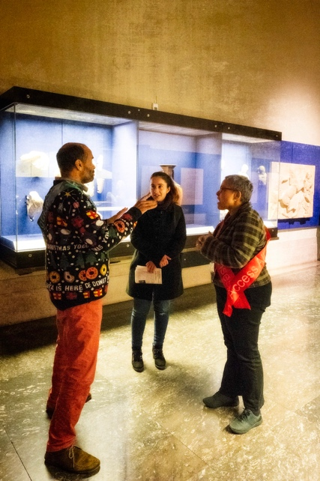 Details subject to change if necessary

Application Form

Please contact Ellen Adams on ellen.adams@kcl.ac.uk if you need to respond in BSL by Skype

Name:

Contact email:

Please confirm that you can attend on:
Saturday 26 October YES NO
Saturday 23 November YES NO

Would you be interested in a gallery tour at the British Museum? YES NO

Would you be interested in a handling session at the Museum? YES NO

Have you ever led a museum or gallery tour in BSL? If so, please give details (e.g. approximate number of years, approximate number of talks). If not, would you like to in the future?

Have you ever done a course in BSL linguistics? If so, please give details.

Do you have any other access needs?

Please contact the organizer at ellen.adams@kcl.ac.uk if you would like to know more about the research project (see also www.mansil.uk). Please contact the organizer if you do not want to be filmed or recorded during the course.

Please send this form to ellen.adams@kcl.ac.uk

