SNAKE AWARENESS TRAINING CLINIC

THE GERMAN SHORTHAIRED POINTER CLUB OF SAN ANTONIO
43nd Consecutive Year SATURDAY, August 21, 2021
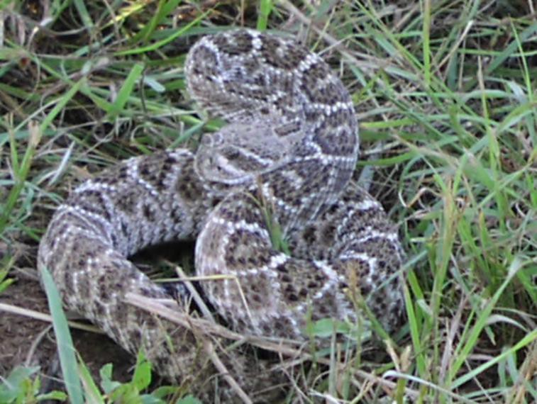
Training time requirements limits registration to 75 dogs!
Registration deadline: Monday – 16 August 2021

Registrations will not be accepted at or on the day of the Clinic.
No exceptions.
Fee per dog--$65.00. No discounts for multiple dogs or re-dos.
Total Amount Enclosed: $
Make check or money order payable to: "GSP Club of San Antonio" or "GSPC/SA"
*Name: *Telephone: | *Address:  *Email Address:
 |  | New | Re-Do
Dog’s Name: | Breed:
Dog’s Name: | Breed:
Dog’s Name: | Breed:
Dog’s Name: | Breed:
Mail Indemnity Release, Registration and Check To:
AJ Johnson - 22800 Bulverde Rd Apt 201
SA, TX 78261
Contact: johnson20@gmail.com
You will receive an Email message notifying you of your time

RELEASE, INDEMNITY, AND ASSUMPTION OF RISKS

Subject: Snake Awareness Training Clinic on Saturday, June 5, 2021 (hereinafter referred to as "Event") at 6442 Green Valley Road, Cibolo, TX 78108 (hereinafter referred to as "Premises")

Persons, Entities and/or Associations Indemnified and Released: The owners of the Premises and their agents, employees, invitees, licensees or visitors and The German Shorthaired Pointer Club of San Antonio and its members, agents, employees, invitees, licensees, visitors and/or volunteers; hereinafter Collectively referred to as "First Party".

- Assumption of Risks. THE UNDERSIGNED ACKNOWLEDGES THAT DANGEROUS NATURAL OR MAN-MADE CONDITIONS MAY EXIST ON THE PREMISES DESCRIBED ABOVE AND THE EVENT DESCRIBED ABOVE INVOLVES DANGERS AND IS AN INHERENTLY DANGEROUS ACTIVITY INVOLVING POISONOUS SNAKES AND DOGS. THE UNDERSIGNED ASSUMES ALL SUCH DANGERS AND RISKS.

- Indemnity. THE UNDERSIGNED, WILL INDEMNIFY, DEFEND, AND HOLD FIRST PARTY HARMLESS AGAINST ALL CLAIMS, DAMAGES, AND COSTS (COLLECTIVELY, "CLAIMS") INCURRED BY OR ALLEGED AGAINST FIRST PARTY AND ARISING OUT OF OR RELATING TO ANY ACT OR OMISSION OF THE UNDERSIGNED OR ANY OF THE UNDERSIGNED'S AGENTS, EMPLOYEES, CONTRACTORS, LICENSEES, OR VISITORS (COLLECTIVELY REFERRED TO AS "SECOND PARTY".) WHILE AT THE PREMISES IN CONNECTION WITH THE SUBJECT EVENT, INCLUDING ANY CLAIMS BASED ON ANY (a) INJURY TO OR DEATH OF ANY PERSON(S), (b) DAMAGE TO OR LOSS OF PROPERTY, OR (c) FAILURE OF THE SECOND PARTY TO COMPLY WITH ANY APPLICABLE LAWS, RULES AND/OR REGULATIONS WHILE ON THE PREMISES IN CONNECTION WITH THE EVENT.

- Release. THE UNDERSIGNED WAIVES ALL CLAIMS AGAINST FIRST PARTY AND RELEASES FROM ANY LIABILITY, BASED ON ANY (a) INJURY TO OR DEATH OF THE SECOND PARTY OR (b) DAMAGE TO OR LOSS OF ANY PROPERTY BELONGING TO OR IN THE CARE OF THE SECOND PARTY.

- Negligence of First Party. THE FOREGOING INDEMNITIES, WAIVERS, AND RELEASES WILL APPLY EVEN IF THE INCIDENT GIVING RISE TO THE CLAIM IS CAUSED IN WHOLE OR IN PART BY THE CONDITION OF THE PREMISES AND/OR OCCURRENCES RELATED TO THE EVENT OR BY THE SOLE OR CONCURRENT ORDINARY NEGLIGENCE OF THE FIRST PARTY (BUT NOT THE GROSS NEGLIGENCE OR WILLFUL MISCONDUCT OF THE FIRST PARTY).

*Date: *Signature: *Print Name:

DIRECTIONS TO SNAKE AWARENESS CLINIC

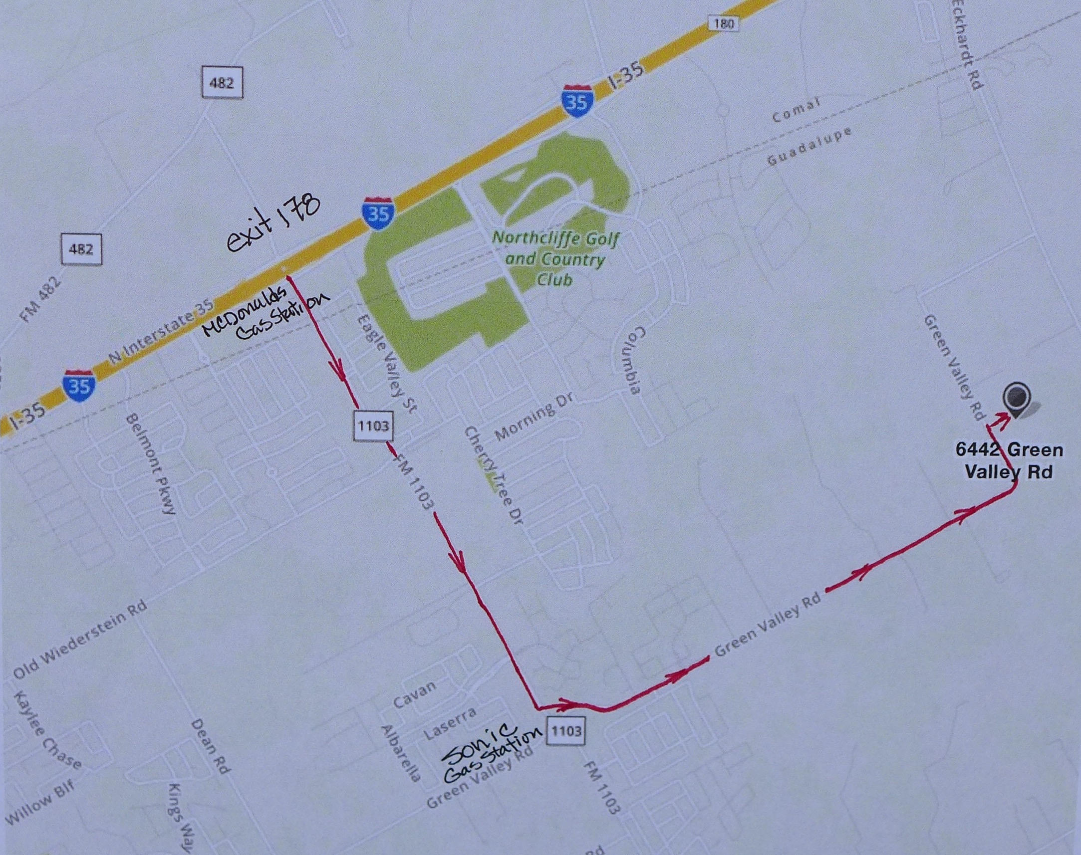

Regardless of direction traveling on IH 35, take Exit 178 at FM 1103 toward Cibolo. There is a McDonalds and EXXON Gas Station at the exit. Take 1103 through one stoplight to the intersection at Green Valley Rd.

The dividing lines and turn lane are not well marked. There will be a Sonic and Gas Station on the Right.

Turn Left onto Green Valley Road for approximately 1.7 miles. Over the last rise you will see the road turns sharply left. This is a 90 degree corner blind in both directions. After the corner it is a short distance to the entrance on your right marked with a sign. Once on the grounds, follow the parking directions.

