Special Events, Catering and Private Party
Information Packet
*Prices are subject to change

540-251-7600
events@thefarmhousechristiansburg.com

(540) 251-7600 285 Ridinger Street, Christiansburg, VA 24073 www.TheFarmhouseChristiansburg.com

Thank you for considering the Farmhouse Restaurant for your Special Event.

Here at The Farmhouse we will do anything we can to ensure your event runs smoothly. Our attentive staff as well as our exceptional Culinary experts are excited to make your special event a memorable one. We have several private rooms, dining areas & a beautiful banquet hall that is sure to accommodate your needs. We also have a variety of event menu packages for you to choose from.

The Farmhouse staff looks forward to you and your guests dining here with us!

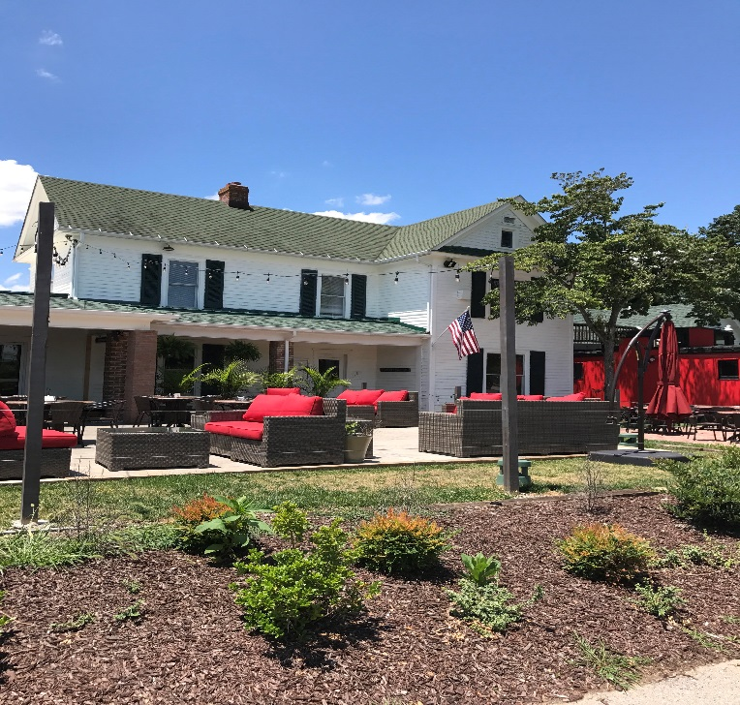

Policies and Procedures
- Fees: The Farmhouse reserves the right to charge an initial room rental deposit fee payable upon receipt of this event policy agreement. This fee is non-refundable but will be refunded in the initial form of payment after the event or will be used towards the total cost of food/beverages at the time of the event. Separate private bar, cake cutting, and room rental fees will be added to the final bill and are not included in the deposit. In the event of cancellation, the event coordinator or manager on duty must be contacted 72 hours prior to the event or a $150 cancellation fee will be accessed in addition to the loss of the paid deposit. (During May-December, 1 weeks’ notice is needed for cancellation).
  - Cake Cutting Fee: A $25 fee will be accessed for all Cake cuttings done by the restaurant staff.
  - Private Bar Fee: A $50 fee will be accessed for each private bar set up for the event with bartender.
  - Room Rental Fee: A $25-$400 fee will be accessed based on the private space reserved.
- Guaranteed Guest Count: The guaranteed guest count is due three business days in advance of the event. If no guaranteed guest count is received, The Farmhouse will set for and charge for the original guest count estimate, or the actual number of guests in attendance, whichever is greater. The Farmhouse cannot ensure additional seating should actual guest count exceed the guaranteed guest count or room capacity. Every attempt will be made to accommodate additional guests on a space available basis/ however, it is possible a guest may not be seated or served.
- Gratuity: A 20% gratuity charge will be automatically applied to all food, beverage, taxes, and other charges, where applicable on all groups.
- Authority: Any person signing an agreement with The Farmhouse in name of the corporation, association, or society represents to The Farmhouse Restaurant that she/he is authorized to sign the agreement on behalf of the organization. In addition, the signature on this Agreement will act as a signature on file if a credit card is used for the room rental fee or final payment; The cardholder must sign this agreement, along with any other responsible parties.
- Payment: All payments must be made by American Express, MasterCard, Visa, Discover, Cash, or by Pre-Approved Company Checks. We will set up Invoice billing on a pre-approval basis.
- Security: The Farmhouse reserves the right to inspect and control all events, and may, in its discretion, require security for certain events, particularly those with minors in attendance. The cost of such services will be the Clients responsibility. The Farmhouse will not assume any liability for theft or any type of loss or damage or injury of any persons or to personal property occurring either prior to, or after the event.
- Deliveries: With prior arrangement, The Farmhouse will accept packages sent no earlier than 3 business days prior to the event. Any shipment prior to such dates or deemed excessive in size or volume may be subject to storage fees or sent back all together.
- Display & Decorations: All displays and/or decorations proposed by the Client’s will be subject to prior approval by the Farmhouse manager or events coordinator in each instance. Any damage caused to the premises will be the responsibility of the Client. No Confetti, sparkles, or similar materials unless approved by management. No paint, holes, or anything else that could cause permanent damage to the walls is allowed. If any damage in incurred, a separate damage fee will be accessed, including forfeit of paid deposit.
- Alcoholic Beverages: The Farmhouse strictly adheres to all laws and regulations pertaining to the sales and service of alcoholic beverages, including sales to minors and intoxicated persons.
- Excused non-performance: Client agrees and acknowledges that The Farmhouse shall be excused from performing any obligations under this Agreement for so long as such performance is prevented, delayed or hindered by an act of nature, fire, flood, or explosion, strikes, labor disputes, inability to procure labor, equipment materials or surplus, or any other causes beyond its reasonable control. If inclement weather prohibits us from opening, management will contact the client in a timely manner and vice versa.

Event Spaces
(Deposits and Room Fees are associated with the purchase of a menu package)

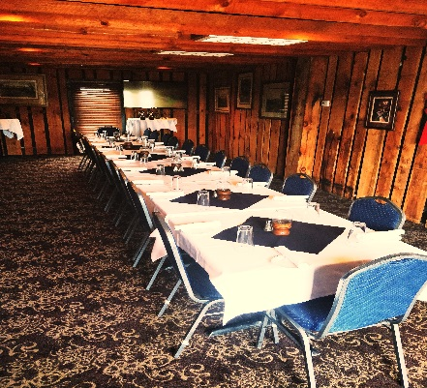
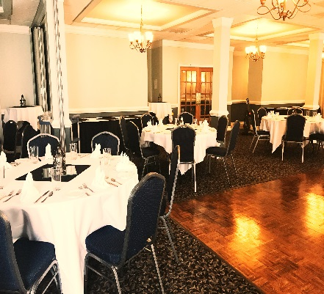
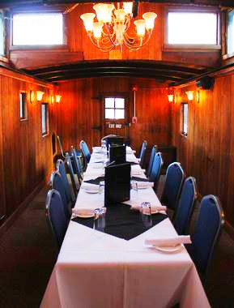

Upstairs Banquet Hall Caboose
20-30 Guests 30-200 Guests 10-20 Guests
A/V Compatible* A/V Compatible* No A/V

*HDTV with HDMI CHORD SET UP, WINDOWS LAPTOP REQUIRED!

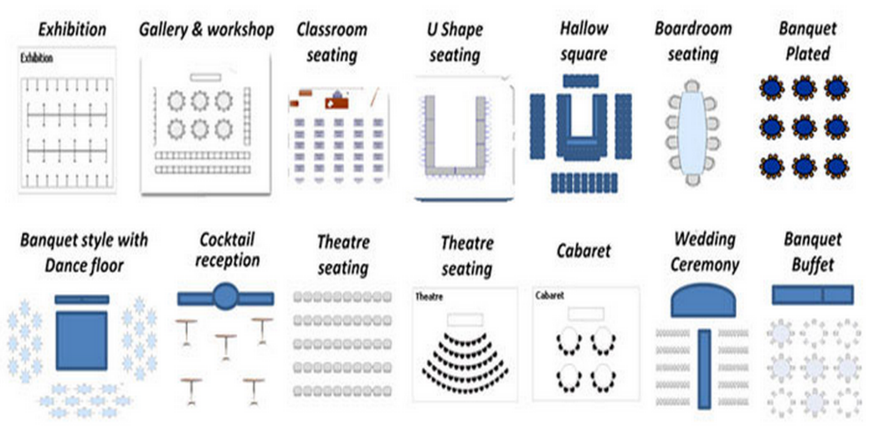
Room Set Up Styles

Menu Tasting
Signed agreement is required one week before tasting reservation. Reservation must be made with the Event Coordinator.
$25- Try 2 Entrees, 2 Sides and 1 Dessert or $35- Try 3 Entrees, 3 Sides and 2 Desserts
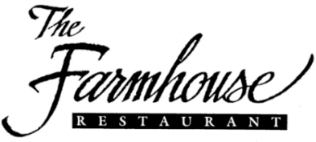

Select Menu 1
$64pp
Prices Not Inclusive of Tax or Gratuity
Package includes Coffee, Iced Tea, and Bread

1st Course
(Choice of 1)
Traditional Wedge
Iceberg lettuce, bleu cheese crumbles, bacon, tomatoes, & bleu cheese dressing
Classic Caesar
Classic Caesar dressing, shredded parmesan, & crostini

2nd Course
(Choice of 1)
Filet Oscar
6oz Filet topped with Crab Meat, Bearnaise Sauce, and Asparagus, served with Smashed Potatoes and Roasted Carrots
Maryland Style Crab Cakes
Two jumbo lump crab cakes with remoulade, served with Smashed Potatoes and Roasted Carrots
Chicken Fried Chicken
Pan Fried Chicken Breast topped with a signature mushroom gravy, served with Smashed Potatoes and Roasted Carrots
Vegetarian Fettuccine
Sautéed Vegetables with Fettuccine in a Marinara Sauce

3rd Course
(Choice of 1)
NY Style Cheesecake
Finished with Whipped Cream and Berries
Lemon Mascarpone Cake
White Cake layers with Lemon Mascarpone cream
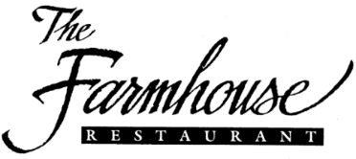

Select Menu 2
$52pp
Prices Not Inclusive of Tax or Gratuity
Package includes Coffee, Iced Tea, and Bread

1st Course
(Choice of 1)
Classic Caesar
Classic Caesar dressing, shredded parmesan, & crostini
Mixed Greens House Salad
Topped with grape tomatoes, cucumbers, & shredded carrots. Choice of Blue Cheese, Ranch, or Honey Mustard dressing

2nd Course
(Choice of 1)
12 oz. Ribeye
12oz Ribeye Char-Grilled to perfection, served with Smashed Potatoes and Roasted Carrots
~Substitute to a 10oz Prime Rib for an extra $2 per person ~
Bourbon Glazed Salmon
Filet of Salmon topped with a Pecan Bourbon Glaze, served with Smashed Potatoes and Roasted Carrots
Chicken Fried Chicken
Pan Fried Chicken Breast topped with a signature mushroom gravy, served with Smashed Potatoes and Roasted Carrots
Vegetarian Fettuccine
Sautéed Vegetables with Fettuccine in a Marinara Sauce

3rd Course
(Choice of 1)
Lemon Mascarpone Cake
White Cake layers with Lemon Mascarpone cream
NY Style Cheesecake
Finished with Whipped Cream and Berries

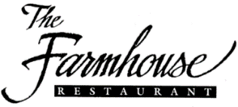

Select Menu 3
$39pp
Prices Not Inclusive of Tax or Gratuity
Package includes Coffee, Iced Tea, and Bread

1st Course
Mixed Greens House Salad
Topped with grape tomatoes, cucumbers, & shredded carrots. Choice of Blue Cheese, Ranch, or Honey Mustard dressing

2nd Course
(Choice of 1)
10 oz. Sirloin
10oz Char-Grilled Sirloin, served with Smashed Potatoes and Roasted Carrots
Chicken Fried Chicken
Pan Fried Chicken Breast topped with a signature mushroom gravy, served with Smashed Potatoes and Roasted Carrots
Vegetarian Fettuccine
Sautéed Vegetables with Fettuccine in a Marinara Sauce

3rd Course
NY Style Cheesecake
Finished with Whipped Cream and Berries

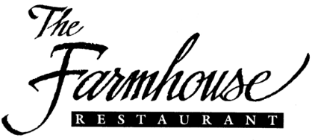

Dinner Buffet Package 1
The Farmhouse
20 or more guests only!
$35pp
Prices Not Inclusive of Tax or Gratuity
Package includes Coffee, Iced Tea, and Bread

Salad
Fresh Mixed Greens
With Ranch, Blue Cheese, and Honey Mustard Dressing
Entrées
Thinly Sliced Roast Beef with Au Jus
(Substitute Prime Rib for an additional charge)
Herb Grilled Chicken Breast
Sides
Your choice of Two Sides
Smashed Potatoes Roasted Glazed Carrots Macaroni and Cheese
Vegetable Medley
Dessert
Your choice of One Dessert
Seasonal Cobbler Bread Pudding Chocolate Mousse

*Vegetarian, Vegan, Alfredo, or Marinara Fettuccine substitutions available upon request
**Extra Entrees, Sides, and Desserts are available for an additional cost per person
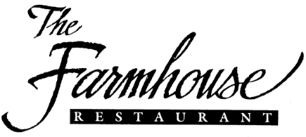
Dinner Buffet Package 2
Surf and Turf
20 or more guests only!
$45pp
Prices Not Inclusive of Tax or Gratuity
Package includes Coffee, Iced Tea, and Bread

Salad
Fresh Mixed Greens
With Ranch, Blue Cheese, and Honey Mustard Dressing
Entrées
12 oz. Ribeye
(Substitute Prime Rib for an additional charge)
Bourbon Glazed Salmon
Sides
Your choice of Two Sides
Smashed Potatoes Roasted Glazed Carrots Macaroni and Cheese
Vegetable Medley
Dessert
Your choice of One
Seasonal Cobbler Bread Pudding Chocolate Mousse

*Vegetarian, Alfredo, or Marinara Fettuccine substitutions available upon request
**Extra Entrees, Sides, and Desserts are available for an additional cost per person
Lunch Buffet Package
11am-3pm
20 or more guests only!
$18.95pp
Prices Not Inclusive of Tax or Gratuity
Package includes Coffee, Iced Tea, and Chips

Salad
Fresh Mixed Greens
With Ranch, Blue Cheese, and Honey Mustard Dressing
Entrees

Main Course
(Choice of 1)
Grilled Chicken
Fried Chicken

Sides
(Choice of 1)
Mac n’ Cheese
Smashed Potatoes

Dessert
Your choice of One
Chocolate Chip Cookies Brownies

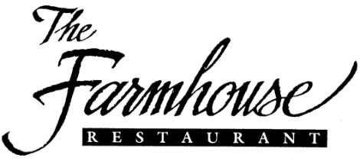
Meeting Packages
All Packages are for room rentals only without menus or service staff
A $50 Set and Clean Fee and $25 A/V Fee (if applicable) per room
20% Gratuity will apply for all food orders
3 Hour Limit for all Spaces

Room Rental Charges
Option One
(Room Only, Coffee and Water included)
Caboose $100
Upstairs $150
Each Banquet Room $200

Option Two
(Includes 2 Small Hors d’oeuvres Trays plus Danishes, Muffins, Assorted Fruits, Coffee, Iced Tea, and Water)
Caboose $200
Upstairs $300
Each Banquet Room $400

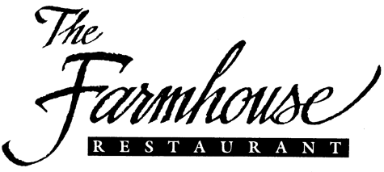
A La Carte
Prices Not Inclusive of Tax or Gratuity

Buffet Upgrades
Extra Entrée- $7pp
Extra Side- $4pp
Extra Dessert- $5pp
Substitute the dessert option to a Fresh Fruit Salad- $3pp
Soda Package- $3pp
Dr. Pepper, Hi-C Pink Lemonade, Coke, Diet Coke, Rotational Soda, Sprite

Stations
Carving Station with Carver $200
Meat Selection- Market Price $
Choice of: Prime Rib, Virginia Ham, Beef Tenderloin, Roasted Turkey, Pork Loin

Bowls
House Chips $25 (20 people)
Small Fruit Salad $50 (20-25 people)
Large Fruit Salad $75 (40-50 people)
Mixed Greens Salad $50 (20-25 people)
Classic Caesar Salad $75 (20-25 people)

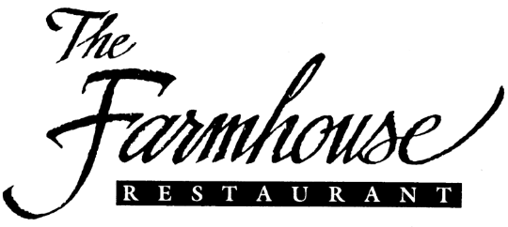
Menu Package Add on Hors d’ Oeuvres
(Can only be selected with an Event Package!)
Fresh Seasonal Fruit & Assorted Cheese Platters
Small Tray $85 (10-15 guests)
Medium Tray $125 (20-35 guests)
Large Tray $175 (40-50 guests)
Assorted Vegetable/Crudités Trays
Small Tray $55 (10-15 guests)
Medium Tray $75 (20-35 guests)
Large Tray $100 (40-50 guests)
Bruschetta Trays
Medium Tray $60 (15-25 guests)
Large $80 (25-50 guests)
Buffalo Chicken Dip
Large Tray $80 (30-50 guests)

Mini Virginia Ham Biscuits with Honey Mustard

$25 per dozen (2 per person, serves 6 people)

Mini Cheeseburger Sliders
$36 per dozen (2 per person, serves 6 people)
Hand-Breaded Fried Boneless Chicken Wings
Farmhouse BBQ, Buffalo(Hot or Mild), or Plain
Served with Ranch and Blue Cheese for dipping
Medium Tray (50 pcs.) $60 (serves 10-20 guests)
Large Tray (100 pcs.) $115 (serves 20-30 guests)
Mini Maryland-Style Crab Cakes
$3.50 per piece (1-ounce) (recommended 2 per guest)
Shrimp Cocktail

Medium Portion $100 (Est. 2 pieces per person, 25 Guests)
Large Portion $200 (Est. 2 pieces per person, 50 Guests)
Cookie/Brownie Trays

$18 per dozen (2 per person, serves 6 people)
***Number of guests served is subject to change
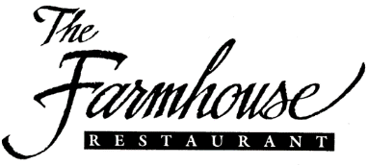
Alcohol List
All Alcohol is at Regular Price
Cocktail and Mixer ingredients will be available
Beer
Up to 5 Choices

Miller Lite
Angry Orchard
Blue Moon

Bud Lite
Corona
Get Bent IPA
Heineken
Michelob Ultra
Yuengling
Coors Lite
Liquor
Up to 5 Choices

Grey Goose Vodka
Titos Vodka
Captain Morgan Rum
1800 Silver Tequila
Patron Silver Tequila

Jose Cuervo Gold Tequila
Maker’s Mark Bourbon Whiskey
Jim Beam Bourbon Whiskey
Jack Daniels Whiskey
Woodford Reserve Bourbon Whiskey
Knob Creek Bourbon Whiskey
Johnny Walker Black Scotch
Absolut Vodka
Bombay Gin
Tanqueray Gin
Bacardi Rum
Wine
Up to 4 Choices

Sterling Pinot Grigio
Matua Sauvignon Blanc
Wente Chardonnay

Fleurs de Prairie Rose
Primo Amore Moscato
Relaxed Bubbles Prosecco
Meiomi Pinot Noir
Greystone Merlot
Josh Cabernet Sauvignon
19 Crimes Red Blend

