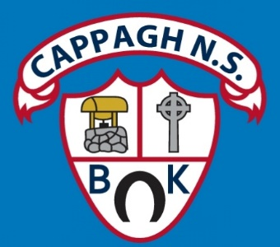

**St Colman’s NS Cappagh, Croghan, Tullamore, Co Offaly, R35Y635**

**ANNUAL ADMISSION NOTICE in respect of admissions to the 2025/2026 school year**

A copy of the school’s **Admission Policy** and the **Application Form for Admission** for the 2024/25 school year is available as follows:

By emailing: [**stcolmans1@gmail.com**](mailto:stcolmans1@gmail.com)

By phoning: 044 922 3452

By writing to: St Colman’s NS, Cappagh, Croghan, Tullamore, Co Offaly R35Y635

**Application and Decision Dates for** **admission to the 2024/25**

The following are the dates applicable for admission to junior infants:

|  |  |
| --- | --- |
| The school will commence accepting applications for admission on | Monday  November 4th 2024 |
| The school shall cease accepting applications for admission on | Friday January 24th  2025 |
| The date by which applicants will be notified of the decision on their application is | Friday February 14th  2025 |
| The period within which applicants must confirm acceptance of an offer of admission is**\*** | Tuesday  February 25th 2025 |

**Number of Places being made Available in** 2025/2026

|  |  |
| --- | --- |
| The number of places being made available in junior infants | **20** |

**\*Failure to accept an offer within the prescribed period above may result in the offer being withdrawn.**

**Note: the school will consider and issue decisions on late applications in accordance with the school’s Admission Policy.**