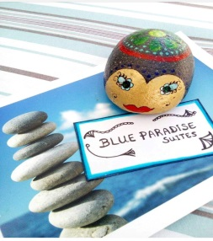

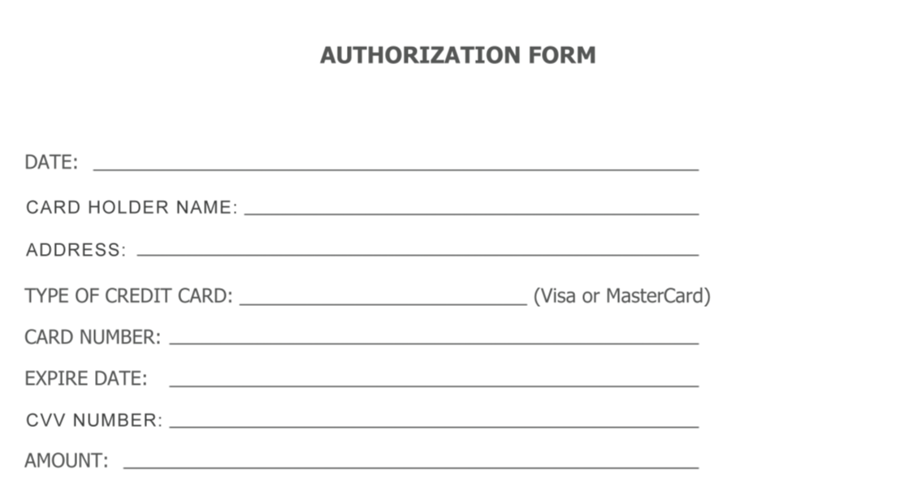

I authorize Blue Paradise Suites Katerina Hatzianatasiou to charge my credit card with the above reference amount, as a deposit for the reservation of one ________________________ (particular to the room type and number of people)

From the ___ / ___ / ___ to ___/ ___ / ___. I am fully aware that if I cancel this booking in less than 21 days before my scheduled arrival date, this deposit will not be refunded.

______________________________

Enter your name and signature above