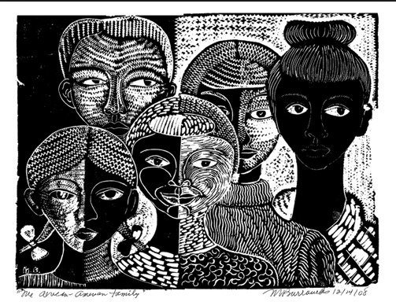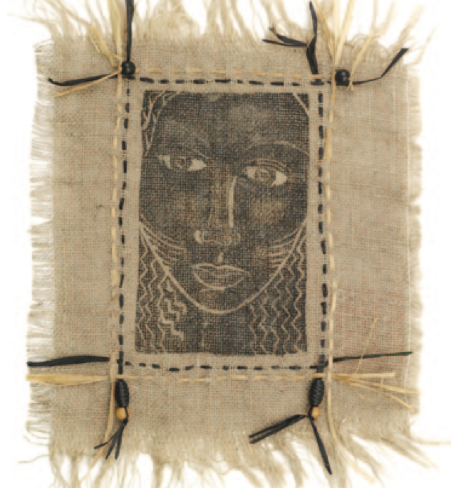

Lesson Name: Printmaking Portraits on Burlap
Historical Reference: Margaret Burroughs (1917-2010) was a poet, visual artist, educator, and arts organizer. She was born in St. Rose, Louisiana, near New Orleans. At the age of five, Margaret was brought by her parents to Chicago, where she grew up, was educated, and where her long career unfolded. Burroughs was known nationally as a visual artist and as an arts organizer. Her extensive exhibition record as a painter and printmaker began in 1949 and has included exhibitions throughout the United States and abroad. It was her founding in 1961 of the DuSable Museum of African American History in Chicago that placed her among the outstanding institution- builders of her generation.
Burroughs was an avid storyteller and incorporated this talent into her artistic portrayals. She devoted her life’s work to African American history and culture but also saw her art as a catalyst for bringing people together and improving life for all humanity. She said her inspiration could come from anything, at any time, without notice. However, most of her work deals with social commentary, oppression, and race-related themes. Her energy is best felt in the vitality of her many prints, including lithographs, woodcuts, and linocuts. The black-and- white format helps to further emphasize her strong subject matter.
Vocabulary:
Graphic- Vividly or clearly described.
Materials: Soft-Kut Linoleum carving plate, linoleum cutters, block printing ink, natural burlap, soft rubber brayers, inking plates, flat brushes, printing paper. Optional: wooden beads and/or black matboard.
Procedure:
1. Sketch a portrait or other image lightly in pencil onto the Soft- Kut material. Focus on simple, strong lines and areas where patterning can be used.
2. Using carving tools of various widths, carve into the Soft-Kut until all areas that are not meant to receive ink are carved away.
3. Using a brayer, evenly spread Blick Water-Soluble Block Printing Ink onto an inking plate or any other smooth surface.
4. Roll the inked brayer evenly over the Soft-Kut design, moving both ways across the image.
5. Place the inked Soft-Kut block face-down on the burlap, carefully turn the burlap over, and go over the inked area with a baren or wadded up piece of paper toweling. If there happen to be areas where the ink is thin on the finished print, use a damp brush to even out and darken the ink.

Evaluation: Students will have a group critique of their printmaking self-portraits and discuss how successful the prints turned out. They will also discuss what could be done to improve the techniques used. Students will also write a self-evaluation of their work in their journals and fill out their grading rubrics.

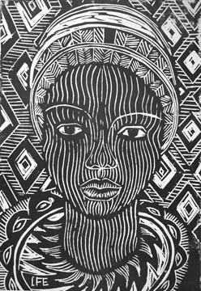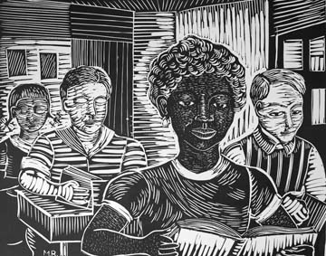

Assessment Rubric
Student Name: | Class Period:
Assignment: Printmaking Self-Portraits on Burlap | Date Completed:
Circle the number in pencil that best shows how well you feel that you completed that criterion for the assignment. | Excellent | Good | Average | Needs Improvement | Rate Yourself | Teacher’s Rating
Criteria 1 – Sketch- How well did your self-portrait capture your simplified likeness? | 10 | 9 – 8 | 7 | 6 or less
Criteria 2 – How well did your linoleum plate turn out? Did it look like your sketch? | 10 | 9 – 8 | 7 | 6 or less
Criteria 3 – How did your print translate onto burlap? Was it well printed? | 10 | 9 – 8 | 7 | 6 or less
Criteria 4 – Effort: took time to develop idea & complete project? (Didn’t rush.) Good use of class time? | 10 | 9 – 8 | 7 | 6 or less
Criteria 5 – Craftsmanship – Neat, clean & complete? Skillful use of the art tools & media? | 10 | 9 – 8 | 7 | 6 or less
Total: 50 possible student points + 50 possible teacher points= 100 possible points | Grade: |  |  |  | Your Total | Teacher Total
Student Comments:

Teacher Comments:

