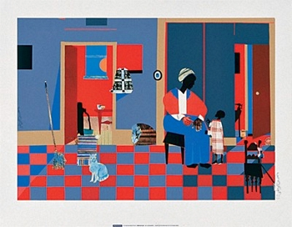
Lesson Name: Quote Collage
Historical Reference: Romare Bearden (September 2, 1911 – March 12, 1988) was an American artist and writer. He worked in several media including cartoons, oils, and collage.
Vocabulary:
Collage- A picture or design created by adhering such basically flat elements as newspaper, wallpaper, printed text and illustrations, photographs, cloth, string, etc., to a flat surface, when the result becomes three-dimensional, and might also be called a relief sculpture / construction / assemblage. Most of the elements adhered in producing most collages are "found" materials. Introduced by the Cubist artists, this process was widely used by artists who followed, and is a familiar technique in contemporary art.
"Collage" was originally a French word, derived from the word coller, meaning "to paste."
Materials: White paper, magazines, scissors, glue sticks, gel medium, paint, collage materials like textured paper, cardboard, glitter, etc.
Goals: To acquaint the students with both collage techniques and the thoughts of famous African Americans.
Procedure: Students will research quotes made by famous African Americans at websites like http://africanamericanquotes.org/ and http://www.african-american-family-spotlight.com/african-american-quotes.html. They will then pick a quote from a famous African American and create a collage using letters from magazines on a background that reflects the quotes meaning.
Evaluation: Students will have a group critique of their black history month projects and discuss how successful the collages turned out. They will also discuss what could be done to improve the techniques used.

